Q1.
Waves may be either longitudinal or transverse.
(a) Describe the difference between a longitudinal and a transverse wave.
___________________________________________________________________
___________________________________________________________________
___________________________________________________________________
___________________________________________________________________
(2)
(b) Describe one piece of evidence that shows when a sound wave travels through the air it is the wave and not the air itself that travels.
___________________________________________________________________
___________________________________________________________________
___________________________________________________________________
(1)
(c) The figure below shows the parts of a moving-coil loudspeaker.
A coil of wire is positioned in the gap between the north and south poles of the cylindrical magnet.
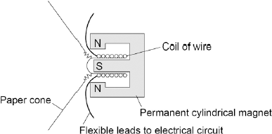
Explain how the loudspeaker converts current in an electrical circuit to a sound wave.
___________________________________________________________________
___________________________________________________________________
___________________________________________________________________
___________________________________________________________________
___________________________________________________________________
___________________________________________________________________
___________________________________________________________________
___________________________________________________________________
___________________________________________________________________
___________________________________________________________________
(6)
(Total 9 marks)
Q2.
Musicians sometimes perform on a moving platform.
Figure 1 shows the parts of the lifting machine used to move the platform up and down.
Figure 1
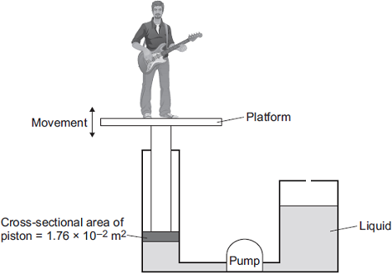
(a) What type of system uses a liquid to transmit a force?
___________________________________________________________________
(1)
(b) The pump creates a pressure in the liquid of 8.75 x 10⁴ Pa to move the platform upwards.
Calculate the force that the liquid applies to the piston.
___________________________________________________________________
___________________________________________________________________
___________________________________________________________________
Force = _________________________ N
(2)
(c) The liquid usually used in the machine is made by processing oil from underground wells. A new development is to use plant oil as the liquid.
Extracting plant oil requires less energy than extracting oil from underground wells.
Suggest an environmental advantage of using plant oil.
___________________________________________________________________
___________________________________________________________________
___________________________________________________________________
(1)
(d) Musicians often use loudspeakers.
Figure 2 shows how a loudspeaker is constructed.
Figure 2
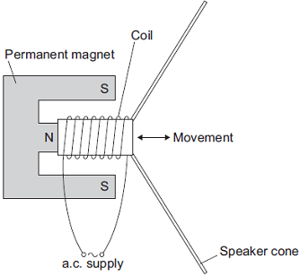
The loudspeaker cone vibrates when an alternating current flows through the coil.
Explain why. (4)
___________________________________________________________________
___________________________________________________________________
___________________________________________________________________
___________________________________________________________________
___________________________________________________________________
___________________________________________________________________
___________________________________________________________________
___________________________________________________________________
___________________________________________________________________
___________________________________________________________________
(4)
(Total 8 marks)

Mark schemes
Q1.
(a) in a longitudinal wave the oscillations / vibrations are parallel to the direction of energy transfer.
accept wave travel for energy transfer throughout
1
in a transverse wave the oscillations / vibrations are perpendicular to the direction of energy transfer.
1
(b) accept any sensible suggestion eg a vibrating drum skin does not move the air away to create a vacuum (around the drum)
1
(c) Level 3 (5–6 marks):
A detailed explanation linking variations in current to the pressure variations of a sound wave, with a logical sequence.
Level 2 (3–4 marks):
A number of relevant points made, but not precisely. A link between the loudspeaker and
a sound wave is made.
Level 1 (1–2 marks):
Some relevant points but fragmented with no logical structure.
0 marks:
No relevant content.
Indicative content
the current in the electrical circuit is varying
the current passes through the coil
the coil experiences a force (inwards or outwards)
reversing the current reverses the force
the size of the current affects the size of the force
the varying current causes the coil to vibrate
the (vibrating) coil causes the cone to vibrate
the vibrating cone causes the air molecules to move
the movement of the air molecules produces the pressure variations in the air needed for
a sound wave
the air molecules bunch together forming compressions and spread apart forming rarefactions
6
[9]
Q2.
(a) hydraulic (system)
1
(b) 15.40 ×10²
or
1540
allow 1 mark for correct substitution, ie
8.75 × 10⁴ = 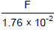
or
87 500 = 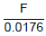
or
F = 8.75 × 10⁴ × 1.76 ×10⁻²
or
F = 87 500 × 0.0176
2
(c) any one environmental advantage:
stating a converse statement is insufficient, or a disadvantage of the usual oil, ie the usual oil is non-renewable
plant oil is renewable
using plant oil will conserve (limited) supplies or extend lifetime of the usual / crude oil.
plant oil releases less carbon dioxide (when it is being produced / processed)
plant oil will add less carbon dioxide to the atmosphere (when it is being produced / processed, than the usual oil)
plant oil removes carbon dioxide from or adds oxygen to the air when it is growing
stating that plant oil is carbon neutral is insufficient
1

(d) (the current flowing through the coil) creates a magnetic field (around the coil)
1
(this magnetic field) interacts with the permanent magnetic field
or
current carrying conductor is in a (permanent) magnetic field
it must be clear which magnetic field is which
1
this produces a (resultant) force (and coil / cone moves)
1
when the direction of the current changes, the direction of the force changes to the opposite direction
accept for 2 marks the magnetic field of the coil interacts with the permanent magnetic field
1
[8]

