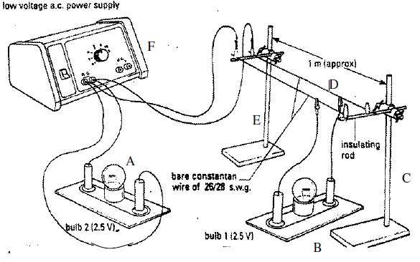
The National Grid is a network of cables, pylons and transformers that distributes (‘shares out’) electrical energy across the UK.
The diagram shows a simplified model of the National Grid system.
1. Which letter represents the power station? __________
2. Which letters represent a pylon? ________ and ________
3. Which letter represents the cables of the National Grid? ________
4. Which letter represents a house close to the power station? ________
5. Which letter represents a house far away from the power station? ________
6. Bulb B is brighter than / the same brightness as / dimmer than bulb A.
7. This happens because energy is gained / remains constant / is lost as electric current travels through the cable because of resistance.
8. The wasted / gained energy results in heating / cooling of the cables.
9. This system can be described as efficient / inefficient because some energy is wasted instead of being transferred usefully.
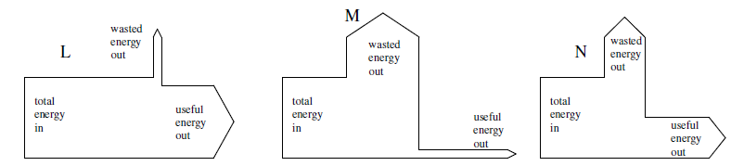
10. Which Sankey Diagram best represents the energy transfer to bulb B in this model?

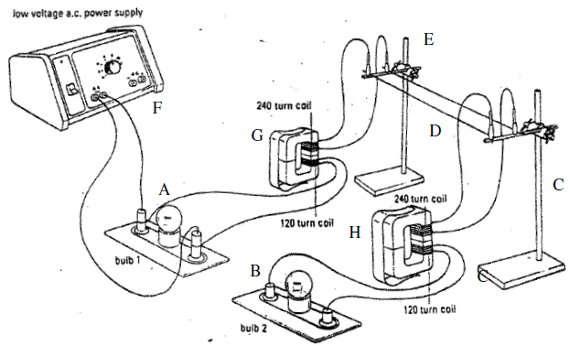
This diagram shows a more realistic model of the National Grid system.
11. Name the two items that have been added. ________________________
12. What is the letter of the step up transformer? ________
13. What is the letter of the step down transformer? ________
14. Bulb B is brighter than / has a similar brightness to / dimmer than bulb A.
15. This indicates that more / less energy is being wasted compared with the simple model.
16. (a) This indicates that the system is more / less efficient than before.
(b) Which Sankey Diagram could show the energy transfer to Bulb B now?
17. The step up transformer increases / decreases the voltage of the power supply.
18. This results in the current being stepped down / stepped up.
19. The same amount of energy is being transferred as before: however, it is being transmitted as a high / low voltage rather than a high / low current.
20. More / The same / Less energy is lost because the energy is carried as a large voltage rather than as a large current.
21. The step down transformer increases / decreases the voltage to a safer level before it is used by the consumer.
The National Grid is a network of cables, pylons and transformers that distributes (‘shares out’) electrical energy across the UK.
The diagram shows a simplified model of the National Grid system.
1. Which letter represents the power station? __________
2. Which letters represent a pylon? ________ and ________
3. Which letter represents the cables of the National Grid? ________
4. Which letter represents a house close to the power station? ________
5. Which letter represents a house far away from the power station? ________
6. Bulb B is brighter than / the same brightness as / dimmer than bulb A.
7. This happens because energy is gained / remains constant / is lost as electric current travels through the cable because of resistance.
8. The wasted / gained energy results in heating / cooling of the cables.
9. This system can be described as efficient / inefficient because some energy is wasted instead of being transferred usefully.
10. Which Sankey Diagram best represents the energy transfer to bulb B in this model?

This diagram shows a more realistic model of the National Grid system.
11. Name the two items that have been added. ________________________
12. What is the letter of the step up transformer? ________
13. What is the letter of the step down transformer? ________
14. Bulb B is brighter than / has a similar brightness to / dimmer than bulb A.
15. This indicates that more / less energy is being wasted compared with the simple model.
16. (a) This indicates that the system is more / less efficient than before.
(b) Which Sankey Diagram could show the energy transfer to Bulb B now?
17. The step up transformer increases / decreases the voltage of the power supply.
18. This results in the current being stepped down / stepped up.
19. The same amount of energy is being transferred as before: however, it is being transmitted as a high / low voltage rather than a high / low current.
20. More / The same / Less energy is lost because the energy is carried as a large voltage rather than as a large current.
21. The step down transformer increases / decreases the voltage to a safer level before it is used by the consumer.

