
Oxbridge Assessment Prep
Week 1 – Mechanics

Physics/Engineering at Oxford: PAT
Engineering at Cambridge: ENGAA
Natural Sciences at Cambridge: NSAA
Assessment date: 4th November 2020

Week 1 – Mechanics
Week 2 – Electricity
Week 3 – Area/volume of shapes
Week 4 – Waves
Week 5 – Differentiation/Integration/Series
Week 6 – Gas laws & nuclear physics
Week 7 – General maths (logs, binomial, trig).

Mechanics Facts (unlike A-level, you need to remember these)
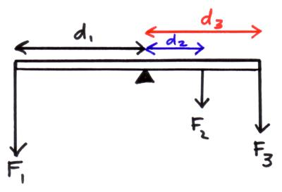
A moment is the force multiplied by the distance perpendicular from the line of action of the force to the pivot. Measured in 𝑁𝑚. $Moment=Fd$
$$F1d1=\left(F2d2\right)+(F3d3)$$
$$∑clockwise moment=∑anticlockwise moment$$

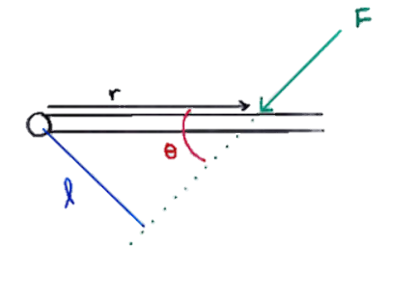
Force not perpendicular?
Turns out that L is the shortest distance along line of force to the axis. So it turns out that:$l=r\sin{θ}$
$$Moment of a couple=Fs$$
Motion: $v=\frac{Δs}{Δt}$ $a=\frac{Δv}{Δt}$
suvat equations: $v=u+at$ $s=\left(\frac{u+v}{2}\right)t$ $v^{2}=u^{2}+2as$ $s=ut+\frac{1}{2}at^{2}$
Newton’s second law: $∑F=\frac{Δ(mv) }{Δt}$ $F=ma$ $FΔt=Δ(mv)$
Momentum: $Δp=mΔv$ $momentum before=momentum after$
Energy: $W=Fs\cos{θ}$ $ΔEp=mgΔh$ $E_{k}=\frac{1}{2}mv^{2}$
Springs: $F=kΔL$ $Ep=\frac{1}{2}FΔL$ $Ep=\frac{1}{2}kΔL^{2}$
Springs in series: $\frac{1}{k_{eq}}=\frac{1}{k_{1}}+\frac{1}{k_{2}}$ Springs in parallel: $k_{eq}=k_{1}+k_{2}$
Density: $\text{ρ}=\frac{m}{V}$ Density of an alloy: $\text{ρ}=\frac{\text{ρ}\text{1}\text{V}\text{1 }\text{+ }\text{ρ}\text{2}\text{V}\text{2 }}{V1+V2}$
$\text{Young Modulus}=\frac{Stress}{Strain}$ $\text{Tensile }\text{Stre}ss=\frac{F}{A}$ $\text{Tensile }Strain=\frac{\text{Δ}L}{L}$ $\text{Young Modulus}=\frac{\text{FL} }{\text{A}\text{Δ}L}$

Q7 PAT 2018
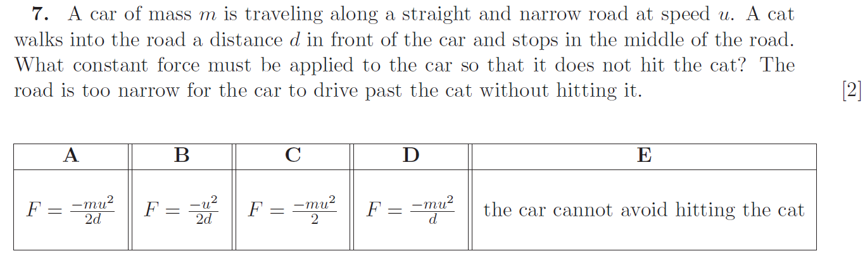

Q5 Section 1 ENGAA 2019 (no calculator)
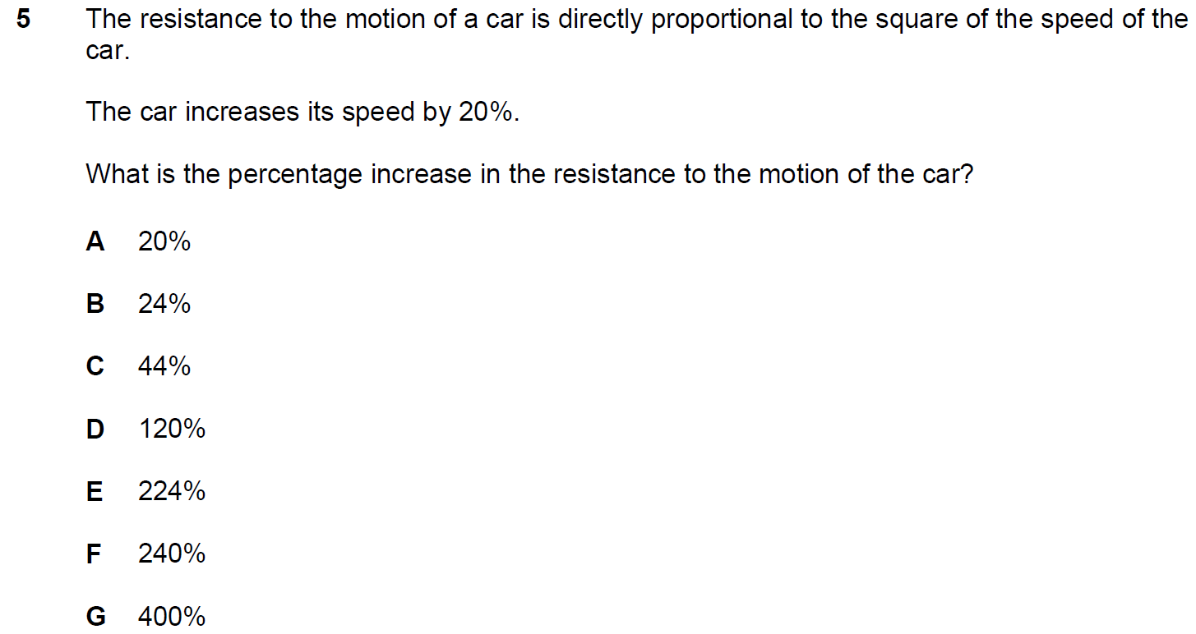

Q14 Section 1 ENGAA 2019 (no calculator)
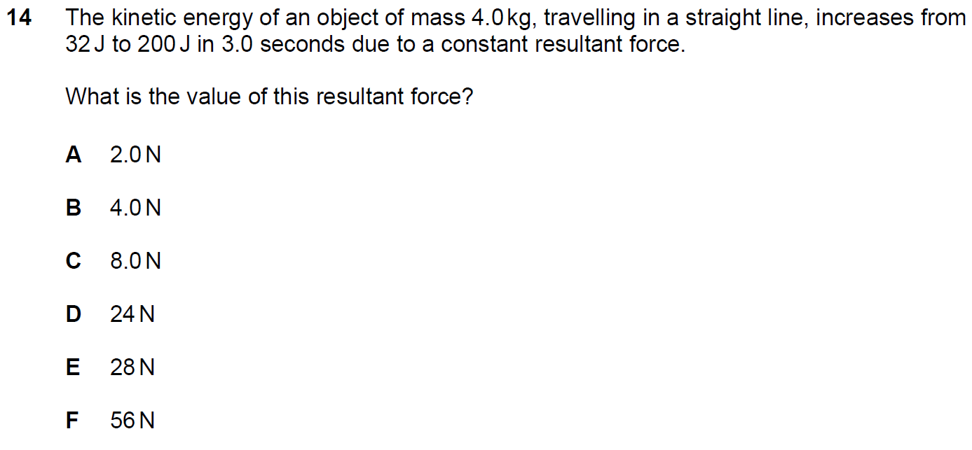

Q22 Section 1 ENGAA 2019 (no calculator)
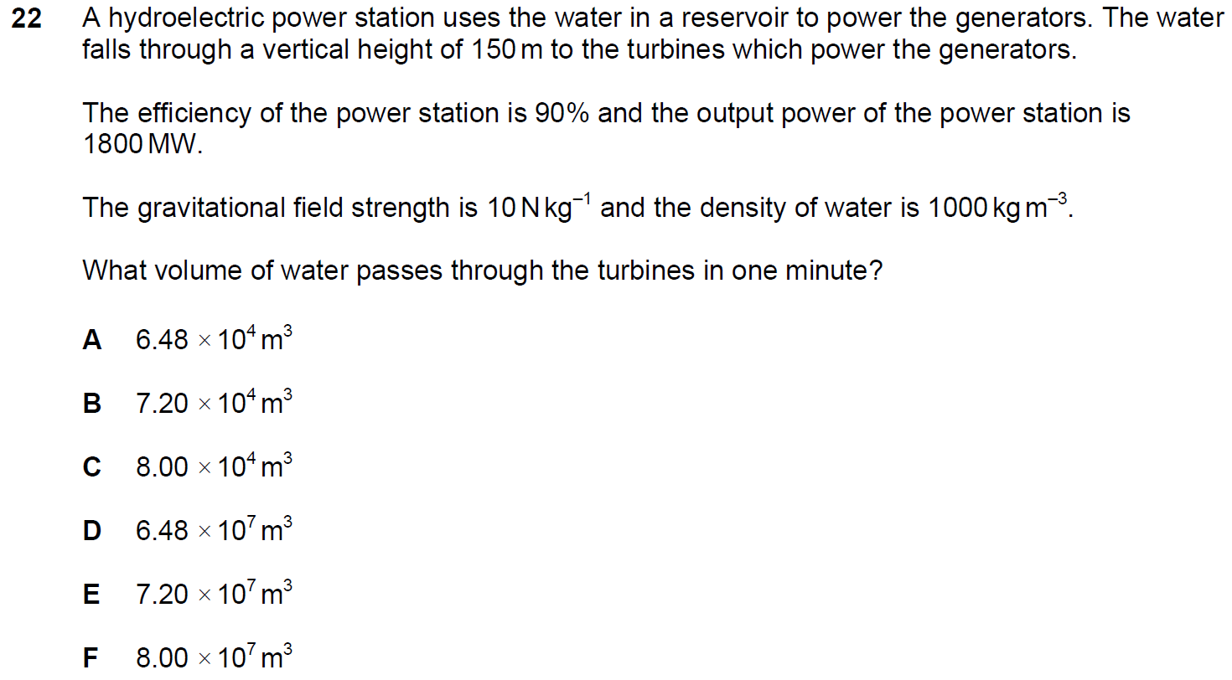

Q21 Section 1 NSAA 2020 Sample (no calculator)
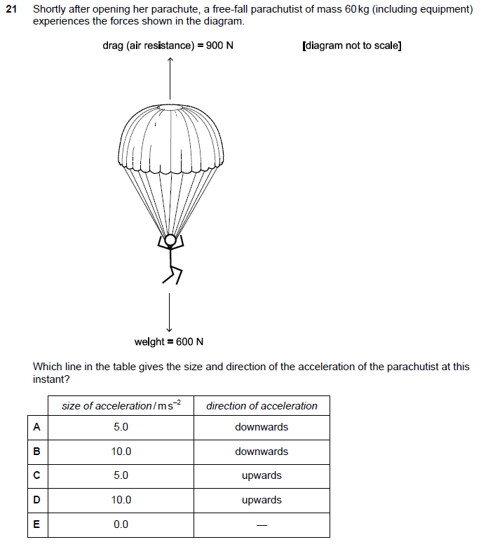

Q24 Section 1 ENGAA 2019 (no calculator)
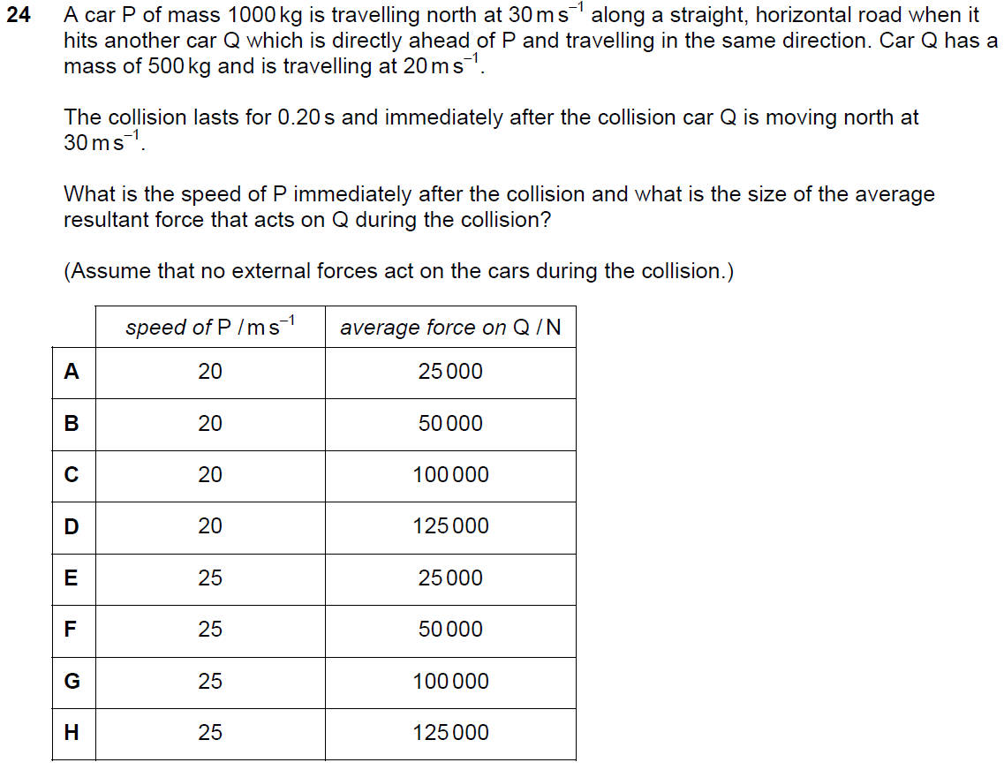

Q12 Section 1 ENGAA 2018 (no calculator)
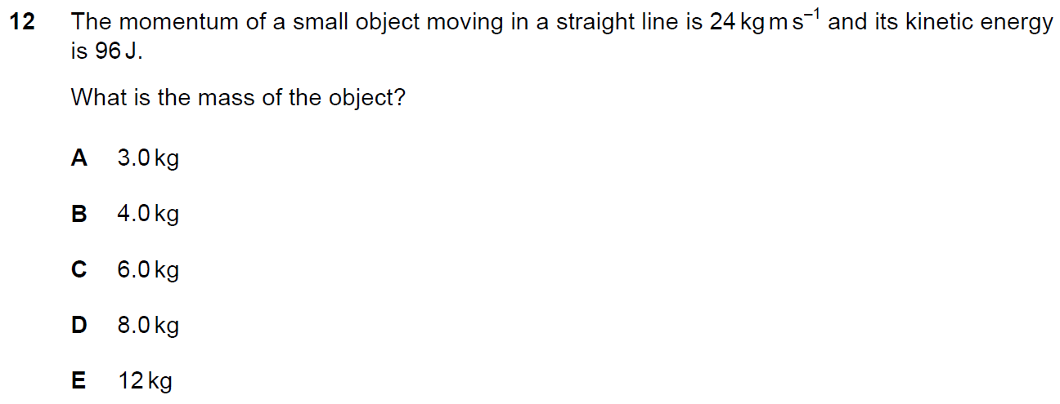

Q16 Section 1 ENGAA 2018 (no calculator)
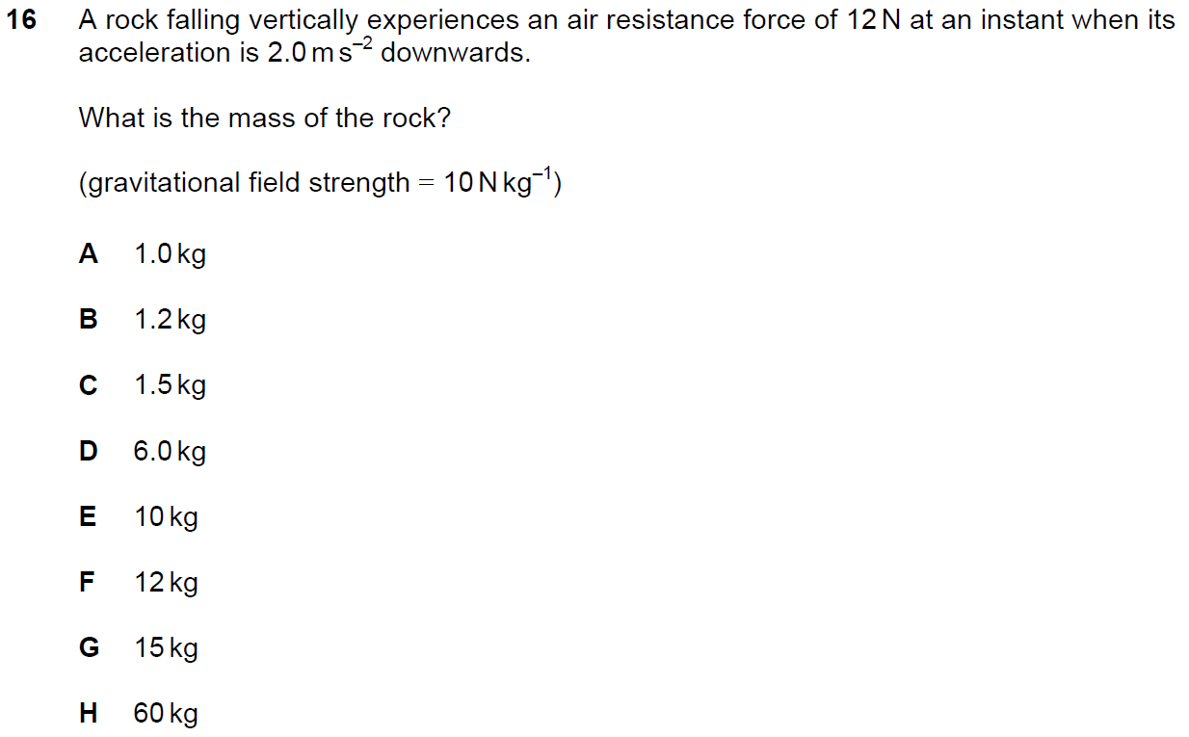

Q25 Section 1 NSAA 2020 Sample (no calculator)
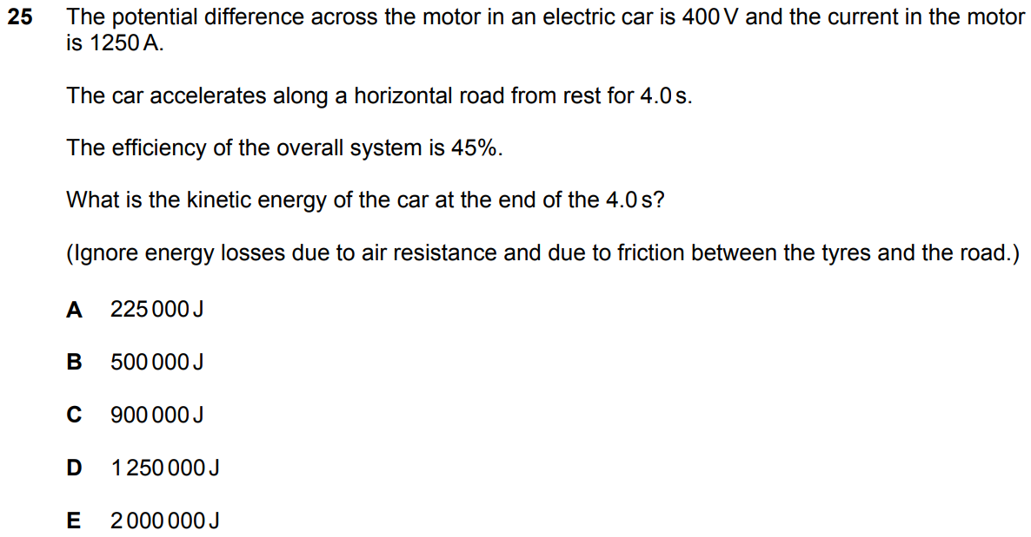

Q74 Section 1 NSAA 2018 (no calculator)
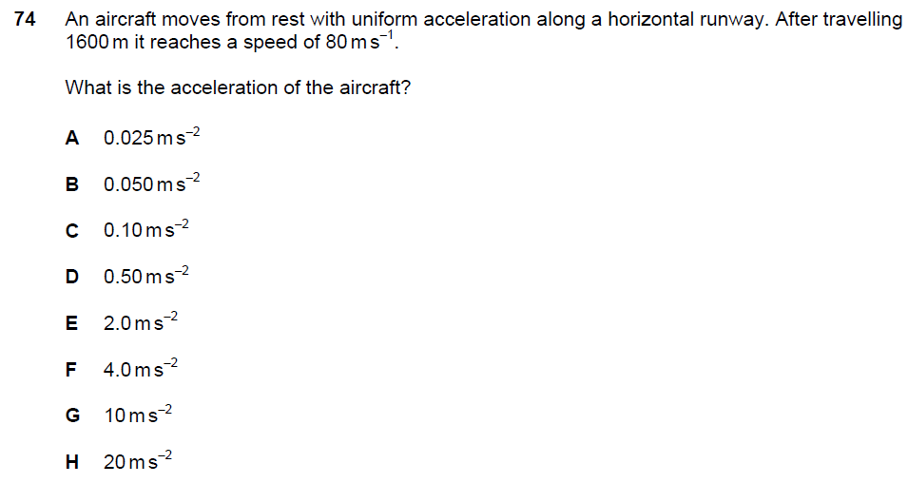
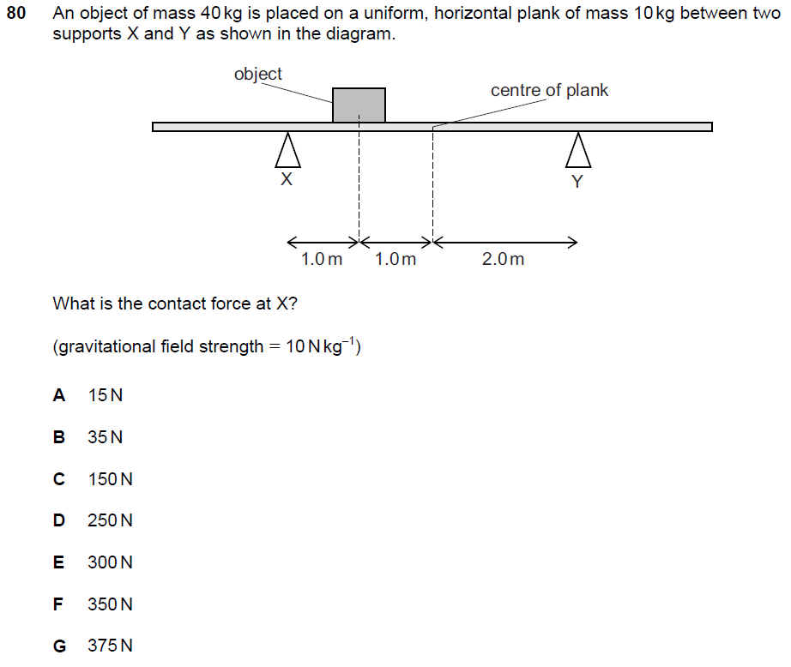
Q80 Section 1 NSAA 2018 (no calculator)
Q17 PAT 2017
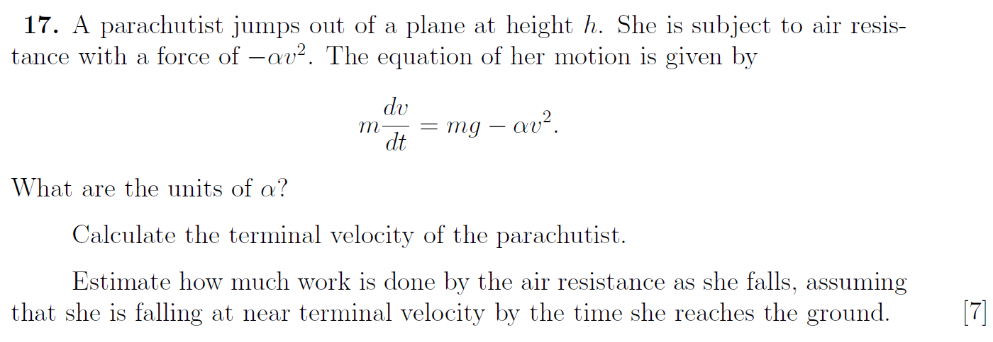

Q14 PAT 2017 Specimen
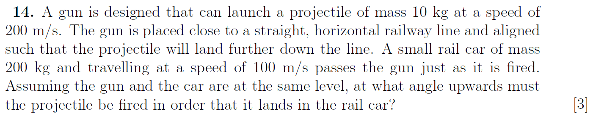

Q16 PAT 2017 Specimen
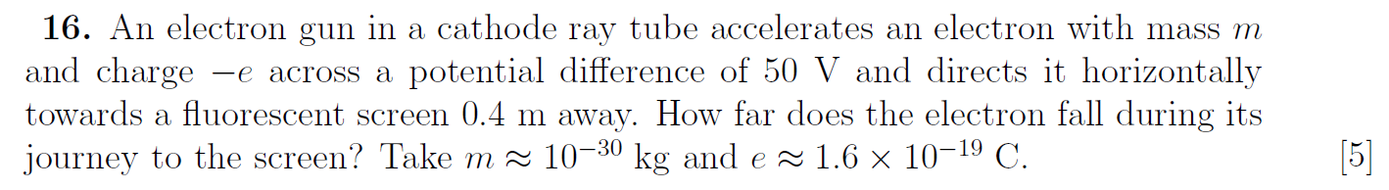

Q23 PAT 2017 Specimen
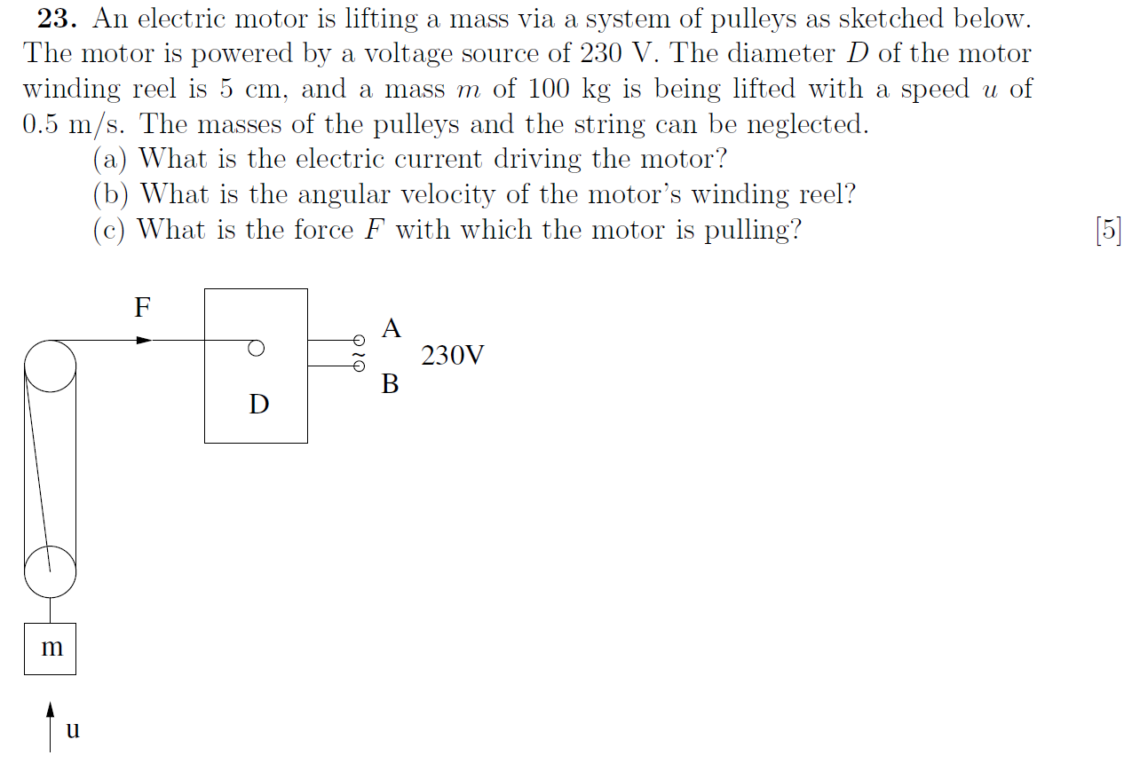

Q28 Section 1 ENGAA 2019 (no calculator)
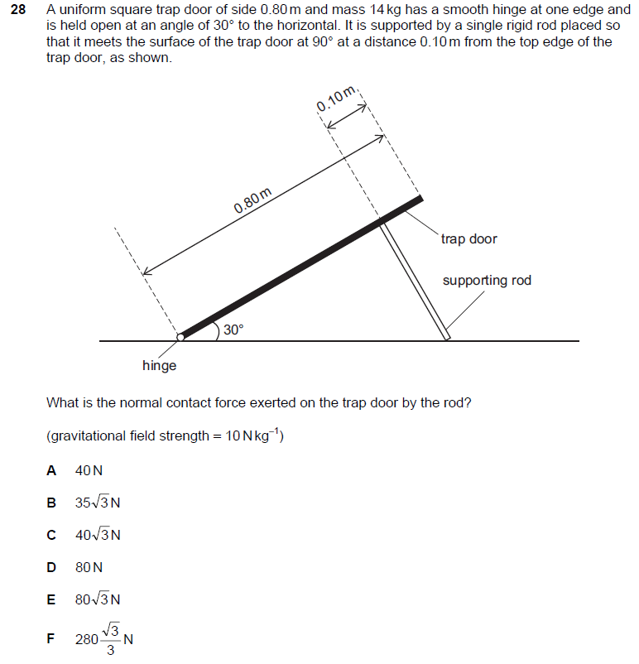

Q3 Section 2 ENGAA 2019 (no calculator)
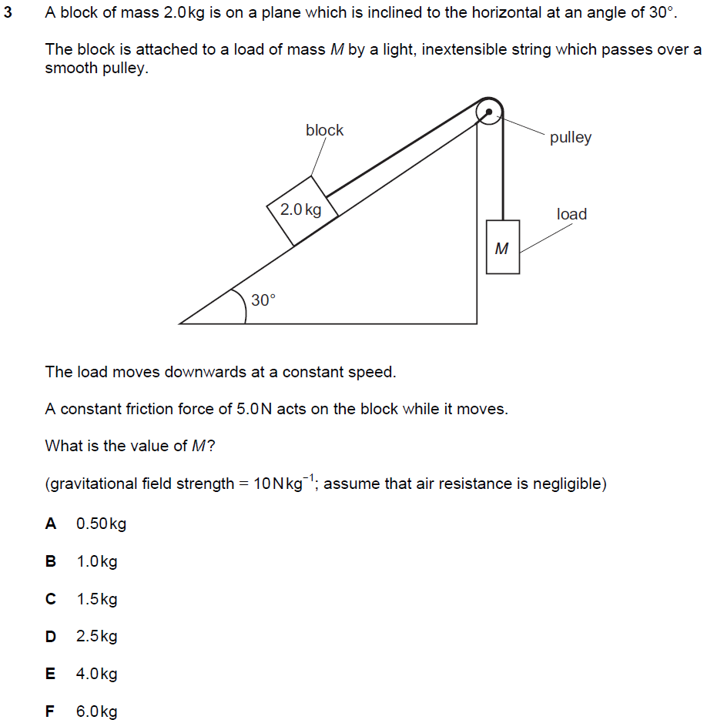

Q9 Section 2 ENGAA 2019 (no calculator)
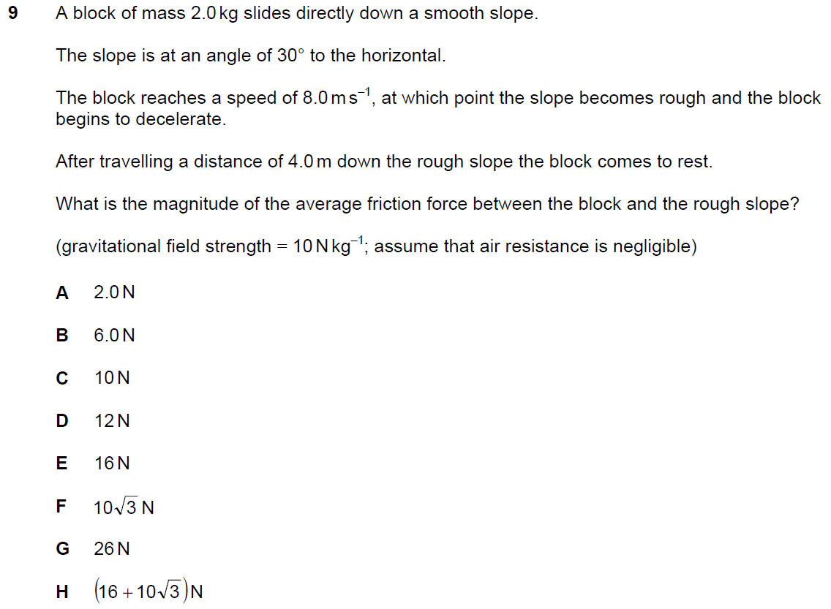

Q10 Section 2 ENGAA 2019 (no calculator)
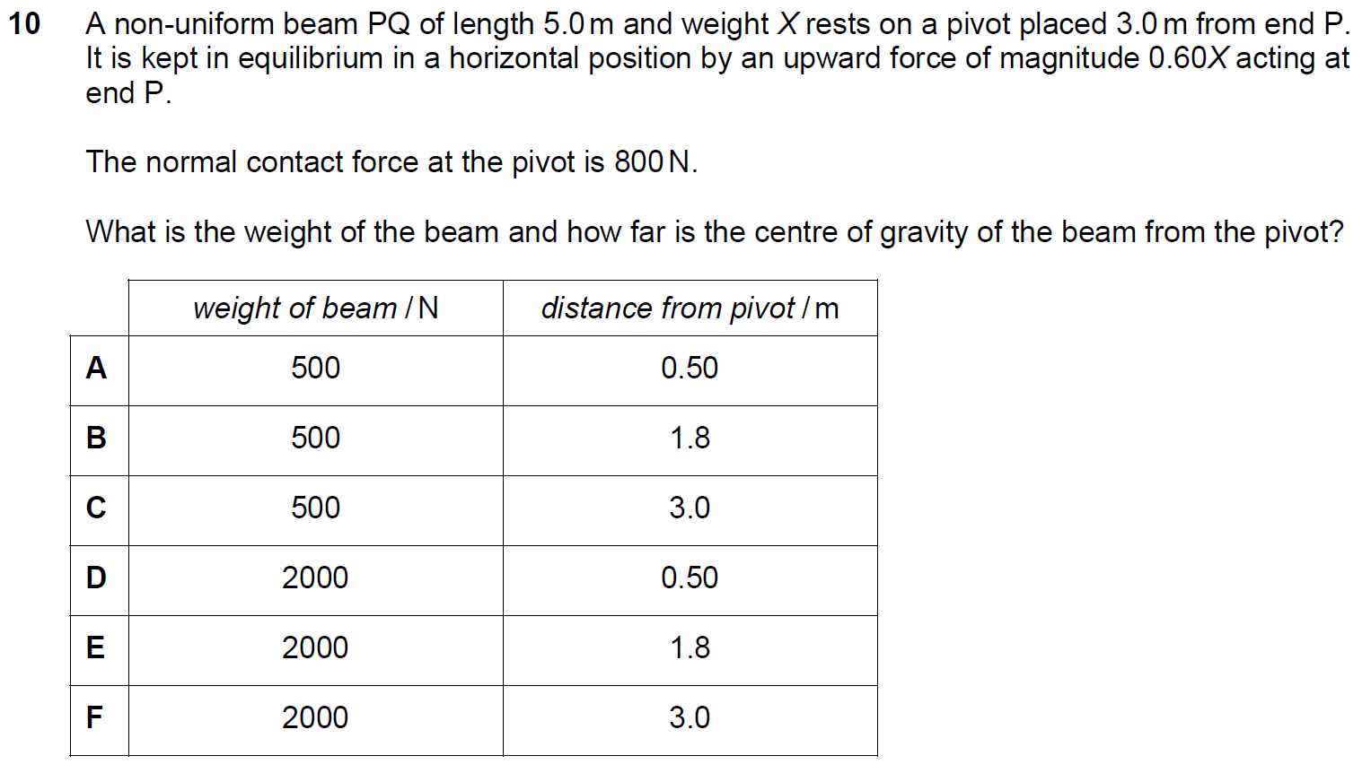

Q11 Section 2 ENGAA 2019 (no calculator)
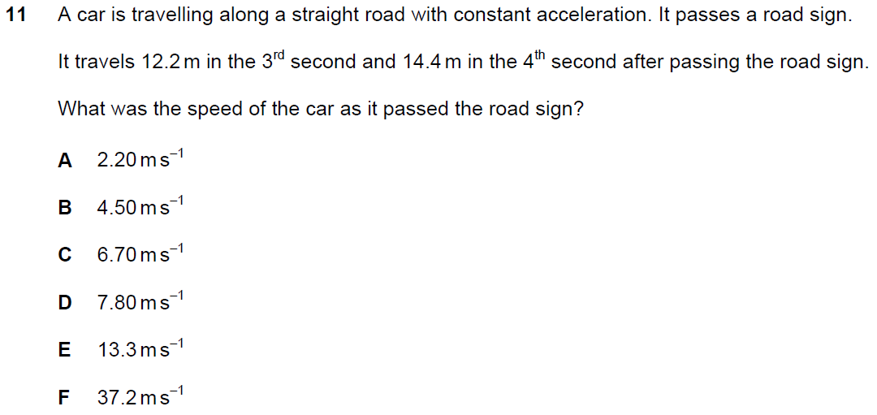

Q12 Section 2 ENGAA 2019 (no calculator)
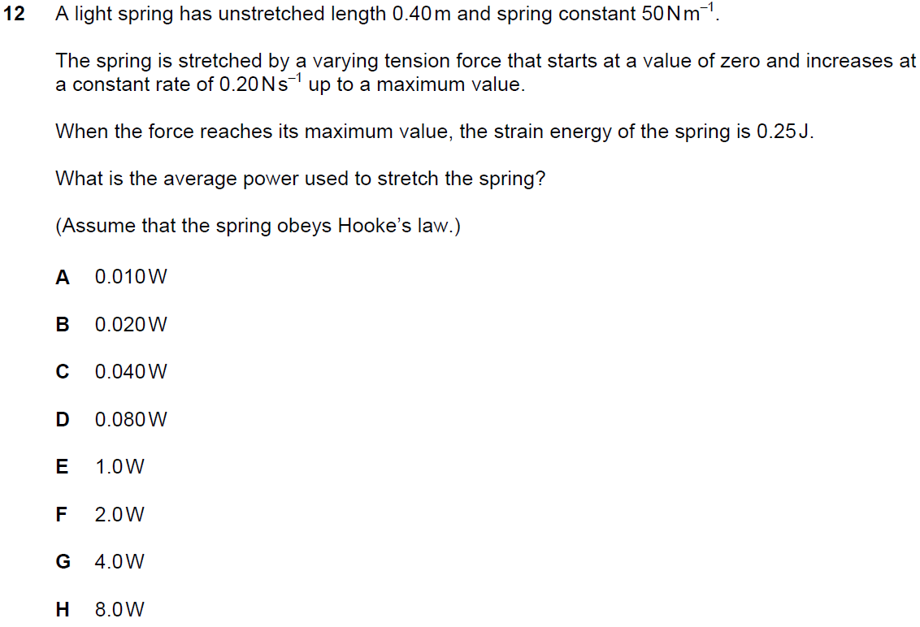

Q14 Section 2 ENGAA 2019 (no calculator)
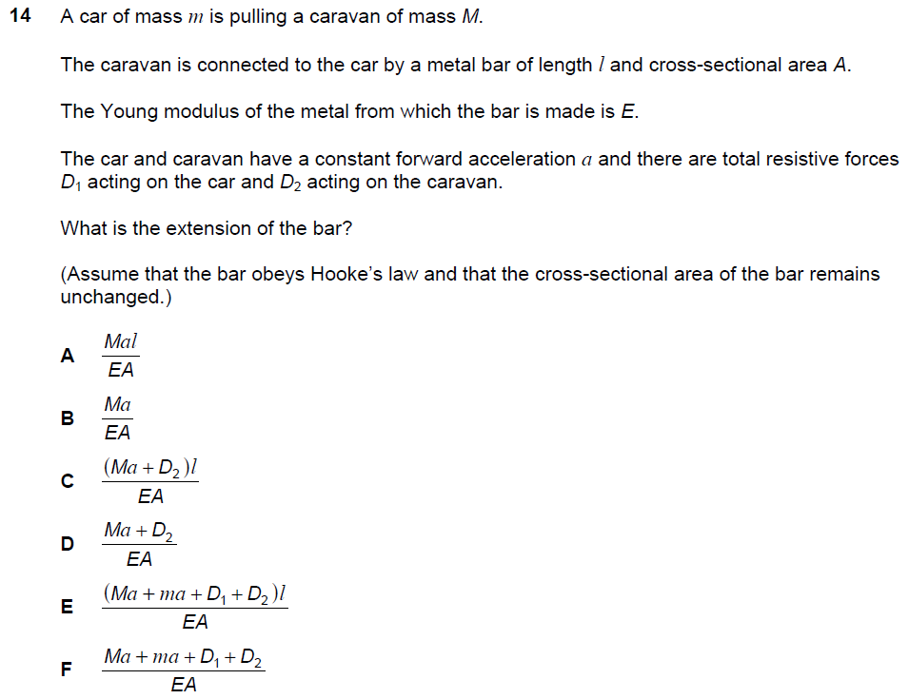

QP1 Section 2 NSAA 2018 (no calculator)
