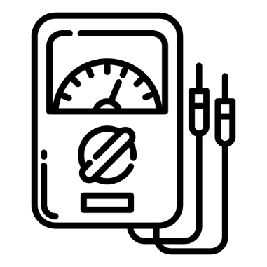
Oxbridge Assessment Prep
Week 2 – Electricity

Physics/Engineering at Oxford: PAT
Engineering at Cambridge: ENGAA
Natural Sciences at Cambridge: NSAA
Assessment date: 4th November 2020

Week 1 – Mechanics
Week 2 – Electricity
Week 3 – Area/volume of shapes
Week 4 – Waves
Week 5 – Differentiation/Integration/Series
Week 6 – General physics
Week 7 – General maths (logs, binomial, trig).

Electricity Facts (unlike A-level, you need to remember these)
Current: $\text{I}=\frac{Q}{∆t}$
Potential difference: $\text{V}=\frac{W}{Q}$
Resistance: $\text{R}=\frac{V}{I}$
Resistivity: $\text{ρ}=\frac{RA}{L}$
Resistors in series: $R_{T}=R_{1}+R_{2}+R_{3}…$
Resistors in parallel: $\frac{1}{R_{T}} =\frac{1}{R_{1}}+\frac{1}{R_{2}}+\frac{1}{R_{3}}…$
Power: $\text{P}=IV=I^{2}R=\frac{V^{2}}{R}$
Energy: $\text{E}=VQ=ItV$
Cells in series: $V_{T}=V_{1}+V_{2}+V_{3}…$
Cells in parallel: $V_{T}=V_{1}=V_{2}=V_{3}$
Kirchoff’s first law: $I_{1}=I_{2}+I_{3}+I_{4}$
Kirchoff’s second law: $V_{o}=V_{1}+V_{2}+V_{3}$
EMF: 𝜀 = 𝑉 + v = IR + Ir = 𝐼(𝑅 + 𝑟)
Potential dividers: $V_{out}=\frac{V_{in}R_{1}}{R_{1}+R_{2}}$

Q24 Section 1 NSAA 2020 Specimen (no calculator)
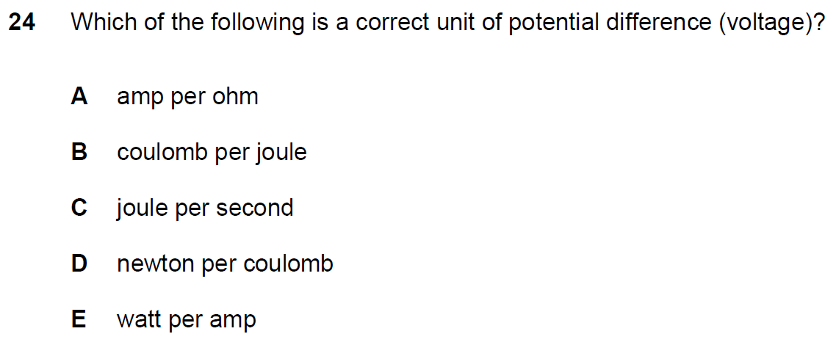
Q28 Section 1 NSAA 2020 Specimen (no calculator)
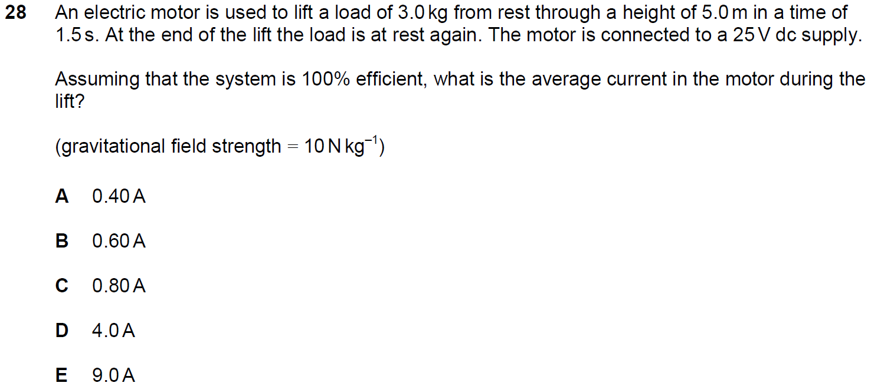

Q36 Section 1 NSAA 2020 Specimen (no calculator)
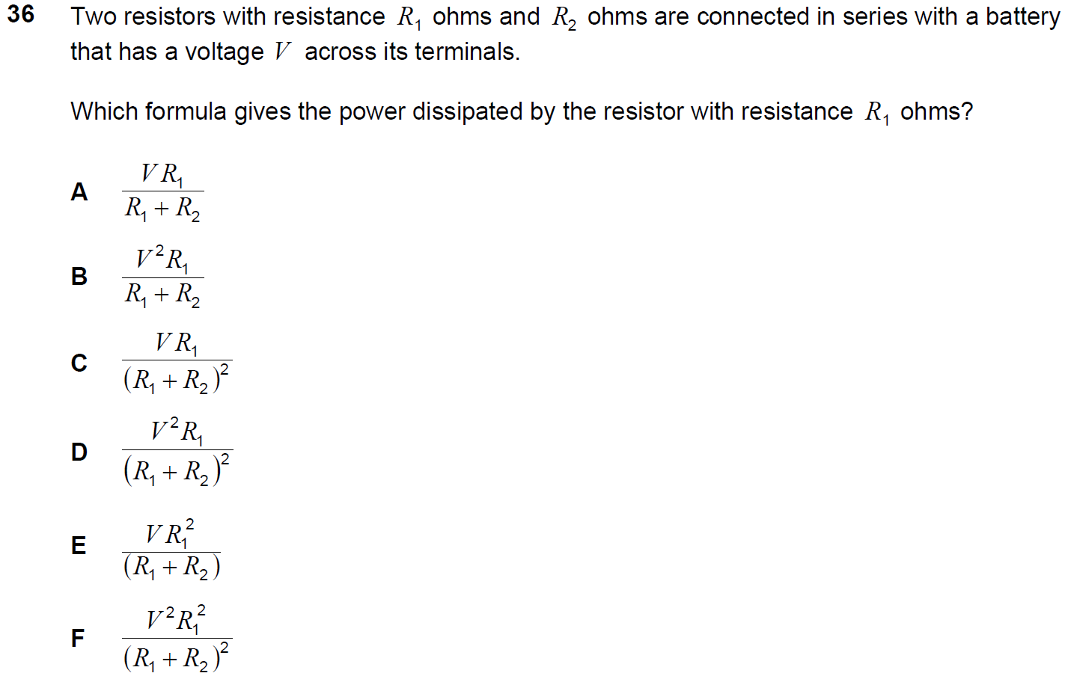
Q23 Section 1 NSAA 2018 (no calculator)
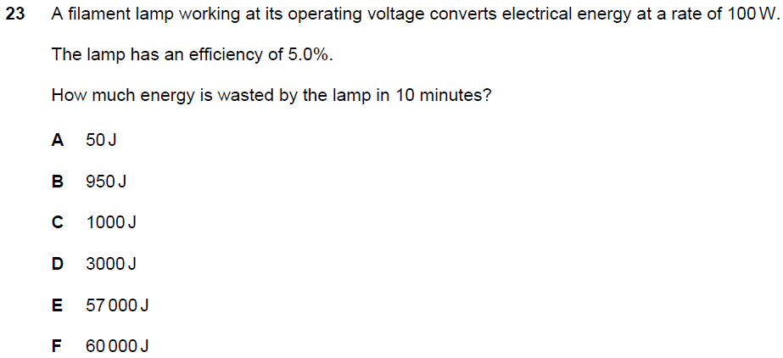

Q2 Section 1 ENGAA 2019 (no calculator)
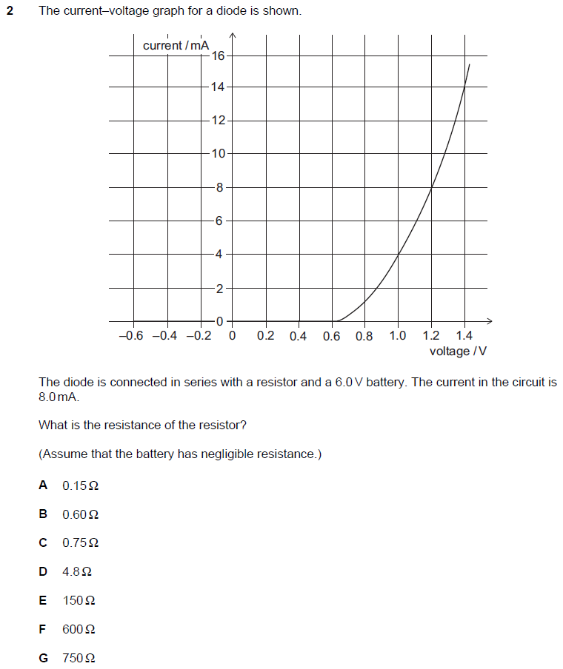

Q8 Section 1 ENGAA 2019 (no calculator)
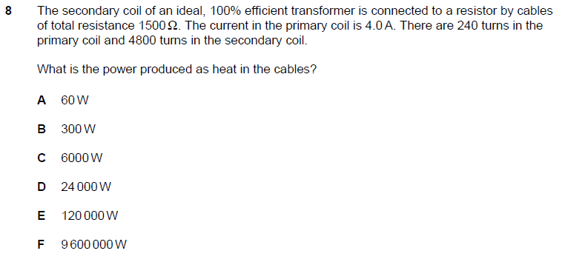
Q20 Section 1 NSAA 2018 (no calculator)
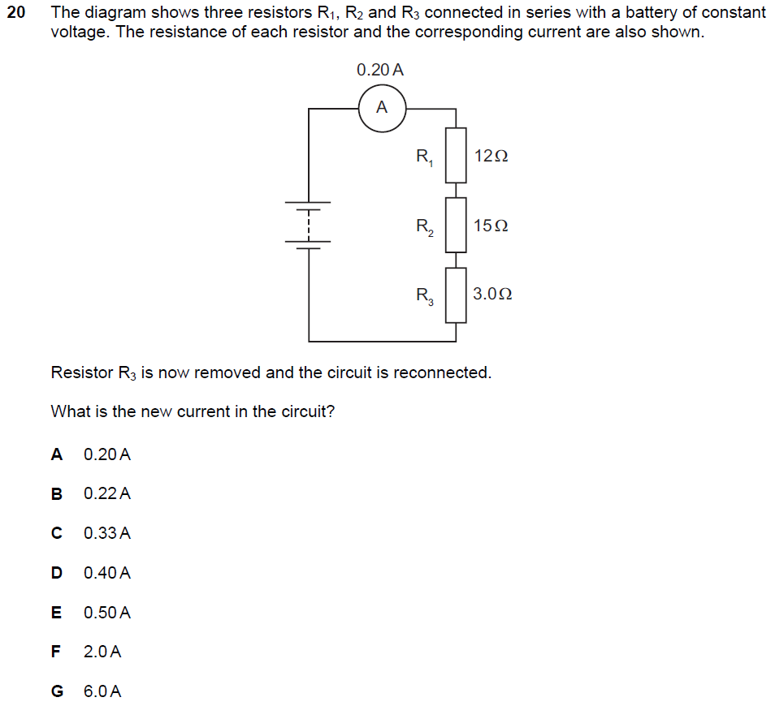
Q13 PAT 2018
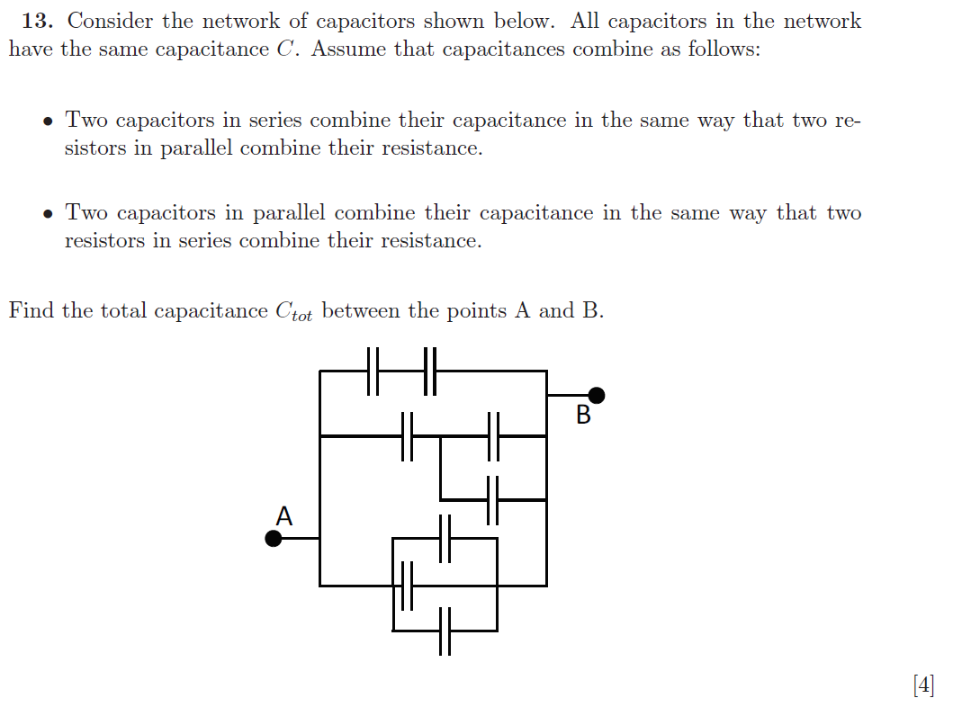

Q9 PAT 2017
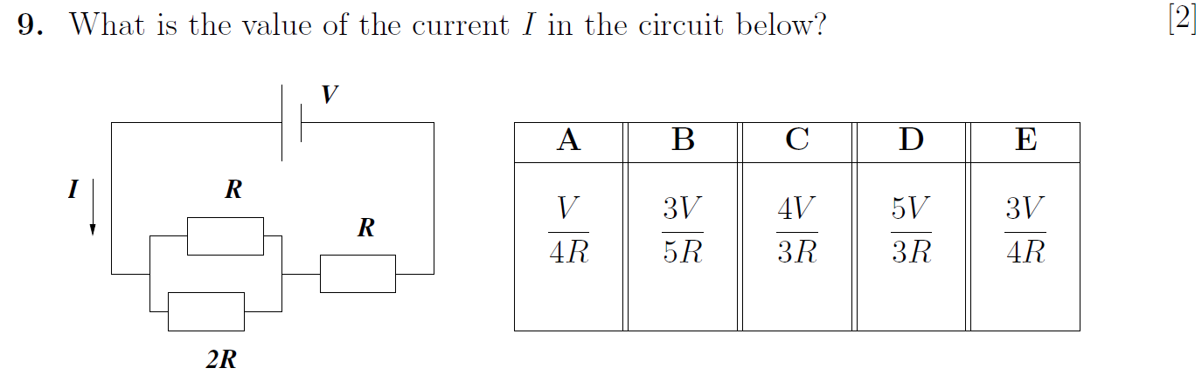

Q2 Section 2 ENGAA 2019 (no calculator)
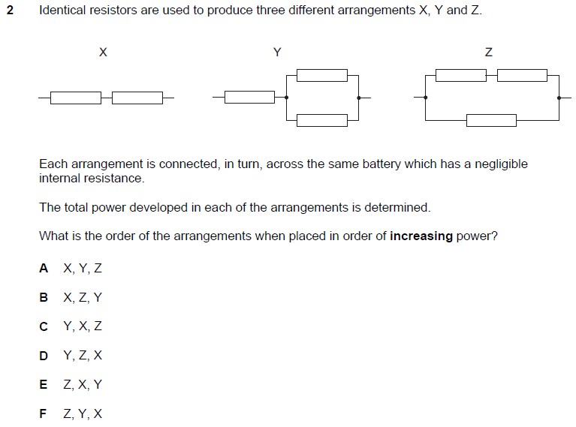

Q19 PAT 2017 specimen
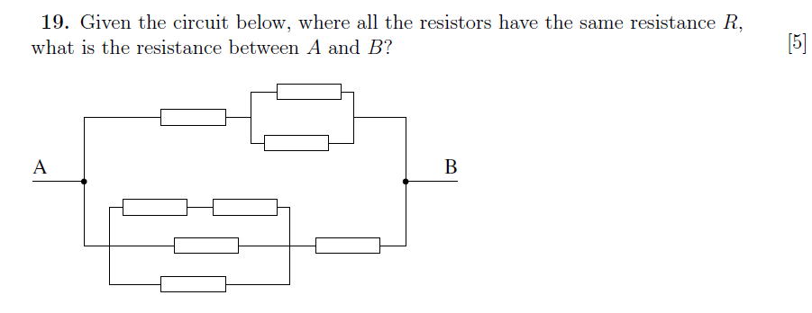

Q4 Section 2 ENGAA 2019 (no calculator)
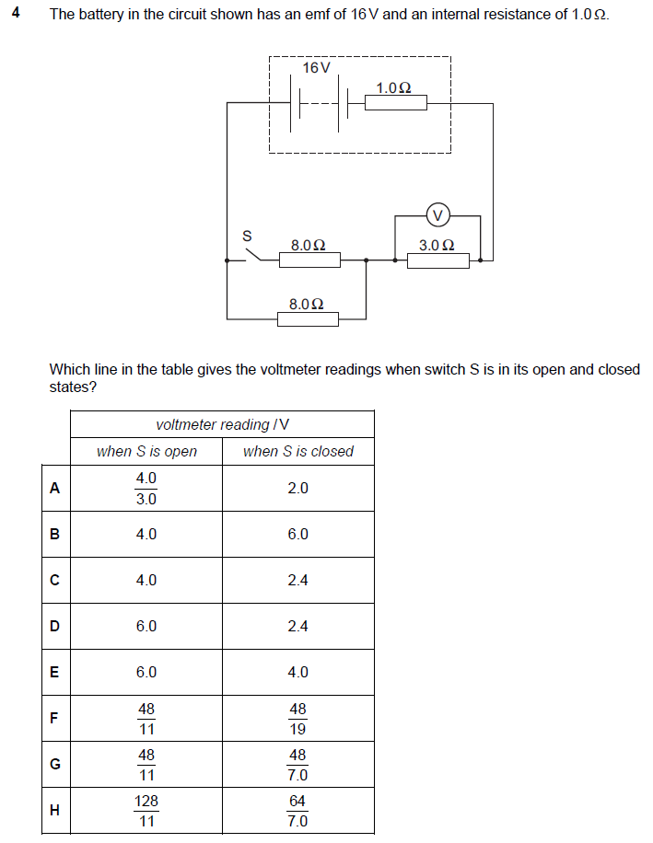

Q15 Section 2 ENGAA 2019 (no calculator)
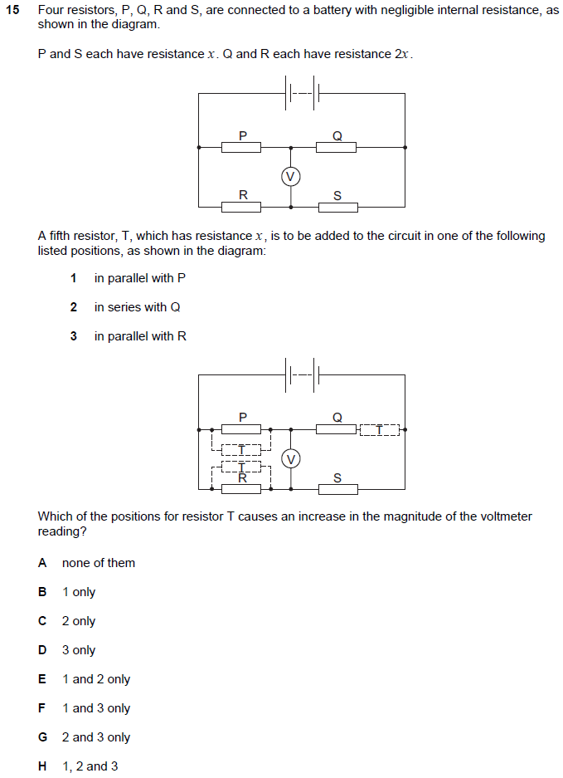

Q16 Section 2 ENGAA 2018 (no calculator)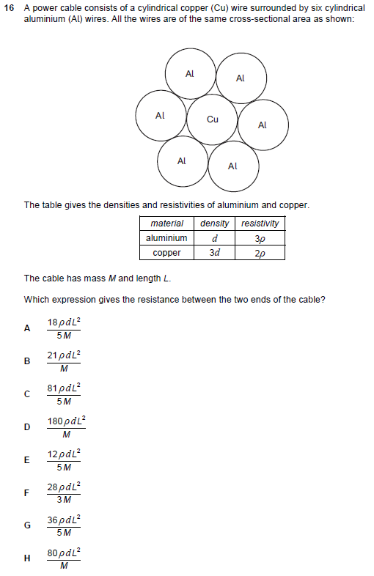
Q19 PAT 2018
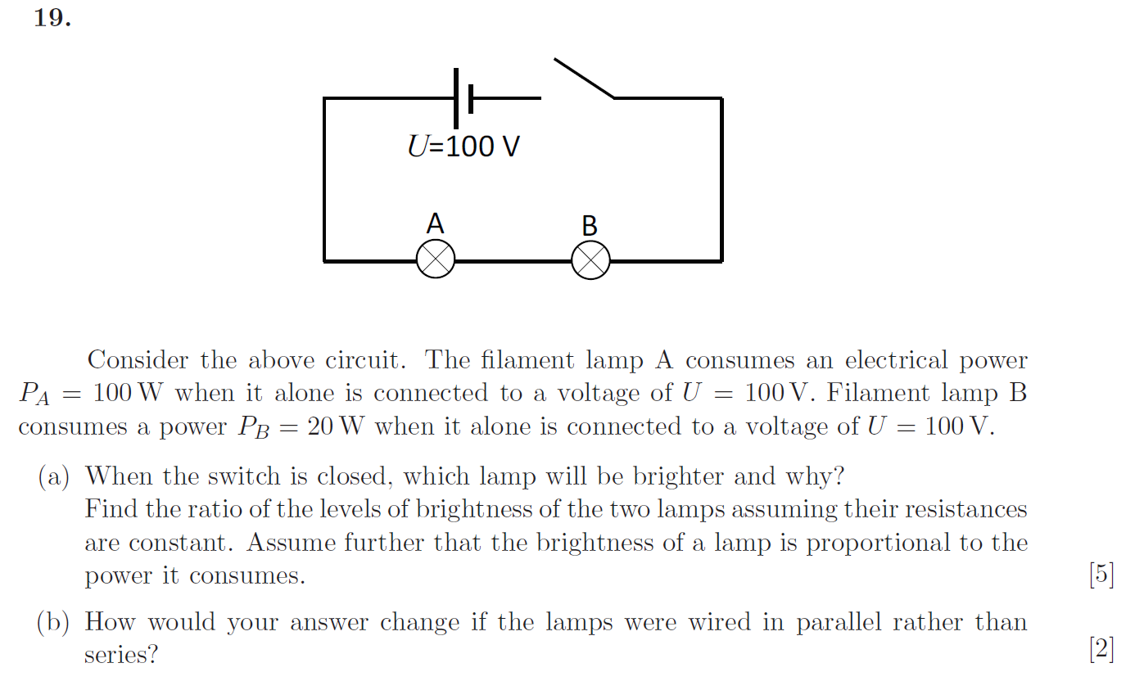

Q35 NSAA 2018
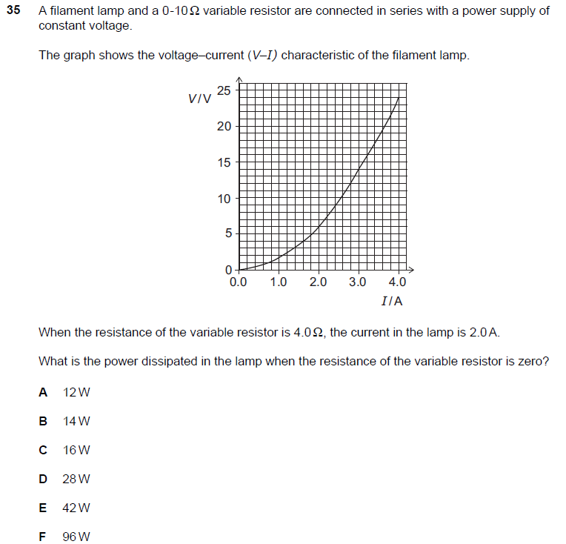

P2 NSAA 2018 SECTION 2
