Oxbridge Assessment Prep
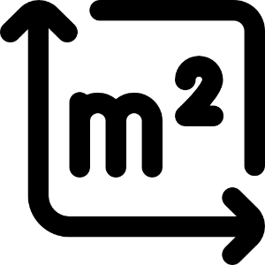
Week 3 – Area/volume of shapes

Physics/Engineering at Oxford: PAT
Engineering at Cambridge: ENGAA
Natural Sciences at Cambridge: NSAA
Assessment date: 4th November 2020

Week 1 – Mechanics
Week 2 – Electricity
Week 3 – Area/volume of shapes
Week 4 – Waves
Week 5 – Differentiation/Integration/Series
Week 6 – General physics
Week 7 – General maths (logs, binomial, trig).

Area/volume Facts (unlike A-level, you need to remember these)
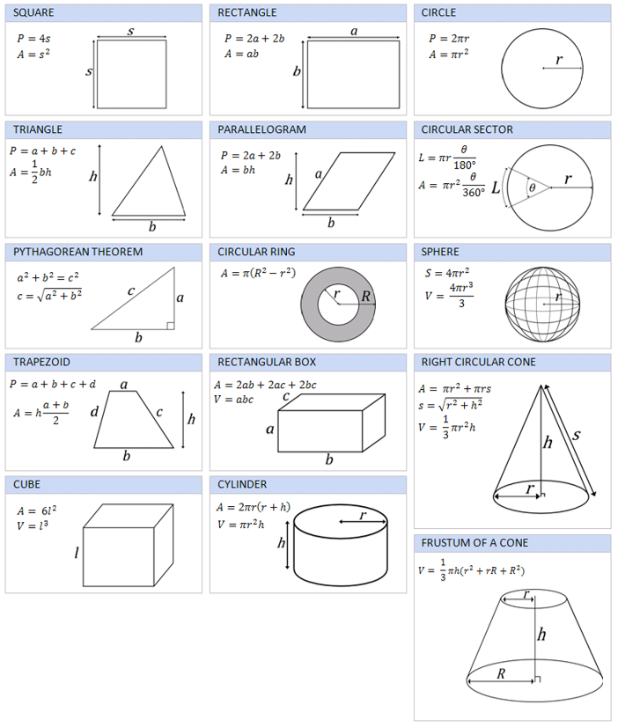

Q13 section 1 ENGAA 2019 (no calculator)
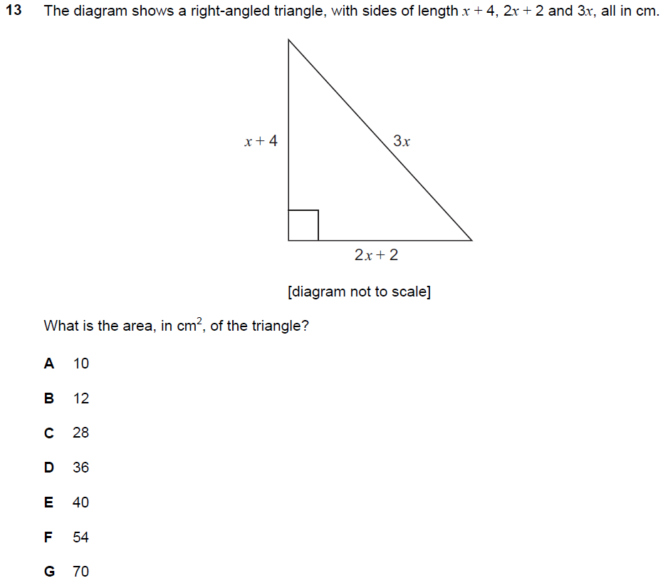

Q21 section 1 ENGAA 2019 (no calculator)
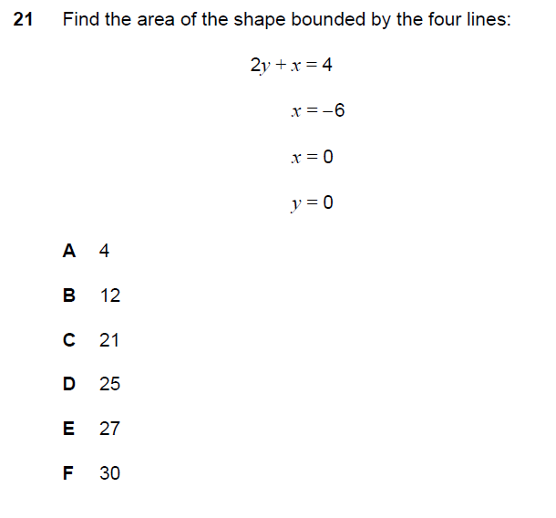

Q6 NSAA 2020 sample (no calculator)
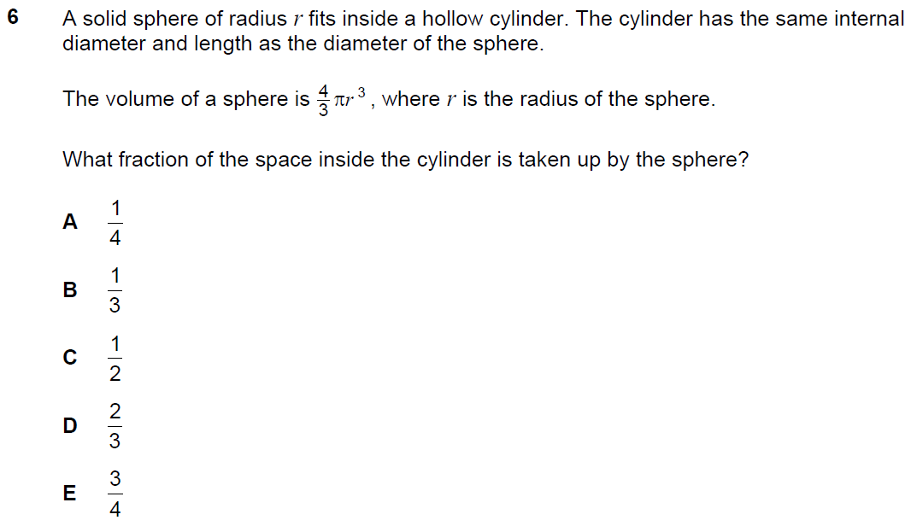

Q13 NSAA 2020 sample (no calculator)
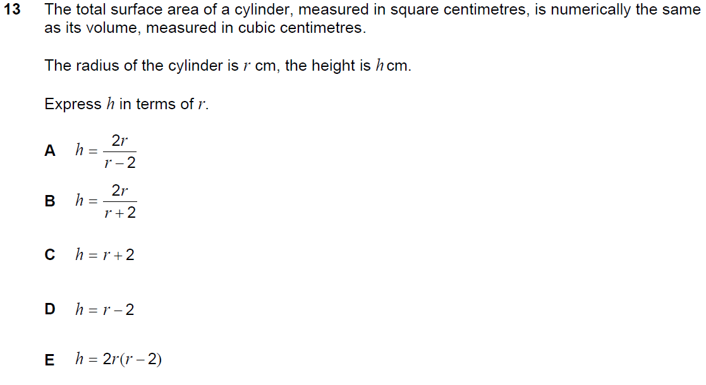

Q29 section 1 ENGAA 2019 (no calculator)
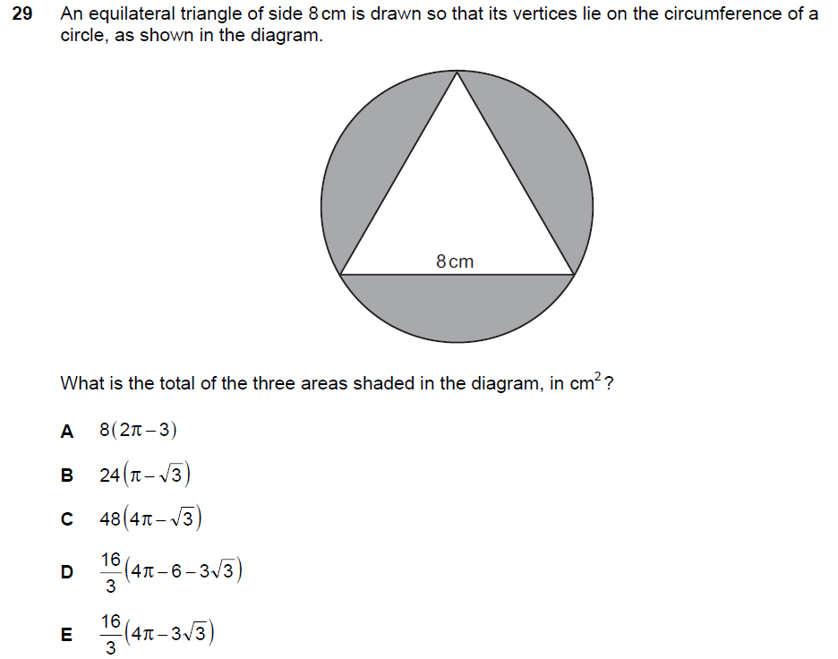

Q11 section 1 ENGAA 2018 (no calculator)
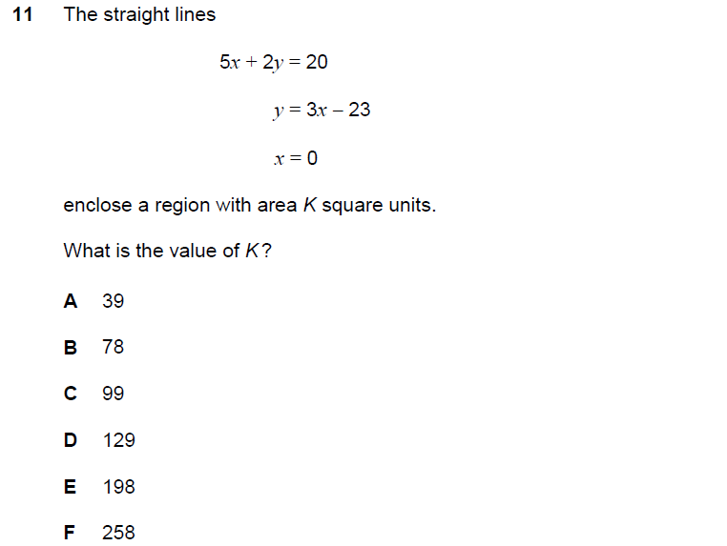

Q29 section 1 ENGAA 2018 (no calculator)

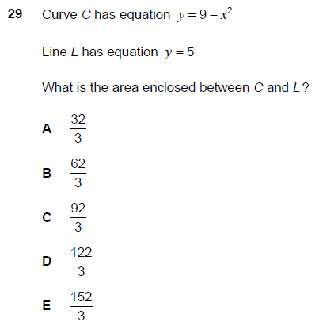
Q2 section 1 NSAA 2018 (no calculator)
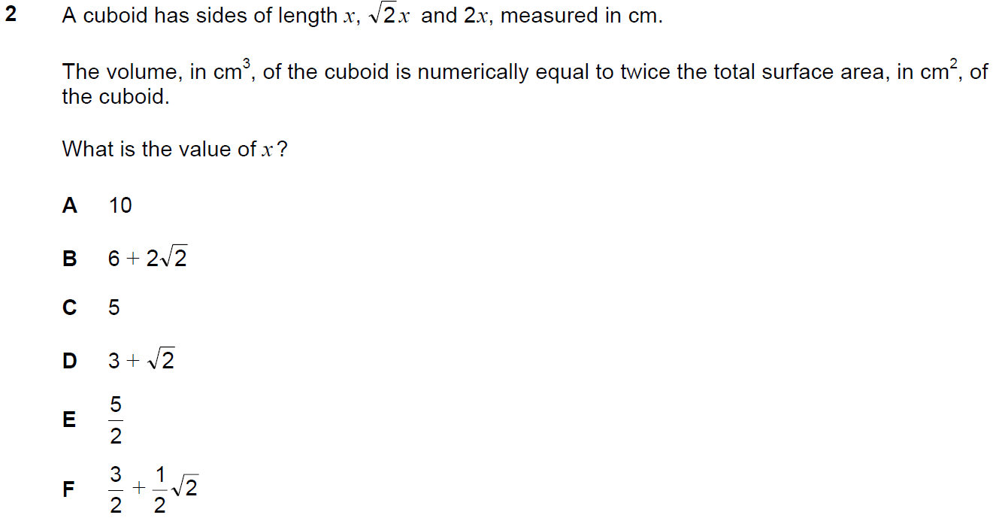

Q16 section 1 NSAA 2018 (no calculator)
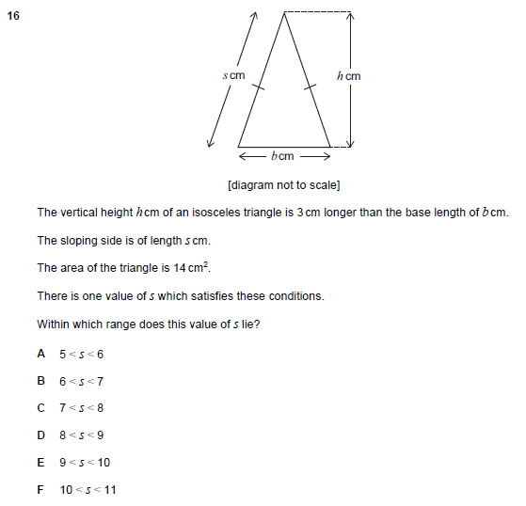

Q16 PAT 2018
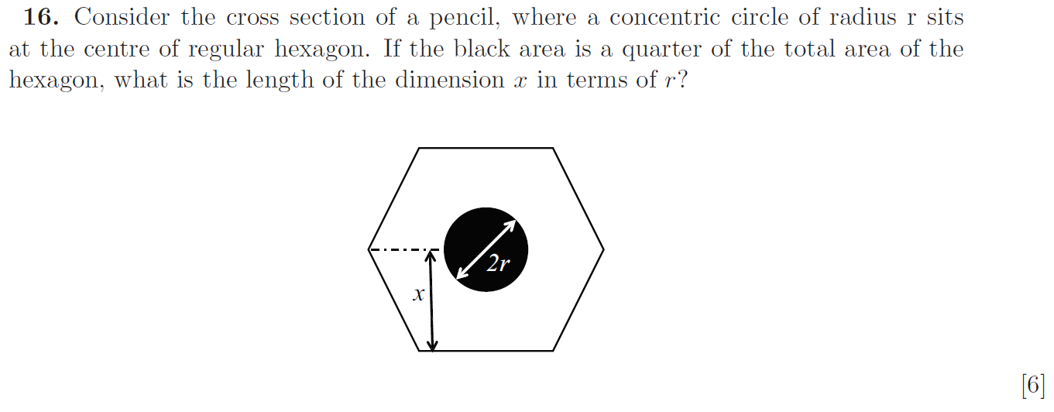

Q19 section 1 ENGAA 2019 (no calculator)
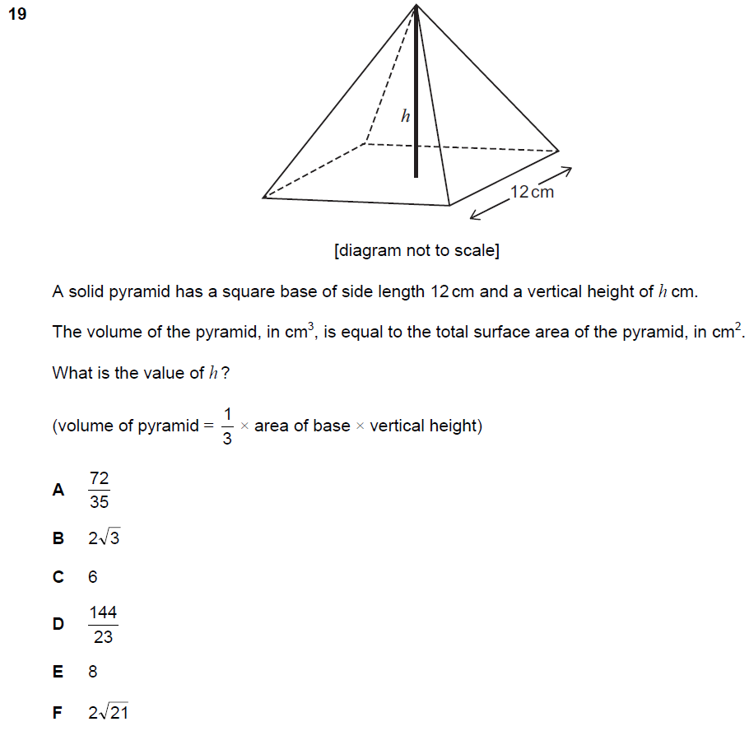

Q7 section 1 ENGAA 2019 (no calculator)
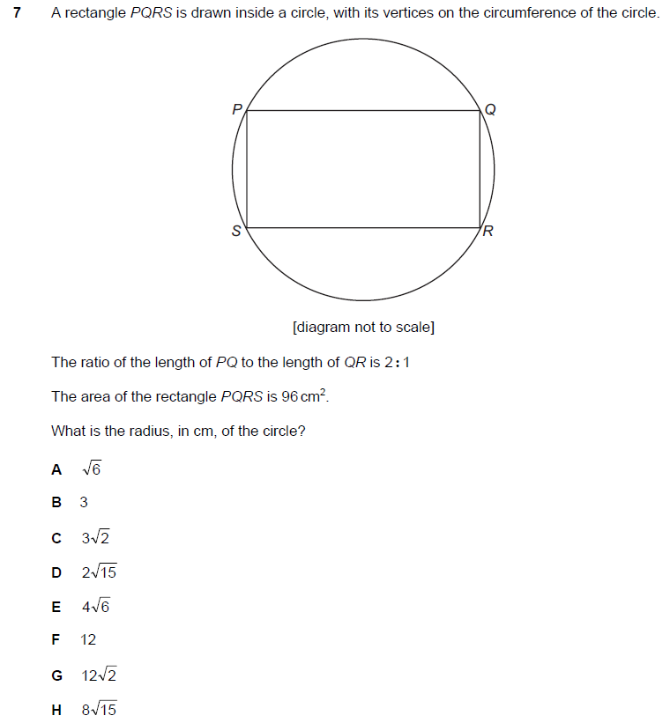

Q35 section 1 ENGAA 2019 (no calculator)
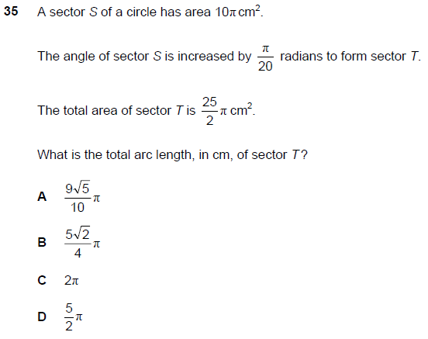

Q53 section 1 ENGAA 2019 (no calculator)
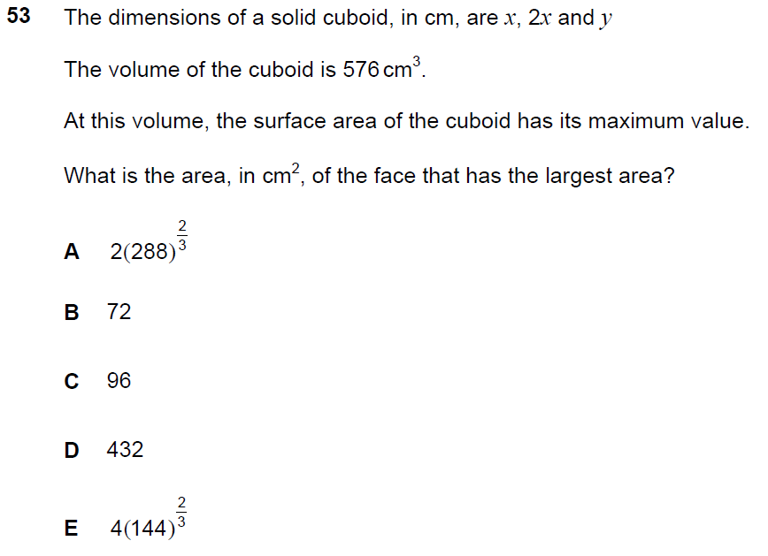
Q16 PAT 2017
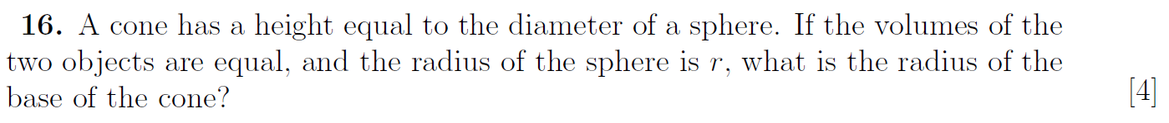

Q20 PAT 2017 Specimen
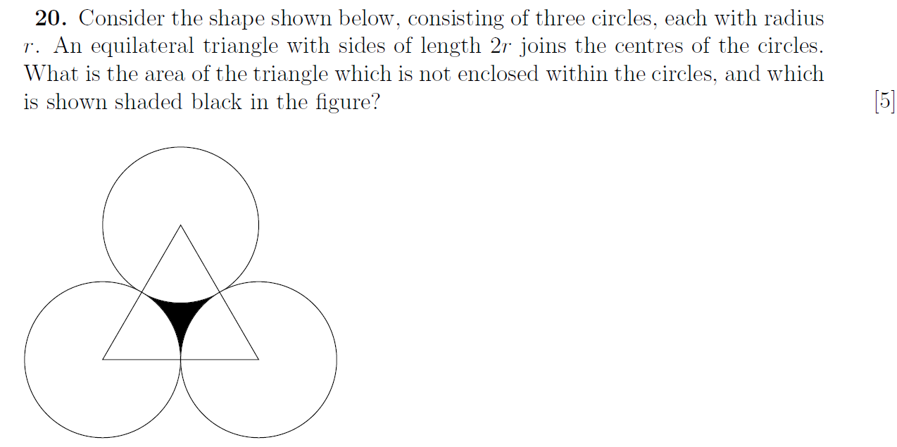

Q22 PAT 2017 Specimen
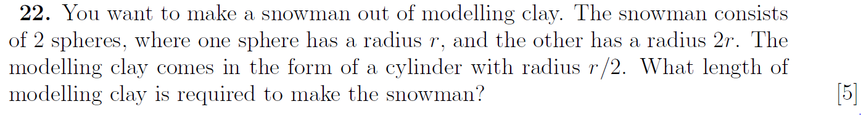

Q23 section 1 ENGAA 2018 (no calculator)
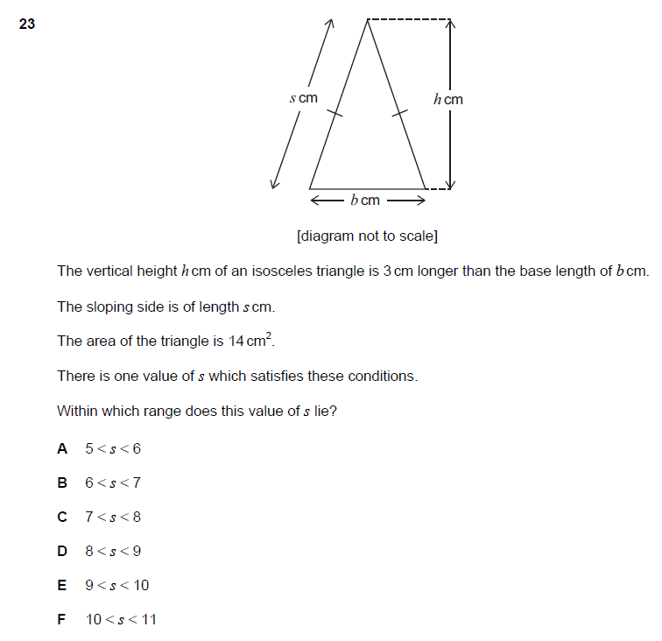

Q22 PAT 2018
