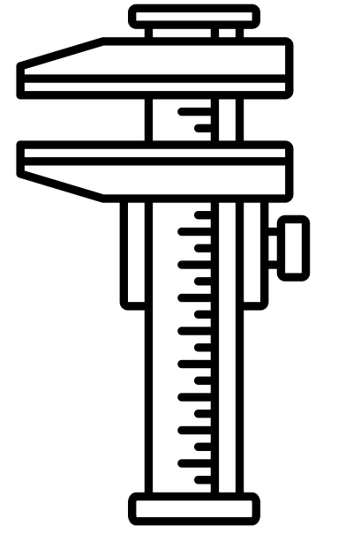
& errors
Measurements
Name ______________________________
Teacher ______________________________
Use of SI units and their prefixes
The phrase SI units refers to the “Système International” units that scientists all over the world have agreed to use so that they can easily compare their work.

There are 7 SI units:

Quantity | Unit | Unit Symbol
Length | Metre | m
Time | Second | s
Mass | Kilogram | kg
Electric Current | Ampere | A
Temperature | Kelvin | K
Amount of Substance | Mole | mol
Luminosity (not needed at A Level) | Candela | cd

Most units are actually combinations of these SI units.

Simple examples include:

$$\text{velocity }(ms^{-1}\text{) = }\frac{displacement \left(m\right)}{time (s)}$$

$$\text{Momentum }\left(kgms^{-1}\right)=mass (kg) × velocity \left(ms^{-1}\right)$$

Some combinations have their own unit name:

$$\text{Force }\left(N\right)= mass (kg) × acceleration \left(ms^{-2}\right)$$

This shows that 1 Newton is equivalent to 1 kgms⁻² in SI units.

1. Use the equation Work Done = Force x Displacement to choose which of the following combinations is equivalent to 1 Joule in SI units
a. kgm²s⁻²
b. kgm³s⁻²
c. kgms⁻³
d. kgms⁻²

2. Use the equation Charge = Current x Time to write 1 Coulomb in SI units

3. Use the equation Energy = Charge x Potential Difference to write 1 volt in SI units
4. Use the equation Wavespeed = Wavelength x Frequency to write 1 Hertz in SI units
5. Use the equation linking energy and power to write 1 Watt in SI units
6. Which of the following is correct?
a. Js = kgm²s⁻³
b. Js = kgm²s⁻¹
c. Js = kgms⁻²
d. Js = kgm²s

7. Which of the following is correct?
a. J/N = s
b. J/N = kg
c. J/N = m
d. J/N = ms⁻¹

8. Use the formula Force = Magnetic Flux Density x Current x Length to find a unit for magnetic field density

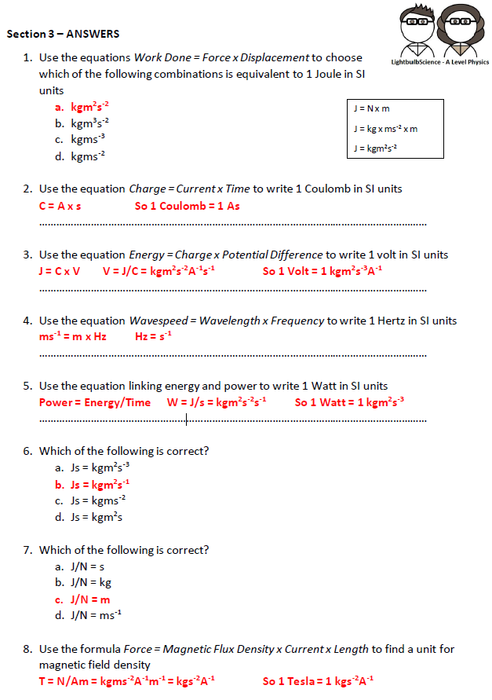

Converting Units
Many quantities are commonly represented by units other than their base units, for a variety of reasons. Some examples are displayed below:
Quantity | Symbol | Alternative unit | Unit symbol | Value in SI units
Energy | E | electron volt | eV | 1.6 × 10⁻¹⁹ J
Charge | Q | charge on electron | e | 1.6 × 10⁻¹⁹ C
Mass | m | atomic mass unit | u | 1.67 × 10⁻²⁷ kg
Mass | m | tonne | t | 10³ kg
Time | t | hour | hr | 3,600 s
Time | t | year | yr | 3.16 × 10⁷ s
Distance | d | miles | miles | 1,609 m
Distance | d | astronomical unit | AU | 3.09 × 10¹¹ m
Distance | d | light year | ly | 9.46 × 10¹⁵ m
Distance | d | parsec | pc | 3.09 × 10¹⁶ m

Convert the following quantities:
- What is 13.6 eV expressed in joules? 2.176 × 10⁻¹⁸ J
- What is a charge of 6e expressed in coulombs? 9.6 × 10⁻¹⁹ J
- An atom of Lead-208 has a mass of 207.9766521 u, convert this mass into kg. 3.47321009 × 10⁻²⁵ kg
- What is 2.39 × 10⁸ kg in tonnes? 2.39 × 10⁵ tonnes
- It has been 54 years since England won the World Cup, how long is this in seconds? 1.7 × 10⁹ s
- A TV program lasts 2,560s, how many hours is this? 0.711 s
- The semi-major axis of Pluto’s orbit around the Sun is 5.91 × 10¹² m, what is this distance in AU?
19.1 AU
- Convert 0.023 kms⁻¹ into ms⁻¹. 23 m/s
- Express 3456 m hr⁻¹ into km hr⁻¹ 3.456 m/hr
- What is 30 miles hr⁻¹ in ms⁻¹? 13.4 m/s
- What is 50 ms⁻¹ in miles hr⁻¹? 112 miles/hr
- Convert 33 km hr⁻¹ into ms⁻¹. 9.2 m/s
- Express 234 miles hr⁻¹ in km hr⁻¹. 377 km/hr

Mathematical Prefixes
Prefix | Symbol | Multiplier
femto | f | 10⁻¹⁵
pico | p | 10⁻¹²
nano | n | 10⁻⁹
micro | µ | 10⁻⁶
milli | m | 10⁻³
kilo | k | 10³
mega | M | 10⁶
giga | G | 10⁹
tera | T | 10¹²
peta | P | 10¹⁵

When you are given a variable with a prefix you must convert it into its numerical equivalent in standard form before you use it in an equation.
Convert the following:

1.4 kW = 1400 W 10 μC = 1 × 10⁻⁵ C

24 cm = 0.24 m 340 MW = 3.4 × 10¹¹ W

46 pF = 4.6 × 10⁻¹¹ F 0.03 mA = 3 × 10⁵ A

52 Gbytes = 5.2 × 10¹⁰ bytes 43 kΩ = 43,000 Ω

0.03 MN = 3 × 10⁷ N 83 Pm = 8.3 × 10¹⁶ m

Now convert between different prefixes

5.46m to cm = 546 cm 65mm to m = 0.065 m

3cm to m = 0.03 m 0.98m to mm = 980 mm

34kW to GW = 3.4 × 10⁻⁵ GW 76nN to kN = 7.6 × 10⁻⁵ kN

Challenge Task
- What is 5.2 mm³ in m³? 5.2 × 10⁻⁹ m³

- What is 24cm² in m²? 2.4 × 10⁻³ m²

- What is 34 m³ in μm³? 3.4 × 10¹⁹ m³

- What is 0.96 x 10⁶ m² in km²? 0.96 km²

- Convert 34 Mm³ into pm³. 3.4 × 10⁵⁵ pm³

Limitation of physical measurements
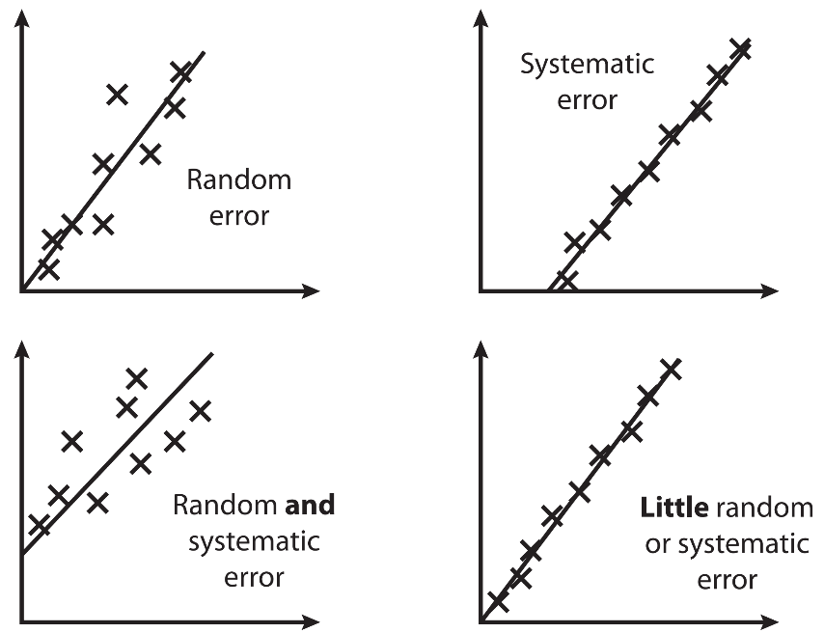
Random error: Measurements vary due to unpredictable circumstances. They cannot be corrected and can only be mitigated by making more measurements and calculating a new mean.

Systematic error: Measurements differ from the true value by a consistent amount each time. They can be corrected by using a different technique to take measurements.
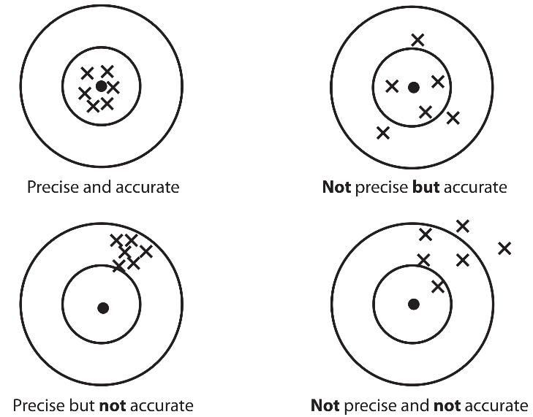

Precision: How close measurements are to each other and the mean.

Accuracy: How close a measurement is to the true value.

Repeatable: When the original experimenter repeats the investigation using the same method and equipment and obtains the same results.

Reproducible: When somebody else repeats the investigation or the investigation is performed using different equipment or techniques and the same results are obtained.

Resolution: The smallest change in a quantity being measured that gives a perceptible change in the reading.

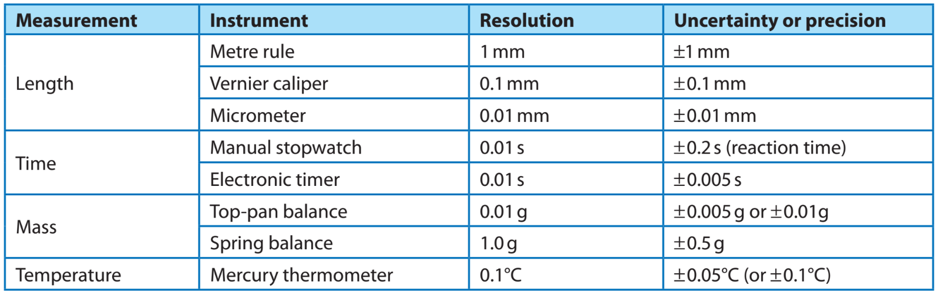
The uncertainty of a result is the interval within which the true value can be expected to lie.
The absolute uncertainty of a reading is no smaller than plus or minus half of the smallest division. The absolute uncertainty of a measurement, where two judgements are required (e.g measuring a length using a ruler), is twice this. For multiple readings, the absolute uncertainty is half the range. Absolute uncertainties have the same units as the quantity.
$$absolute uncertainty= \frac{\text{range (largest value }-\text{ smallest value)}}{2}$$All measurements should be written as mean value ± measurement error (a ± Δa). E.g. A voltmeter gives a reading of 1.70 ± 0.01 V.
Quoting results along with errors:
- When giving results in terms of scientific notation or in standard form, always quote the value and the error with the same exponent.
- Quote the result to the same number of significant figures as the quoted error implies.
- Always quote the error to 1 or at most 2 significant figures.

- A stopwatch that is accurate to 100th of a second is used to record timings of an object in motion. What is the resolution of the stopwatch and what would be a typical value for its precision?
- A metre rule is being used to determine the vertical height of an object. Give two precautions that should be taken to ensure an accurate result.
- What device can be used to measure widths typically less than a centimetre and what is the precision of such a device?
- A measured value of 132 is quoted with an uncertainty of 18. Write the value to 2 s.f. along with the uncertainty.
- A measured value of 11.448 is quoted with an uncertainty of 0.25. Write the value to an appropriate degree of accuracy along with the uncertainty.
- The potential difference measured on a digital voltmeter is 3.36 V. Give this value together with the instrument uncertainty.
- A current is measured with an analogue ammeter using a scale from 0 to 5 A. The reading obtained is 4.25 A and the interval size is 0.2 A. Give the value on the ammeter together with the uncertainty.
- A metre rule is used to measure the width of a bench. The ruler’s smallest interval is 1 mm and the length of the bench is measured to be 64.5 cm. Express this length together with the uncertainty in metres.
- A set of measurements for the diameter of a piece of wire is made and the results are shown in the table.

Diameter (mm) | 5.01 | 4.94 | 4.98 | 4.92 | 4.95
- What is the name of the device used to measure such small distances? Give both the value of the resolution and the precision of this device.
- What precautions should be taken before using this device?
- The true value is 4.81 mm. Explain whether the results are accurate and/or precise.
- A thermometer is used to record the temperature of water as it is heated from frozen. The results are shown in the table.
Temperature (°C) | 1.0 | 2.4 | 3.9 | 5.0 | 6.3 | 7.1 | 7.9 | 9.6 | 10.1
Time (min) | 0 | 1 | 2 | 3 | 4 | 5 | 6 | 7 | 8

- What is the resolution and uncertainty in the measuring device?
- Draw a graph and plot the results of temperature (y-axis) against time (x-axis).
- Draw the best line of fit through the points.
- Given what you found in part a), determine the nature of the results in terms of random and/or systematic errors and justify your conclusion.
- A steel rule is being used to measure the length of a metal bar that has a “true” length of 795 mm. The rule can be read to the nearest millimetre. Repeated measurements give the following results.

Reading | 1 | 2 | 3 | 4 | 5
Value (mm) | 792 | 791 | 791 | 792 | 792

- What is the mean value for the length?
- Are the readings accurate to 1 mm? Give a reason for your answer.
- Are the readings precise to 1 mm? Give reasons for your answer.

- Resolution 0.01 s; precision ± 0.02 s.
- Ensure the ruler is truly vertical; avoid error due to parallax.
- Micrometer; ±0.01 mm
- 130 ± 20
- 11.4 ± 0.3
- 3.36 ± 0.01 V
- 4.3 ± 0.1 A
- 0.654 ± 0.001 m
- a) Micrometer, resolution = 0.01 mm, precision = ± 0.005 mm
b) Make a note of the “zero error” and account for it if necessary.
c) Results are precise but not accurate.
- a) Resolution 0.1 °C
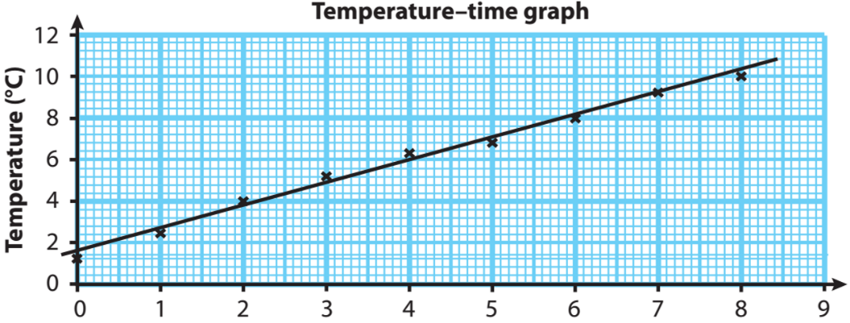
b) and c)

- Random errors are small; points plotted around line of best fit
Systematic error as zero error on thermometer. Line should pass through origin.
- a) Mean = 792 mm
b) Not accurate, true reading is 795 mm and all five measurements are either 791 or 792 mm.
c) Readings are precise. All measurements are within ±0.5 mm of 791.5 mm, which is within the precision of the device.

The fractional uncertainty is the absolute uncertainty divided by the measured value (if multiple readings, divided by the mean).
$$fractional uncertainty= \frac{\text{absolute uncertainty}}{\text{mean value}}= \frac{∆a}{a}$$This can be converted into a percentage uncertainty by multiplying by 100.
$\frac{∆a}{a}$ × 100 = εa
There are different rules for combining uncertainties. Remember:
Δa = absolute uncertainty
εa = percentage uncertainty

When adding or subtracting data with uncertainties, add the absolute uncertainties.
When multiplying or dividing data with uncertainties, add the percentage uncertainties.
When raising data with an uncertainty to a power, multiply the percentage uncertainty by that power.
Combination | Uncertainties
a = b ± c | Δa = Δb + Δc
a = bc or a = b/c | ϵa = ϵb + ϵc
a = b^{c} | ϵa = c × ϵb
When multiplying data with an uncertainty by a constant, multiply the absolute uncertainty by that constant but not the percentage uncertainty.

- A thermometer is graduated in intervals of 1°C. What is the measurement uncertainty associated with this thermometer?
- What is meant by the resolution of an instrument?
- If the resolution of a set of weighing scales is said to be 0.1 g, what is the uncertainty in the values obtained?
- An analogue ammeter is graduated in intervals of 0.2 A. What is the uncertainty of the device for recording current?
- If the value of a measurement is a, what does Δa mean?
- How is the percentage uncertainty determined from a single measurement whose value is a?
- How is the absolute uncertainty determined from a range of measurements?
- A particular resistor was measured on five occasions to give the following results: 1.20 kΩ, 1.16 kΩ, 1.24 kΩ, 1.22 kΩ and 1.28 kΩ. What is the mean value of the resistor?
- In the above set of results, what is the uncertainty associated with the measuring device used?
- In question 8, what is the absolute uncertainty in the measurement?
- In question 10, what is the percentage uncertainty in the measurement?
- The resistance of a component is being measured. The potential difference across it is 8.2 ± 0.2 V and the current through it is 0.8 ± 0.1 A. The resistance, R, of any component is given by the equation V =IR, where V is the potential difference and I is the current.
- What is the value of the resistance of the component?
- Determine the percentage uncertainties in both the potential difference and current readings?
- From part b) calculate i) the total percentage uncertainty in R and ii) the absolute uncertainty in R.
- Give the final value of the resistance together with its uncertainty.
- The density of a piece of metal in the shape of a cube is being determined. The mass of the cube is measured to give the following results: 34.5 g, 34.2 g, 34.7 g, 34.9 g and 34.1 g.
- Calculate the mean mass of the metal cube. Give your answer to an appropriate number of significant figures.
- What is the uncertainty in the weighing scales used to determine the mass?
- Determine the absolute and percentage uncertainty in the above set of measurements and give your answer in the form: mass ± uncertainty in the mass.
The dimension of the cube is 2.3 ± 0.01 cm for each side.
- Determine the volume of the cube and calculate the percentage and absolute uncertainty in the volume of the cube.
- Density is given by ρ = m/V. Calculate the absolute uncertainty in the density of the metal and give your final answer in units of kg/m³.
- Hooke’s law states that the extension of a spring is directly proportional to the load, i.e. F = kx where F is the load in N, x is the extension in m and k is a constant, known as the spring constant.
- If the spring extends by 4.6 mm when a load of 15 N is applied, determine the value of the spring constant in N/m.
The uncertainty in the extension is ± 0.5 mm and the uncertainty in the force is ± 0.5 N.
- Calculate the percentage uncertainties in i) the extension and ii) the load.
- Determine the absolute uncertainty in the spring constant and write your answer as spring constant ± uncertainty.
Other measurements taken using the same spring give a set of spring constants of values 3300, 3240, 3190 and 3140 N/m.
- Using the result in part c) together with the four other results above, determine the mean spring constant and the measured uncertainty in this set of results.

- ± 0.5 °C
- The smallest observable difference in a quantity being measured.
- ± 0.05 g
- ± 0.1 A
- The absolute uncertainty
- $\frac{∆a}{a}$ × 100 = εa
- $absolute uncertainty= \frac{\text{range (largest value }-\text{ smallest value)}}{2}$
- 1.22 kΩ
- ± 0.005 kΩ
- ± 0.06 kΩ
- 4.9 %
- a) 10.3 Ω
- εV = 2.4 %
εI = 12.5 %
- i) εR = 14.9 %
ii) ΔR = 1.5 Ω
- R = 10.3 ± 1.5 Ω
- a) Mean mass = 34.5 g
b) Resolution = 0.1 g
Uncertainty of scales = ± 0.05 g
- Uncertainty = ± 0.4 g
% uncertainty = 1.2 %
Mass = 34.5 ± 0.4 g
- V = 12.2 cm³
εV = 1.3 %
ΔV = 0.16 cm³
- ρ = 2830 kg/m³
ερ = 2.46 %
Δρ = 70
ρ = 2800 ± 70 ≈ 2800 ± 100 kg/m³
- a) k = 3260 N/m
b) Δx = ± 0.5 mm, ΔF = ± 0.5 N
i) εx = 10.9 %
ii) εF = 3.3 %
- εk = 14.2 %
Δk = 462.9
k = 3250 ± 500 N/m
- Mean = 3230 N/m
Uncertainty = ± 80 N/m
k = 3230 ± 80 N/m

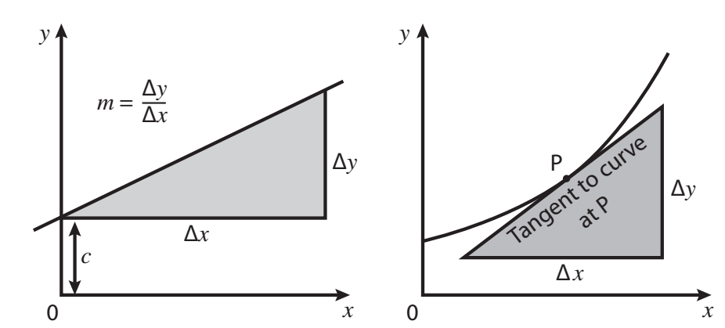
Usually (but not always!) independent variable goes on the x-axis and dependent variable goes on the y axis.
Equation of a straight line graph: y = mx + c
m = Δy ÷ Δx
For gradient on a curve, you need to draw a tangent.
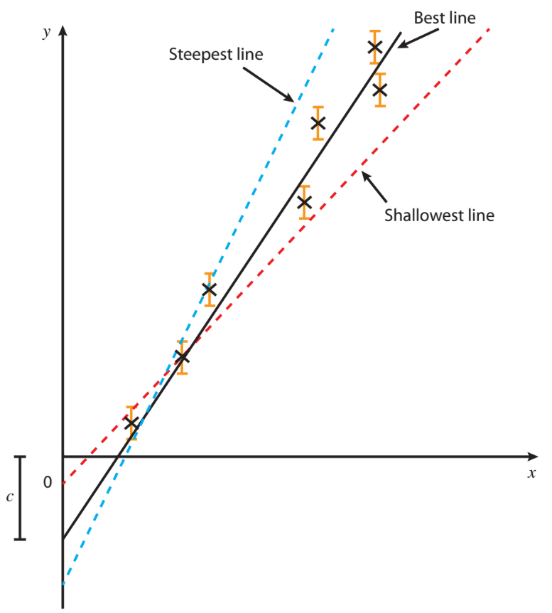
Errors can be show by error bars on a graph. Absolute uncertainties of a gradient can be calculated from worst case lines of best fit.

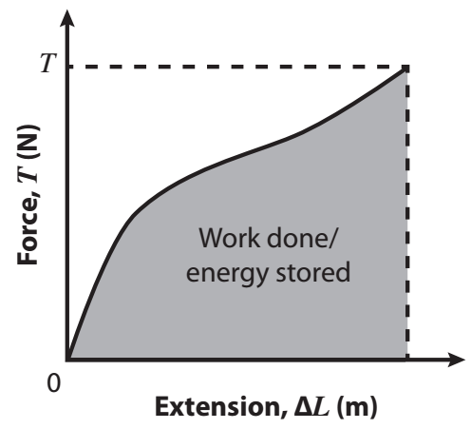

Can work out some other quantities from area under the graph.
E.g. area under a force vs extension graph gives work done.
The uncertainty in a data point on a graph, can be represented by using error bars. Two lines of best fit should be drawn on the graph. The ‘best fit line’, which passes as close to the plotted points as is possible, and the ‘worst line of best fit’, either the steepest, or the shallowest possible line which is constrained by the error bars. The percentage uncertainty in the gradient, and y intercept, can them be found as:
$$\% uncertainty=\frac{\left(best gradient-worst gradient\right)}{best gradient}×100$$

$$\% uncertainty=\frac{\left(best y intercept-worst y intercept\right)}{best y intercept}×100$$
What Graph?
An essential aspect of carrying out a practical is plotting the data to determine how your variables are related. It also allows us to determine values for constants to help decide whether the data collected is accurate.
For the practicals outlined below, state the graph(s) that should be plotted. From this, explain what further analysis you can do with the graph.

- Energy of a photon
In an experiment there were a variety of LEDs, each with a different wavelength. The experiment allowed us to determine the energy of the photons emitted by each LED. The following equation relates energy and the wavelength:
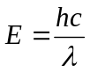
- What graph should be plotted to show a straight line relationship between E and λ?
- What would the gradient of this line be? How could this be used to verify the accuracy of the experiment?

- Acceleration of a falling ball
In an experiment a metal ball bearing was dropped from a range of heights. The time taken for the ball to fall the distance was measured. The following equation relates acceleration and time taken:
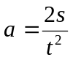
where s is the vertical displacement fallen by the ball bearing.

- Use the equation to decide on a graph to plot that shows the relationship between s and t as a straight line.
- What would the gradient of this line be? How could this be used to verify the accuracy of the experiment?

- Resistivity of a wire
In an experiment, the resistance of a wire is obtained at a variety of different lengths. The resistivity, a property of the material of the wire, is determined using the following equation:
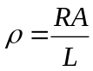
where R is the resistance, A is the cross-sectional area of the wire and L is the length of the wire.
- Considering the quantities measured in the experiment, explained above, decide on a graph to plot in order to get a straight line relationship between those quantities.
- What would the gradient of this line be? How could this be used to verify the accuracy of the experiment?
- An experiment is carried out to determine the value of an unknown resistor. The table shows the results of the experiment.

Current, I (A) | 0.3 | 0.5 | 0.7 | 0.9 | 1.1 | 1.3
Potential difference, V (V) | 1.2 | 1.9 | 3.1 | 3.6 | 4.7 | 5.2

The uncertainty in the current reading was ± 0.1 A and in the potential difference was ± 0.2 V.
- Plot a graph of V against I. For each point, draw an error bar to represent the uncertainties. Draw the line of best fit.
- Determine the gradient of the line of best fit and give its units.
- Draw the shallowest and steepest line that goes through these points and determine the gradients of these lines.
- Express the gradient with the associated uncertainty based on these results.

- A parachutist jumped from an aeroplane and the first 7 seconds of free fall was recorded as shown in the table.

Time, t (s) | 0 | 1 | 2 | 3 | 4 | 5 | 6 | 7
Velocity, v (m/s) | 0 | 4.6 | 6.9 | 7.6 | 7.8 | 8.0 | 8.0 | 8.0

- Plot a graph of v against t between 0 and 7 seconds.
- From the graph determine the gradient at i) t = 0.5 s ii) t = 2 s iii) t = 6 s.
- What does the gradient represent? Give its units.
- Determine the area under the curve for time between i) 0 and 1 s ii) 0 and 7 s.
- What does the area under the curve represent?

- The kinetic energy of a car of mass 1 tonne is determined as a function of its speed on a straight track. The table shows the data that was obtained.

Speed, v (m/s) | 5 | 10 | 15 | 20 | 40 | 60 | 100
Kinetic energy, E (J) | 12,000 | 47,000 | 115,000 | 195,000 | 710,000 | 1,855,000 | 4,875,000

- Plot a graph of kinetic energy (J) as a function of the speed, v, in m/s.
- Re-plot the graph to obtain a straight-line relationship and determine the gradient of the line.
- What does the gradient of the line represent?

Q1.
Data analysis question
Capillary action can cause a liquid to rise up a hollow tube. Figure 1 shows water that has risen to a height h in a narrow glass tube because of capillary action.
Figure 1
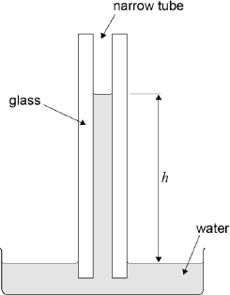
Figure 2 shows the variation of h with temperature θ for this particular tube.
Figure 2
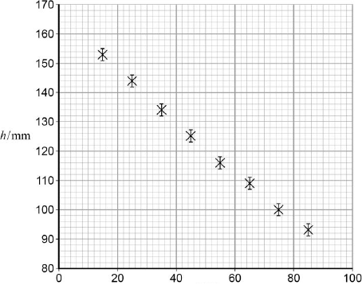
θ / °C
The uncertainty in the measurement of h is shown by the error bars. Uncertainties in the measurements of temperature are negligible.

(a) Draw a best-fit straight line for these data (Figure 2).
(1)
(b) It is suggested that the relationship between h and θ is
h = h₀ — (h₀k)θ
where h₀ and k are constants.
Determine h₀.

h₀ = = ____________________ mm
(1)
(c) Show that the value of h₀k is about 0.9 mm K^{–1}.

(3)
(d) Determine k. State a unit for your answer.

k = ____________________ unit = __________
(2)

(e) A similar experiment is carried out at constant temperature with tubes of varying internal diameter d. Figure 3 shows the variation of h with at a constant temperature.
Figure 3
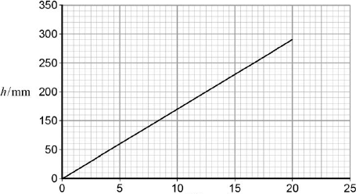
d^{–1} / mm^{–1}
It is suggested that capillary action moves water from the roots of a tree to its leaves.
The gradient of Figure 3 is 14.5 mm².
The distance from the roots to the top leaves of the tree is 8.0 m.
Calculate the internal diameter of the tubes required to move water from the roots to the top leaves by capillary action.

(2)
(f) Comment on the accuracy of your answer for the internal tube diameter in part (v).
___________________________________________________________________
___________________________________________________________________
___________________________________________________________________
(1)
(Total 10 marks)

Q1.
(a) Straight line of best fit passing through all error bars ✓
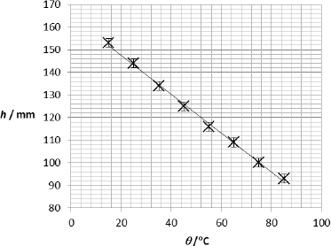
Look for reasonable distribution of points on either side
1
(b) h₀ = 165 ± 2 mm✓
1
(c) Clear attempt to determine gradient ✓
1
Correct readoffs (within ½ square) for points on line more than 6 cm apart and correct substitution into gradient equation ✓
1
h₀k gradient =( -) 0.862 mm K⁻¹ and
negative sign quoted ✓
Condone negative sign
Accept range -0.95 to -0.85
1
(d) k =
= 5.2 x 10⁻³ ✓
Allow ecf from candidate values
1
K⁻¹ ✓
Accept range 0.0055 to 0.0049
1
(e) for h = 8000 mm, d⁻¹ = ✓
1
d = 1.8 x 10⁻³ mm ✓
1
(f) Little confidence in this answer because
One of
It is too far to take extrapolation ✓
OR
This is a very small diameter ✓
1
[10]

Q1.
A student performs an experiment to find the acceleration due to gravity. The student measures the time t for a spherical object to fall freely through measured vertical distances s. The time is measured electronically. The results are shown in the table below.

s/m | t₁/s | t₂/s | t₃/s | mean time  t_{m}/s | t_{m}²/s ²
0.300 | 0.245 | 0.246 | 0.244 | 0.245 | 0.0600
0.400 | 0.285 | 0.286 | 0.286 | 0.286 | 0.0818
0.500 | 0.319 | 0.321 | 0.318 | 0.319 | 0.102
0.600 | 0.349 | 0.351 | 0.348 | 0.349 | 0.122
0.700 | 0.378 | 0.380 | 0.378 | 0.379 | 0.144
0.800 | 0.403 | 0.406 | 0.404
0.900 | 0.428 | 0.428 | 0.430
(a) Complete the table by entering the missing values for t_{m} and t_{m}²
(1)
(b) Complete the graph below by plotting the remaining two points and draw a line of best fit.
(2)
(c) Determine the gradient of the graph.
___________________________________________________________________
___________________________________________________________________
___________________________________________________________________
___________________________________________________________________
___________________________________________________________________
(3)
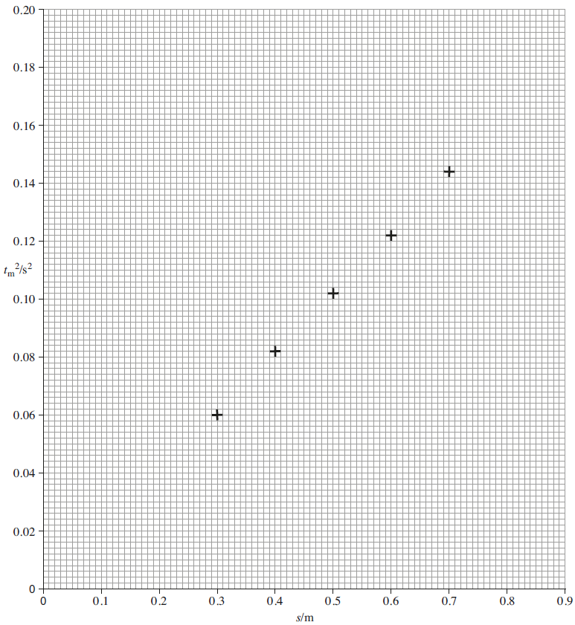
(d) Theory suggests that the equation for the line is 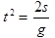 where g is the acceleration due to gravity.
Calculate a value for g using the above equation and the gradient of your graph above.
___________________________________________________________________
___________________________________________________________________
___________________________________________________________________
___________________________________________________________________
___________________________________________________________________
(1)
(e) Calculate the percentage difference between your value for g and the accepted value of 9.81 m s ^{–2}.
___________________________________________________________________
___________________________________________________________________
___________________________________________________________________
___________________________________________________________________
(1)
(f) Calculate the uncertainty in the smallest value of t_{m}.
___________________________________________________________________
___________________________________________________________________
(1)
(g) Calculate the value of g which would be given from the smallest value of t_{m} and the corresponding value of s.
___________________________________________________________________
___________________________________________________________________
___________________________________________________________________
___________________________________________________________________
___________________________________________________________________
___________________________________________________________________
(3)
(h) The uncertainty in each value of s is ± 0.001 m.
Calculate the uncertainty in the value of g you calculated in part (g).
You will need to use the uncertainty for t_{m} you calculated in part (f).
___________________________________________________________________
___________________________________________________________________
___________________________________________________________________
___________________________________________________________________
___________________________________________________________________
___________________________________________________________________
___________________________________________________________________
(3)

(i) A student wishes to investigate the effect of changing the mass of the spherical object on the acceleration of free fall.
Explain how you would modify the experiment seen at the start of this question.
___________________________________________________________________
___________________________________________________________________
___________________________________________________________________
___________________________________________________________________
___________________________________________________________________
___________________________________________________________________
___________________________________________________________________
___________________________________________________________________
___________________________________________________________________
___________________________________________________________________
___________________________________________________________________
___________________________________________________________________
___________________________________________________________________
___________________________________________________________________
___________________________________________________________________
___________________________________________________________________
___________________________________________________________________
___________________________________________________________________
(3)
(Total 18 marks)

Q1.
(a) Both t_{m} values correct: 0.404, 0.429
AND
Both t_{m}² values correct: 0.163, 0.184 ✔
Exact values required for the mark.
1
(b) Both plotted points to nearest mm ✔
Best line of fit to points ✔
The line should be a straight line with approximately an equal number of points on either side of the line.
2
(c) Large triangle drawn (at least 8 cm × 8 cm) ✔
Correct values read from graph ✔
Gradient value in range 0.190 to 0.222 ✔
Allow 2 or 3 sf for gradient
3
(d) g = 9.71 (ms^{–2}) or correct value from gradient value in (c) ✔.
(The answer must be in the range 9.0 to 10.5 (ms^{–2})).
Allow 2 or 3 sf.
Unit not required
1
(e) 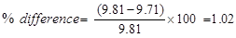
OR correct computation using value from (d) ✔
If the candidate’s value is exactly 9.81, then a statement that there is no (or zero) percentage difference is acceptable.
No sf penalty.
NB. Allow an answer from a calculation with either the candidate’s value or the accepted value as the denominator in the equation.
1
(f) 0.001 s✔ (half the spread)
(Must have unit).
1
(g) g = 2s/t_{m}² ✔
= 2 × 0.300/0.245² ✔
= 10.0 (or 10.00) ms⁻² ✔
Unit required and 3 or 4sf for the last mark.
3
(h) % uncertainty in s = 0.33 and
% uncertainty in t_{m} = 0.41 ✔
Allow ecf from part (f).
% uncertainty in g
= 0.33 + (2 × 0.41) = 1.15 ✔
Allow ecf at each stage of calculation.
Uncertainty in g
= 10.0 × 1.15/100 = 0.12 m s⁻² or 0.1 m s⁻² ✔
Allow ecf from part (g).
(allow 1 or 2 sf only)
(Must have unit for 3rd mark).
3
(i) (a) Use spherical objects of different mass and determine mass with balance ✔
Annotate the script with the appropriate letter at the point where the mark has been achieved.
(b) Would need same diameter spherical objects for fair comparison (same air resistance etc) ✔
(c) Time spherical object falling through same height and compare times
Alternative for (c):
i.e. repeat whole of experiment, plot extracted values of g against mass. Horizontal line expected, concluding acceleration same for different masses.
3
[18]

- Define the term Order of Magnitude
Estimation

- For the following, estimate to the nearest order of magnitude:

Example | Order of Magnitude Estimate
Height of a human in m
Height of a human in cm
Mass of a human in kg
Weight of an apple in N
Thickness of a piece of paper in m
Height of a house in m
Diameter of a dinner plate in m
The length of a lesson in s
Volume of a pencil in m³
Mass of a standard car in kg
Wavelength of visible light in m

- Make order of magnitude estimates of the following quantities:

- Surface area of a door in m²

- Volume of a raindrop in m³

- Density of wood in kgm⁻³

- Work done in lifting a physics textbook in J

- Energy transferred by passing through a 2kW kettle to make a cup of tea, in J

- Impact force on a football (F = change in momentum / impact time) in N

Acknowledgements:
The questions on SI units were originally from TES user LightbulbScience. The original resources can be downloaded here:
https://www.tes.com/teaching-resource/si-units-and-dimensional-analysis-12200994
Questions in multiple areas (including use of SI units, limitation of physical measurements and estimations) are originally from TES user dathomson. The original resources can be downloaded here:
https://www.tes.com/teaching-resource/aqa-a-level-physics-unit-1-measurements-and-their-errors-11061217
Some notes in the limitation of physical measurements section are from physics and maths tutor. The original notes can be downloaded here:
https://pmt.physicsandmathstutor.com/download/Physics/A-level/Notes/AQA/01-Measurements-and-Errors/Key%20Points%20-%20Section%201%20Measurements%20and%20Their%20Errors%20-%20AQA%20Physics%20A-level.pdf

