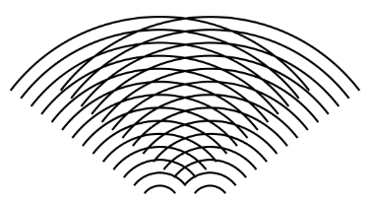
Oxbridge Assessment Prep
Week 4 – Waves

Physics/Engineering at Oxford: PAT
Engineering at Cambridge: ENGAA
Natural Sciences at Cambridge: NSAA
Assessment date: 4th November 2020

Week 1 – Mechanics
Week 2 – Electricity
Week 3 – Area/volume of shapes
Week 4 – Waves
Week 5 – Differentiation/Integration/Series
Week 6 – General physics
Week 7 – General maths (logs, binomial, trig).

Waves Facts (unlike A-level, you need to remember these)
Frequency: $f=\frac{1}{T}$
Time period:$T=\frac{1}{f}$
Wave speed equation:$c=fλ$
Phase difference: $Δϕ=\frac{2πΔd}{λ} or\frac{2πΔt}{T}$
Frequency of first harmonic: $f=\frac{1}{2L}\sqrt{\frac{T}{μ}}$ where $μ =\frac{m}{l}$
Snell’s law: $n_{1} sinθ_{1}= n_{2} sinθ_{2}$
Refractive index: $n=\frac{c}{c_{s}}$
Critical angle: $sinθ_{c}=\frac{n_{2}}{n_{1}}$
Fringe spacing: $w=\frac{λD}{s}$
Diffraction grating: $d\sin{θ}=nλ$

Q18 section 1 ENGAA 2018 (no calculator)
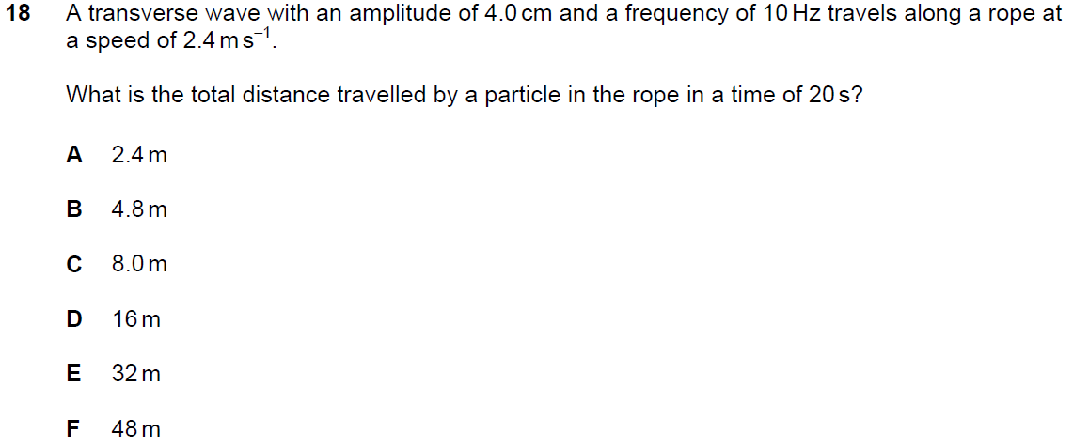
Q22 section 1 NSAA 2020 specimen (no calculator)
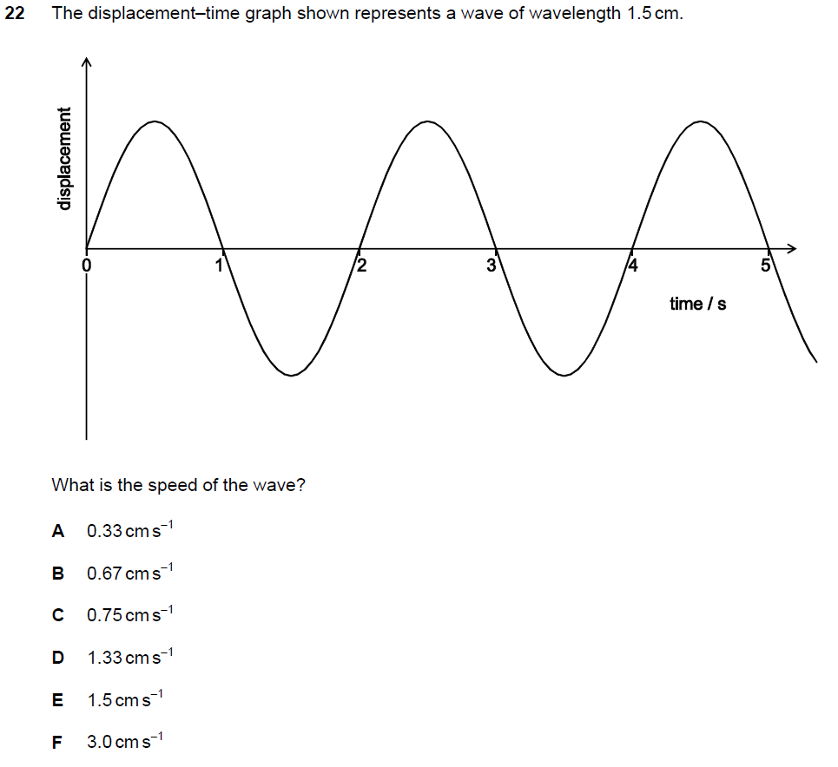
Q6 PAT 2018
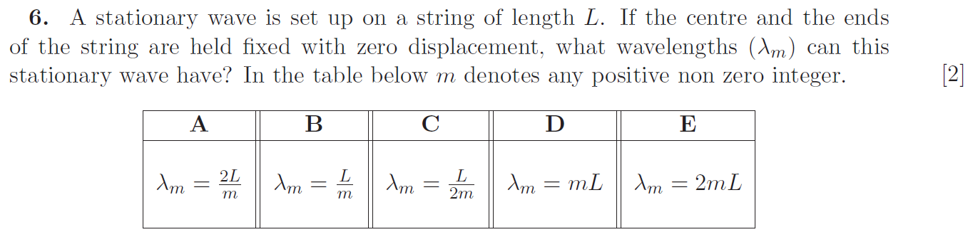

Q12 PAT 2018
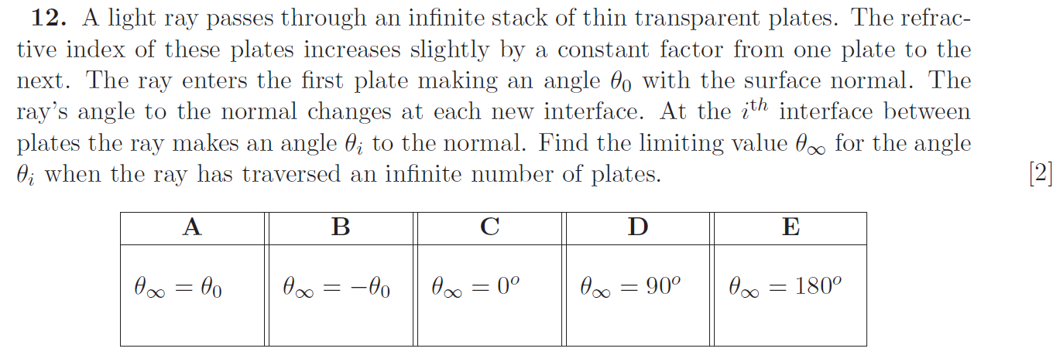

Q32 section 1 NSAA 2020 specimen (no calculator)

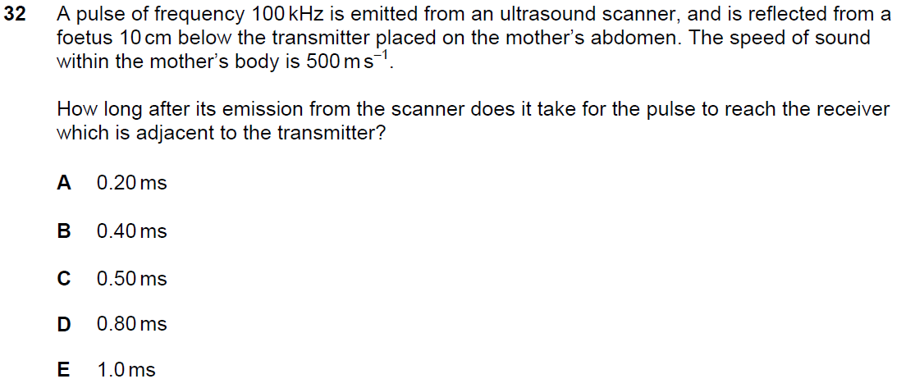

Q6 section 1 ENGAA 2018 (no calculator)
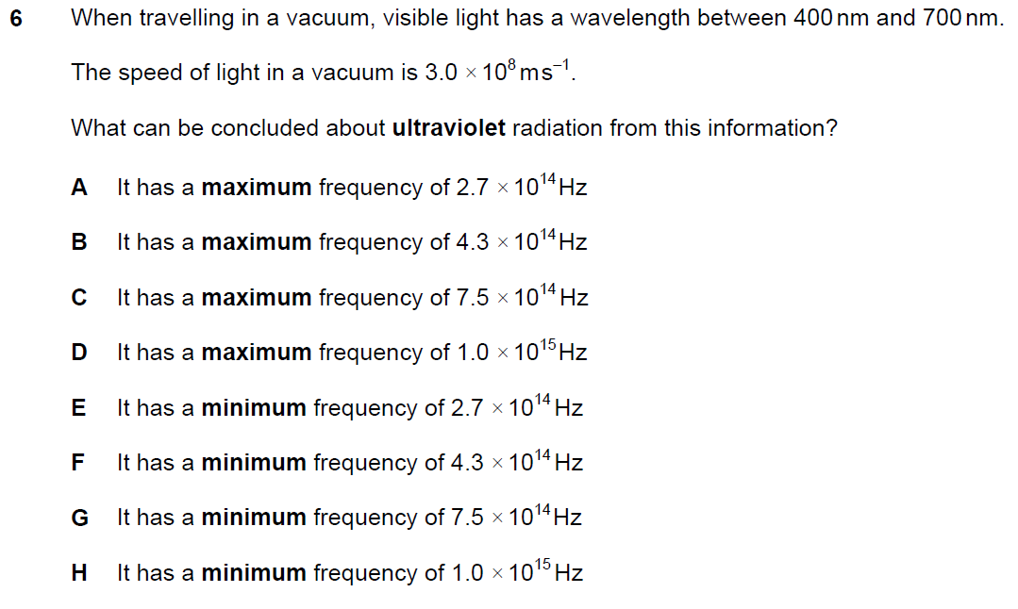

Q8 PAT 2017
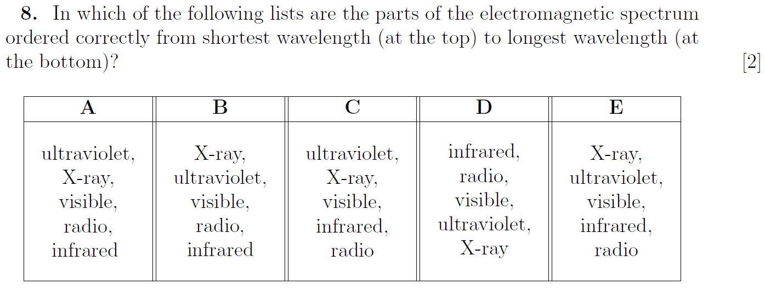

Q8 PAT 2017 Specimen
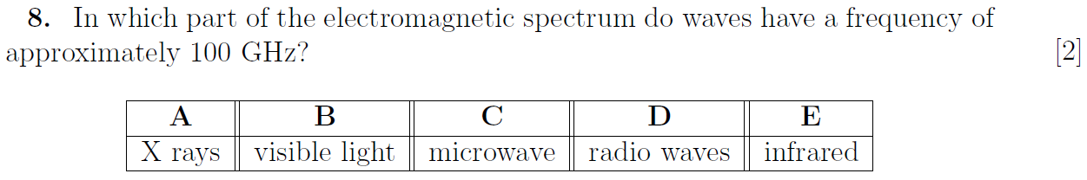

Q4 section 1 ENGAA 2019 (no calculator)
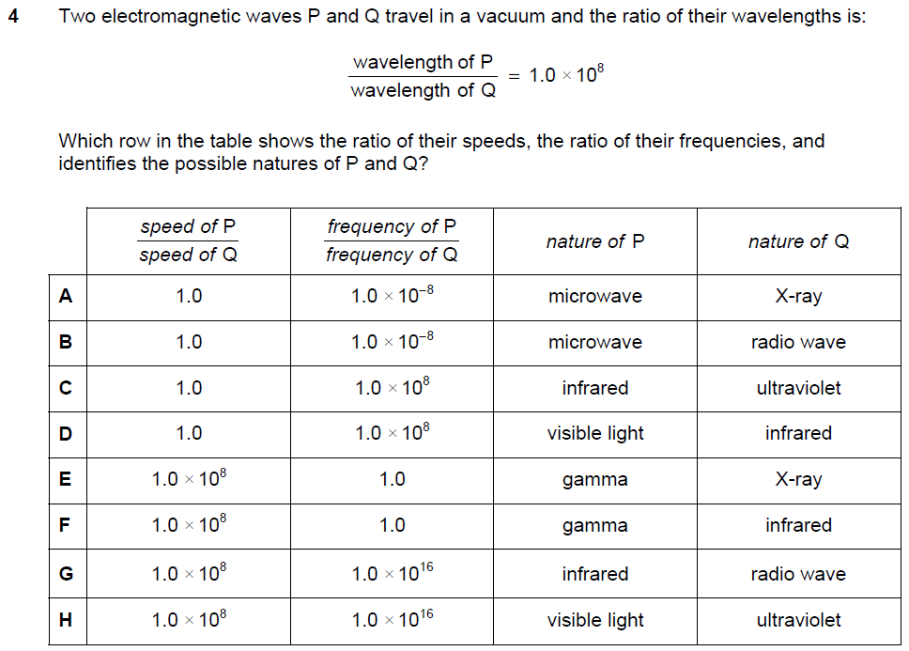

Q1 section 2 ENGAA 2019 (no calculator)
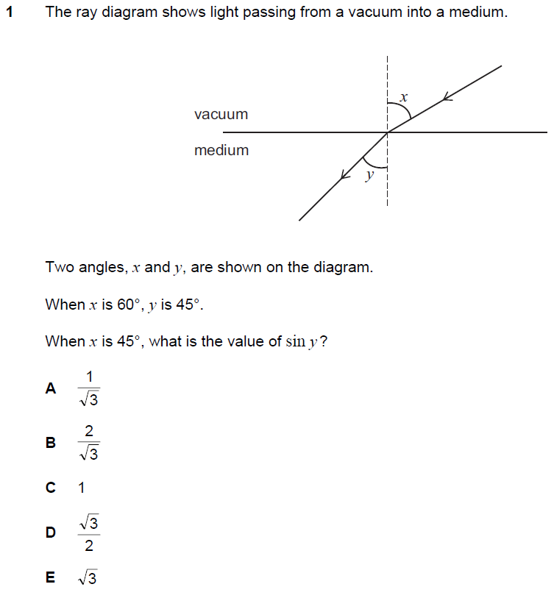

Q30 section 1 ENGAA 2019 (no calculator)
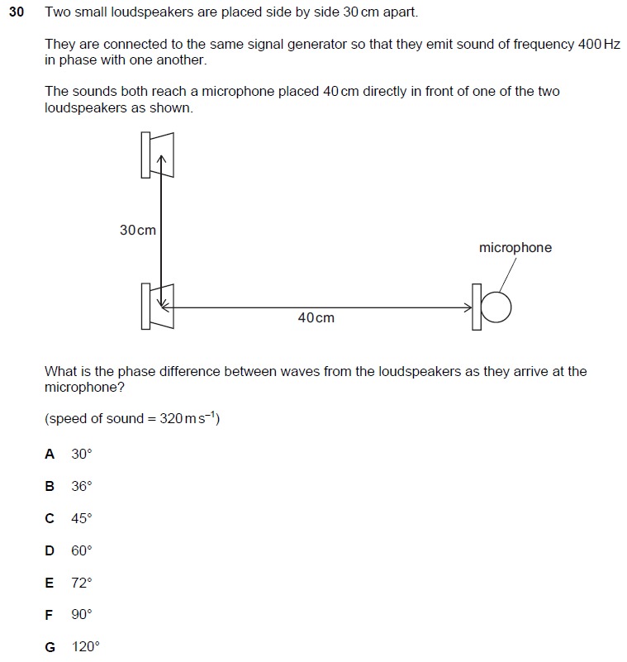

Q38 section 1 ENGAA 2019 (no calculator)
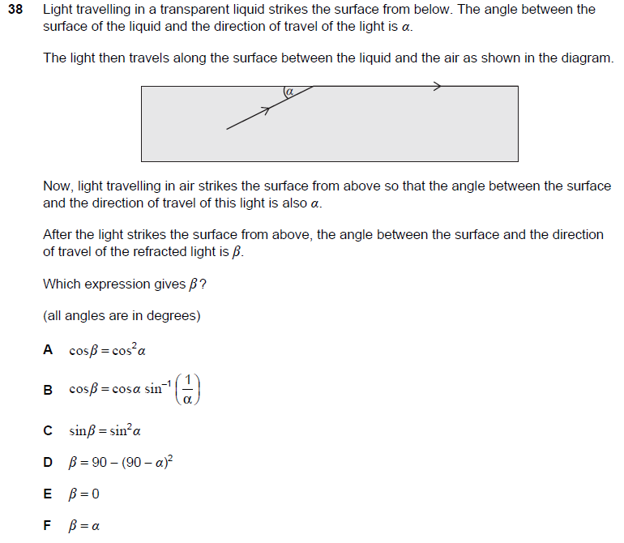

Q5 section 2 ENGAA 2019 (no calculator)
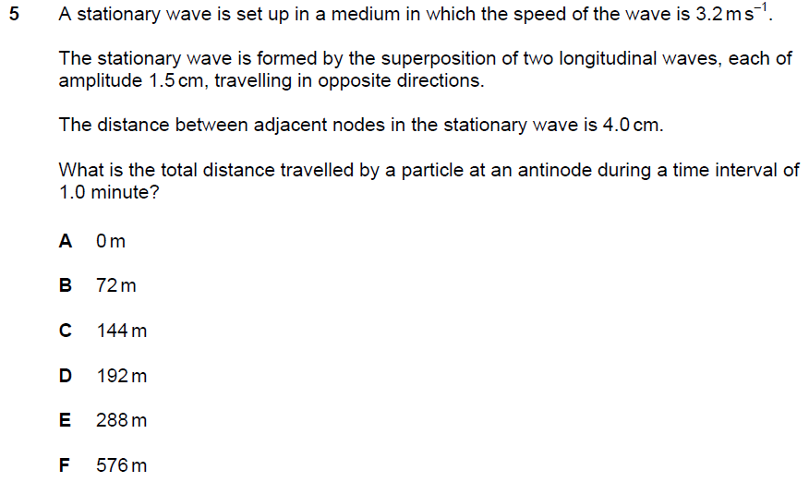

Q6 section 2 ENGAA 2019 (no calculator)
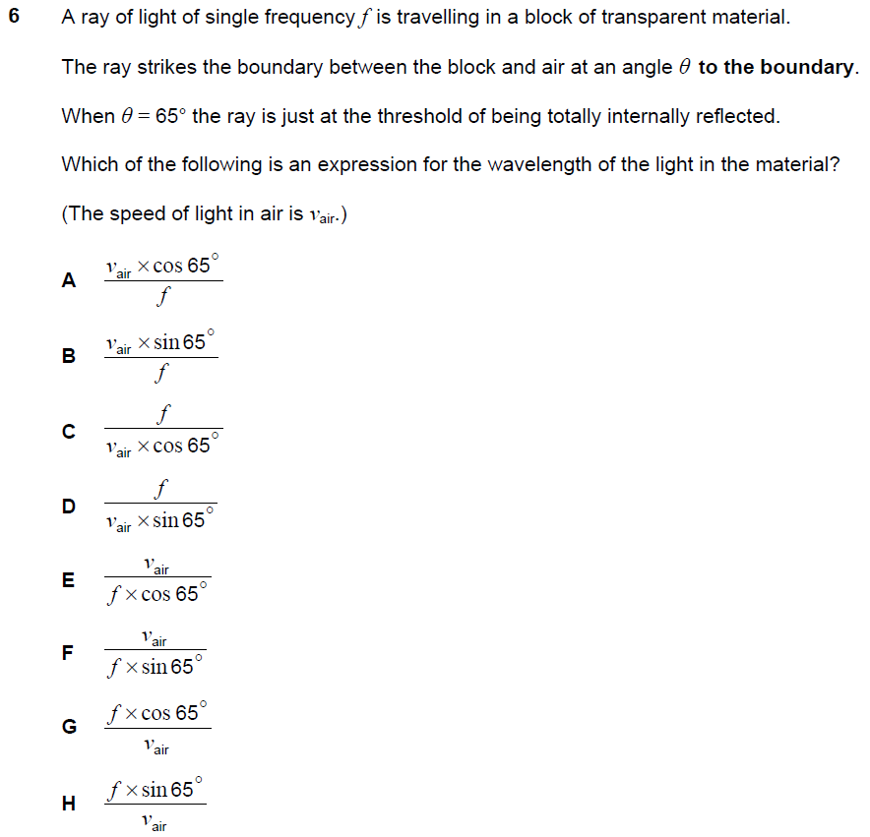

Q38 NSAA 2020 Sample (no calculator)
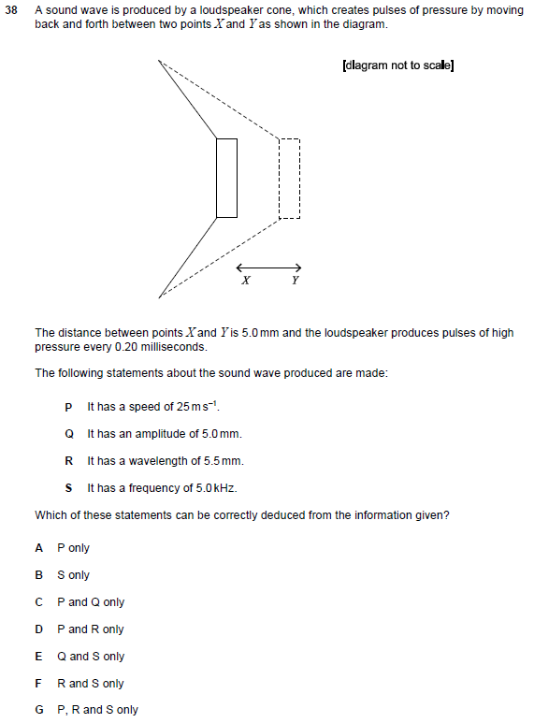

Q6 section 2 ENGAA 2018 (no calculator)
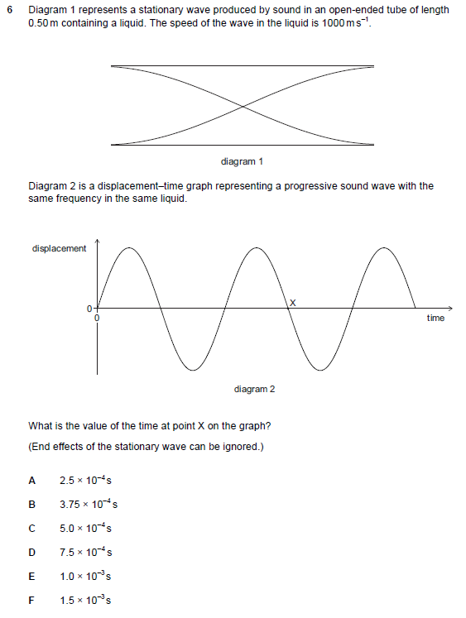

Q18 PAT 2017
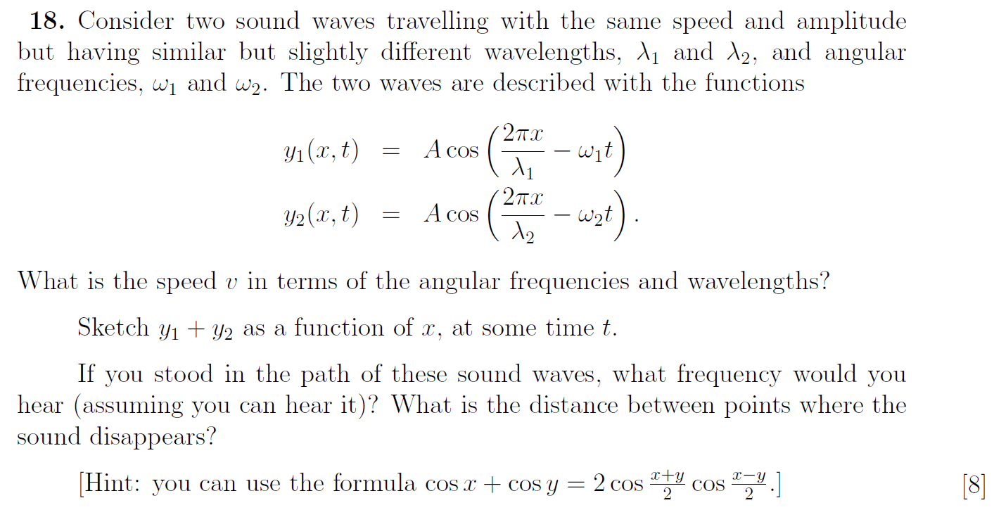

Q27 PAT 2017 Specimen
