Oxbridge Assessment Prep

Week 5 – Differentiation, Integration and Series

Physics/Engineering at Oxford: PAT
Engineering at Cambridge: ENGAA
Natural Sciences at Cambridge: NSAA
Assessment date: 4th November 2020

Week 1 – Mechanics
Week 2 – Electricity
Week 3 – Area/volume of shapes
Week 4 – Waves
Week 5 – Differentiation/Integration/Series
Week 6 – General physics
Week 7 – General maths (logs, binomial, trig).

Differentiation facts
Common Functions | Function | Derivative
Constant | c | 0
Line | x | 1
 | ax | a
Square | x² | 2x
Square Root | √x | (½)x^{-½}
Exponential | e^{x} | e^{x}
 | a^{x} | ln(a) a^{x}
Logarithms | ln(x) | 1/x
 | log_{a}(x) | 1 / (x ln(a))
Trigonometry (x is in radians) | sin(x) | cos(x)
 | cos(x) | −sin(x)
 | tan(x) | sec²(x)
Inverse Trigonometry | sin⁻¹(x) | 1/√(1−x²)
 | cos⁻¹(x) | −1/√(1−x²)
 | tan⁻¹(x) | 1/(1+x²)
Rules | Function | Derivative
Multiplication by constant | cf | cf’
Power Rule | x^{n} | nx^{n−1}
Sum Rule | f + g | f’ + g’
Difference Rule | f - g | f’ − g’
Product Rule | fg | f g’ + f’ g
Quotient Rule | f/g | (f’ g − g’ f )/g²
Reciprocal Rule | 1/f | −f’/f²
Chain Rule (using ’ ) | f(g(x)) | f’(g(x))g’(x)
Chain Rule (using ddx ) | dydx = dydududx

Integration facts
Common Functions | Function | Integral
Constant | ∫a dx | ax + C
Variable | ∫x dx | x²/2 + C
Square | ∫x² dx | x³/3 + C
Reciprocal | ∫(1/x) dx | ln|x| + C
Exponential | ∫e^{x} dx | e^{x} + C
 | ∫a^{x} dx | a^{x}/ln(a) + C
 | ∫ln(x) dx | x ln(x) − x + C
Trigonometry (x in radians) | ∫cos(x) dx | sin(x) + C
 | ∫sin(x) dx | -cos(x) + C
 | ∫sec²(x) dx | tan(x) + C
Rules | Function | Integral
Multiplication by constant | ∫cf(x) dx | c∫f(x) dx
Power Rule (n≠-1) | ∫x^{n} dx | $\frac{x^{n+1}}{n+1}$+ C
Sum Rule | ∫(f + g) dx | ∫f dx + ∫g dx
Difference Rule | ∫(f - g) dx | ∫f dx - ∫g dx

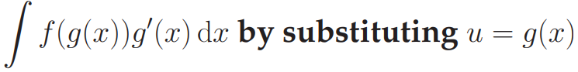
Integration by parts: ∫u v dx = u∫v dx −∫u' (∫v dx) dx
Integration by substitution:

Geometric Series {a, ar, ar², ar³, ... }
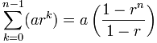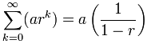

Arithmetic Series {a, a+d, a+2d, a+3d, ... }
$$S_{n}=n\left(\frac{a_{1}+a_{n}}{2}\right)$$

Q1 PAT 2018
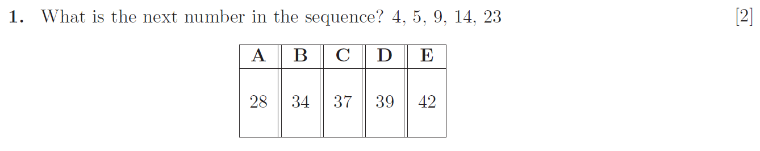

Q5 PAT 2017 Specimen

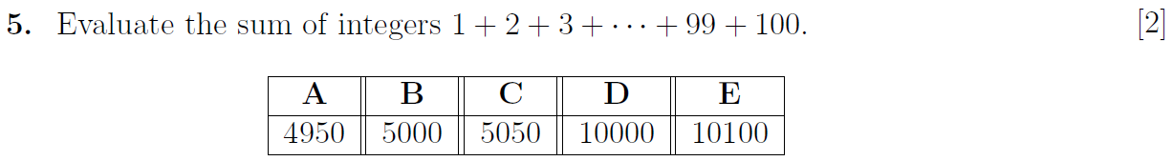

Q5 PAT 2018
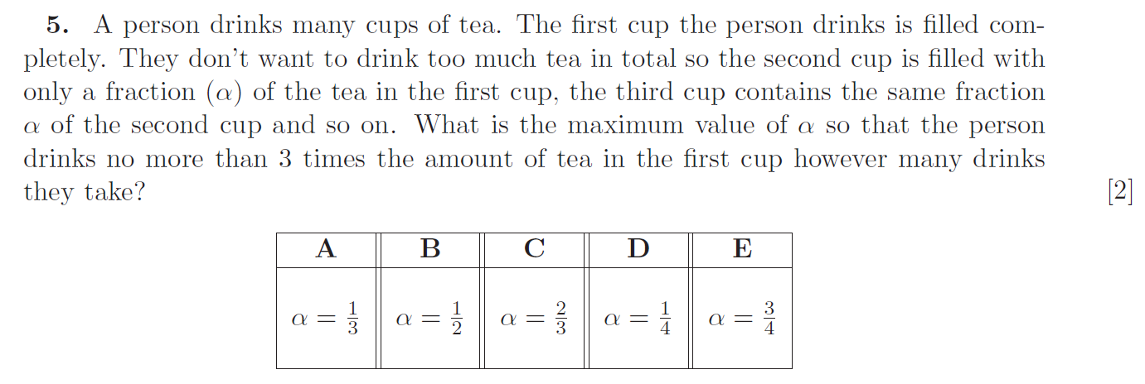

Q3 PAT 2017
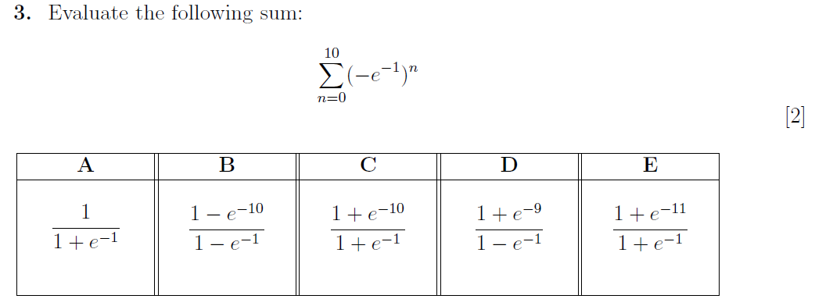

Q15 PAT 2017 Specimen

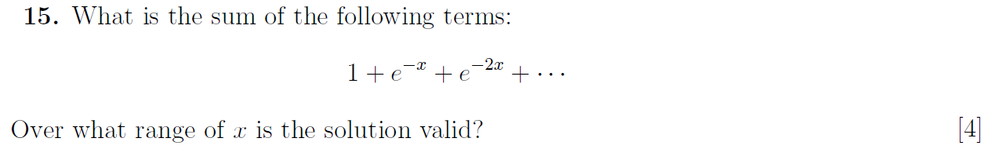

Q17 Section 1 NSAA 2018 (no calculator)
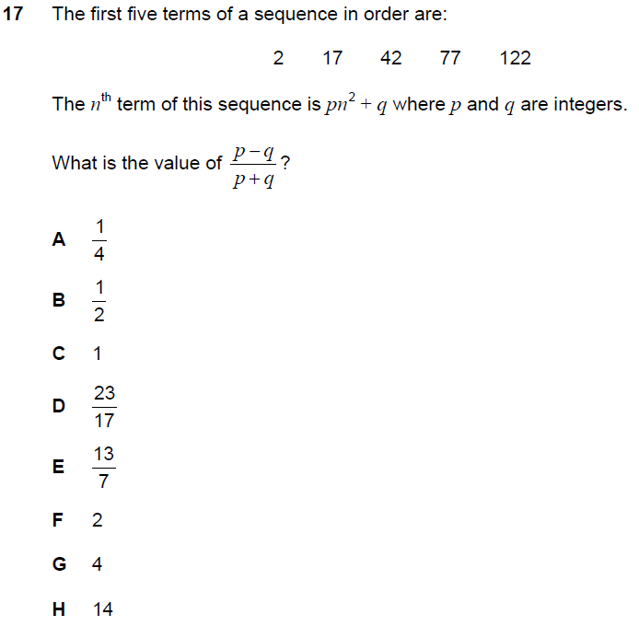

Q37 Section 1 ENGAA 2018 (no calculator)
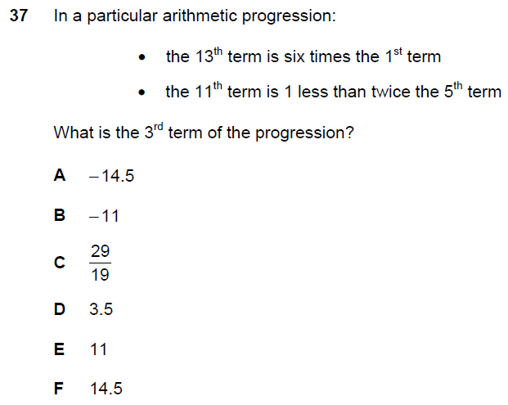

Q39 Section 1 ENGAA 2018 (no calculator)
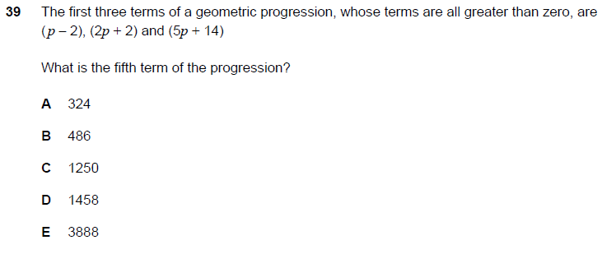

Q1 PAT 2017
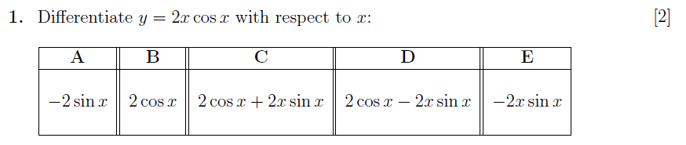

Q3 PAT 2017 Specimen
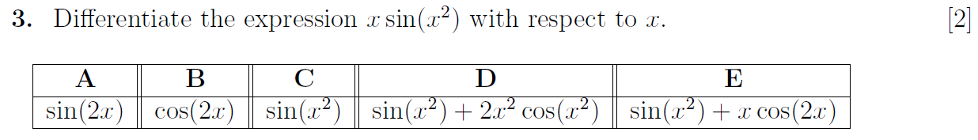

Q8 PAT 2018
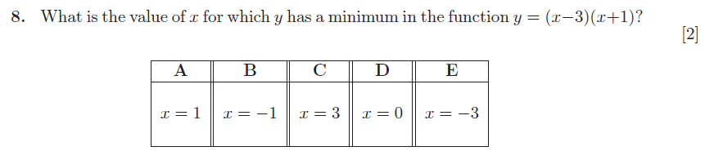

Q23 section 1 ENGAA 2019 (no calculator)
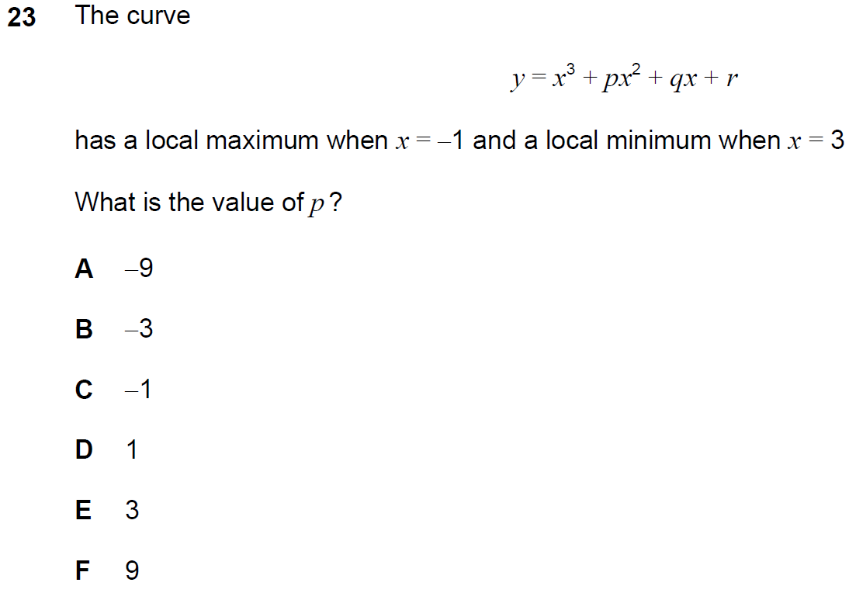

Q5 PAT 2017
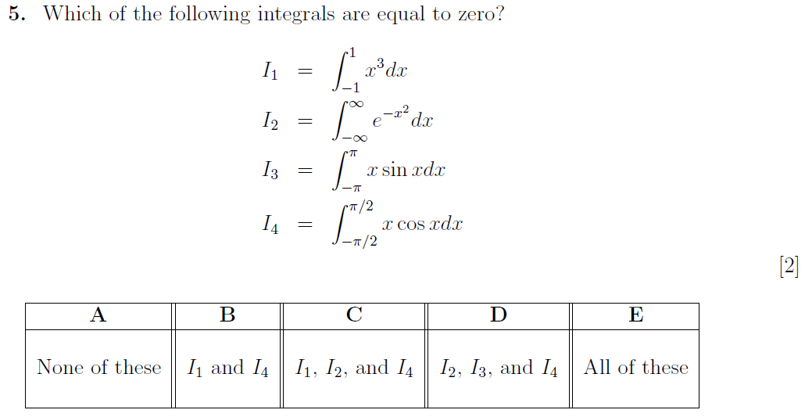

Q49 ENGAA 2018 (no calculator)
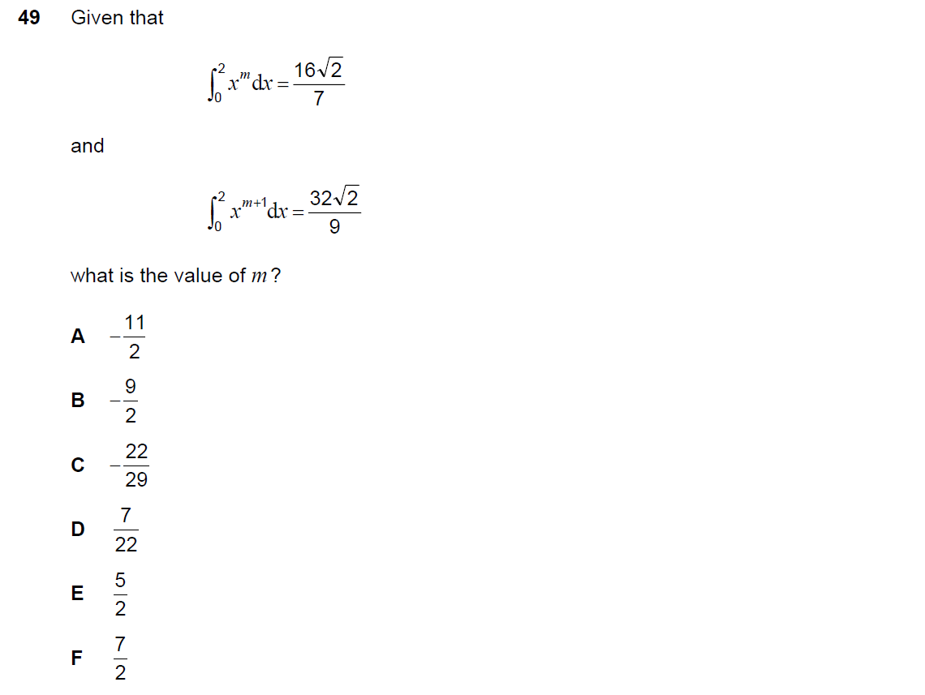

Q17 PAT 2017 Specimen

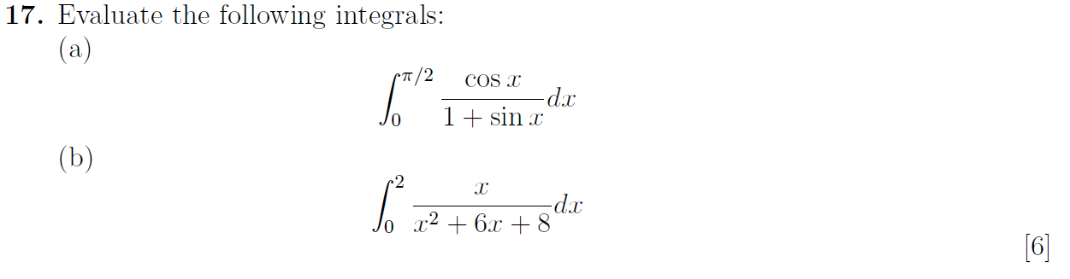

Q21 PAT 2017
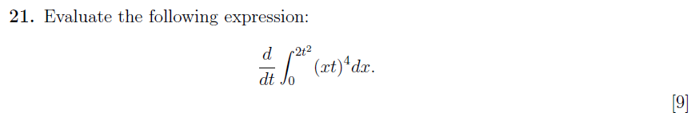

Q33 Section 1 ENGAA 2019

