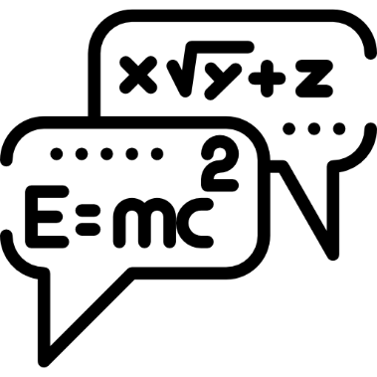
Oxbridge Assessment Prep
Week 6 – General physics

Physics/Engineering at Oxford: PAT
Engineering at Cambridge: ENGAA
Natural Sciences at Cambridge: NSAA
Assessment date: 4th November 2020

Week 1 – Mechanics
Week 2 – Electricity
Week 3 – Area/volume of shapes
Week 4 – Waves
Week 5 – Differentiation/Integration/Series
Week 6 – General physics
Week 7 – General maths (logs, binomial, trig).

Q2 PAT 2018
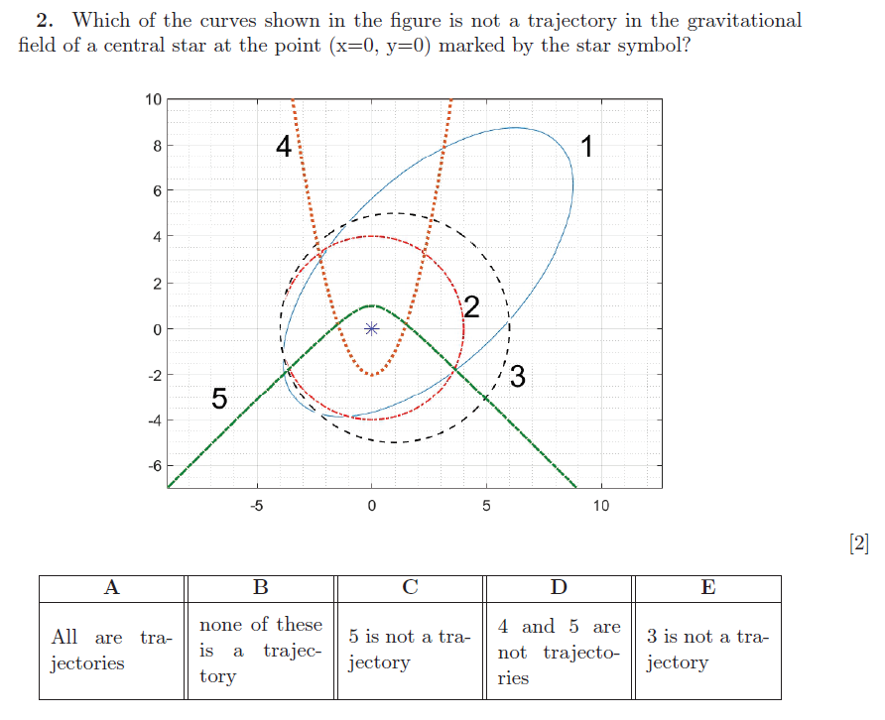

Q3 PAT 2018
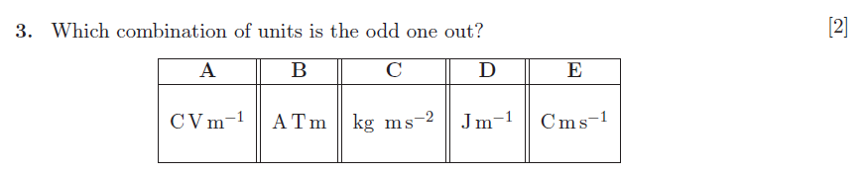

Q24 section1 NSAA 2020 sample (no calculator)

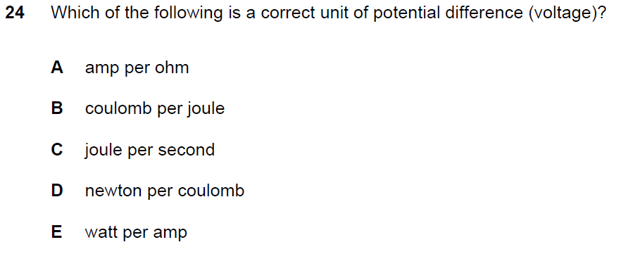

Q7 PAT 2017
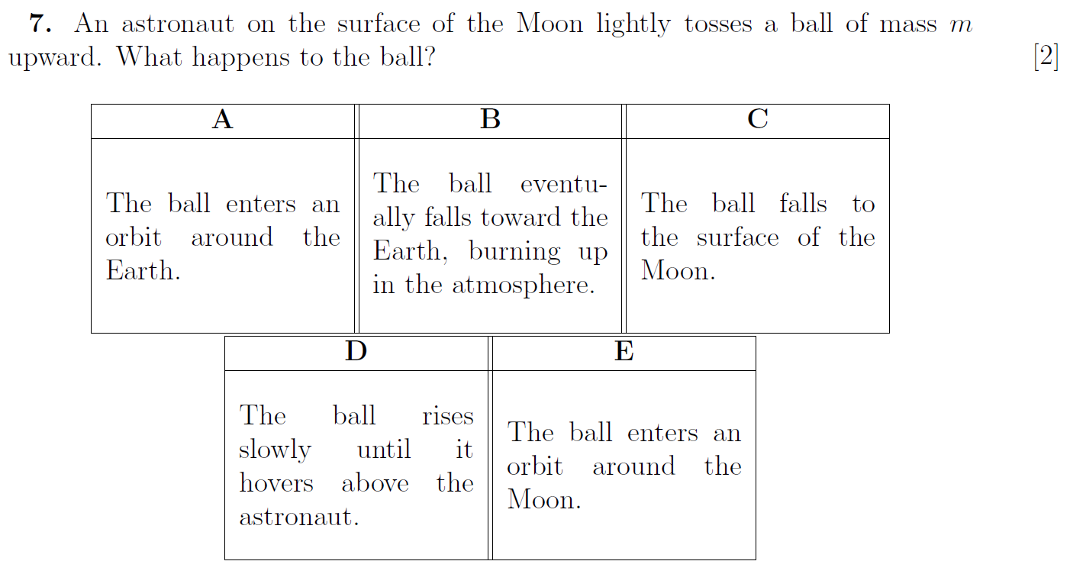

Q7 PAT 2017 Specimen
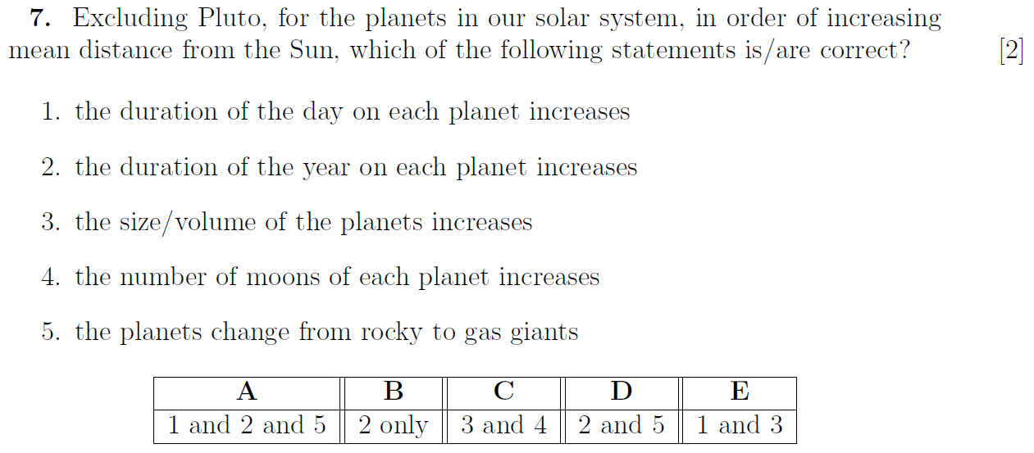

Q9 PAT 2017 Specimen
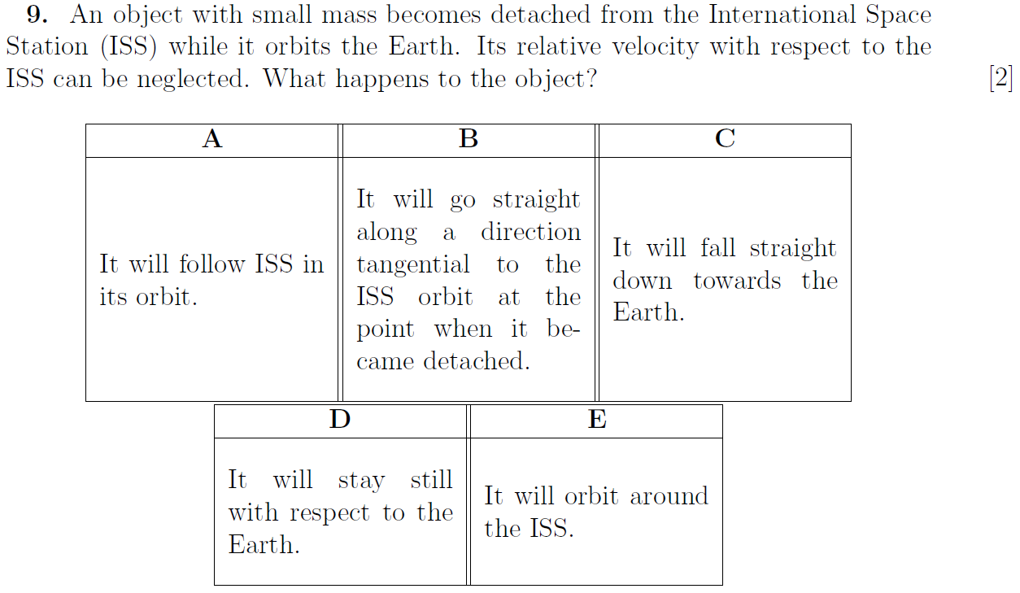

Q10 PAT 2017 Specimen
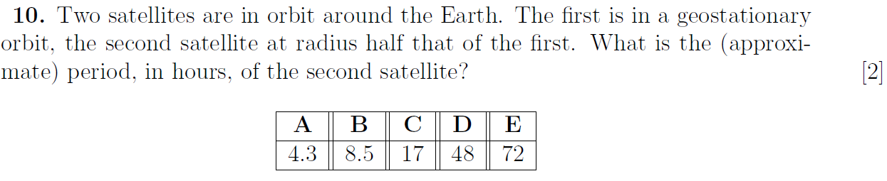

Q11 PAT 2017 Specimen
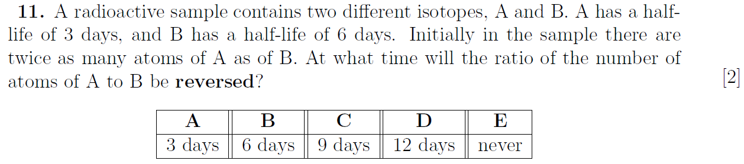

Q7 section1 ENGAA 2019 (no calculator)

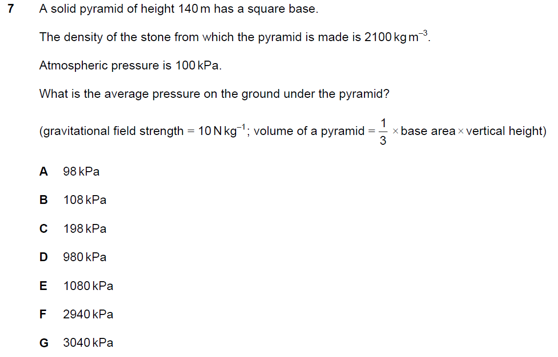

Q8 section1 ENGAA 2019 (no calculator)
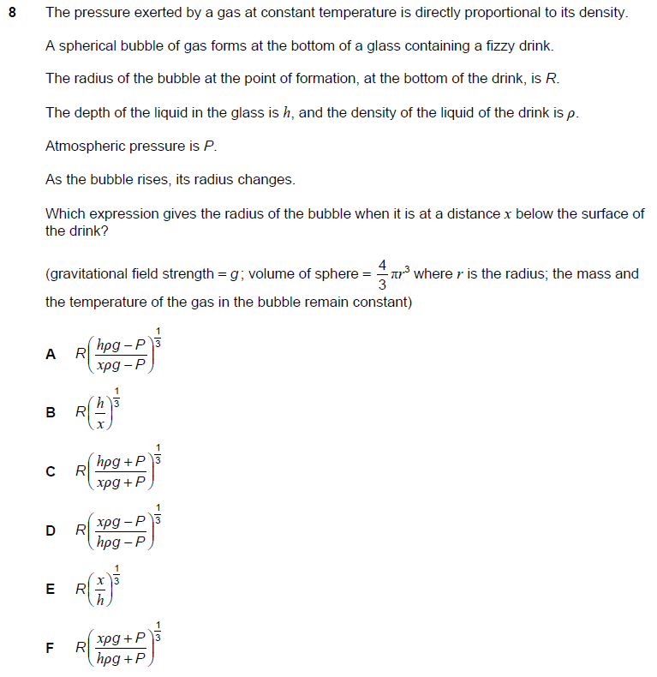

Q2 section1 ENGAA 2018 (no calculator)
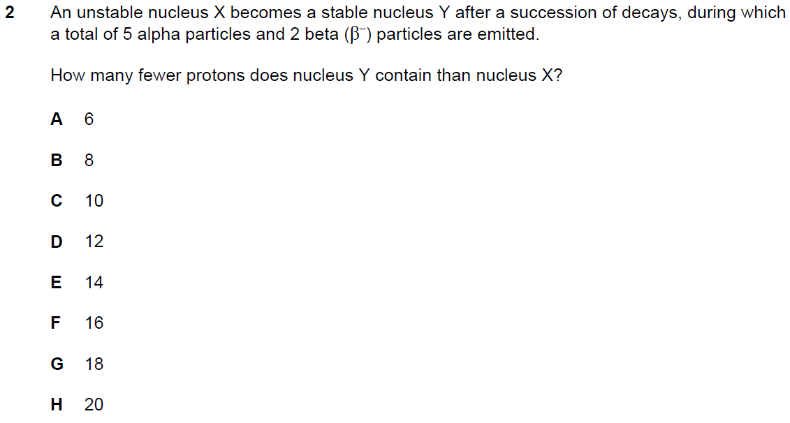

Q14 section1 ENGAA 2018 (no calculator)
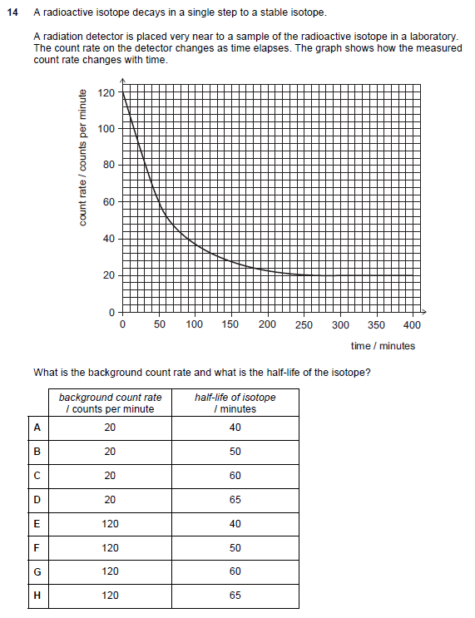

Q24 section1 ENGAA 2018 (no calculator)
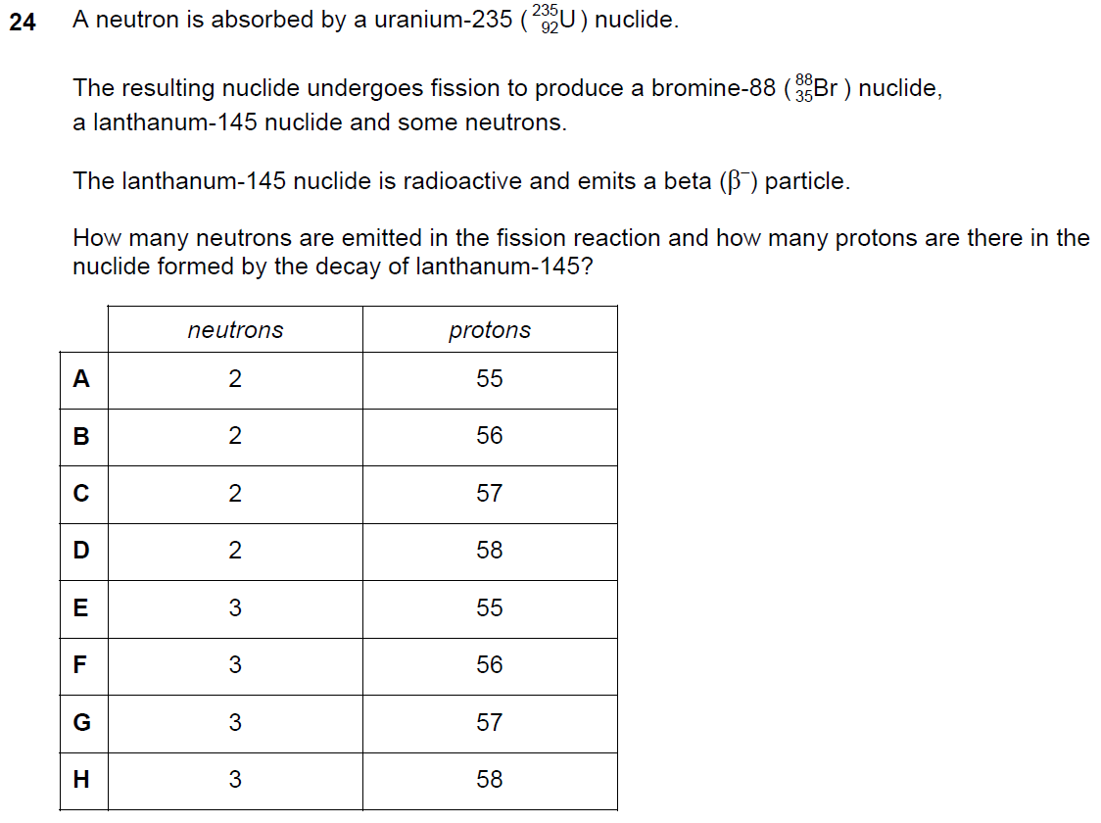

Q25 section1 NSAA 2020 sample (no calculator)
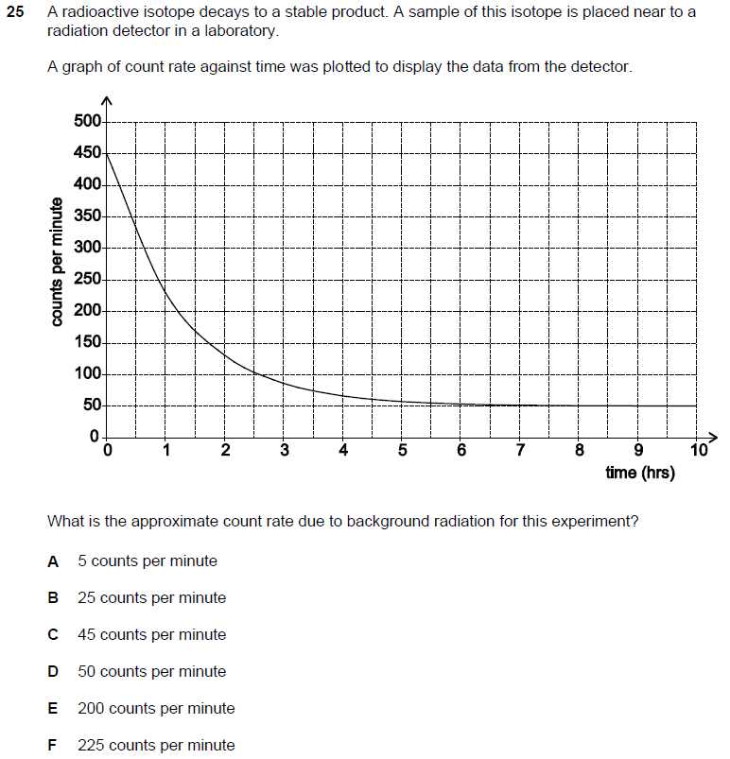

Q31 section1 NSAA 2020 sample (no calculator)
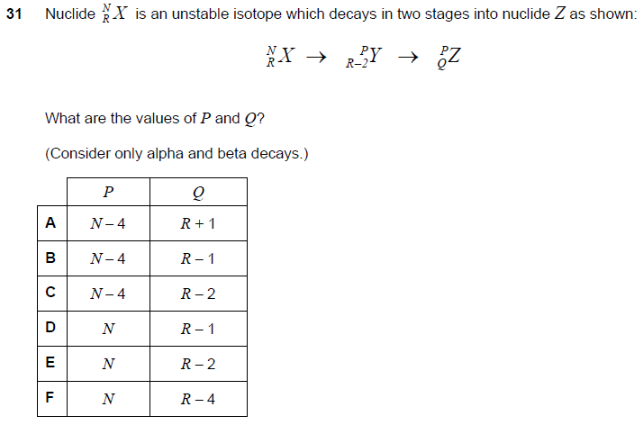

Q35 section1 NSAA 2020 sample (no calculator)
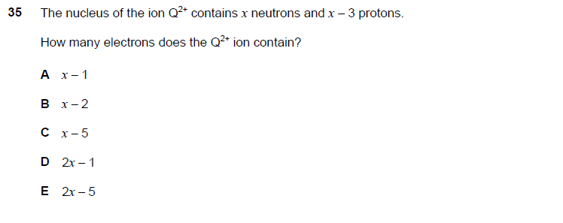

Q40 section1 NSAA 2020 sample (no calculator)
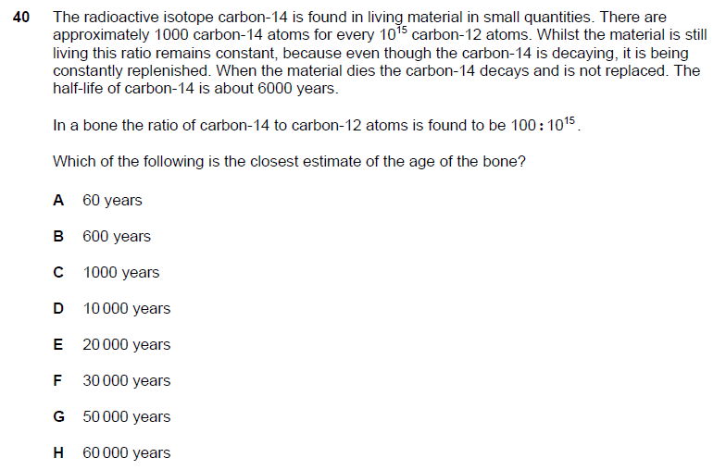

Q18 PAT 2018
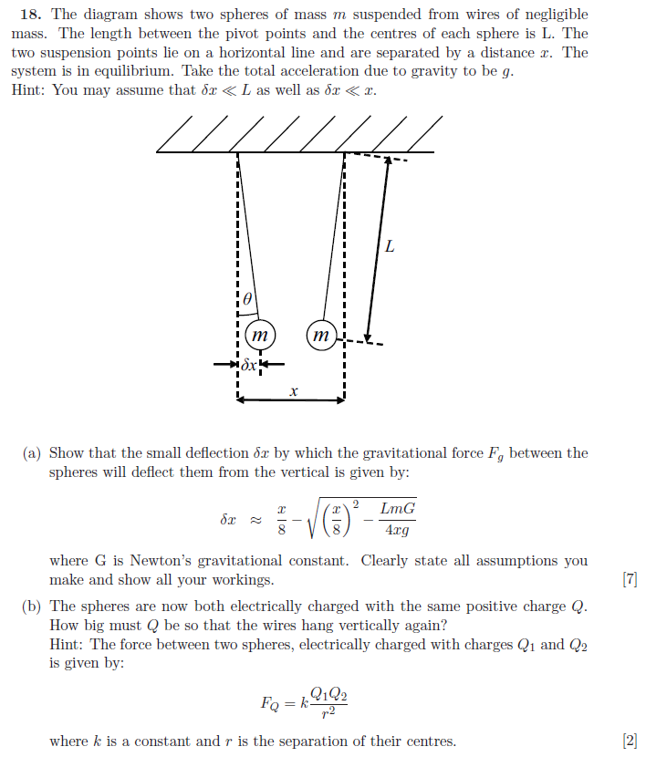

Q20 PAT 2017
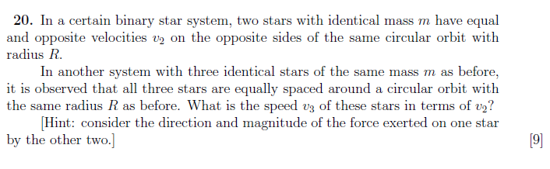

Q21 PAT 2018
