
Combined Science
Waves
Name ______________________________
Class ______________________________
Teacher ______________________________

Waves facts
- What does a wave transfer?
- What causes a wave?
- What is the definition of a transverse wave?
- What is the definition of a longitudinal wave?
- Give three examples of longitudinal waves.
- Give three examples of transverse waves
- What is a compression?
- What is a rarefaction?
- What is the amplitude?
- What is the wavelength?
- What is the frequency?
- What are the units of wave speed, wavelength and frequency?
- What is the wave speed equation?
- What speed do EM waves travel at?
- What speed does sound travel at?
- List the EM waves in order from longest to shortest wavelength.
- Which EM wave has the highest frequency?
- Which EM wave has the most energy?
- Which three EM waves are ionising?
- What happens when light travels from air into a glass block?
- What happens when light travels from a glass block into air?
- What is the law of reflection?
- What is the danger of ultra-violet radiation?
- What is the danger of X-rays and gamma ray?
- What are radio waves used for?
- What are microwaves used for?
- What is infra-red used for?
- What is visible light used for?
- What is ultra-violet used for?
- What are X-rays used for?
- What are gamma rays used for?

- A wave transfers energy from one place to another.
- A vibration.
- The vibration causing a transverse wave is perpendicular to the direction of travel of the wave.
- The vibration causing a longitudinal wave is parallel to the direction of travel of the wave.
- Sound, ultrasound and primary earthquake (P) waves
- Water waves, all EM waves and secondary earthquake (S) waves.
- A compression is when particles in a longitudinal wave are closest together.
- A rarefaction is when particles in a longitudinal wave are furthest apart.
- The amplitude is the maximum displacement of a wave from its equilibrium position.
- The wavelength is the distance from a point on one wave to the same point on the next wave.
- The frequency is the number of waves passing a point each second.
- Wave speed – m/s, wavelength – m, frequency – Hz.
- v = f × λ
- 300,000,000 m/s
- 330 m/s
- Radio, microwave, infra-red, visible, ultra-violet, x-ray, gamma.
- Gamma
- Gamma
- Ultra-violet, x-ray and gamma.
- It refracts towards the normal as glass is more dense than air.
- It refracts away from the normal as air is less dense than glass.
- The angle of incidence is equal to the angle of reflection.
- Can cause skin to age prematurely and increase the risk of skin cancer.
- X-rays and gamma rays are ionising radiation that can cause the mutation of genes and cancer.
- Television and radio transmission.
- Satellite communication (as they can travel through ionosphere) and for cooking food.
- Electrical heaters, cooking food and infrared cameras
- Fibre optic communications (and our vision!)
- Energy efficient lamps, sun tanning.
- Medical imaging and security scanning.
- Medical treatment (radiotherapy).

Fold page here
Waves transfer energy from one place to another.
Transverse and longitudinal waves
There are two types of wave; longitudinal and transverse.
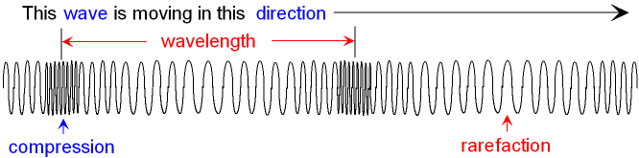
In longitudinal waves, the vibrations are parallel to the direction of wave travel.
In a longitudinal wave, the region where the particles are closest together is called a compression. The region where the particles are furthest apart is called a rarefaction. The distance between one compression/rarefaction and the next compression/rarefaction is called the wavelength.
Transverse | Longitudinal
Light | Sound
UV | Ultrasound
Water
EM Waves
In transverse waves, the vibrations are at right angles to the direction of wave travel.
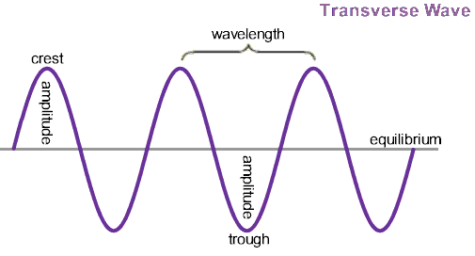
In a transverse wave, the area of zero displacement is called the equilibrium position. The top of a wave is called the peak or crest, and the bottom of a wave is called the trough. The distance between the equilibrium position and the peak/crest is called the amplitude. The distance between one crest/trough and the next crest/trough is called the wavelength.
Place the following waves in the correct column opposite:
Light Sound Ultra-violet Ultra-sound Ripples on water All EM waves

Basic:
- What do waves transfer? energy
- What are the two types of wave? Transverse and longitudinal
- Cross out the wrong one:
- Transverse waves vibrate at right angles to the direction of energy transfer
- Longitudinal waves vibrate parallel to the direction of energy transfer
- The wave below is transverse / longitudinal. Label the wave.
Top left – wavelength; top right – crest; bottom left – trough; bottom right - amplitude
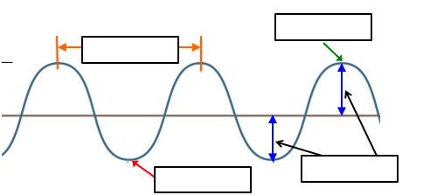

- The wave below is transverse / longitudinal. Label the wave.
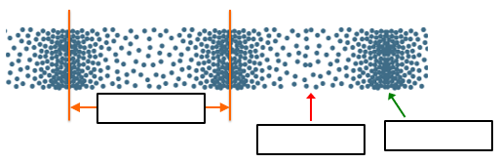

Wavelength rarefaction compression

Distance between two waves
Height of a wave
Top of a wave
Bottom of a wave
Where particles are closest together
Where particles are furthest apart
Medium: Draw a line from the word to the correct definition.
Wavelength
Amplitude
Crest
Trough
Compression
Rarefaction

For each wave described below, identify the wave as a transverse or longitudinal wave.
- The wave created by moving the end of a spring toy up and down. Transverse
- The wave created by moving the end of a spring toy back and forth parallel to the length of the spring. Longitudinal
- A sound wave. Longitudinal
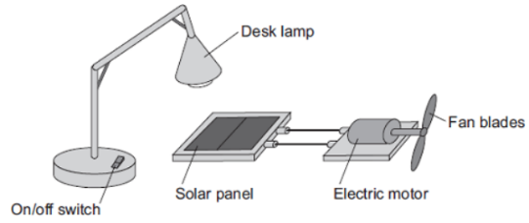
- An ocean wave. Transverse
- An electromagnetic wave. Transverse
Hard: Use complete sentences. Look at the number of marks available.
- Describe the differences between longitudinal waves and transverse waves (3).
1 – In transverse waves, the vibrations are at right angles to the direction of travel whereas in longitudinal waves the vibrations are parallel.
2 – Transverse waves have peaks and troughs whereas longitudinal waves have compressions and rarefactions
3 – Transverse waves have an equilibrium position, at the point of zero displacement
- Radio waves are electromagnetic waves. Describe how radio waves are different from sound waves. (4)
1 – Radio waves are transverse waves and sound waves are longitudinal
2 – Radio waves travel at a right angle to the direction of travel
3 – Radio waves have peaks and troughs, not compressions & rarefactions
4 – Radio waves have an equilibrium position
- Describe how switching the desk lamp on and off shows that light waves transfer energy. (2)
When the light is switched on, energy will be transferred to the solar panel, which will in turn transfer energy to the electric motor and the blades will spin.
(a) Figure 1 shows two waves.
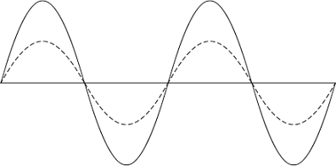
(i) Name one wave quantity that is the same for the two waves. (1)
____________wavelength_____________________
(ii) Name one wave quantity that is different for the two waves. (1)
______________amplitude____________________
(iii) The waves in Diagram 1 are transverse.
Which one of the following types of wave is not a transverse wave?
Draw a ring around the correct answer. (1)
gamma rays | sound | visible light

Figure 2 shows a longitudinal wave being produced in a stretched spring.
Figure 2
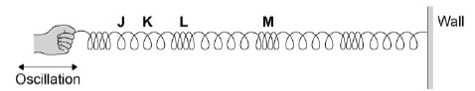
(b) Which of the letters on Figure 1 shows the centre of a rarefaction? (1)

J |  | K |  | L |  | M

(b) Which two letters in Figure 1 have a distance of one wavelength between them? (1)

J and K |  | K and L |  | L and M |  | J and M
(d) Describe how the end of the stretched spring should be moved in order to produce a transverse wave. (1)
the oscillation should be perpendicular to the direction of the stretched spring

The time period is similar to the wavelength, but is a measure of how long it takes a wave to travel a wavelength.
Time period and frequency
The frequency measures how many waves travel past a point every second. The equation that links time period and frequency is:
T = 1 ÷ f
where T is the time period (in seconds)
f is the frequency (in Hertz)
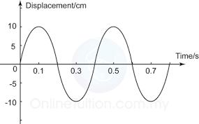
Stretch:
- How many waves are on the diagram? 2
- What is the time period of the wave? 0.4s (time of one wave)
- What is the frequency of the wave? 2.5Hz (1 / 0.4)

The larger the amplitude, the louder the sound
The smaller the wavelength, the higher the pitch of the sound
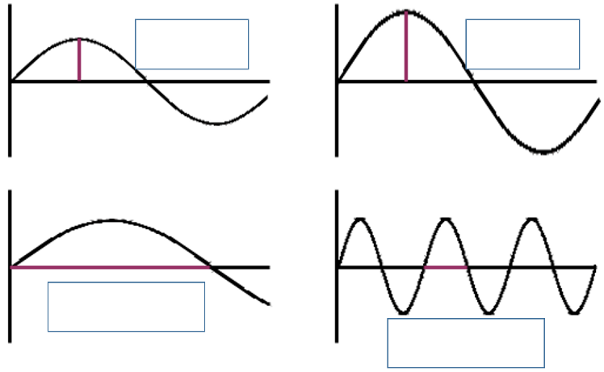
Example question 1) Which of these waves is louder? Why? The second because the amplitude is larger
Example question 2) Which of these waves has a higher pitch? Why? The second because the wavelength is smaller

Basic
Q1: Write the equation that links time period and frequency. T = 1 / f
Q2: What are the units of time period and frequency? Time (seconds), frequency (Hertz)
Q3: Calculate the time period when the frequency is:
- 10 Hz 0.1s b) 5 Hz 0.2s c) 0.2 Hz 5s d) 1200 Hz 0.000083s e) 0.006 Hz 166.6s
Q4: What is the definition of frequency? how many waves travel past a point every second
Medium
Q5: Rearrange the equation to give an equation for frequency. f = 1 / t
Q6:
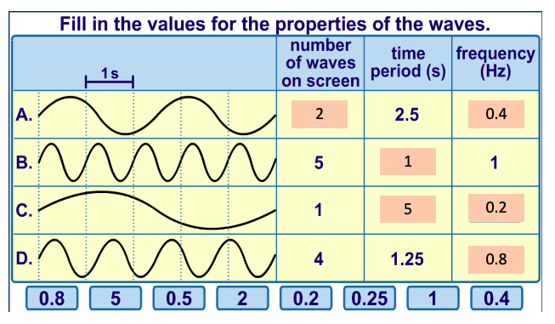
Hard
Q7: A note is played on an electric keyboard. The frequency of the note was 440 Hz. What does a frequency of 440 Hz mean? 440 waves travel past a point every second
Q8: Calculate the time period when the frequency is:
To go from kHz to Hz → × 1000
a) 2 kHz. 0.0005s b) 0.5 kHz 0.002s c) 150 kHz 0.0000066s d) 0.2 kHz 0.005s
e) 0.01 kHz 0.1s
Q9: Calculate the frequency when the time period is:
- 0.5 seconds 2Hz
- 0.01 seconds 100Hz
- b) 5 milliseconds 200Hz
- c) 2 milliseconds 500Hz
- 1 minute 0.0166Hz
- 30 minutes 0.00055Hz
- 1 hour 0.00027Hz g) 1 year. 3.168x10⁻⁸ Hz
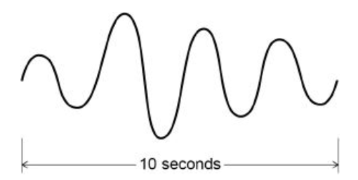
Q10: What is the time period of the wave opposite? 2.5 s
Q11 Using the answer to Q10, what is the frequency of the wave opposite? 0.4 Hz
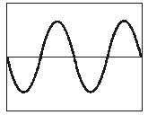
Q1. The teacher places a microphone near the pupil as she plays her flute. The diagram below shows the pattern on an oscilloscope screen.

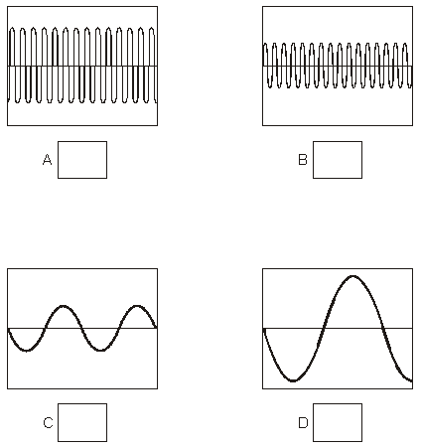
The pupil then plays her flute at a higher pitch and more quietly.
Which diagram below shows the pattern that would be seen on the oscilloscope?
Tick the correct box. B

1 mark

Q2. The diagrams below show the patterns produced on an oscilloscope by three
different sound waves.
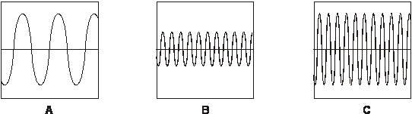
(i) Which two waves have the same loudness?
Write the letters.
A and C

How do the diagrams show this?
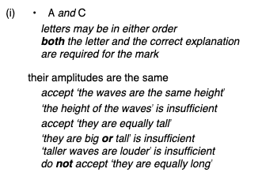

(ii) Which two waves have the same pitch?
Write the letters.
B and C
How do the diagrams show this?
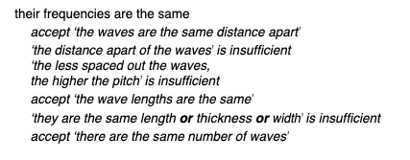[5]

The wave equation
The wavelength equation says that the velocity of a wave is equal to the frequency multiplied by the wavelength:

$$v=f×λ$$
where v is the velocity (m/s)
f is the frequency (Hz)
λ is the wavelength (m)
Example question: A wave has a frequency of 12 kHz and a wavelength of 20 cm. Calculate the wave speed.
Step 1: Write the equation.
$$v=f×λ$$
Step 2: Write down the variables
f = 12 kHz = 12,000 Hz
v = 20 cm = 0.2 m
Step 3: Calculate the answer
v = 12,000 × 0.2 = 2400 m/s

The speed of light is always constant at 300,000,000 m/s (3 x 10⁸ m/s).
Nothing can travel faster than this.
All electro-magnetic waves travel at the speed of light.

Stretch: Sound travels a distance of 686 m in a time of 2 seconds. Calculate the speed of sound.
How does it compare to the speed of light?

F = 1 / t
= 0.5Hz
$$v=f×λ$$
= 0.5 x 686
= 343m/s
How does it compare to the speed of light? Much slower than the speed of light.

Tasks:
Basic:
Q1. Write down the wave equation. $v=f×λ$
Q2. Write down the units and symbols for velocity, frequency and wavelength. m/s, Hz, m
Q3. What is the wave speed if:
- f = 5 Hz, λ = 1 m 5m/s b) f = 6 Hz, λ = 0.25 m 1.5m/s c) f = 10 Hz, λ = 0.2 m 2m/s
d) f = 0.01 Hz, λ = 25 m 0.25m/s e) f = 2000 Hz, λ = 4 m 8000m/s f) f = 0.05 Hz, λ = 80 m 4m/s
Medium (need to rearrange equations)
Q4. Re-arrange the equation to give two equations for f and λ.
$f= \frac{v}{λ}$
$$λ= \frac{v}{f}$$
Q5. What is the wave frequency if:
- v = 5 m/s, λ = 1 m 5Hz
- v = 330 m/s, λ = 0.01 m 33,000Hz
- v = 1,500 m/s, λ = 0.5 m 3000Hz
- v = 0.1 m/s, λ = 80 m 0.00125Hz
- v = 17 m/s, λ = 0.1 m 170Hz
- v = 300,000,000 m/s, λ = 0.002 m 150,000,000,000Hz
Q6. What is the wavelength if:
- f = 25 Hz, v = 2 m/s 0.08m
- f = 15 Hz, v = 0.1 m/s 0.0066m
- f = 1,800 Hz, v = 0.2 m/s 0.00011m
- f = 22 Hz, v = 2 m/s 0.0909m
- f = 1,300 Hz, v = 20 m/s 0.0154m
- f = 6,500,000 Hz, v = 343 m/s 0.0000527m
Hard (word questions with unit conversions)
Q7. A sound wave has a frequency of 3.43 kHz and a wavelength of 0.1m. Calculate the speed of sound.
To go from kHz to Hz → × 1000
$$v=f×λ$$
= 3430 x 0.1
= 343m/s

Q8. Dr. Edmunds (strangely) decides to sing to the class and sings with a frequency of 6.86 kHz and a wavelength of 0.05 m. Calculate the speed.
6860 x 0.05 = 343m/s
Q9. A wave has a speed of 550 m/s and a frequency of 11 kHz. Calculate the wavelength.
$$λ= \frac{v}{f}$$
= 550 / 11,000
= 0.05m
Q10 A wave has a speed of 250 m/s and a frequency of 15 kHz. Calculate the wavelength.
$$λ= \frac{v}{f}$$
= 250 / 15,000
= 0.0166m
Q11 The speed of any EM wave is 300,000,000 m/s. Calculate the frequency of a radio wave with wavelength of 10 cm.
To go from cm to m → ÷ 100
$f= \frac{v}{λ}$
= 300,000,000 / 0.1
= 3,000,000,000Hz
Q12 Microwaves are a transverse wave of wavelength 0.05 cm. Calculate the frequency of a microwave.
$f= \frac{v}{λ}$
= 300,000,000 / 0.0005
= 600,000,000,000Hz

Q1.
A note was played on an electric keyboard.
The frequency of the note was 440 Hz.
(a) (i) What does a frequency of 440 Hz mean?
440 (sound) waves produced in one second (1)
(ii) The sound waves produced by the keyboard travel at a speed of 340 m / s.
Calculate the wavelength of the note.
Give your answer to three significant figures.

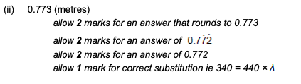 (3)
(b) Figure 1 shows a microphone connected to a cathode ray oscilloscope (CRO) being used to detect the note produced by the keyboard.
Figure 1
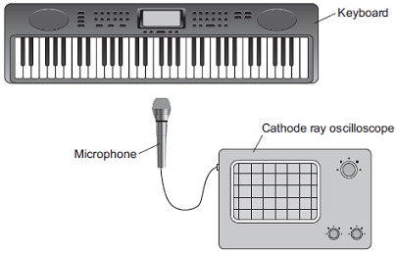
Figure 2 shows the trace produced by the sound wave on the CRO.
Figure 2
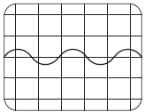
A second note, of different wavelength, was played on the keyboard.
Figure 3 shows the trace produced by the sound wave of the second note on the CRO.
Figure 3
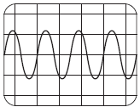
The settings on the CRO were unchanged.
What two conclusions should be made about the second sound wave produced by the keyboard compared with the first sound wave?
Give a reason for each conclusion.
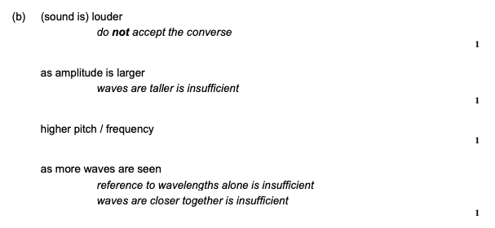(4)
(Total 8 marks)

Ripple tank practical
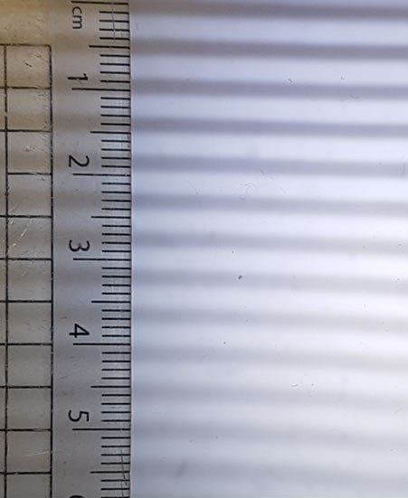
To measure the wavelength of a wave in a ripple tank, use a ruler and take a picture with a camera.
Example question:
- Use just one wave from the photo to get the wavelength of a wave.
- Now use ten and take an average. Which is more accurate?
To measure the frequency count the number of waves that pass a point in 10 seconds and divide by 10. We can record it and play back in slow motion.
Example question: If 15 waves pass a point in 10 seconds, then the frequency is 15 ÷ 10 = 1.5 Hz
Mini-task. Calculate the frequency if:
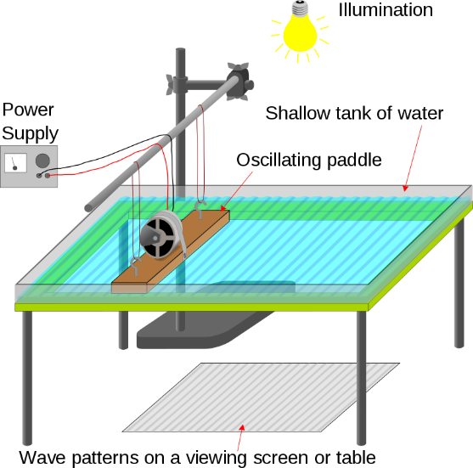
- 120 waves pass every 10 seconds 12Hz
- 5 waves pass every 10 seconds 0.5Hz
- 1500 waves pass every 10 seconds. 150Hz
When we’ve measured the frequency and the wavelength we can use the wave speed equation to calculate the speed of the wave.

Mini-task.
- What is the wave speed equation? Velocity = frequency x wavelength
- The measured frequency was 10 kHz and the measured wavelength was 15 mm. Calculate the speed of the wave. 10,000 x 0.015 = 150m/s
Task: Complete in your exercise book
Basic
Q1. How do we measure the wavelength of a wave in a ripple tank? Use a ruler and take a picture with a camera.
Q2. How do we measure the frequency of a wave in a ripple tank? Count the number of waves that pass a point in 10 seconds and divide by 10. We can record it and play back in slow motion.
Q3. Once we’ve measured the frequency and the wavelength of a wave in a ripple tank, how do we find out the wave speed? Use the wave equation
Medium
Q4. Why is it a benefit to measure the length of ten wavelengths and then take an average? It’s more accurate
Q5. Calculate the frequency if: a) 50 waves pass a point in 10 seconds. 5Hz
b) 20 waves pass a point in 2 seconds. 10Hz
c) 100 waves pass a point in 20 seconds. 5Hz
Q6. The measured frequency of a wave is 5 Hz. Calculate the wave speed for each of the wavelengths:
- 0.1 m 0.5m/s
- 20 cm 1m/s
- 2 mm 0.01m/s
Q7. The measured wavelength is 0.02m. Calculate the wave speed for each of the frequencies:
- 10 Hz 0.2m/s
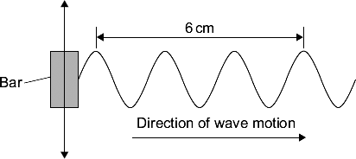
- 0.2 kHz 4m/s
- 5 kHz 100m/s
Hard
A ripple tank is used to investigate the behaviour of water waves. A bar moves up and down to make the waves.
Q8. What is the wavelength of each wave in the diagram? 2cm
Q9. The ripple tank produces 10 waves in 2 seconds. What is the frequency of the waves? 5Hz
Q10. The bar is made to move faster. It now produces waves with a frequency of 20 Hz and a wavelength of 0.5 cm. Calculate the speed of the waves in units of cm/s.
Velocity = frequency / wavelength
= 20 / 0.5
= 40cm/s

Q11. A student uses the ripple tank to investigate the relationship between depth of water and speed of waves. The graph shows the student’s results.
There is one anomalous result. On the graph, draw a ring around the anomalous result.
Q12. On the graph, draw a line of best fit.
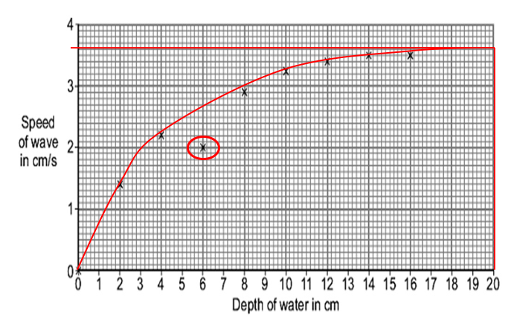
Q13. Use your line of best fit to find the speed of a wave at a depth of 20cm. approx. 2.6cm/s

Q1.
Small water waves are created in a ripple tank by a wooden bar. The wooden bar vibrates up and down hitting the surface of the water.
The figure below shows a cross-section of the ripple tank and water.
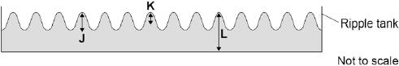
- Which letter shows the amplitude of a water wave? (1)
K

(b) The speed of the wooden bar is changed so that the bar hits the water fewer times each second.
What happens to the frequency of the waves produced? (1)
The frequency decreases

(c) Describe how the wavelength of the water waves in a ripple tank can be measured accurately. (2)
use a metre rule / 30 cm ruler to measure across 10 (projected) waves
(accept any practical number of waves number for 10)
and then divide by 10
(d) The water waves in a ripple tank have a wavelength of 1.2 cm and a frequency of 18.5 Hz.
How does the speed of these water waves compare to the typical speed of a person walking?

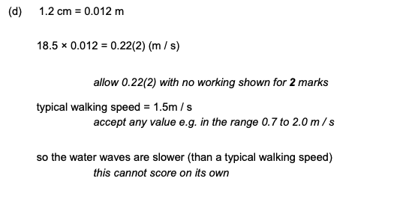(4)

All EM waves reflect if they hit a reflective surface. Light is the most common example of this and it’s how we can see ourselves in a mirror.
Reflection
Law of Reflection:
Angle of incidence (°) = angle of reflection (°)
i (°) = r (°)
The law of reflection is true for any type of wave being reflected from a surface.
Put your mirror carefully on the line labelled ‘mirror’. Draw a line from each dot to the point where the normal line meets the mirror. Shine your light ray along this line and then draw another line to show where the reflected ray is.

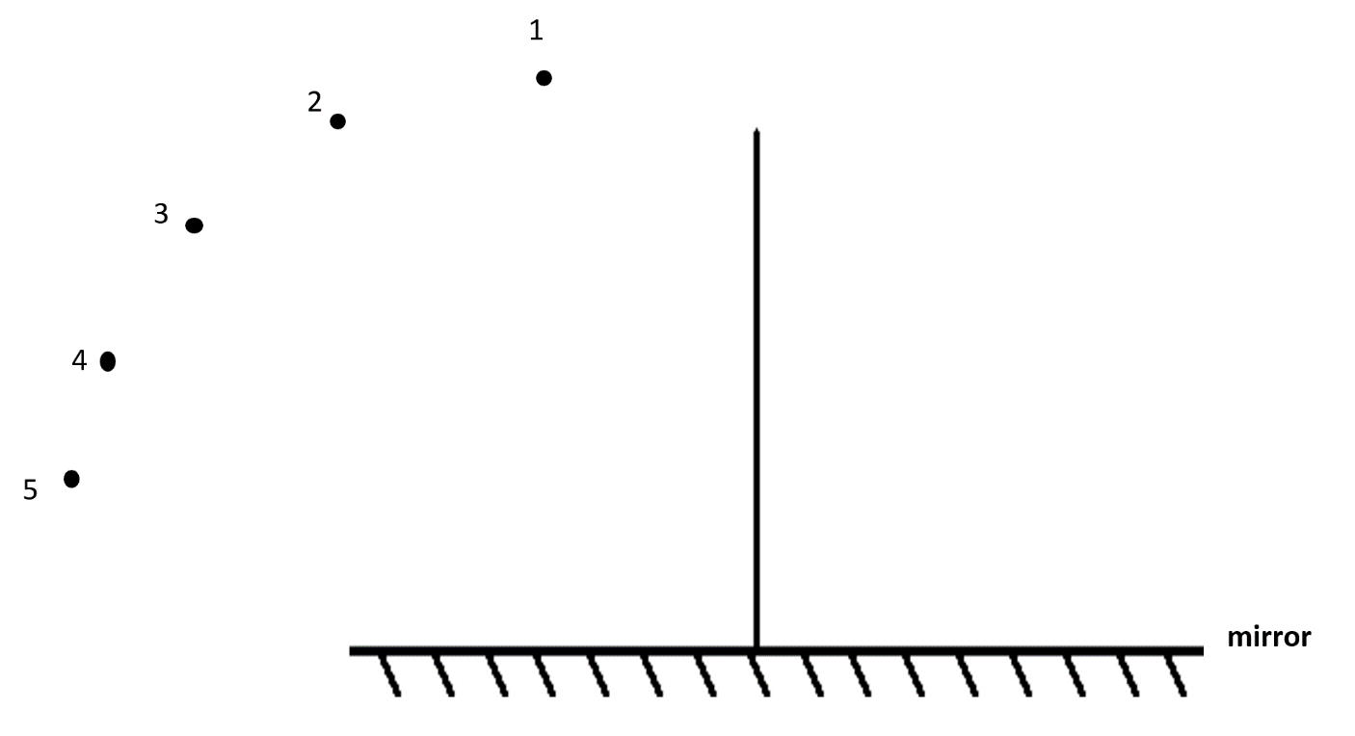

Measure the angles using a protractor and fill in the table below:
 | Angle of incidence (°) | Angle of reflection (°)
1
2
3
4
5

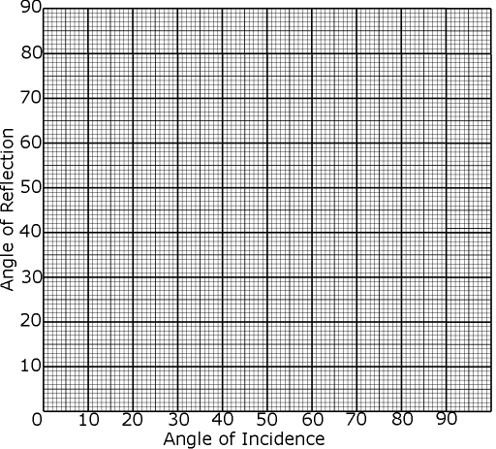
Plot your results on the graph below.
Q1.
The diagram below shows the apparatus a student used to investigate the reflection of light by a plane mirror.
The student drew four ray diagrams for each angle of incidence.
The student measured the angle of reflection from each diagram.
The table below gives the student’s results.
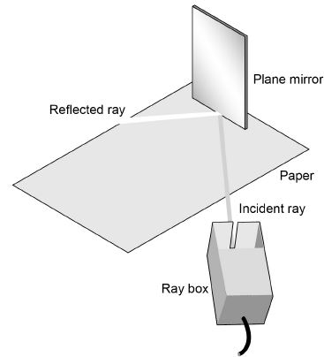

 | Angle of reflection
Angle of incidence | Test 1 | Test 2 | Test 3 | Test 4
20° | 19° | 22° | 20° | 19°
30° | 31° | 28° | 32° | 30°
40° | 42° | 40° | 43° | 41°
50° | 56° | 49° | 53° | 46°
(a) For each angle of incidence, the angle of reflection has a range of values.
This is caused by an error.
What type of error will have caused each angle of reflection to have a range of values?
Random error
(1)

(b) Suggest what the student may have done during the investigation to cause each angle of reflection to have a range of values.
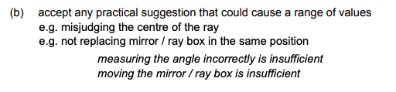 (1)
(c) Estimate the uncertainty in the angle of reflection when the angle of incidence is 50°.
Show how you determine your estimate.
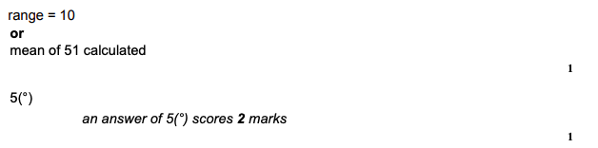Uncertainty = ± _____________________ °
(2)
(d) The student concluded that for a plane mirror, the angle of incidence is equal to the angle of reflection.
Explain whether you agree with this conclusion.
Use examples from the results in the table below in your answer.
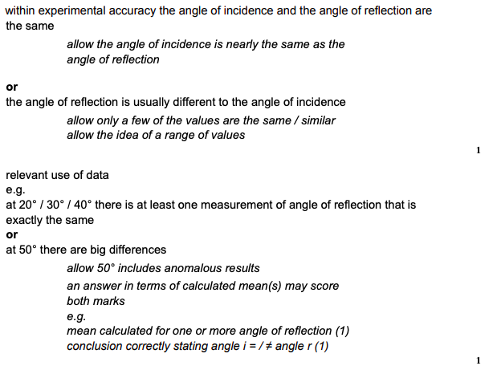

(2)
(e) What extra evidence could be collected to support the student’s conclusion?
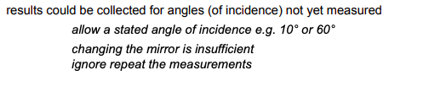 (1)
(f) State one change the student should make to the apparatus if he wants to use the same method to investigate diffuse reflection.
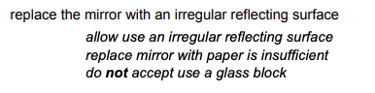 (1)
(Total 8 marks)

When an EM wave (like light) travels into a material that is more dense (for example from air into a glass block), it refracts towards the normal (an imaginary line at right angles to the surface). This is because light travels slower in objects that are more optically dense.
Refraction
Label the diagram below:
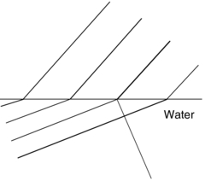
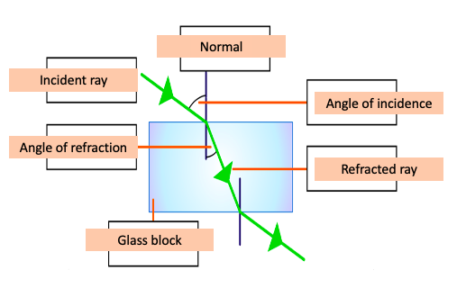
Refraction can also be shown with wavefronts.
In a more dense material (like glass) the wave travels more slowly. The wavelength therefore decreases.
Waves can be absorbed, transmitted, reflected or refracted when travelling from one object to another.
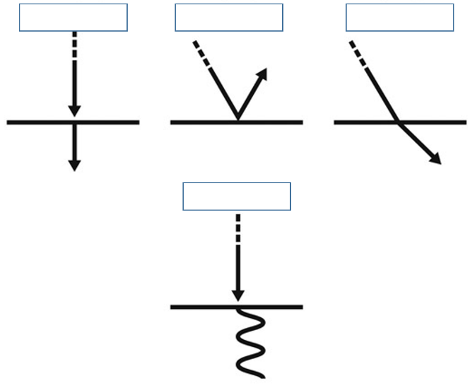
Which of the diagrams show absorption, transmission, reflection and refraction?
Transmission, reflection, refraction and absorption (left to right)

Aim: To investigate how angle of incidence affects angle of refraction
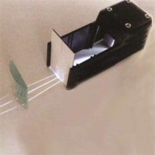
Prediction:
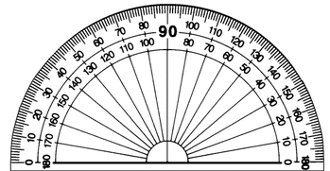
I predict that as the angle of incidence increases, the angle of refraction will increase/decrease.
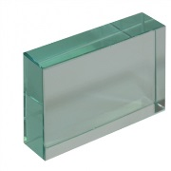
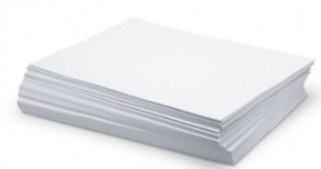
Equipment:




Method
- Put a piece of plain ________ on the desk. (use the blank page opposite)
- Set up a power pack and ____ _______ so that a single ray of light is shining across the plain ________.
- Place a rectangular _________ _________ on the paper.
- Draw around the ______ ___________.
- Draw a normal line at _______ ________ to the block.
- Shine the ray of light into the _________ line.
- Using a ________, put small crosses to show where the rays of light go.
- Take the __________ __________ off the paper. Use a ________ to join the crosses and show the path of the light.
- Use a ___________ to measure the angles of incidence and the angles of refraction from the normal.
Results
Light entering the block |  | Light leaving the block
Angle of incidence | Angle of refraction | Angle of incidence | Angle of refraction
Q1.
The data given in the table below was obtained from an investigation into the refraction of light at an air to glass boundary.

Angle of incidence | Angle of refraction
20° | 13°
30° | 19°
40° | 25°
50° | 30°
(a) Describe an investigation a student could complete in order to obtain similar data to that given in the table above.
Your answer should consider any cause of inaccuracy in the data.
A labelled diagram may be drawn as part of your answer.
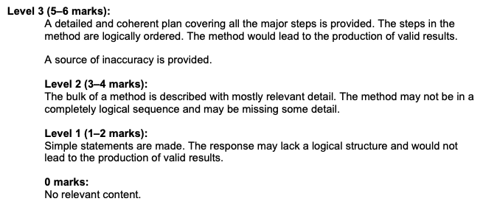
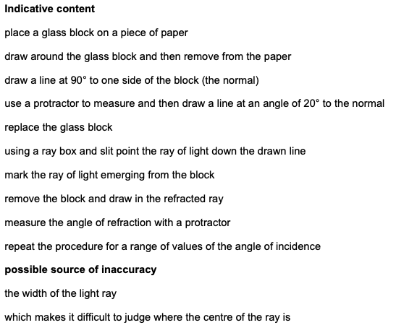 (6)
(b) State the reason why light is refracted as it crosses from air into glass.
velocity / speed of the light decreases
allow velocity / speed of the light changes
(1)
(Total 7 marks)

The electro-magnetic (EM) spectrum is a family of 7 waves.
Electromagnetic Waves
They are all transverse and travel at the speed of light.
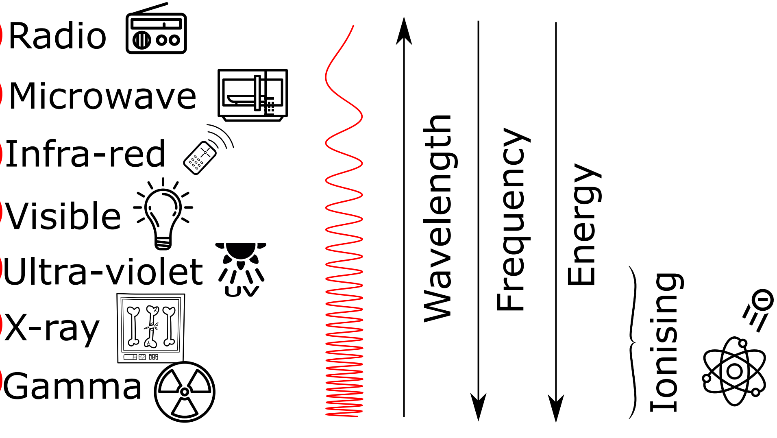
Mini task:
- Which wave has the longest wavelength? Radio
- Which wave has the highest frequency? Gamma
- Which wave has the highest energy? Gamma
- Which wave has the biggest hazard? Gamma, Xray and UV
The three EM waves with the most energy are ionising:
- UV
- X-rays
- Gamma rays
The order of visible light: ROY G. BIV

Task: Complete in exercise book
Basic
- How many EM waves are there? Seven
- All EM waves are transverse/longitudinal? Transverse
- What speed do EM waves travel at? 300,000,000m/s
- List the EM waves in order (from longest wavelength to shortest wavelength). What is the mnemonic we use to memorise this? RMIVUXG – Radio, Microwaves, Infrared, Visible light, Ultraviolet, X-ray, Gamma
- Write the order of the colours in visible light (from longest wavelength to shortest wavelength). ROYGBIV – Red, Orange, Yellow, Green, Blue, Indigo, Violet
- Which EM wave:
- Has the longest wavelength? Radio waves
- Has the highest frequency? Gamma
- Has the least energy? Radio waves
- What three EM waves that are ionising? Describe what ionisation is. UV, Xray and gamma rays. Ionisation can cause atoms to become charged
Medium
- What wave(s) have more energy than ultraviolet? Gamma and Xray
- What wave(s) have a longer wavelength than infrared? Microwaves and radiowaves
- Describe why ionising radiation can be harmful. Ionisation radiation can damage body cells and tissues, causing tissue damage or cancer
- Microwaves and visible light are two types of EM wave. Both can be used for communications. Give two properties that are common to both visible light and microwaves. Non-ionising, longer wavelength
Hard
- We use ultrasound to scan unborn babies, and not X-rays. Explain why we do not use X-rays to scan unborn babies. To prevent unborn babies being exposed to dangerous ionising radiation
- Describe the differences between visible light waves and sound waves. Visible light waves are transverse waves – travel at right angles to the direction of travel, have an equilibrium point. Sound waves are longitudinal and travel parallel to direction of travel. Sound waves cannot travel through a vacuum.
- Mobile phones send signals using microwaves. Explain why most people believe that these microwaves are not harmful to health. Microwaves have a long wavelength, low frequency, low energy and are non-ionising.
- A mobile phone network uses microwaves to transmit signals through the air. The microwaves have a frequency of 1.8 × 10⁹ Hz and travel at a speed of 3.0 × 10⁸ m/s. Calculate the wavelength of the microwaves. 0.016m
- Dr. Edmunds used to work with a “frequency-doubled Nd:YAG” laser. This emitted scary green light at a wavelength of 532nm. Calculate the frequency of this light. 5.64x10¹⁴
nm → m × 10⁻⁹

Dr. Edmunds also used to work with an even scarier CO₂ laser which he definitely didn’t accidentally set fire to a computer monitor with once. Nope. That definitely didn’t happen. It had a wavelength of 10.6 μm. Calculate the frequency of this laser.
2.83x10¹³
μm → m × 10⁻⁶

- A thunderstorm is happening near HAB. The thunder is heard a time of 15 seconds after the lightning. How far away is the thunderstorm?

Sound travels at 340m/s
340 x 15 = 2600m
Q1. The diagram shows some of the kinds of waves in the electromagnetic spectrum.
Choose words from this list to complete the empty boxes on the diagram. (3)
alpha radiation infrared radiation radio waves X-rays
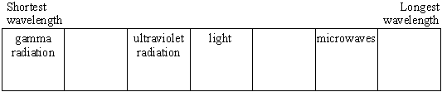
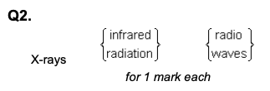
Q2. Infrared and microwaves are two types of electromagnetic radiation.
The diagram below shows the positions of the two types of radiation within part of the electromagnetic spectrum.
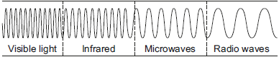
(a) Name one type of electromagnetic radiation which has more energy than infrared. 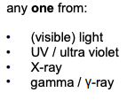
(b) Use the correct answer from the box to complete each sentence.
Each answer may be used once, more than once or not at all. (3)

greater than | less than | the same as
The wavelength of infrared is less than the wavelength of microwaves.
The frequency of microwaves is less than the frequency of infrared.
The speed of microwaves in a vacuum is the same as the speed of infrared in a vacuum.
Q3. (a) Which one of the following is not an electromagnetic wave? (1)
Tick one box.

Gamma rays
Sound | X
Ultraviolet
X-rays
(b) What type of electromagnetic wave do our eyes detect? (1)
Visible light
Scientists have detected radio waves emitted from a distant galaxy.
Some of the radio waves from the distant galaxy have a frequency of 1 200 000 000 hertz.
(c) Which is the same as 1 200 000 000 hertz? (1)
Tick one box.

1.2 gigahertz | X
1.2 kilohertz
1.2 megahertz
1.2 millihertz
(d) Radio waves travel through space at 300 000 kilometres per second (km/s).
How is 300 000 km/s converted to metres per second (m/s)? Tick one box. (1)

300 000 ÷ 1000 = 300 m/s
300 000 × 1000 = 300 000 000 m/s
300 000 + 1000 = 301 000 m/s
300 000 – 1000 = 299 000 m/s
(e) Write the equation which links frequency, wavelength and wave speed. (1)
wave speed = frequency × wavelength

(f) Calculate the wavelength of the radio waves emitted from the distant galaxy.
Give your answer in metres. (3)
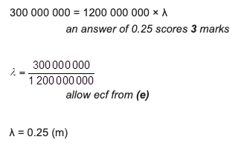

Radio waves are used for radio/TV transmissions. They are used for this purpose because they are long wavelength and can diffract (bend) around large objects. They are reflected from a part of the atmosphere called the ionosphere and so travel long distances.
Uses of Electromagnetic Waves
Microwaves are used in microwave ovens (duh!), mobile phones and satellite communication (as they can travel through the ionosphere). A danger of microwaves is that they can cause internal tissue heating.
Infrared is used in remote controls, heating and in night vision (because warmer objects give out more infrared). A danger of infred is skin burns.
Light is used for seeing, in devices that look inside our body (called endoscopes) and for fibre-optic communication. The danger of light is blindness. This is why you should never look directly into the Sun.
Ultraviolet is used in sun beds and in security marking on bank notes. Too much ultraviolet can cause sun burn (sun cream works by absorbing U-V). As ultraviolet is ionising it can damade/mutate cells and cause cancer.
X-rays are used to image luggage and to X-ray broken bones. X-rays are also ionising and so X-rays should not be taken of pregnant women. Instead ultra-sound scans are used as ultra-sound is not ionising.
X-rays are absorbed by dense structure like bone (but go through less dense objects). X-rays show up on film or charge-couple device (CCD).
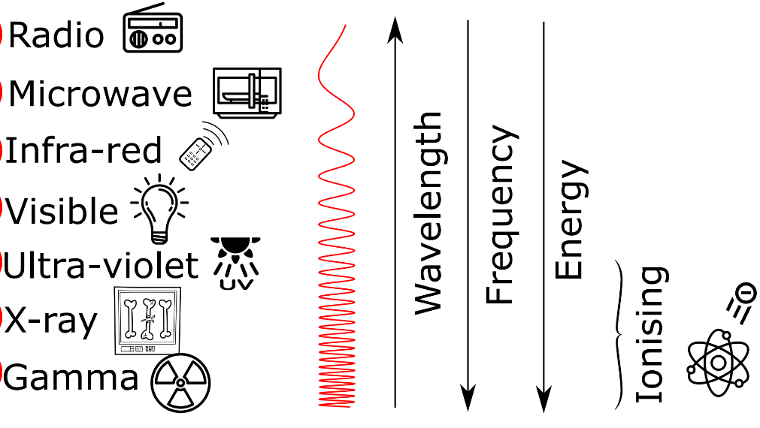
Gamma radiation is used to sterlise food and medical equipment. It can also be used in radiotherapy to kill cancerous cells. Gamma is the most ionising out of all the EM waves.

Basic: Match up the following parts of the EM spectrum with their uses
Gamma rays Sterilise equipment
Radio waves Carry TV signals
Ultra Violet Causes sun burn ‘
Visible Allow us to see
Microwaves Mobile phones
X rays See’ broken bones
Infra Red Remote Controls
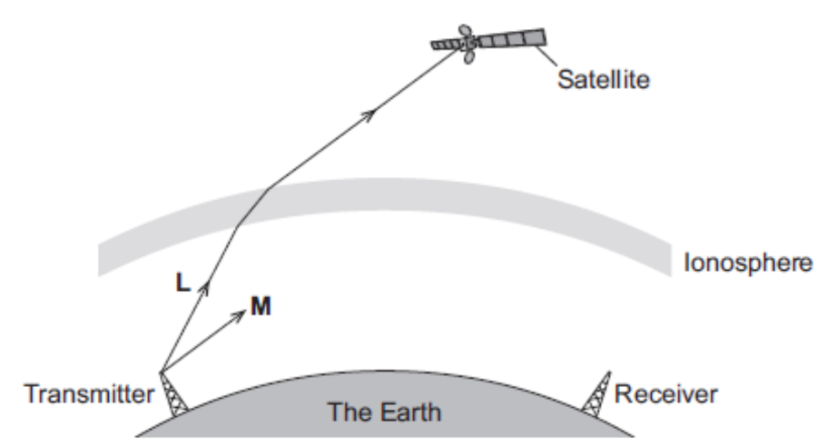
Medium
- What is the danger of:
- Visible light Can cause blindness
- Infra-red Can cause skin burns
- Microwaves Can cause internal tissue heating
- Which three EM waves are ionising? What does ionising mean and what is it dangerous?
Gamma, UV and Xray. Can cause atoms to become charged which can damage body cells and tissues or cause cancer.
- What does sterilisation mean? What property of gamma waves makes it suitable for sterilising food/medical equipment?
Sterilisation is the process of making something free of bacteria or microorganisms. Gamma rays are ionising so kill bacteria.
- What does sun-screen do to UV light? Sunscreen blocks and absorbs UV light
- Different parts of the EM spectrum are useful for different methods of communication. The diagram shows a transmitter emitting two electromagnetic waves L and M.
- i) Wave L is used to send a signal to a satellite. Which part of the electromagnetic spectrum does wave L belong to? Microwave
ii) What name is given to the process that occurs as wave L passes into the ionosphere? Refraction
- I) Wave M is reflected by the ionosphere. On the diagram above, draw the path of wave M until it reaches the receiver. Reflects off at the same angle
ii) On the diagram above, draw a line to show the normal where wave M meets the ionosphere. Label the line N.
- Give two properties of all electromagnetic waves. EM waves are all transverse waves, so vibrations are at right angles to the direction of travel. Can travel through vacuums. Transfer energy as radiation.
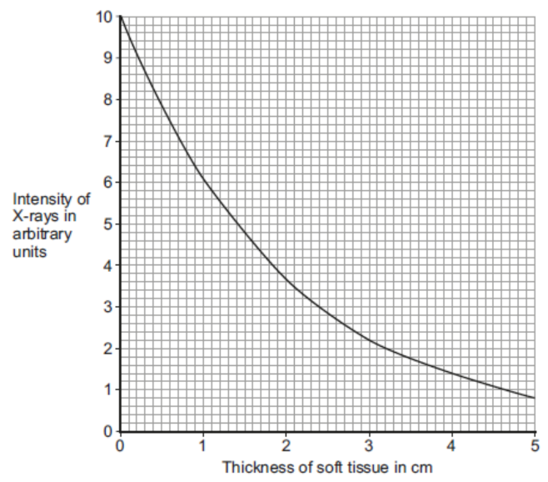
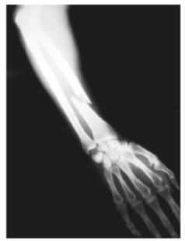
Hard
- The photo shows an X-ray of an arm with a broken bone.
- Complete the following sentence. X-rays are part of the electromagnetic spectrum.
- The graph shows how the intensity of the X-rays changes as they pass through soft tissue and reach a detector.
- Use the graph to determine the intensity of X-rays reaching the detector for a 3cm thickness of soft tissue. 2.2
- Describe how the thickness of soft tissue affects the intensity of the X-rays. As the thickness of soft tissue increases, the intensity of X-rays decreases
- The data in the graph is shown as a line graph and not as a bar chart. Explain why.
The data collected is continuous
- What happens to X-rays when they enter a bone? Bones absorb the radiation
- How are images formed electronically in a modern X-ray machine? Bones absorb the radiaton but other tissues let the radiation pass through. Black areas show where x-rays passed through to the film, white areas show where denser tissue like bones have absorbed the radiation.
- Radiographers who take X-ray photographs may be exposed to X-rays. X-rays can increase the risk of the radiographer getting cancer. Why can X-rays increase the risk of getting cancer? Xrays are ionising radiation
- What should the radiographer do to reduce the risk from X-rays? Aim the xray at the target area and stand behind a protective screen
Q1.
The figure below shows an incomplete electromagnetic spectrum.

A | microwaves | B | C | ultraviolet | D | gamma
(a) What name is given to the group of waves at the position labelled A in the figure above?

Tick one box.
infrared | 
radio | X
visible light
X-ray
(1)

(b) Electromagnetic waves have many practical uses.
Draw one line from each type of electromagnetic wave to its use.

Electromagnetic wave |  | Use
 |  | For fibre optic communications
Gamma rays
 |  | For communicating with a satellite
Microwaves
 |  | To see security markings
Ultraviolet
 |  | To sterilise surgical instruments
(3)

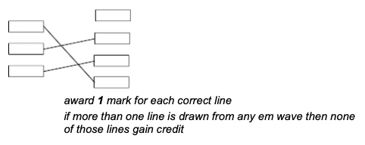
(c) Complete the sentence.
Use an answer from the box.

black body | ionising | nuclear
X-rays can be dangerous to people because X-rays are
__ionising_______ radiation.
(1)
(Total 5 marks)
Q2.
Diagram 1 shows four of the seven types of wave in the electromagnetic spectrum.
 |  |  | Diagram 1
J | K | L | Visible  light | Infrared | Microwaves | Radio  waves
(a) The four types of electromagnetic wave named in Diagram 1 above are used for communication.
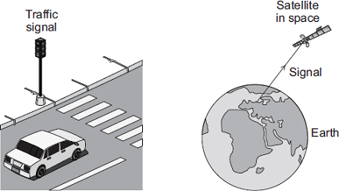

(i) Which type of electromagnetic wave is used when a traffic signal communicates with a car driver?
visible light
(1)
(ii) Which type of electromagnetic wave is used to communicate with a satellite in space?
microwaves
(1)
(b) Gamma rays are part of the electromagnetic spectrum.
Which letter, J, K or L, shows the position of gamma rays in the electromagnetic spectrum?
Draw a ring around the correct answer.

J | K | L
(1)
(c) Diagram 2 shows an infrared wave.
Diagram 2
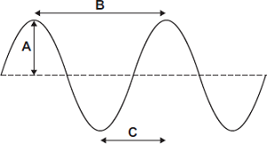
(i) Which one of the arrows, labelled A, B or C, shows the wavelength of the wave?

Write the correct answer, A, B or C, in the box. | B
(1)
(ii) Draw a ring around the correct answer to complete the sentence.

 | shorter than
The wavelength of infrared waves is | the same as | the wavelength
 | longer than
of radio waves.
(1)

(d) Mobile phone networks send signals using microwaves. Some people think the energy a person’s head absorbs when using a mobile phone may be harmful to health.
(i) Scientists have compared the health of people who use mobile phones with the health of people who do not use mobile phones.
Which one of the following statements gives a reason why scientists have done this?
Tick () one box.

To find out if using a mobile phone is harmful to health. | X
To find out if mobile phones give out radiation. | 
To find out why some people are healthy.
(1)
(ii) The table gives the specific absorption rate (SAR) value for two different mobile phones.
The SAR value is a measure of the maximum energy a person’s head absorbs when a mobile phone is used.

Mobile Phone | SAR value in W/kg
X | 0.28
Y | 1.35
A parent buys mobile phone X for her daughter.
Using the information in the table, suggest why buying mobile phone X was the best choice.
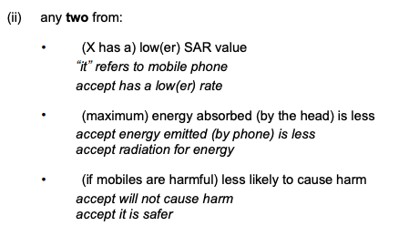(2)

Heat can move by travelling as infrared waves.
Infra-Red radiation
Infrared waves heat objects that absorb them and so can be called thermal radiation.
Matt black surfaces are the best absorbers and emitters of radiation.
Shiny surfaces are the worst absorbers because they reflect most of the radiation away and the worst emitters.
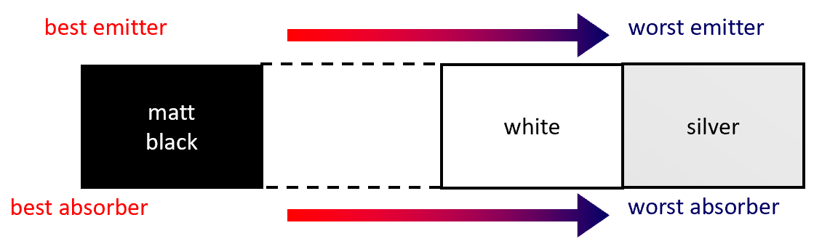
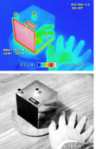
An object called a Leslie cube can help show this. A Leslie cube is a metal can with one silvered side and one matt black side. There is a hole in the hole so that it can be filled with hot water.
The matt black side is a better emitter of IR radiation and so a thermal camera or IR thermometer shows a greater temperature.
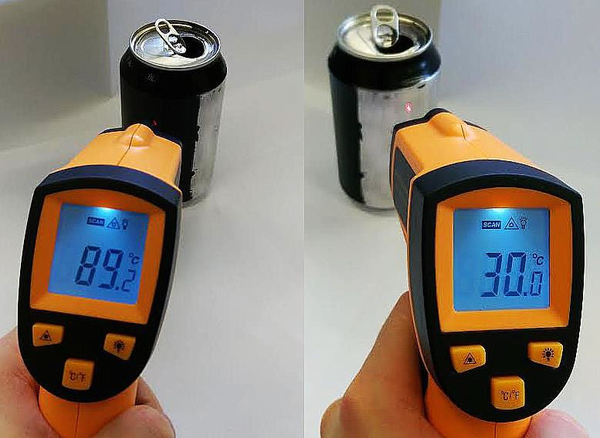
This can also be shown by using an aluminium can, with one side painted matt black.

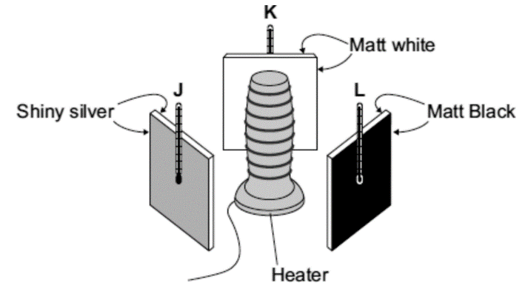
Basic
- How do infrared waves heat objects? Infrared waves transfer energy to objects which causes them to heat up
- What is another name for infrared waves? Thermal radiation
- Which type of surface is the best absorber of infra-red radiation? Matt black
- Which type of surface is the worst absorber of infra-red radiation? Shiny silver
- Which type of surface is the best emitter of infra-red radiation? Shiny silver
- Which type of surface is the worst emitter of infra-red radiation? Matt black
- Using the diagram opposite, which of the metal plates (J, K or L) will have the hottest temperature after being heated for 5 minutes. Explain why. L because it absorbs radiation better and may also absorb radiation reflected by the other two plates.
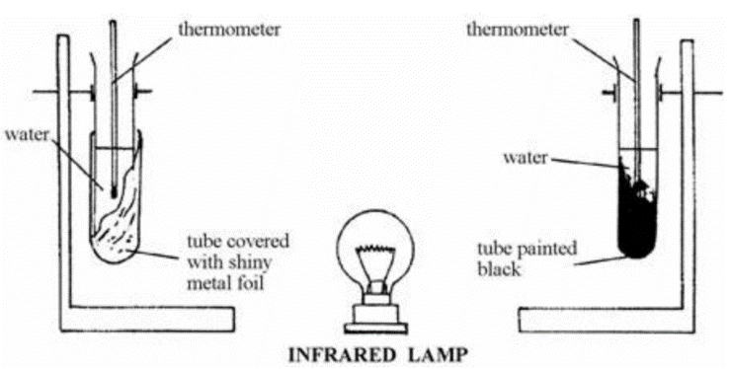
Medium

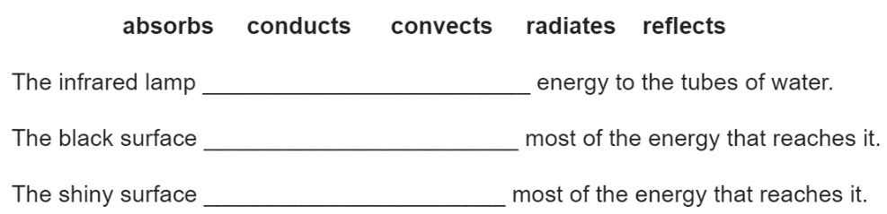
- The diagram to the left shows an experiment to find out what happens to infrared waves when they strike different surfaces. The water in the black tube gets hotter than the water in the shiny tube. Choose words from the list to complete the sentences below.

Radiates, absorbs, reflects

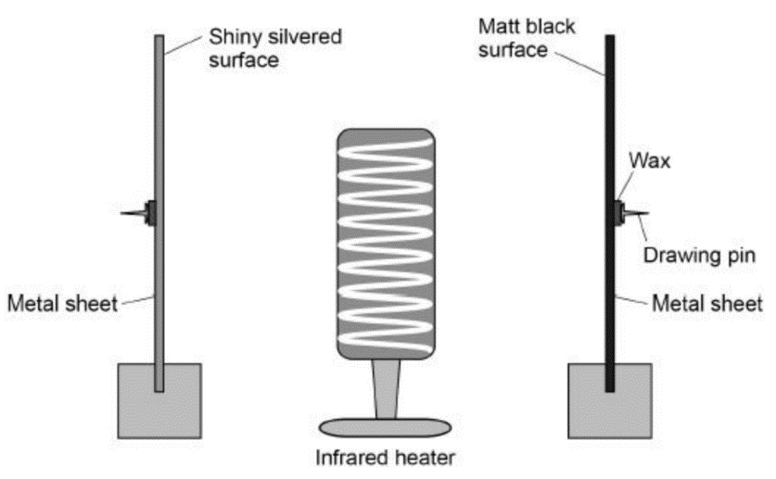

- The metal sheets in the diagram to the left absorb infrared radiation. The wax melts and the drawing pins fall off the surfaces.
- Draw one line from each variable to the correct description of that variable.
Control – distance from metal sheets
Dependent – time taken for pins to fall off
Independent – surface colour of sheets
- The drawing pin attached to the matt black metal sheet fell off first. What can be concluded from this result? Matt black metal sheet conducts heat more quickly
Hard
- a) A company is developing a system which can heat up and melt ice on roads in the winter. During the summer, the black surface of the road will heat up in the sunshine. This energy will be stored in a large amount of soil deep under the road surface. Pipes will run through the soil. In winter, cold water entering the pipes will be warmed and brought to the surface to melt ice. The system could work well because the road surface is black. Suggest why.
- What is meant by specific latent heat of fusion? The specific latent heat of a substance is the amount of energy needed to change the state of 1 kg of the substance without changing its temperature.
- Calculate the amount of energy required to melt 15 kg of ice at 0°C. Specific latent heat of fusion of ice = 3.4 × 10⁵ J/kg. E = mL = 15 × 3.4 × 10⁵ = 5.1 × 10⁶ J

The diagram shows the design of a solar cooker. The cooker heats water using infrared radiation from the Sun.
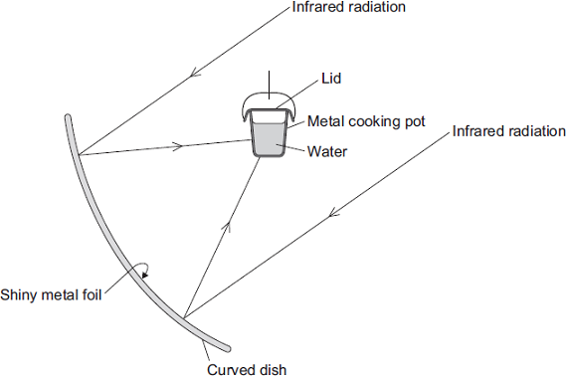
(a) Why is the inside of the large curved dish covered with shiny metal foil? (1)
To reflect the infrared
(b) Which would be the best colour to paint the outside of the metal cooking pot?
Draw a ring around the correct answer.

black | silver | white

Give a reason for your answer. (2)
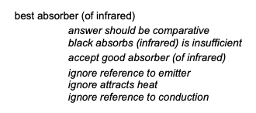
(c) Why does the cooking pot have a lid? (1)
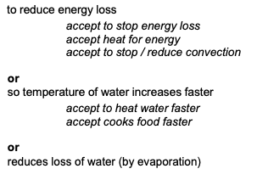
(d) Calculate how much energy is needed to increase the temperature of 2 kg of water by 80 °C. (3)
The specific heat capacity of water = 4200 J/kg °C.



