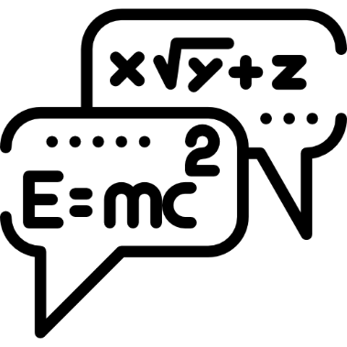
Oxbridge Assessment Prep
Week 7 – General maths

Physics/Engineering at Oxford: PAT
Engineering at Cambridge: ENGAA
Natural Sciences at Cambridge: NSAA
Assessment date: 5th November 2020

Week 1 – Mechanics
Week 2 – Electricity
Week 3 – Area/volume of shapes
Week 4 – Waves
Week 5 – Differentiation/Integration/Series
Week 6 – General physics
Week 7 – General maths

Q31 section 1 ENGAA 2019
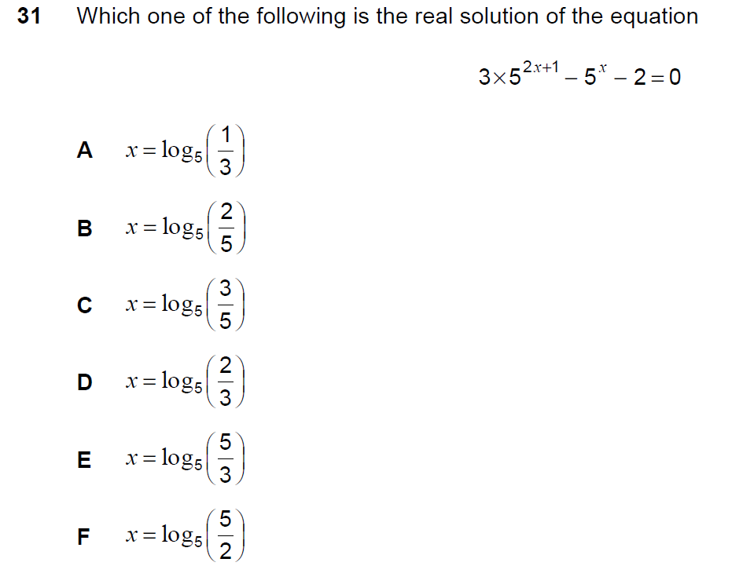

Q2 PAT 2017 Specimen
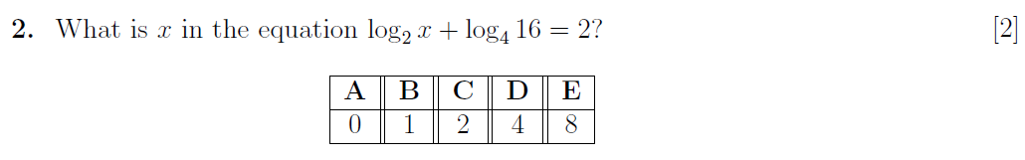

Q81 section 1 NSAA 2018
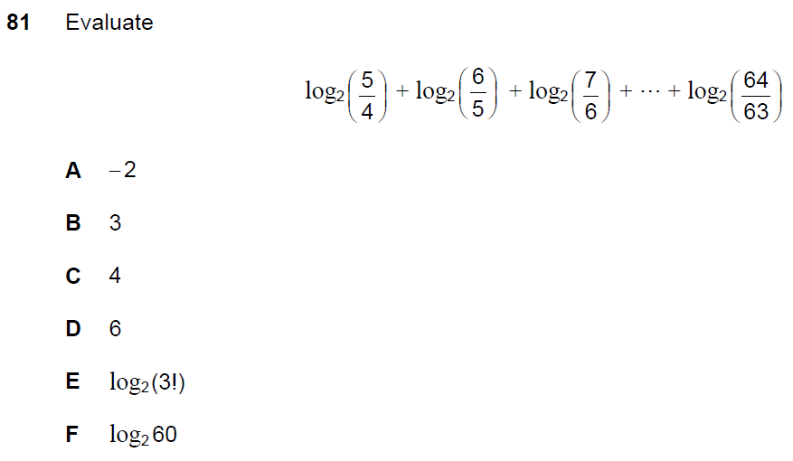

Q23 section 1 ENGAA Specimen
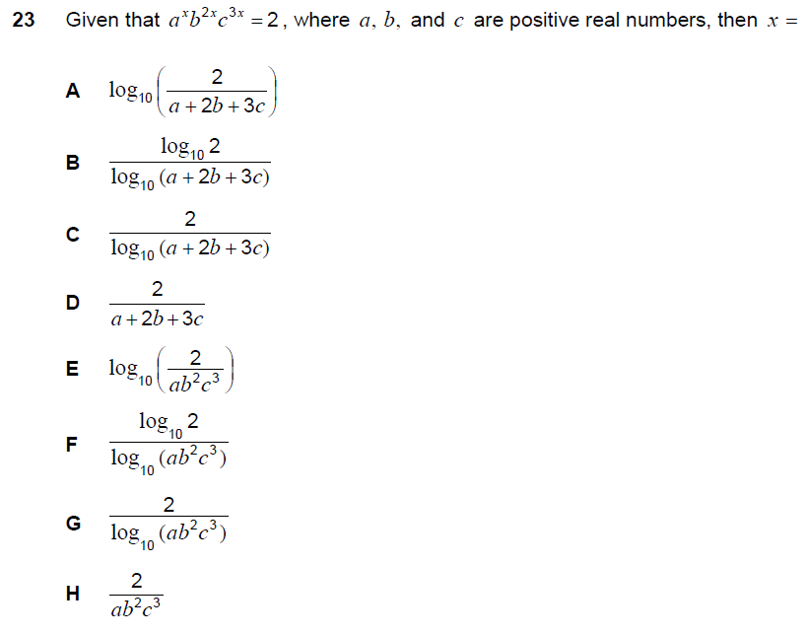

Q14 PAT 2018

Q4 PAT 2017
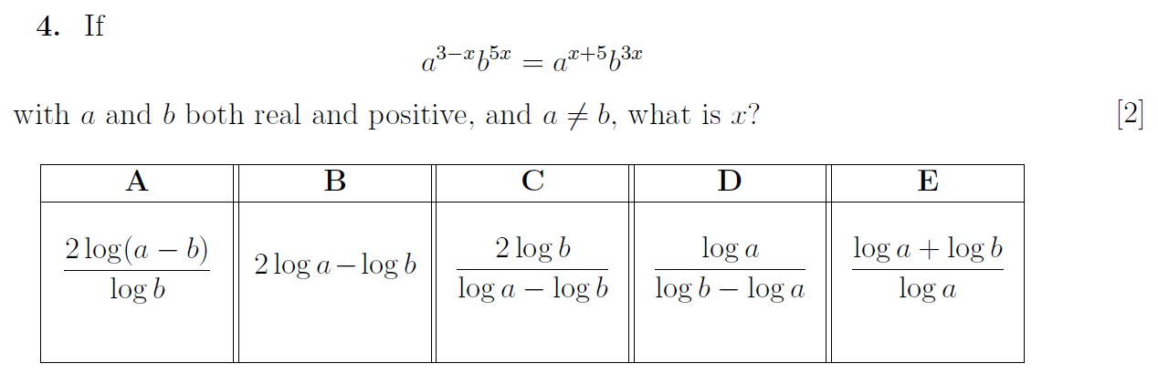

Q23 PAT 2018

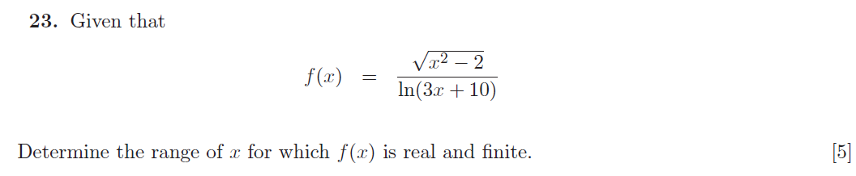

Q13 PAT 2017

Q1 PAT 2017 Specimen

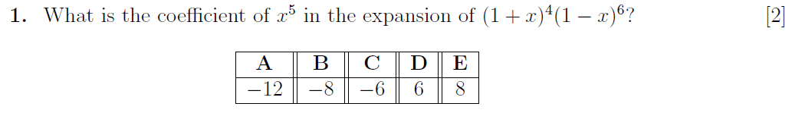

Q85 Section 1 NSAA 2018
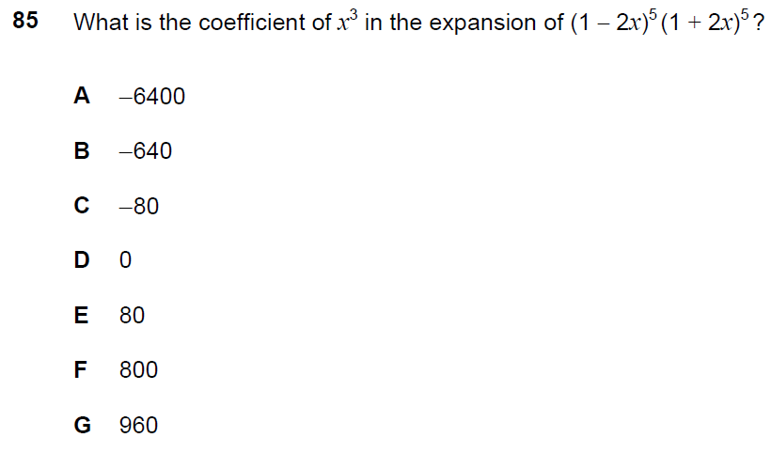

Q17 PAT 2018

Q14 PAT 2017
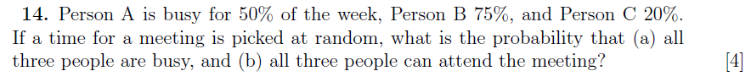

Q13 PAT 2017 Specimen
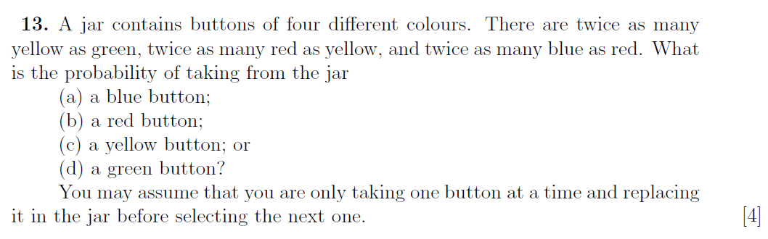

Q1 section 1 ENGAA 2018
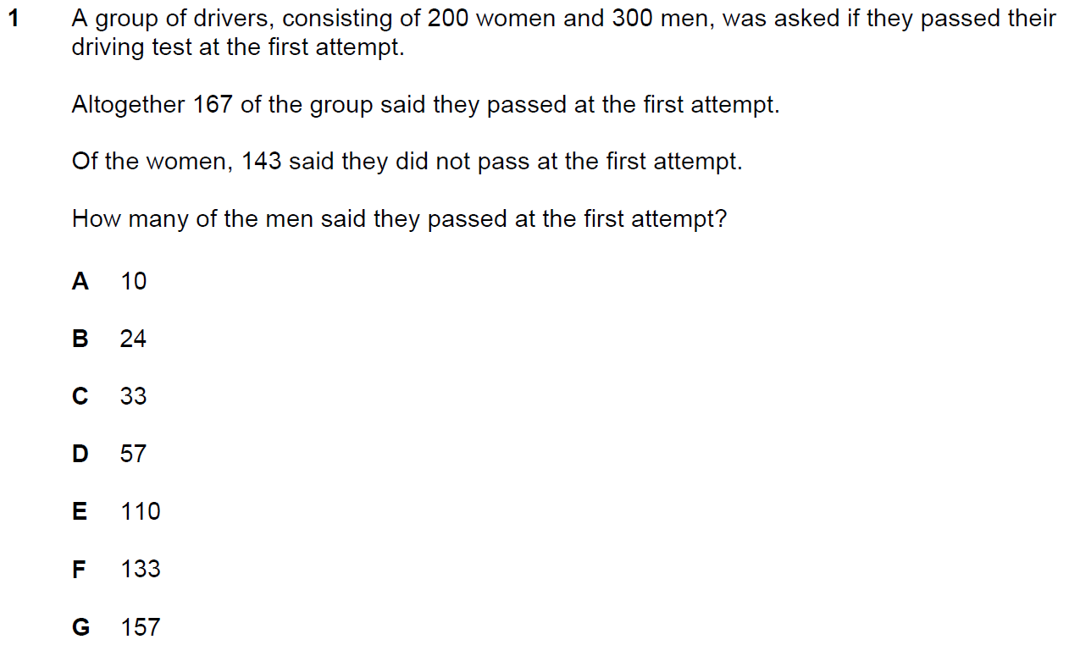

Q19 Section 1 NSAA 2020 Specimen
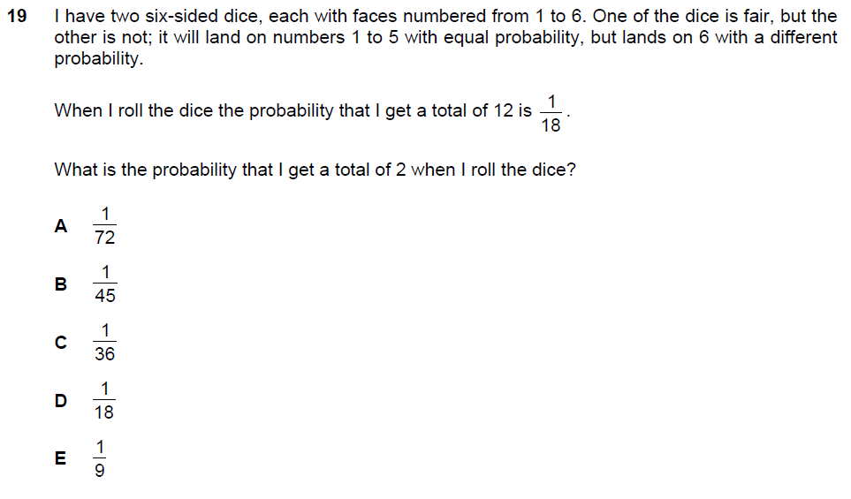

Q21 section 1 ENGAA 2019
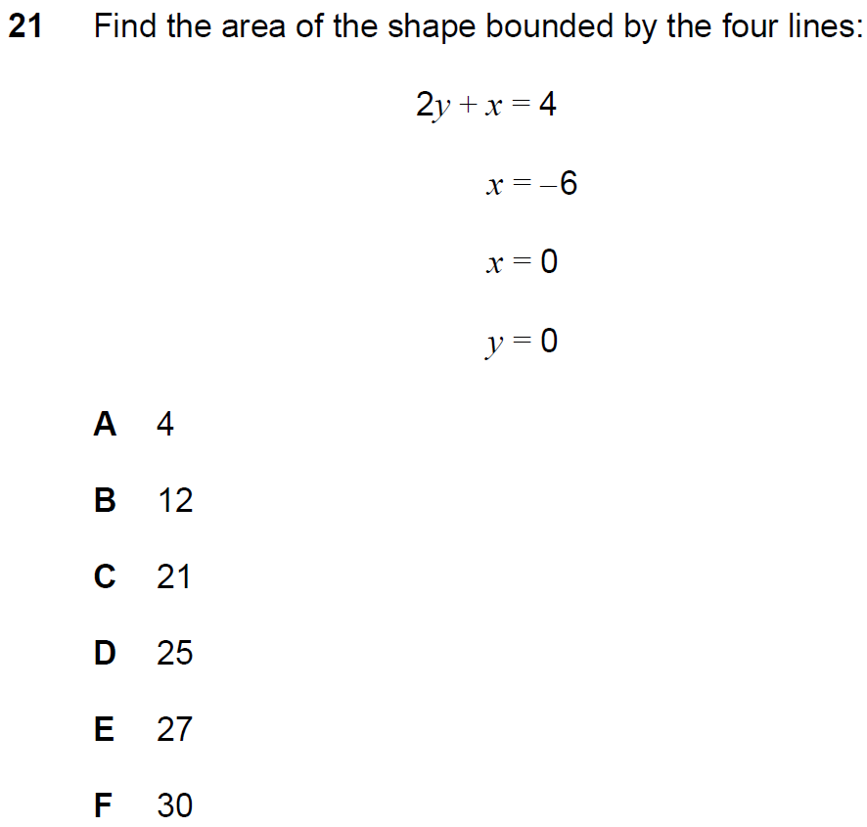

Q4 PAT 2017 Specimen

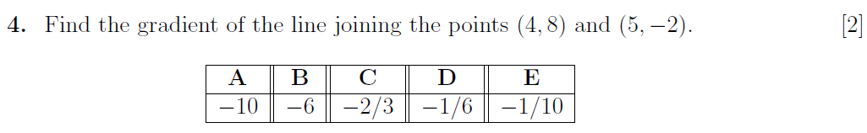

Q73 section 1 NSAA 2018
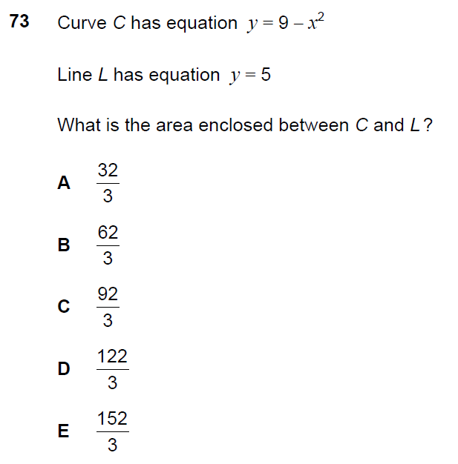
Q6 PAT 2017
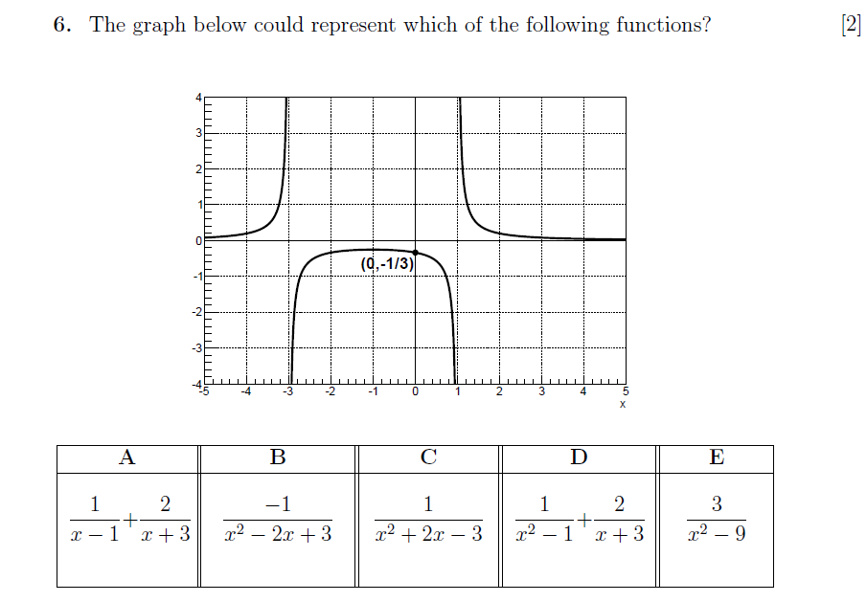
Q83 section 1 NSAA 2018
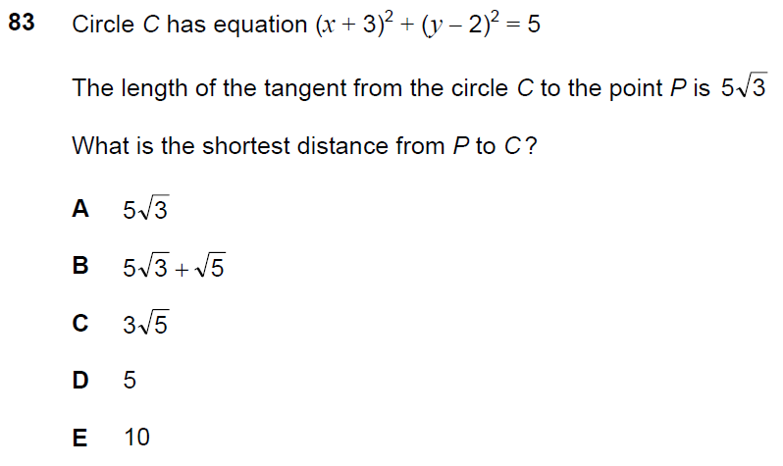
Q22 PAT 2017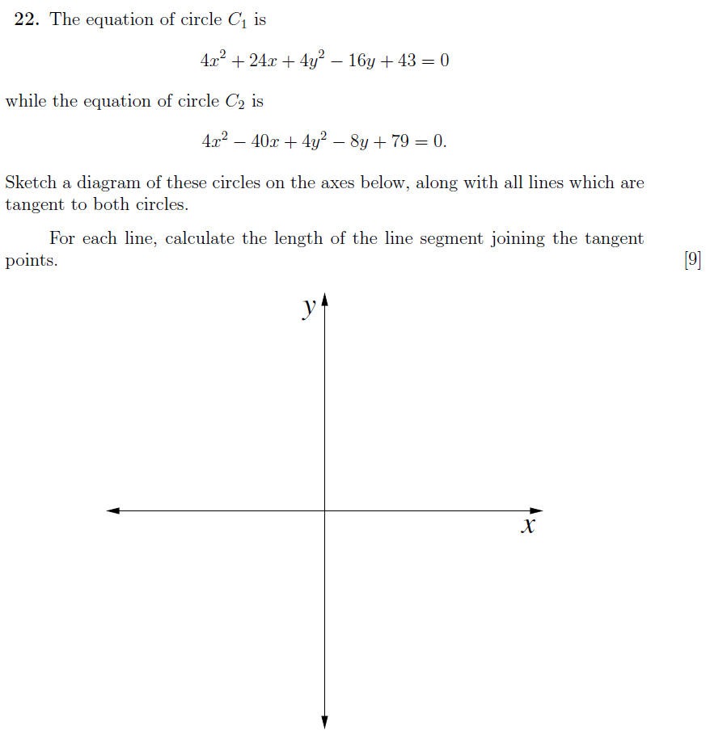

Q26 PAT 2017 Specimen

Q6 PAT 2017 Specimen
