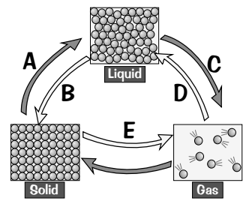
Basic
- A, B, C, D and E represent changes from one state to another. Name each of these changes.
- What is happening to the particles in the substance when change C happens?
- Which state of matter:
- Can be compressed.
- Takes up the shape of the container
- Has no fixed volume
- Has no fixed shape.
- Has a low density.
- Causes pressure.
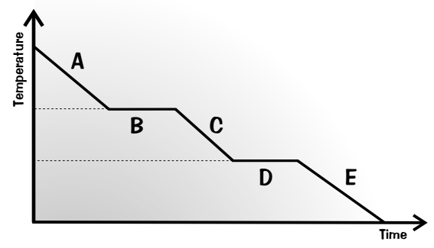
Medium
A scientist measured the temperature of water as it was cooled from 150°C to -20°C. She used her results to make the graph.
- What state is the water in at points A, C and E?
- Name the processes that are happening at points B and D.
- Explain why the graph is flat at points B and D.
- Describe what happens to the arrangement of particles as it goes through state change D.
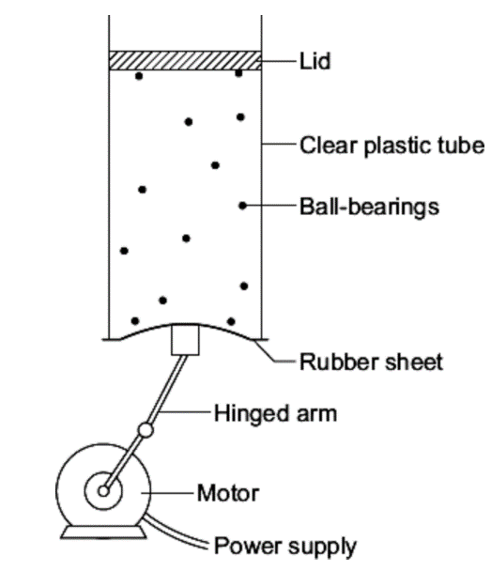
- The diagram shows the model that a science teacher used to show her students that there is a link between the temperature of a gas and the speed of the gas particles.

The ball-bearings represent the gas particles. Switching the motor on makes the ball-bearings move around in all directions.

- Explain, in terms of the particles, why gases are easy to compress.
- How is the motion of the ball bearings similar to the motion of the gas particles?
- The faster the motor runs, the faster the ball-bearings move. Increasing the speed of the motor is like increasing the temperature of a gas. Use the model to predict what happens to the speed of the gas particles when the temperature of a gas is increased.
Hard
- One kilogram of a gas has a much larger volume than one kilogram of a solid. Explain why (4).
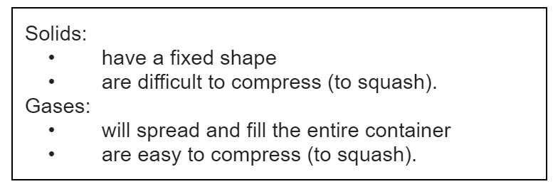
- The information in the box is about the properties of solids and gases.
Use your knowledge of kinetic theory to explain the information given in the box. You should consider:
- The spacing between the particles.
- The movement of individual particles.
- The forces between the particles. (6)

