Two students investigated the change of state of stearic acid from liquid to solid.
They measured how the temperature of stearic acid changed over 5 minutes as it changed from liquid to solid.
The diagram below shows the different apparatus the two students used.
Student A’s apparatus Student B’s apparatus
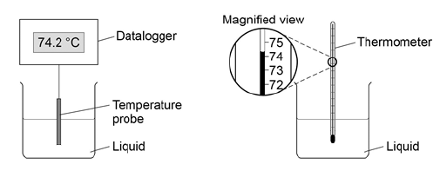
(a) Choose two advantages of using student A’s apparatus. Tick two boxes. (2)
Student A’s apparatus made sure the test was fair. | 
Student B’s apparatus only measured categoric variables.
Student A’s measurements had a higher resolution.
Student B was more likely to misread the temperature.
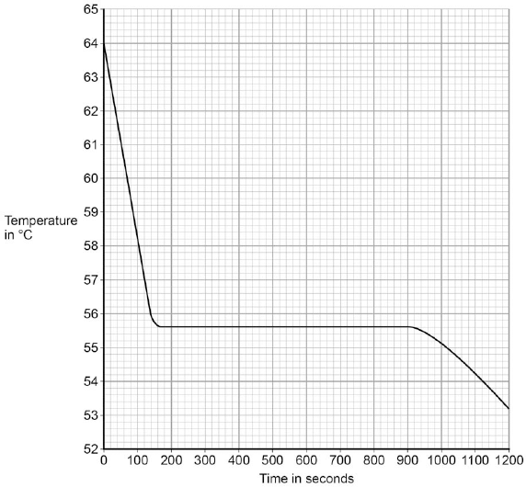
(b) Student A’s results are shown in the graph.

What was the decrease in temperature between 0 and 160 seconds? Tick one box. (1)
8.2 °C
8.4 °C
53.2 °C
55.6 °C
(c) Use the graph to determine the time taken for the stearic acid to change from a liquid to a solid. (1)
Time = ____________ seconds
(d) Use the graph to obtain the melting point of stearic acid. (1)
Melting point = ____________ ˚C
(e) Why doesn’t the temperature change when the stearic acid is melting? (1)
___________________________________________________________________
___________________________________________________________________

(f) After 1200 seconds the temperature of the stearic acid continued to decrease.
Explain why. (2)
___________________________________________________________________
___________________________________________________________________
___________________________________________________________________
___________________________________________________________________

