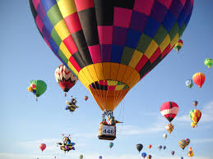
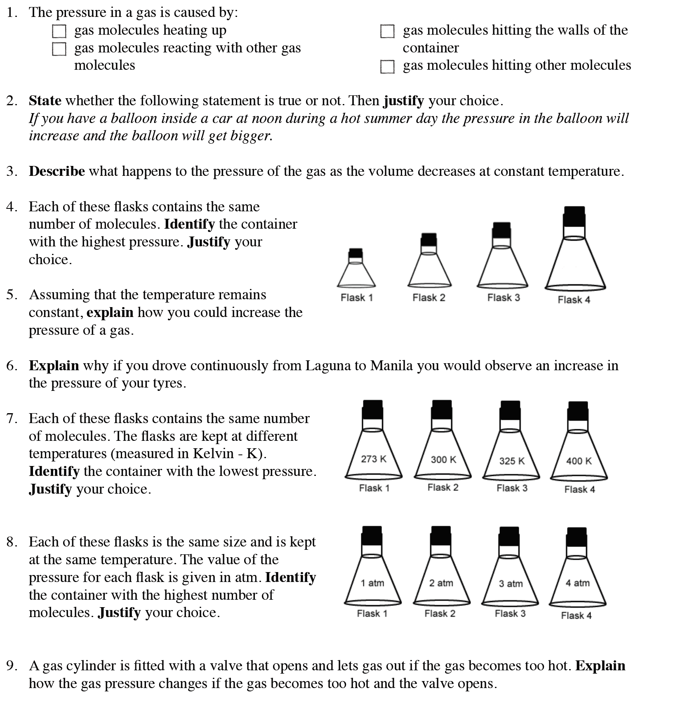
Task: Complete in exercise book
Stretch: John and Lisa are taking part in an air balloon
competition. They need to do the following:
- Rise to 500 m, move at that altitude for a while before moving up to 1000 m.
- After which they need to drift slowly down to the ground at the finishing line.
To accomplish this they have a flap at the top of the balloon, a heater in the basket of the
balloon, and weights on the side of the balloon.
Write a full account of what they have to do, and how it works according to the rules of density, pressure and temperature and kinetic theory of particles.

