Specific Heat Capacity of Aluminium – Extended Response
The specific heat capacity of aluminium can be determined by experiment.
(a) Draw a labelled diagram showing how the apparatus used to determine the specific heat capacity of aluminium should be arranged.
(3)
(b) Describe how you could use the apparatus you drew in part (a) to determine the specific heat capacity of aluminium.
(6)

Draw your diagram – it must be labelled. If it includes a circuit, you must use circuit symbols and the appropriate convention to draw a circuit.

Complete?

Outline what measurements you will take, what equipment you will use to take them, and the range of measurements you will take.  Complete? | …………………………………………………………………………....  …………………………………………………………………………....  …………………………………………………………………………....  …………………………………………………………………………....  …………………………………………………………………………....  …………………………………………………………………………....  …………………………………………………………………………....  …………………………………………………………………………....  …………………………………………………………………………....  …………………………………………………………………………....  …………………………………………………………………………....  …………………………………………………………………………....  …………………………………………………………………………....  …………………………………………………………………………....  …………………………………………………………………………....  …………………………………………………………………………....  …………………………………………………………………………....…………………………………………………………………………...
What calculation(s) will you complete?
How will you represent your data?

Complete?

What safety precautions will you put in place?

Complete?

Q1.
A student used the apparatus in Figure 1 to compare the energy needed to heat blocks of different materials.
Each block had the same mass.
Each block had holes for the thermometer and the immersion heater.
Each block had a starting temperature of 20 °C.
Figure 1
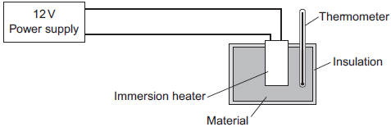
The student measured the time taken to increase the temperature of each material by 5 °C.
(a) (i) State two variables the student controlled.
1. ____________________________________________________________
2. ____________________________________________________________
(2)
Figure 2 shows the student’s results.
Figure 2
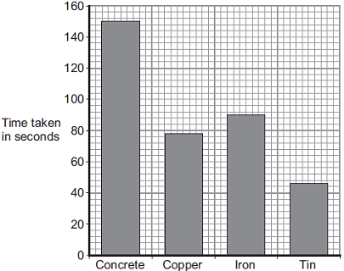
Material
(ii) Why was a bar chart drawn rather than a line graph?
______________________________________________________________
______________________________________________________________
(1)
(iii) Which material was supplied with the most energy?
______________________________________________________________
Give the reason for your answer.
______________________________________________________________
______________________________________________________________
(2)
(iv) The iron block had a mass of 2 kg.
Calculate the energy transferred by the heater to increase the temperature of the iron block by 5 °C.
The specific heat capacity of iron is 450 J / kg °C.
______________________________________________________________
______________________________________________________________
______________________________________________________________
Energy transferred = ______________________________ J
(2)

(b) The student used the same apparatus to heat a 1 kg block of aluminium.
He recorded the temperature of the block as it was heated from room temperature.
The results are shown in Figure 3.
Figure 3
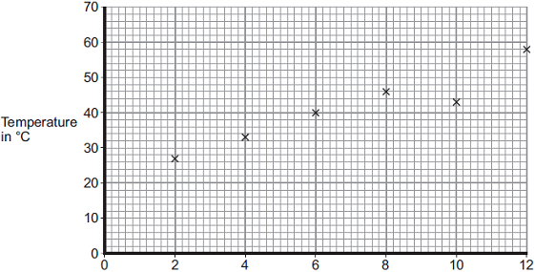
Time the immersion heater is switched on for in minutes
(i) One of the student’s results is anomalous.
Draw a ring around the anomalous result.
(1)
(ii) Draw the line of best fit for the points plotted in Figure 3.
(1)
(iii) What was the temperature of the room?
Temperature = _______________ °C
(1)
(iv) What was the interval of the time values used by the student?
Interval = _______________ minutes
(1)
(Total 11 marks)

