An element is made from only one type of atom. There are over 100 known elements and they are listed on the periodic table. For example, argon and oxygen are both elements as they both contain only one type of atom.
Elements, compounds and mixtures.
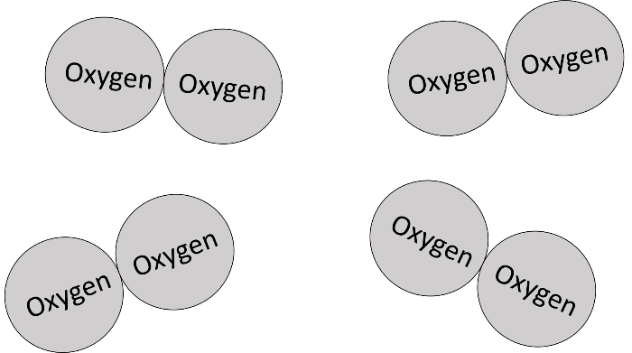
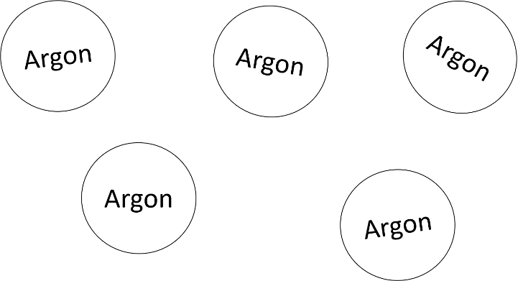

Here, we have the element argon. We know that we have an element because there is only one type of atom.
Here, we have the element oxygen. Oxygen is a diatomic gas as it contains two atoms that are chemically joined. A monatomic gas contains only single atoms that are not chemically joined.

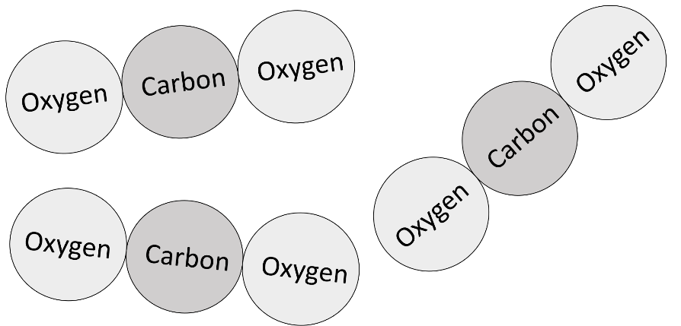

A compound is a substance where two or more atoms (of different elements) are chemically joined. For example, carbon dioxide is a compound as it contains the elements carbon and oxygen.
Carbon dioxide is a compound; it has two different types of atom that are chemically joined.

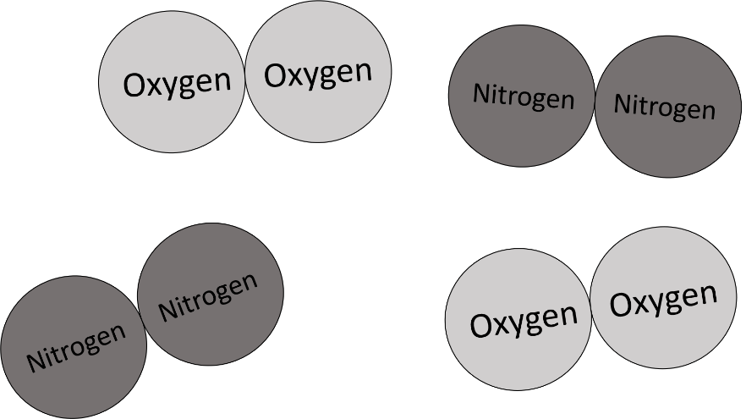
A mixture is a substance that contains two or more elements or compounds that are not chemically joined together. For example, nitrogen gas mixed with oxygen gas is a mixture of elements. Carbon dioxide mixed with carbon monoxide is a mixture of compounds.
Here we have a mixture of two different elements; nitrogen and oxygen.

Q1. What is an element?
………………………………………………………………………………………………………………………………………………………………………………………………………..
………………………………………………………………………………………………………………………………………………………………………………………………………..
Q2. What is a compound?
………………………………………………………………………………………………………………………………………………………………………………………………………..
………………………………………………………………………………………………………………………………………………………………………………………………………..
Q3. What is a mixture?
………………………………………………………………………………………………………………………………………………………………………………………………………..
………………………………………………………………………………………………………………………………………………………………………………………………………..
Q4. Below is a list of substances. Write which are elements and which are compounds.
Iron | Iron Oxide | Nitrogen | Oxygen
Carbon dioxide | Aluminium | Hydrochloric acid | Water
Elements:
………………………………………………………………………………………………………………………………………………………………………………………………………..
Compounds:
………………………………………………………………………………………………………………………………………………………………………………………………………..
Q5. For the compounds you’ve listed in Q4. write what elements each compound contains.
………………………………………………………………………………………………………………………………………………………………………………………………………..
………………………………………………………………………………………………………………………………………………………………………………………………………..
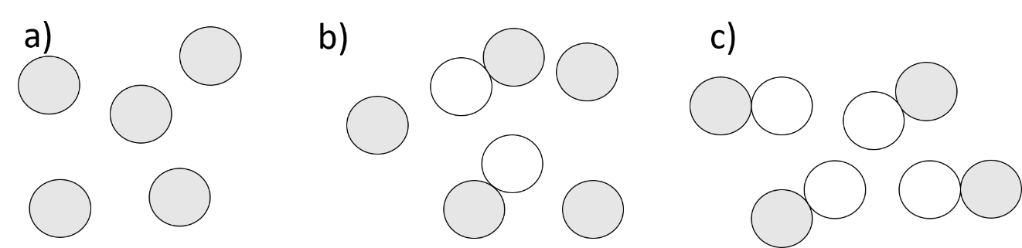
Q6. Below are diagrams of three different substances. Write which is an element, which is a compound and which is a mixture.

………………………………………………………………………………………………………………………………………………………………………………………………………..
………………………………………………………………………………………………………………………………………………………………………………………………………..
Q7. Describe the difference between an element and a compound.
………………………………………………………………………………………………………………………………………………………………………………………………………..
………………………………………………………………………………………………………………………………………………………………………………………………………..
Q8. Describe the difference between a compound and a mixture.
………………………………………………………………………………………………………………………………………………………………………………………………………..
………………………………………………………………………………………………………………………………………………………………………………………………………..

