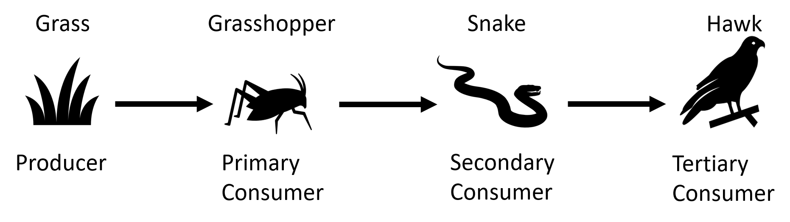
A food chain is a way of showing what eats what. For example, the diagram below shows that grasshoppers eat grass.
Food chains and webs

Below are some important definitions:
Producers | Organisms that make their own food through photosynthesis.
Primary consumer | Animal that eats the producer.
Secondary consumer | Animal that eats the primary consumer.
Tertiary consumer | Animal that eats the secondary consumer.
Herbivore | Animal that eats only plants.
Carnivore | Animal that eats other animals.
Omnivore | Animal that eats both plants and animals.
Predator | An organism that eats another organism.
Prey | The organism that a predator eats.

Usually, patterns of eating is more complicated than a simple food chain. A food web contains lots of food chains linked together.
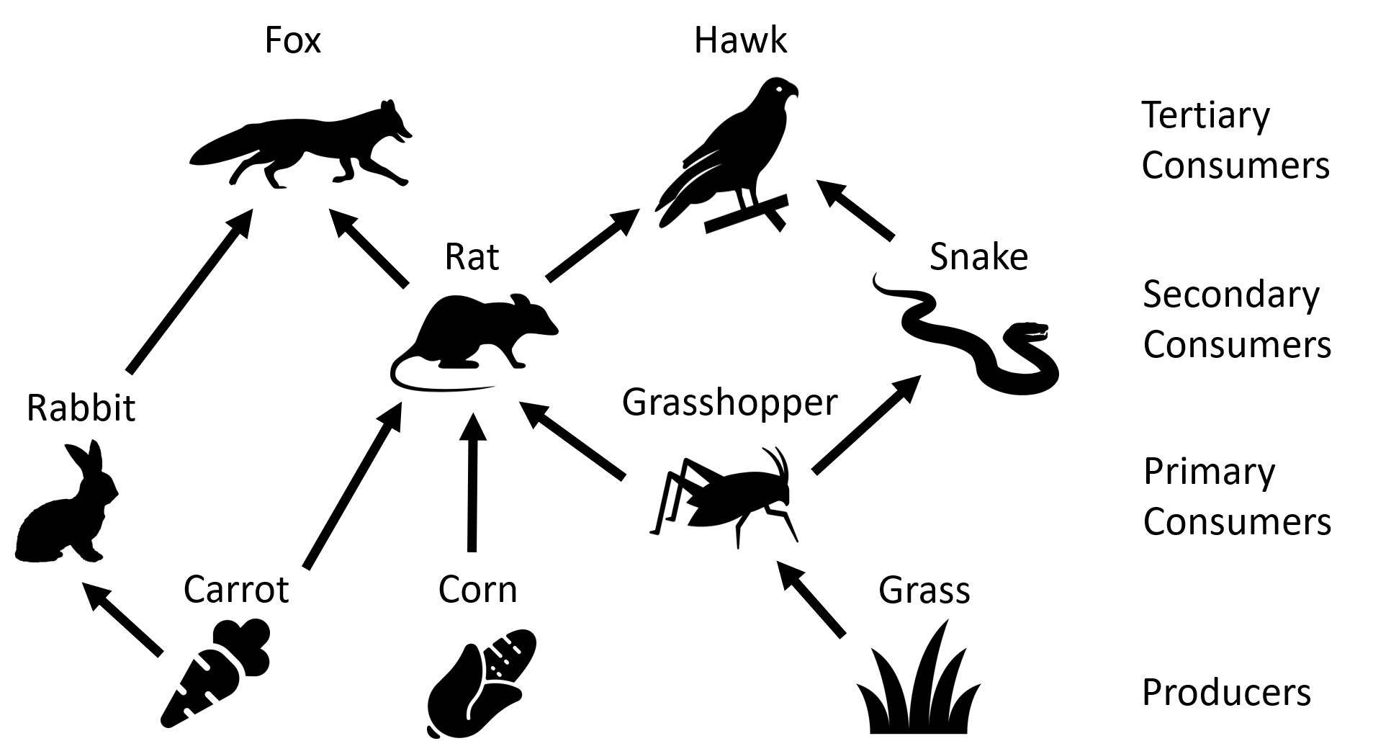

Each part of a food chain/web is linked to others. For example, if all of the carrots in the food web above died then there would be less rabbits (as they’d have less food to eat).
Q1. What is a producer?
………………………………………………………………………………………………………………………………………………………………………………………………………..
Q2. What is a herbivore?
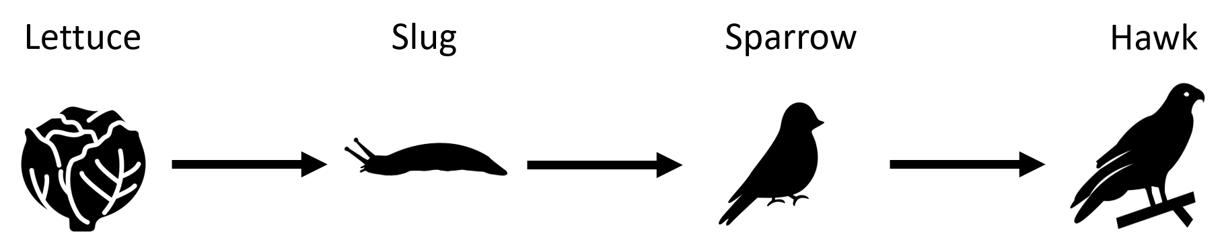
………………………………………………………………………………………………………………………………………………………………………………………………………..

Use the food chain above to answer the following questions.
Q3. The producer is ………………………………
Q4. The secondary consumer is ………………………………
Q5. The prey of the hawk is ………………………………
Q6. The predator of the slug is ………………………………
Q7. What would happen to the sparrow population if most of the slugs died?
………………………………………………………………………………………………………………………………………………………………………………………………………..
Q8. What would happen to the lettuce population if most of the slugs died?
………………………………………………………………………………………………………………………………………………………………………………………………………..
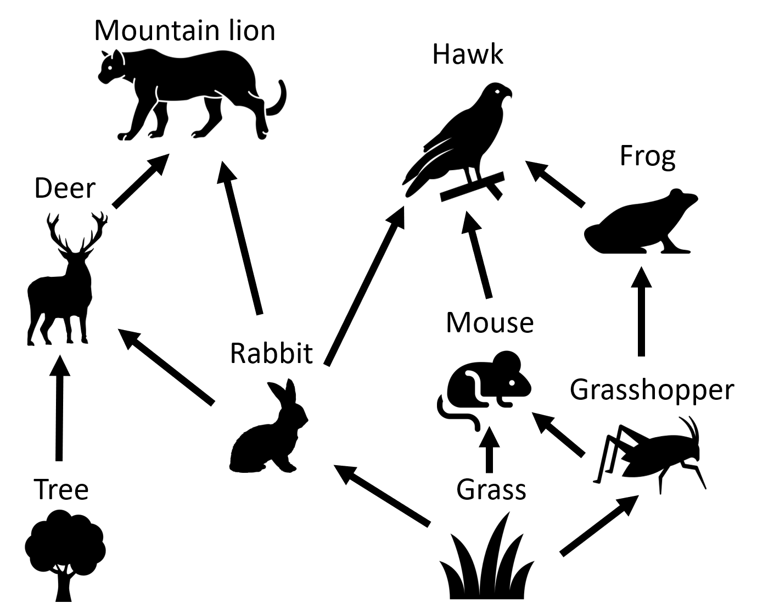

Use the food web above to answer the following questions.
Q9. Name a primary consumer.
………………………………………………………………………………………………………………………………………………………………………………………………………..
Q10. Name the predators of a rabbit.
………………………………………………………………………………………………………………………………………………………………………………………………………..
Q11. Name an omnivore.
………………………………………………………………………………………………………………………………………………………………………………………………………..
Q12. Name a carnivore.
………………………………………………………………………………………………………………………………………………………………………………………………………..

