Combination | Uncertainties
a = b ± c | Δa = Δb + Δc
a = bc or a = b/c | %a = %b + %c
a = b^{c} | %a = c × %b
Measurements revision:

- Measurements are taken to determine the resistance of a resistor. Three separate readings of current through the bulb are taken for each potential difference across the bulb. These results are shown in the table.
Potential difference (V) | Current (A)
 | I₁ (mA) | I₂ (mA) | I₃ (mA) | I_{av} (mA) | ΔI_{av} (mA)
0.10 | 120 | 100 | 110
0.20 | 230 | 260 | 290
0.30 | 370 | 360 | 390
0.40 | 480 | 490 | 520
0.50 | 620 | 600 | 630
0.60 | 750 | 760 | 700

- Calculate the average current for each potential difference and write your answer in the table above.
- Calculate the absolute uncertainty for each average current, writing this in the table above.
- Calculate the percentage uncertainty for the current at a potential difference of 0.10 V.
- The absolute uncertainty on each potential difference is ± 0.01 V. Calculate the percentage uncertainty for the potential difference at 0.10 V.
- Calculate the resistance of the resistor at a potential difference of 0.10 V. Give the percentage uncertainty.
- Calculate the absolute uncertainty of the resistance at a potential difference of 0.10 V.
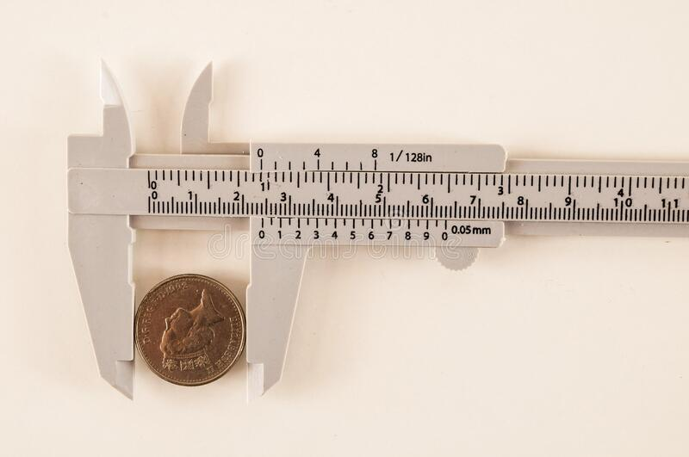
- The dimensions of a penny are measured by using a set of Vernier callipers. The diameter of the coin is measured three times:

20.1 mm | 19.9 mm | 20.3 mm

- Calculate the mean diameter of the coin.
- Calculate the absolute uncertainty of the mean diameter of the coin.
- Calculate the percentage uncertainty of the diameter of the coin.
- Using the mean diameter, calculate the cross-sectional area of the coin.
- Calculate the percentage uncertainty in the cross-sectional area of the coin.
The width of the penny is now measured three times:
1.52 mm | 1.48 mm | 1.47 mm

- Calculate the mean width of the coin.
- Calculate the absolute uncertainty of the mean width of the coin.
- Calculate the percentage uncertainty of the width of the coin.
- Using the cross-sectional area and width, calculate the volume of the coin.
- Calculate the percentage uncertainty of the volume of the coin.
- Calculate the absolute uncertainty of the volume of the coin.

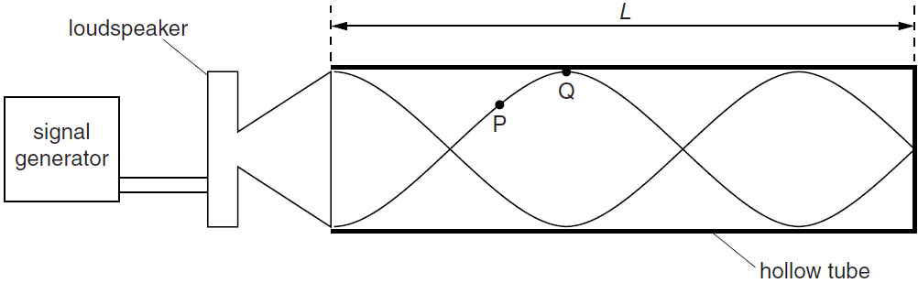
- A speaker was attached to one side of a hollow tube and stationary waves are formed. There is always a node at the closed end of the tube, and always an antinode at the open end of the tube. The distance between the speaker and the closed end of the tube is measured to be 15.0 ± 0.3 cm.

Harmonic | Frequency, f (Hz) |  |  | Wavelength, λ (m)
First | 567 | 555 | 570 | 0.60
Second | 1705 | 1710 | 1698 | 0.20
Third | 2830 | 2842 | 2825 | 0.12

Harmonic | Mean Frequency, f (Hz) | Δ f (Hz) | % f | Wave Speed, v (m/s)
First
Second
Third

- Calculate the mean frequency for each harmonic
- Calculate the absolute uncertainty in the mean frequency for each harmonic.
- Calculate the percentage uncertainty in the mean frequency for each harmonic.
The percentage uncertainty in each measured wavelength is 2%.
- Calculate the wave speed for each harmonic. Give the absolute uncertainty for each calculation.

- Two speakers are at a distance of 0.30 m apart. The sound waves form an interference pattern, with alternating loud and quiet areas. By measuring the separation of the loud interference fringes at a different distance from the speakers we can measure the wavelength of the sound waves.

Distance to Speaker,  D (m) | Fringe Separation,  w (m) |  |  | Mean  w (m) | Δ w (m) | % w
1.00 | 0.20 | 0.21 | 0.21
1.50 | 0.33 | 0.33 | 0.29
2.00 | 0.41 | 0.47 | 0.42
2.50 | 0.52 | 0.56 | 0.51
3.00 | 0.63 | 0.66 | 0.63
3.50 | 0.77 | 0.72 | 0.73
4.00 | 0.89 | 0.84 | 0.82
4.50 | 0.91 | 0.98 | 0.99

- Calculate the mean values of the fringe separation.
- Calculate the absolute uncertainty in each fringe separation.
- Calculate the percentage uncertainty in each fringe separation.
The absolute uncertainty in all values of D is ±0.01 m. The absolute uncertainty in the distance between the speakers is also ±0.01 m.
- Using the values measured for a distance of 1.00 m to the speaker, calculate the wavelength of the sound wave. Include the absolute uncertainty.
- Using the values measured for a distance of 4.50 m to the speaker calculate the wavelength of the sound wave. Include the absolute uncertainty.
- State a reason for the difference in the absolute uncertainty in your answers d) and e).
- Describe how you could use a graph to get the wavelength of sound. How would you obtain the absolute uncertainty?

