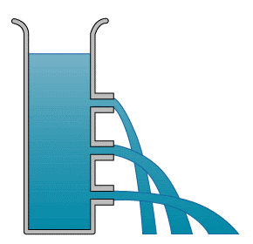
Forces
Pressure
Higher Only
Name ______________________________
Class ______________________________
Teacher ______________________________

Forces & Pressure facts
- What is pressure?
- What is the equation that links Area, Force and Pressure?
- What is pressure measured in?
- Pressure in liquids is due to?
- What happens to the pressure in a liquid as you increase depth, and why?
- What is the equation that links Density, Gravitational field strength, Height and Pressure?
- What causes air pressure?

- What factors can change air pressure?

- What is Upthrust?

- Why do things float?

- What is the Archimedes principle?
- Pressure is the amount of force over an area.
- $Pressure= \frac{Force}{Area}$
- Pascals, 1Pa = 1N/m²
- The weight of the liquid pushing on surfaces
- The pressure increases as the water above you weighs more and has a larger force.
- Pressure = density x gravitational field strength x height of water above
P = ρ x g x h
- Air Pressure is caused by air particles colliding with surfaces and exerting a force on an area.
- Temperature of the air, Volume of the container, Height of air column above
- A force pushing an object up in a liquid, due to a difference in pressure at the top and bottom of the object.
- The upthrust is greater than the weight, or the density of the object is lower than the liquid.
- The weight of liquid displaced by an object is equal to the upthrust

Fold page here
Pressure is the amount of force spread over an area. It is measured in Pascals (Pa) where 1 Pascal is equal to 1Newton of force for every meter².
Pressure in Solids
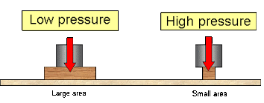
If we think of an object with a small surface area like a pin, there will be a large pressure for even a small force. An object with a large surface area like the tracks on a tank will have a small pressure even though the tank has a larger force.
We can calculate the pressure on a surface by using the equation:
p = F ÷ A
where p is the pressure (in Pa)
F is the Force (in N)
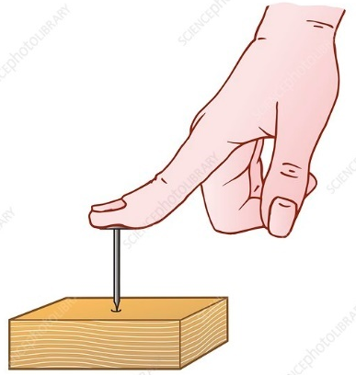
A is the area (is m²)
Worked example: A 7N weight is placed upon a nail with a surface area of 4x10⁻⁶m². Calculate the pressure on the nail tip.
List varibles : F=7N A=4x10⁻⁶m² p=?
Equation : p = F ÷ A
Enter values : p = 7 ÷ 4x10⁻⁶
Result : p = 1,750,000 Pa
: = 1.75 MPa
Milli = m = x10⁻³ | Kilo = K = x10³
Micro = μ = x10⁻⁶ | Mega = M = x10⁶
Nano = n = x10⁻⁹ | Giga = G = x10⁹
Pressures can quickly become very large, so we use the SI prefixes to write large pressures. Remember:
1m² = 10,000 cm² | 1cm² = 1x10⁻⁴ m²
1m² = 1,000,000 mm² | 1mm² = 1x10⁻⁶ m²
1m² = 1x10⁻⁶ km² | 1km² = 1,000,000 m²
We must also be careful with area conversions.

In different situations you may want high pressures or low pressures.
E.g. we want knives to have a higher pressure so they cut easily, we do this by making the surface area very small.
If we don’t want to sink into snow, we can decrease the pressure by using snow-shoes with a large area.

Basic Q1 Work out the pressure of the following objects:
a) 100 N over 10 m² e) 1000 N over 200 m²
b) 320 N over 16 m² f) 300 N over 20 m²
c) 1500 N over 180 m² g) 50 N over 4 m²
d) 700 N over 35 cm² h) 450 N over 22 cm²
Medium Q2 Calculate the Force needed to make the following pressures:
a) 10 Pa over 30 m² e) 15 Pa over 28 m²
b) 15 Pa over 20 m² f) 20 Pa over 20 cm²
Don’t forget to convert
c) 12 kPa over 180 m² g) 100 MPa over 300 m²
d) 5 mPa over 70 m² h) 180 GPa over 20 m²
Q3 What area is needed to make the following pressures:
a) 10 Pa with 20 N e) 180 Pa with 6 N
b) 50 Pa with 10 N f) 40 Pa with 12 N
Don’t forget to convert
c) 55 kPa with 30 N g) 200 Pa with 8 kN
d) 90 GPa with 20 kN h) 2,000 mPa with 16 N

Hard
Q4 Mr JP has a mass of 87kg, his shoes have an area of 0.2m².
- What is Mr JP’s weight? (g = 9.8 N/kg)
- What is the pressure under Mr JP’s shoes.
- Mr JP tries on a pair of high heels with an area of 0.01m² what is the new pressure?
- If Mr JP wants snow shoes that reduce the pressure to under 1000 Pa, what is the minimum area the snow shoes need to be?
Q5 The area between the car and a tyre is 0.3m2. The pressure between the tire and the road is 9800Pa, what is the mass of the car?
Q6 A syringe needle has a 1x10⁻⁶m² area, what force is needed to inject a vaccine if the pressure needed is 3x10⁴Pa?
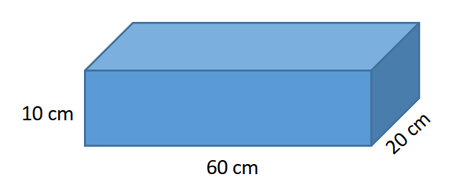
Q7 The block has a weight of 58 N.
- What is the highest pressure the block can exert on the surface it sits on?
- This block has a density of 2.7 g/cm³. What pressure in Pascals does it exert on the surface it lies
on?
Q8 A car has a weight of 1810 kg, and each wheel has an area in contact with the floor of 0.024 m2. What is the overall pressure of the car on the ground?

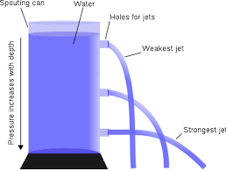
The pressure in a liquid is caused by the weight of the liquid above an object pushing down on a surface.
Pressure in a Fluid
The deeper an object, the more pressure as it has more weight above it. You can see this in the diagram, the highest holes have very low pressure, but as you go down, the pressure increases due to the increase in weight above it.
If we made more holes at the same height, all the water jets would have the same pressure.

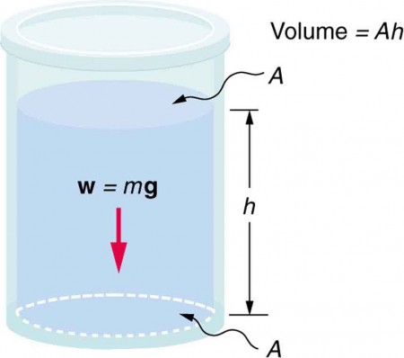
The formula we use is related to the last equation. To calculate the weight of the liquid we need to know the volume, density, and gravitational field strength.
p is pressure (Pa)
ρ is density (kg/m³)
g is gravitational field strength (N/kg)
h is height (m)
W = mg = ρVg = ρAhg

We also know that the pressure is the force ÷ area, and that the volume is equal to the Area x height. So we can put it all together to get:
p = ρ × g × h
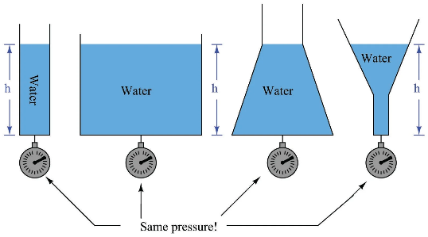
This has an interesting outcome, it means that the pressure in a liquid does not depend on the shape, mass of water or the surface area. For example, the bottom of each container would have the same pressure because it has the same height of water above it.

Worked example: what is the pressure due to sea water of density 1028kg/m³ at a depth of 130m. (assume g = 9.8 N/kg)
List varibles : ρ = 1028kg/m³ g = 9.8 N/kg h = 130m
Equation : p = ρ × g × h
Enter values : p = 1028 x 9.8 x 130
Result : p = 1309672 Pa = 1.31 MPa

Basic
Calculate the pressure difference in the following situations:
- A fish descends 2 m in fresh water from the surface.
- A fish descends 4 m in salt water (ρ= 1027 kg/m³).
- A scuba diver that rises from 10 m below the surface to 2 m below the surface in salt water. (ρ= 1027 kg/m³).
- A diver descends 20m in sea water (ρ= 1027 kg/m³).
- Milk has a density of around 1033 kg⁄ms.
What will be the total pressure exerted on the bottom surface of the glass below?
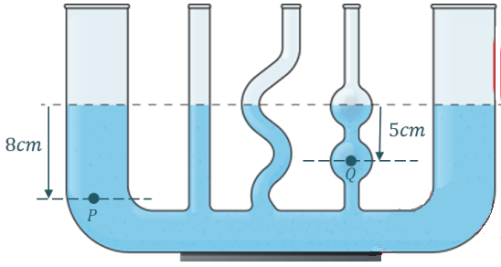
- A diver ascends from a depth of 20m to a depth of 15m in sea water. What is the total pressure exerted on him when he has finished his ascent?

- The tubes on the right are filled with pure water (ρ= 1000 kg/m³) and connected at their base. What is the difference in pressure between the points P and Q?
Medium
- The pressure at the bottom of the Marianna Trench is 0.1 GPa, how deep is it?
- In a mystery fluid, the pressure 10cm below the surface was found to be 784 Pa, find the density.
- On the ice moon of Europa, the pressure at the bottom of a 30cm tube of pure water was found to have a pressure of 414 Pa. What is the gravitational field strength of Europa?
- A submersible has a maximum pressure rating of 4 MPa, how deep can it go in salt water? How deep can it go in pure water?
Hard
- Explain why the bottom of a dam has to be thicker than the top of the dam.
- A water tank at the top of a tall building supplies water to taps in the building. Explain why the pressure of the water from a tap on the ground floor is greater than the pressure from a tap on a higher floor.
- A rainwater gutter collects rainwater that runs off a sloped roof. The water in the gutter runs into a vertical downpipe joined to one end of the gutter. Explain why the downpipe end of the gutter needs to be no higher than the other end.
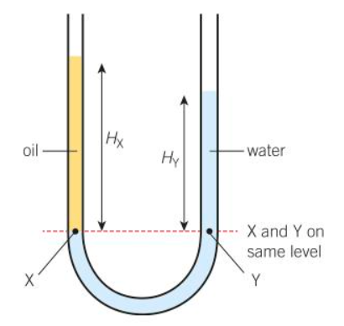
- A sink plug has an area of 0.0006 m². It is used to block the outlet of a sink filled with water to a depth of 0.090 m. Calculate:
  - the pressure on the plug due to the water.
  - the force needed to remove the plug from the outlet
- Explain how you would use the arrangement in the diagram right to find out the density of sea water compared with tap water.

Q1.
The diagram below shows an unusually shaped container.
The container has four vertical tubes of different shape and size.
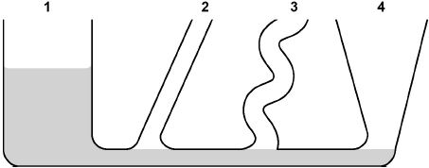
Water is poured into the container up to the level shown in tube 1.
(a) Complete the diagram above to show the height of the water in tubes 2, 3 and 4.
(1)
(b) The further a swimmer dives below the surface of the sea, the greater the pressure on the swimmer.
Explain why.
___________________________________________________________________
___________________________________________________________________
___________________________________________________________________
___________________________________________________________________
(2)
(c) A person swims from a depth of 0.50 m to a depth of 1.70 m below the surface of the sea.
density of the sea water = 1030 kg/m³
gravitational field strength = 9.8 N/kg
Calculate the increase in pressure on the swimmer.
Give the unit.
Use an equation from the Physics Equation Sheet.
___________________________________________________________________
___________________________________________________________________
___________________________________________________________________
___________________________________________________________________
Increase in pressure = _____________________ Unit ____________
(4)
(Total 7 marks)

Air pressure is caused by air particles bumping into surfaces and exerting a force, this force over an area is the pressure. A few factors affect the pressure:
Atmospheric Pressure
- The number of particles – more collisions, more pressure
- The speed of the particles – higher force, more pressure
- The volume of the container – more collision, more pressure
The atmosphere exerts a pressure on us all of the time. We don’t feel it because the air in our bodies is exerting the same pressure outwards. The forces are balanced. If two pressures are not the same, the gas will try to move from high pressure to low pressure areas.
Below are some demos that show the strength of atmospheric pressure.
Experiment | Observation | Explanation
Vacuum pump with marshmallows
Egg in the bottle trick
Magdeburg hemispheres
The collapsing can

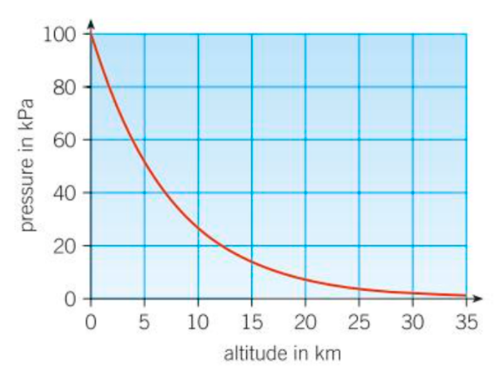
The atmosphere is a thin layer (relative to the size of the Earth) of air round the Earth. The atmosphere gets less dense with increasing altitude.

As we get higher, the air pressure decreases (this is why it is hard to breathe at the top of tall mountains).
A simple way to model this is based on the pressure in fluids: p = ρ × g × h
The number of air molecules (and so the weight of air) above a surface decreases as the height of the surface above ground level increases.
So as height increases there is always less air above a surface than there is at a lower height.
So atmospheric pressure decreases with an increase in height.

Pilots and climbers use changes in pressure to figure out what height they are above sea level.
Example question: A hiker hikes up a nearby mountain. At the top he records the pressure has decreased by 620Pa, how high is he now? Assume that density is constant at 1.225kg/m³ and g = 9.8 N/kg.
List varibles : ρ = 1.225 kg/m³ g = 9.8 N/kg P = 620Pa
Equation : p = ρ × g × h
Enter values : 620 = 1.225 x 9.8 x h
h = 620 ÷ (1.225 x 9.8)
Result : h = 51.6 m
Example question: The atmospheric pressure at an altitude of 10km is about 25kPa and at 30km is less than 2kPa.
Estimate the average density between these two altitudes.
List varibles : P=25-2=24kPa=24,000Pa h=30-10=20km=20,000m
Equation : p = ρ × g × h
Enter values : 24,000 = ρ x 9.8 x 20,000
ρ = 24,000 ÷ (20,000 x 9.8)
Result : ρ = 0.12kg/m³
Task: Complete in your exercise book
Basic Q1 Calculate the Force due to the atmosphere on these areas (assume P=101,325Pa): (use P=F/A)
- A 1m² square b) the area of the top of your head: ~0.2m² c) a 10x15m roof
- The tip of a 0.001 m² pin f) a suction cup (0.012m²)

- Explain how rubber suckers work.
- If Mr JP wanted to hang from the ceiling using a rubber sucker how big would it have to be? (Assume a perfect vacuum in the sucker. Take atmospheric pressure to be 101 325 Pa and Mr JP’s weight as 870N).
- One of the windows in a plane flying at high altitude breaks. Explain what happens.
- Explain what would happen to an astronaut doing a space walk if their space suit was punctured by a tiny meteorite.
Medium
- Mercury barometers are used to measure changes in pressure. Mercury is used because it is very dense, it has a density of 13600kg/m3. What height of mercury is needed to create a pressure of 101,325Pa?
- You could use water to make a barometer, water has a density of 1000kg/m3, what height of water is needed to create a pressure of 101,325Pa?
- Each window of a passenger jet has an area of 0.040m2 and the cabin pressure is 75kPa. Calculate the force on the window due to this pressure difference.

Hard
- Calculate the mass of a vertical column of air that exerts a pressure of 101,325Pa over a 1x1m area.
- Before a storm the pressure at sea level can drop to 3000Pa, Calculate the mass of a vertical column of air above a 1x1m area.
- The atmospheric pressure at an altitude of 25km is about 5kPa and at 30km is less than 2kPa. Estimate the average density between these two altitudes.
- A hiker hikes up a nearby mountain. At the top he records the pressure has decreased by 18kPa, how high is he now? Assume that density is constant at 1.225kg/m3 and g = 9.8 N/kg.
- A plane records a pressure change of 40kPa how high has it flown? Assume that density is constant at 1.225kg/m3 and g = 9.8 N/kg.
Q1.
Figure 1 shows how atmospheric pressure varies with altitude.
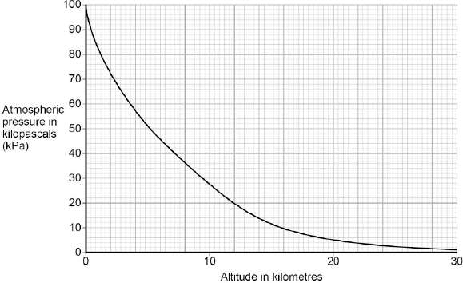
(a) Explain why atmospheric pressure decreases with increasing altitude.
___________________________________________________________________
___________________________________________________________________
___________________________________________________________________
___________________________________________________________________
___________________________________________________________________
___________________________________________________________________
(3)
(b) When flying, the pressure inside the cabin of an aircraft is kept at 70 kPa.
The aircraft window has an area of 810 cm².
Use data from Figure 1 to calculate the resultant force acting on an aircraft window when the aircraft is flying at an altitude of 12 km.
Give your answer to two significant figures
___________________________________________________________________
___________________________________________________________________
___________________________________________________________________
___________________________________________________________________
___________________________________________________________________
___________________________________________________________________
Resultant force = ___________________ N
(5)
(c) Figure 2 shows the cross-section of one type of aircraft window.
Figure 2
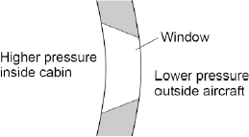
Explain why the window has been designed to have this shape.
___________________________________________________________________
___________________________________________________________________
___________________________________________________________________
(2)
(Total 10 marks)
(Total 6 marks)

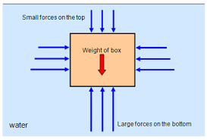
Things float if the upthrust of an object is equal to (or greater than) the weight. Upthrust is caused by water particles colliding with surfaces in the water. We know that pressure increases with depth, so an object in a liquid will have a slight pressure difference on the top and bottom. This pressure difference leads to a difference in forces which causes upthrust.
Upthrust and Floatation

We can calculate the maximum upthrust of an object by using the equation:
Upthrust = density of liquid x grav field strength x volume of object in water
This is also equal to the weight of water that gets displaced.
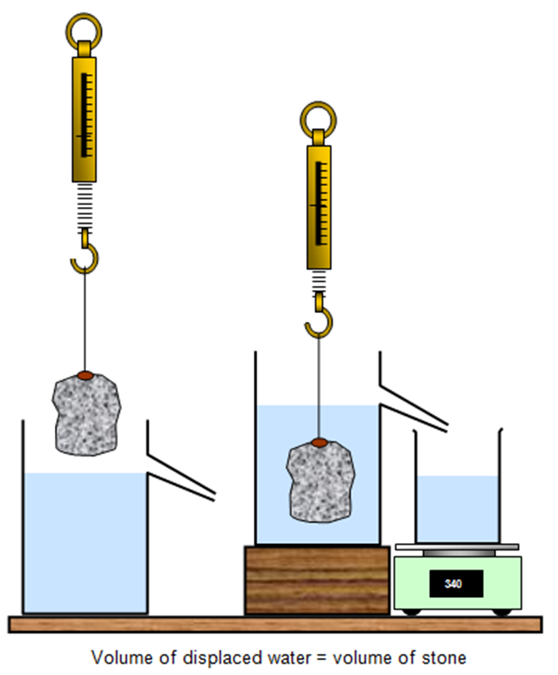
This gives a nice link between the density practicals. When we submerge the object it displaces water equal to the volume of the object.
If the object has a higher weight than the weight of the water, it will sink. If the object has a lower weight, it will float.
In both cases the volume is the same, so the only thing that is affecting whether or not it floats is the density of the object. If it is higher density than the water, it will be heavier so will sink, and visa versa.
This is why wood floats but lumps of metal will sink.
Investigation into Upthrust
- Measure the weight of the object using the Newton meter.
- Submerge it in water in a displacement can and measure the difference in weight measured by the Newton meter.
- Measure the mass of the water ejected.
- Convert this into it’s force due to gravity and compare with the weight difference of the object in and out of the water.

Task: Complete in your exercise book
- Complete the sentences below:
When an object is placed in water it will float if the density is ________ than water.
This is because the water that is being displaced has a __________ weight than the weight of the object.
The weight of the water displaced is the same as the ___________ force.
The upthrust force is caused by a __________ difference between the top and bottom of the object.
- An object was measured with a Newton-meter to have a weight of 12N, it was then dipped into a displacement can. The weight of the water was found to be 8N. Did the object float or sink?
- A different object was measured with a Newton-meter to have a weight of 7N, it was then dipped into a displacement can full of oil. The weight of the oil was found to be 7N. Did the object float or sink?
- An object that sank in a tank of water, displaced 32N worth of water. Give the smallest weight the object could be.
- An iceberg displaces 300,000,000m³ of sea water (ρ= 1027 kg/m³) what is the weight of the iceberg?
- Amazon accidently deliver Aneesh’s package into the ocean. Knowing the volume of the packages is 0.2m3 and its mass is 100kg, will it float? The density of water is 1000kg/m3.
- Aneesh builds a boat out of another box to fetch his package. The length of the boat is 140cm, the width is 40cm and the height is 60cm. The combined mass of Aneesh and his box boat is 90kg will he float?
- The radius of a bowling balls 10.8cm. What does its mass have to be in order for it to float?
- Ice and lead are both solids. Which has the greatest density and how do you know?
- A submarine has can be assumed to be the shape of a perfect cylinder the submarine has a mass of 8000kg. What must its volume be for it to float?
- Ami is floating perfectly upright in a swimming pool. If she has a height 1.2m, what is the difference in pressure between the top of his head and the bottom of his feet?
- Explain in a couple of sentences why cruise liners are really heavy, yet they can float on water.
- When an object is weighed using a newton-meter, the reading on the newton-meter is 5.2 N when the object is in air, and 4.7 N when the object is immersed in water.
  - Explain why the reading on the newton-meter is less when the object is in water.
  - Describe how the newton-meter reading changes as the object is lowered into water.
- Three blocks A, B, and C are released in a bowl of a water.
Block A sinks to the bottom
Block B floats with its top half above the water
Block C floats with a small proportion above the water.
  - Which object has the greatest density? Give a reason for your answer.
  - Which object has the lowest density? Give a reason for your answer.
Q1.
Figure 1 shows four blocks of different materials floating on water.
The four blocks are the same volume.
Figure 1
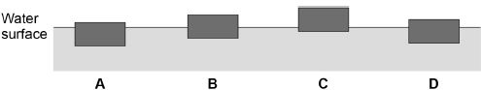
(a) Which of the blocks has the smallest weight?
Tick one box.

A |  | B |  | C |  | D
(1)
Figure 2 shows a lifebuoy next to a deep swimming pool.
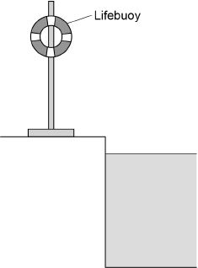
(b) The lifebuoy has a mass of 2.5 kg.
gravitational field strength = 9.8 N/kg
Calculate the weight of the lifebuoy.
Use the equation:
weight = mass × gravitational field strength
___________________________________________________________________
___________________________________________________________________
___________________________________________________________________
___________________________________________________________________
Weight = _____________________ N
(2)

(c) When thrown into the water the lifebuoy floats. The two forces acting on the lifebuoy are the weight of the lifebuoy downwards and upthrust upwards.
How big is the upthrust on the lifebuoy compared to the weight of the lifebuoy?
Tick one box.

The upthrust is greater than the weight.
The upthrust is less than the weight.
The upthrust is the same as the weight.
(1)
(d) Write down the equation which links acceleration, mass and resultant force.
___________________________________________________________________
(1)
(e) A rope is used to pull the lifebuoy to the side of the swimming pool.
A resultant force of 4.0 N acts on the lifebuoy.
The mass of the lifebuoy is 2.5 kg.
Calculate the acceleration of the lifebuoy.
___________________________________________________________________
___________________________________________________________________
___________________________________________________________________
___________________________________________________________________
Acceleration = _______________________ m/s²
(3)
(Total 8 marks)

Q2.
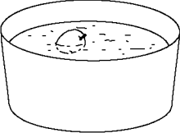
In a science lesson, some children float an apple on some water.
One of the children says:
“The apple is not moving. That means that there cannot be any forces acting on it.”
Do you agree?
Explain your answer as fully as you can.
_______________________________________________________________________
_______________________________________________________________________
_______________________________________________________________________
(Total 3 marks)

