Magnetism is an example of a non-contact force.
Introduction to magnetism
A contact force is one that acts when two objects are physically touching each other. Conversely, a non-contact force acts between objects that are not touching each other.
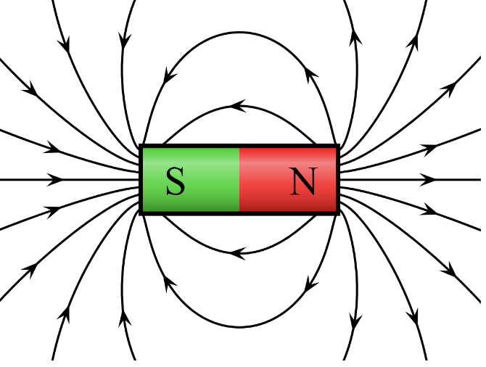
Non-contact forces are caused by field lines. The magnetic field lines for a bar magnet are shown in the diagram to the right.
The bar magnet consists of a North pole and a South pole. The magnetic field lines point away from the North pole and towards the South pole. The field lines give the direction of force on the North pole of another magnet.
Like poles repel. Unlike poles attract.
By Geek3 - Own work, CC BY-SA 3.0, https://commons.wikimedia.org/w/index.php?curid=10587119
The diagram also shows that the magnetic field is stronger near the ends (poles) of the bar magnet. We can tell this because the magnetic field lines are closer together.
A permanent magnet (like a bar magnet) produces its own magnetic field. There are three metals that become magnetic when placed in a magnetic field. These magnetic metals are iron, nickel and cobalt. Steel is also a magnetic metal as it contains iron. Metals other than these are not magnetic.
The magnetic metals are attracted by permanent magnets, but never repelled.
A permanent magnet can be demagnetised by heating it, hitting it with a hammer or by placing it in a reversed magnetic field.
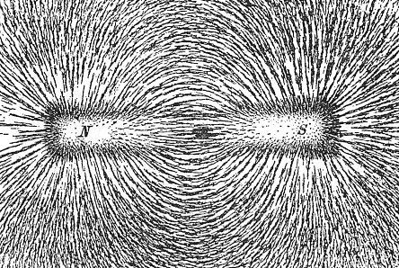
We can visualise the magnetic field around a bar magnet by using iron filings. A bar magnet can be put under a piece of paper, with iron filings then sprinkled on top of the paper.
Newton Henry Black, Public domain, via Wikimedia Commons
The iron filings arrange themselves in the shape of the field and are most attracted to the regions with the strongest field (the poles).

Q1. State the direction that magnetic lines point.
………………………………………………………………………………………………………………………………………………………………………………………………………..
Q2. State the difference between a contact force and a non-contact force.
………………………………………………………………………………………………………………………………………………………………………………………………………..
………………………………………………………………………………………………………………………………………………………………………………………………………..
Q3. State whether magnetism is a contact or non-contact force.
………………………………………………………………………………………………………………………………………………………………………………………………………..
Q4. In the space below, sketch the pattern of magnetic field lines around a bar magnet.
Q5. State the three magnetic metals.
………………………………………………………………………………………………………………………………………………………………………………………………………..
Q6. The following statements are either true or false. State which are true and which are false.
- Cobalt is attracted to a bar magnet.
………………………………………………………………………………………………………………………………………………………………………………………………………..
- A north pole repels another north pole.
………………………………………………………………………………………………………………………………………………………………………………………………………..
- Copper is attracted to a bar magnet.
………………………………………………………………………………………………………………………………………………………………………………………………………..
- A north pole attracts a south pole.
………………………………………………………………………………………………………………………………………………………………………………………………………..
- The closer together the magnetic field lines, the stronger the field.
………………………………………………………………………………………………………………………………………………………………………………………………………..
- Iron is repelled by a bar magnet.
………………………………………………………………………………………………………………………………………………………………………………………………………..
- Magnetic field lines point away from a South pole and towards a North pole.
………………………………………………………………………………………………………………………………………………………………………………………………………..

