Convection worksheet
Basic
Q1. State which states of matter convection happens in.
Q2. Describe the particle arrangement in a gas.
Q3. Describe what happens to the motion of gas particles as the gas is heated.
Q4. State what happens to the density of a gas as the gas is heated.
Q5. Describe the particle arrangement in a liquid.
Q6. Describe what happens to the motion of liquid particles as the liquid is heated.
Q7. State what happens to the density of a liquid as the liquid is heated.
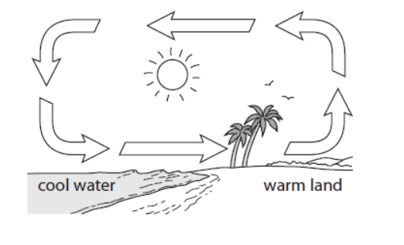

Medium
Q8. Describe why hot air rises and cold air sinks.
Q9. The diagram shows how air moves near the coast on a warm day. Explain why air moves as shown on the diagram.

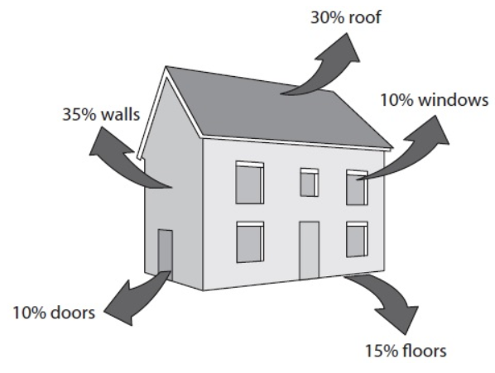
Hard
Q10. The diagram shows typical values for the percentage energy losses from a house.
- State which area of the house most energy is lost from.
- Calculate the total percentage energy loss from the roof and the windows.
- Insulation is used to reduce energy losses from houses.
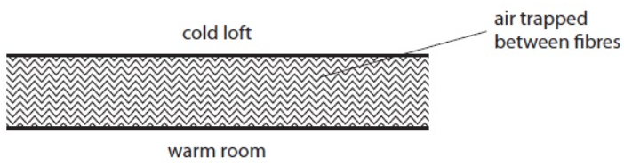
Insulating material often consists of fibres with air between them. The diagram shows a section through some insulating material.
- Explain how this type of insulation reduces energy loss by conduction.
- Explain how this type of insulation reduces energy loss by convection.

