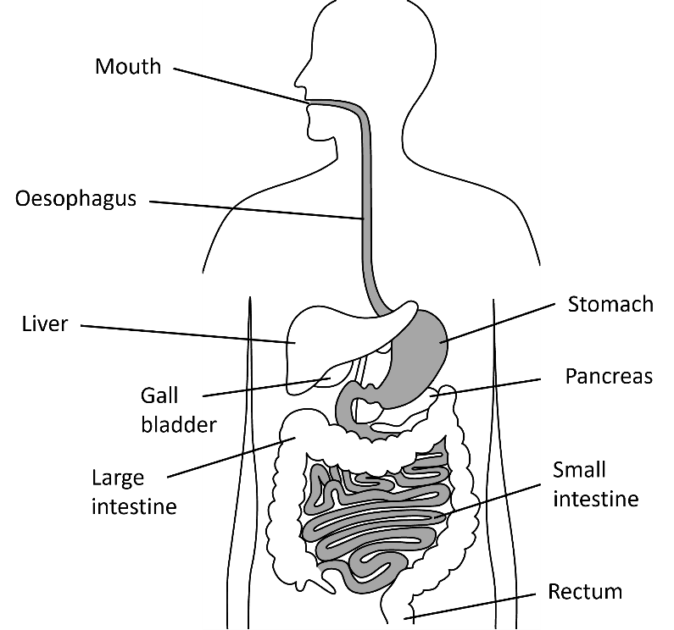
Food that we eat is broken down by our digestive systems into small molecules. The digestive system consists of many different organs which serve a specific role in the process of digestion.
Digestive system
Enzymes have an important role in digestion and help chemically break the food down. Enzymes are biological catalysts. Catalysts increase the rate of a chemical reaction.
Some bacteria also live in our digestive systems. They live mainly in the large intestine and protect against harmful bacteria and help with the digestion of food
Lozzaaa, Public domain, via Wikimedia Commons
Mouth | Contains teeth that mechanically break food down. Saliva in the mouth contains the enzyme amylase which breaks down starch (a carbohydrate).
Oesophagus | After food is swallowed, the walls of the oesophagus squeeze together and moves the food towards the stomach.
Stomach | The stomach has muscular walls that mechanically breaks food down. It also contains hydrochloric acid that kills bacteria. The enzyme protease works best in acidic conditions. Protease breaks down proteins.
Small intestine | Contains villi which have a very large surface area. This allows digested food to be absorbed more quickly into the blood stream.
Large intestine | The large intestine is where water is absorbed.
Rectum | Waste material (called faeces) is stored here before it leaves the body through the anus.
A diagram of the digestive system is shown above, food travels through each of the structures and organs in the order of the table below:
Food does not travel through the below organs, but they still play a vital role in digestion.
Liver | Produces bile, which is used to neutralise stomach acid.
Gall bladder | Stores bile and releases it into the small intestine.
Pancreas | Produces the enzymes protease, amylase and lipase which are passed into the small intestine. Lipase breaks down lipids.
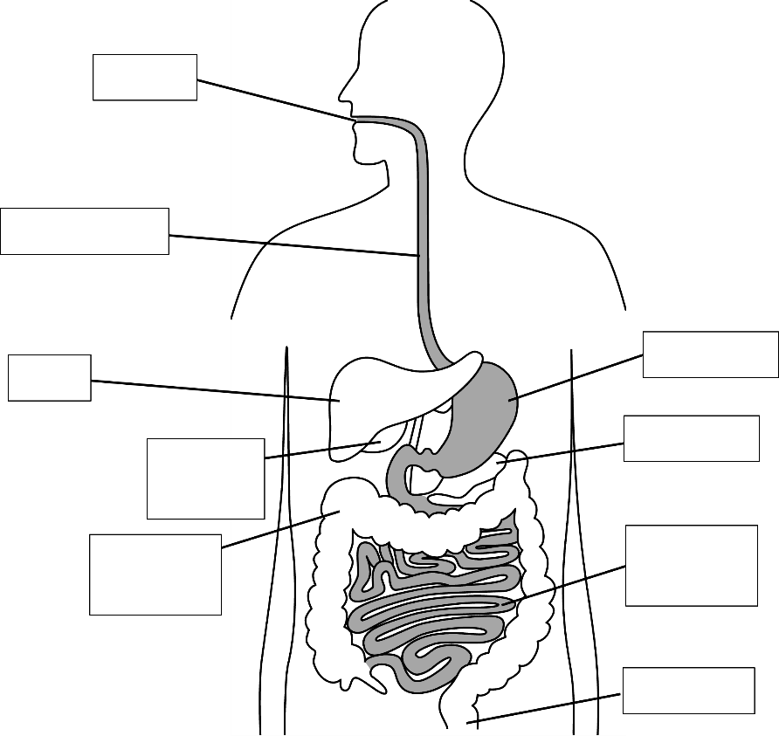
Q1. Label the diagram of the digestive system.

Q2. State the name of the organ that contains hydrochloric acid.
………………………………………………………………………………………………………………………………………………………………………………………………………..
Q3. State the name of the organ where digested food is absorbed into the blood.
………………………………………………………………………………………………………………………………………………………………………………………………………..
Q4. Describe the purpose of bile and state the name of the organ where bile is produced.
………………………………………………………………………………………………………………………………………………………………………………………………………..
Q5. State where villi are found and describe why it is advantageous for them to have a large surface area.
………………………………………………………………………………………………………………………………………………………………………………………………………..
Q6. State the name of the organ where water is absorbed.
………………………………………………………………………………………………………………………………………………………………………………………………………..
Q7. State the name of an organ where food is mechanically broken down.
………………………………………………………………………………………………………………………………………………………………………………………………………..
Q8. Describe what faeces is and state the name of the organ where faeces is stored.
………………………………………………………………………………………………………………………………………………………………………………………………………..
Q9. State an organ that produces an enzyme.
………………………………………………………………………………………………………………………………………………………………………………………………………..
Q10. Describe the role of enzymes in digestion. Include the name of a specific enzyme and the purpose of that enzyme.
………………………………………………………………………………………………………………………………………………………………………………………………………..
………………………………………………………………………………………………………………………………………………………………………………………………………..

