We need to eat a certain amount of food to survive. Food is a store of chemical energy. When we eat food, that chemical energy is transferred to us. The unit of energy is the joule (J), but when referring to food we use the unit kilojoule (kJ). Another unit that you may have heard of is the calorie. One calorie is equal to 4.2 J.
Food energy requirements
If we do not eat the right amount of food or have an unbalanced diet, then we’re at risk of becoming malnourished.
If somebody eats too little food, then they lose weight. If this persists for a long period of time, then it could lead to starvation. If starvation persists, then it can eventually lead to death.
If somebody eats too much food, then they gain weight. If this persists for a long period of time, then it could lead to obesity. Obesity is when somebody has too much body fat.
Obesity can lead to heart disease and diabetes.
Our basal metabolic rate is a measure of the energy content of food that we need to eat to survive if we are inactive (doing no physical exercise).
If we are active, then we need to eat more. Our physical activity level is a measure of the energy content of food that we need to eat because of our activity. Together, our basal metabolic rate and our physical activity level combine to form our overall metabolic rate.
Various factors affect our overall metabolic rate:
- Age (young children require less food than fully grown adults. As adults get older, they also require less food).
- Gender (men require more food than women).
- Body mass (the larger somebody’s body mass, the more food they require).
- Exercise levels (the more somebody exercises, the more food they require).
- Pregnancy (while pregnant, someone requires more food).
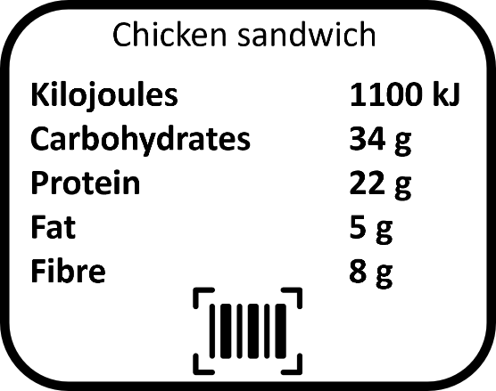
The average man needs to consume 10 500 kJ a day from their food, while the average woman needs 8400 kJ a day.
It is important that food is clearly labelled to show its energy content and how much of each food group it contains. This is so that we can make sure what we’re eating forms a balanced diet. An example food label is shown to the right.

Q1. State the unit of energy that we use when referring to food.
………………………………………………………………………………………………………………………………………………………………………………………………………..
Q2. Describe what might happen if we eat too little food.
………………………………………………………………………………………………………………………………………………………………………………………………………..
………………………………………………………………………………………………………………………………………………………………………………………………………..
Q3. Describe what might happen if we eat too much food.
………………………………………………………………………………………………………………………………………………………………………………………………………..
………………………………………………………………………………………………………………………………………………………………………………………………………..
Q4. Explain what basal metabolic rate means.
………………………………………………………………………………………………………………………………………………………………………………………………………..
………………………………………………………………………………………………………………………………………………………………………………………………………..
Q5. Describe how somebody’s overall metabolic rate depends on the amount they exercise.
………………………………………………………………………………………………………………………………………………………………………………………………………..
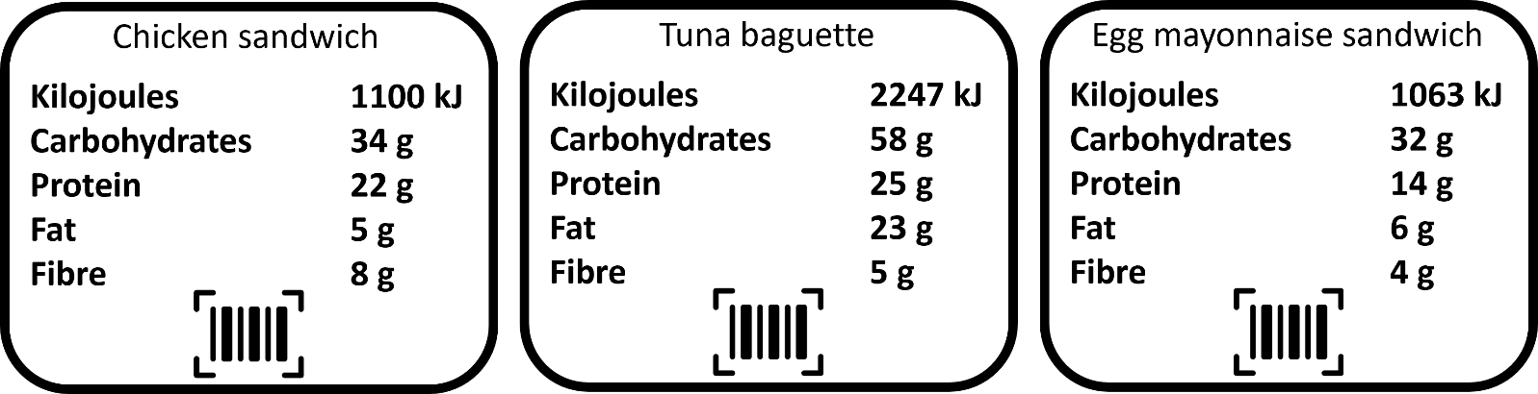
………………………………………………………………………………………………………………………………………………………………………………………………………..
Q6. Using the diagrams above, state which sandwich has:
- The highest energy content. ……………………………………..
- The highest amount of carbohydrates. ……………………………………..
- The least amount of fat. ……………………………………..
- The most amount of fibre. ……………………………………..
- The least amount of protein. ……………………………………..
Q7. Using the diagrams above, state which sandwich would be most suitable for someone who does a lot of exercise. Explain why.
………………………………………………………………………………………………………………………………………………………………………………………………………..
………………………………………………………………………………………………………………………………………………………………………………………………………..
Q8. State two risks of obesity.
………………………………………………………………………………………………………………………………………………………………………………………………………..
Q9. Describe why it is important that food is clearly labelled, showing the amounts of each food group.
………………………………………………………………………………………………………………………………………………………………………………………………………..

