We can carry out food tests to test what substances are in our foods. These food tests are:
Food Tests
- To test for the presence of protein we use Biuret solution.
To carry out the test, add a sample of the food to a test tube and then add a few drops of Biuret solution (which is coloured blue).
If the colour of the solution remains blue, then there is no protein in the food. If the colour of the solution changes to purple, then protein is present in the food.
Examples of foods that contain protein are meat, fish, eggs, cheese, milk and nuts.
- To test for the presence of sugar we use Benedict’s solution.
Again, the solution needs to be added to a sample of the food. The reaction is slow, though, and so it needs to be heated in a water bath for a few minutes.
If there is sugar in the food, then it will turn green, yellow, orange or red. The colour it turns depends on the concentration of sugar in the food.
Examples of foods that contain sugar are fizzy drinks, fruit juices, sweets and cakes.
- To test for the presence of starch (a carbohydrate) we use iodine solution.
The iodine reagent is initially yellow/brown but when it comes into contact with starch it quickly turns blue/black.
Examples of foods that contain carbohydrates are bread, pasta, potatoes and rice.
- To test for the presence of lipids (fats) we can use ethanol.
If fats are present in the sample of food, then the ethanol will turn a cloudy milky white.
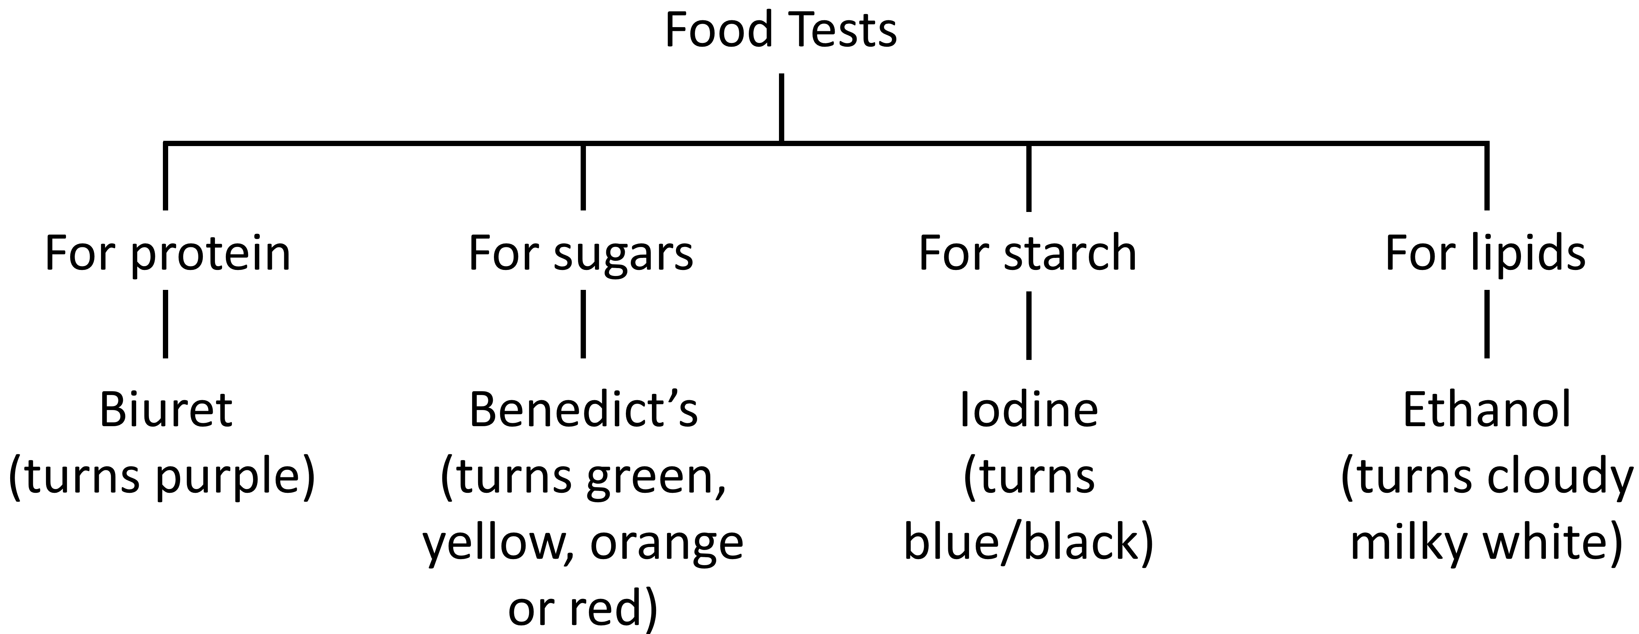
Examples of foods that contain lipids are oil, cheese, butter and some meats.
Q1. Give an example of a food that contains a lot of lipids.
………………………………………………………………………………………………………………………………………………………………………………………………………..
Q2. Give an example of a food that contains a lot of protein.
………………………………………………………………………………………………………………………………………………………………………………………………………..
Q3. Give an example of a food that contains a lot of sugars.
………………………………………………………………………………………………………………………………………………………………………………………………………..
Q4. Give an example of a food that contains a lot of carbohydrates.
………………………………………………………………………………………………………………………………………………………………………………………………………..
Q5. An investigation is carried out to determine if a food sample contains sugars. State which food test we should use and what colour changes will occur if sugar is present.
………………………………………………………………………………………………………………………………………………………………………………………………………..
………………………………………………………………………………………………………………………………………………………………………………………………………..
Q6. An investigation is carried out to determine if a food sample contains lipids. State which food test we should use and what colour changes will occur if lipids are present.
………………………………………………………………………………………………………………………………………………………………………………………………………..
………………………………………………………………………………………………………………………………………………………………………………………………………..
Q7. An investigation is carried out to determine if a food sample contains protein. State which food test we should use and what colour changes will occur if protein is present.
………………………………………………………………………………………………………………………………………………………………………………………………………..
………………………………………………………………………………………………………………………………………………………………………………………………………..
Q8. Some iodine solution is dropped onto a slice of bread. Describe what we will see. Explain why.
………………………………………………………………………………………………………………………………………………………………………………………………………..
………………………………………………………………………………………………………………………………………………………………………………………………………..
Retrieval questions:
Q9. State the reason why we need to eat carbohydrates.
………………………………………………………………………………………………………………………………………………………………………………………………………..
Q10. State the reason why we need to eat lipids.
………………………………………………………………………………………………………………………………………………………………………………………………………..
Q11. State the reason why we need to eat proteins.
………………………………………………………………………………………………………………………………………………………………………………………………………..
Q12. State the name of the deficiency disease caused by a lack of protein.
………………………………………………………………………………………………………………………………………………………………………………………………………..

