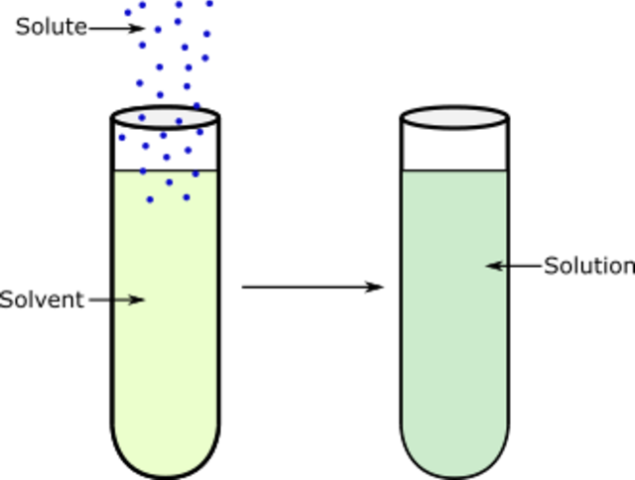
If we add a sugar cube to water, the sugar dissolves. It looks like the sugar has disappeared, but the particles are just mixed in with the water.
Making and separating solutions
To make the sugar dissolve faster, we could heat the water and stir it.
A substance that dissolves is called the solute, while something that dissolves other substances is called a solvent.
In the example above, sugar is the solute and water is the solvent. Once a solute is dissolved in a solvent, a solution is formed.
Maxmath12, CC0, via Wikimedia Commons
If a substance can dissolve, it is called soluble. If it is not able to dissolve it is insoluble. While salt dissolves in water, sand does not. Sand is insoluble in water.
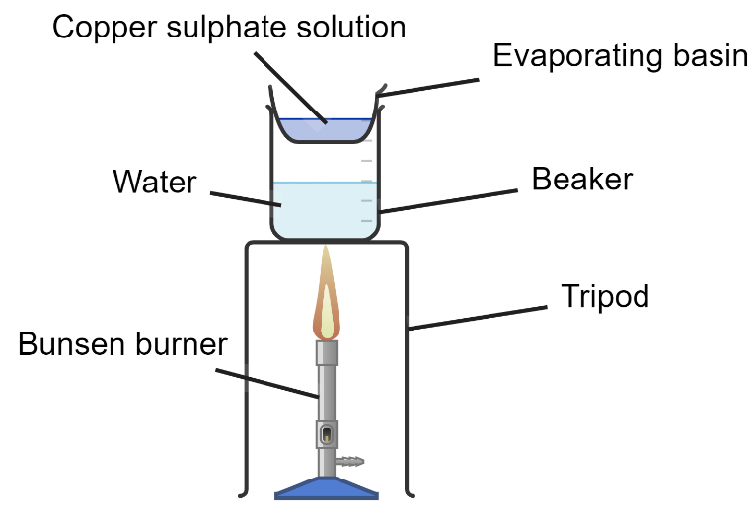
To separate out a solute we can use a setup like that in the diagram to the left. Here, we are trying to obtain copper sulphate crystals from the solution.
The solution is poured into an evaporating basin and gently heated. When some of the solvent has evaporated, the solution is removed from the heat.
Eventually, copper sulphate crystals are formed as the solvent evaporates.
Created with Chemix (https://chemix.org)
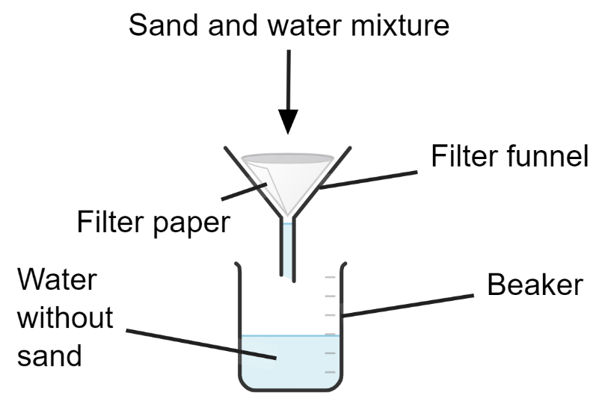
Because sand is insoluble in water, this method cannot work for a sand and water mixture.
Instead, we use filtration. The sand and water mixture is poured onto some filter paper.
Because the water molecules are smaller than the sand particles, water passes through the filter funnel but the sand doesn’t. Therefore, we can separate the water and sand.
Created with Chemix (https://chemix.org)
Q1. The following statements are either true or false. State which are true and which are false.
- Sand is soluble in water.
………………………………………………………………………………………………………………………………………………………………………………………………………..
- Salt is soluble in water.
………………………………………………………………………………………………………………………………………………………………………………………………………..
- Sugar dissolves faster in hot water than it does in cold water.
………………………………………………………………………………………………………………………………………………………………………………………………………..
- You can filter out the salt from a saltwater solution by passing the solution through filter paper.
………………………………………………………………………………………………………………………………………………………………………………………………………..
Q2. In fizzy drinks, the bubbles are caused by carbon dioxide. The carbon dioxide is initially dissolved in the water.
- State the solute.
………………………………………………………………………………………………………………………………………………………………………………………………………..
- State the solvent.
………………………………………………………………………………………………………………………………………………………………………………………………………..
Q3. Describe what the word soluble means.
………………………………………………………………………………………………………………………………………………………………………………………………………..
Q4. Describe what the word insoluble means.
………………………………………………………………………………………………………………………………………………………………………………………………………..
Q5. State two ways of making salt dissolve faster in water.
………………………………………………………………………………………………………………………………………………………………………………………………………..
Q6. Describe how you would separate sand from a sand and water mixture.
………………………………………………………………………………………………………………………………………………………………………………………………………..
………………………………………………………………………………………………………………………………………………………………………………………………………..
………………………………………………………………………………………………………………………………………………………………………………………………………..
Q7. Describe how you would separate sugar from a sugar and water solution.
………………………………………………………………………………………………………………………………………………………………………………………………………..
………………………………………………………………………………………………………………………………………………………………………………………………………..
………………………………………………………………………………………………………………………………………………………………………………………………………..

