
digestion
Nutrition &
Name ______________________________
Class ______________________________
Teacher ______________________________
A balanced diet involves consuming an appropriate amount of each food group. A balanced diet is important to keep us healthy. Each of these food groups are in the table below:
Nutrition
Name of food group | How the body uses this food group | Examples of foods that include this
Carbohydrates | The body breaks carbohydrates into simple sugars like glucose. Glucose is used for respiration. | Bread, pasta, potatoes, rice.
Lipids (fats) | Long term energy storage. | Oil, cheese, butter, some meats.
Proteins | Needed for growth and repair of tissues. | Meat, fish, eggs, cheese, milk, nuts.
Vitamins | Different vitamins are needed for many different aspects of our health (some examples below). | Fruit and vegetables.
Minerals | Different minerals are needed for many different aspects of our health (some examples below). | A wide variety of foods (examples below).
Fibre | Needed to help food move through the intestines. | Cereals, fruit and vegetables.
Water | Needed to keep us hydrated. | Any drink, fruit and vegetables.

If we do not eat enough of one of the food groups, we’re at risk of developing a deficiency disease. Some examples of these are below:
- Anaemia. This is caused by a lack of the mineral iron. Eating meat is a good source of iron. Anaemia causes pale skin, tiredness and shortness of breath.
- Rickets. This is caused by a lack of vitamin D. If a child does not get enough vitamin D then they can develop rickets. This causes problems with bone growth, fragile bones and painful bones.
- Scurvy. This is caused by a lack of vitamin C. Scurvy can cause tiredness, swelling of gums and loss of teeth.
- Kwashiorkor. This is caused by a lack of protein. Developing kwashiorkor means that the body can’t grow and repair its tissues. It can cause stunted growth.
Q1. Explain why a balanced diet is important.
………………………………………………………………………………………………………………………………………………………………………………………………………..
Q2. Name the seven food groups.
………………………………………………………………………………………………………………………………………………………………………………………………………..
………………………………………………………………………………………………………………………………………………………………………………………………………..
Q3. State the reason why we need to eat fibre.
………………………………………………………………………………………………………………………………………………………………………………………………………..
Q4. State the reason why we need to eat carbohydrates.
………………………………………………………………………………………………………………………………………………………………………………………………………..
Q5. State the reason why we need to eat lipids.
………………………………………………………………………………………………………………………………………………………………………………………………………..
Q6. Give an example of a food that contains a lot of protein.
………………………………………………………………………………………………………………………………………………………………………………………………………..
Q7. Give an example of a food that contains a lot of lipids.
………………………………………………………………………………………………………………………………………………………………………………………………………..
Q8. The following statements are either true or false. State which are true and which are false.
- Carbohydrates are needed for growth and repair of tissues.
………………………………………………………………………………………………………………………………………………………………………………………………………..
- Pasta is an example of a food that contains a lot of carbohydrates.
………………………………………………………………………………………………………………………………………………………………………………………………………..
- Cheese is an example of a food that contains a lot of fibre.
………………………………………………………………………………………………………………………………………………………………………………………………………..
Q9. State what we’re at risk of developing if we do not eat enough of one of the food groups.
………………………………………………………………………………………………………………………………………………………………………………………………………..
Q10. Calcium is a mineral that helps us to maintain strong bones. Name another mineral.
………………………………………………………………………………………………………………………………………………………………………………………………………..
Q11. Somebody suffers from anaemia. Suggest what food they could eat to resolve this. Explain your reasons why.
………………………………………………………………………………………………………………………………………………………………………………………………………..
Q12. Somebody suffers from kwashiorkor. Suggest what food they could eat to resolve this. Explain your reasons why.
………………………………………………………………………………………………………………………………………………………………………………………………………..

We need to eat a certain amount of food to survive. Food is a store of chemical energy. When we eat food, that chemical energy is transferred to us. The unit of energy is the joule (J), but when referring to food we use the unit kilojoule (kJ). Another unit that you may have heard of is the calorie. One calorie is equal to 4.2 J.
Food energy requirements
If we do not eat the right amount of food or have an unbalanced diet, then we’re at risk of becoming malnourished.
If somebody eats too little food, then they lose weight. If this persists for a long period of time, then it could lead to starvation. If starvation persists, then it can eventually lead to death.
If somebody eats too much food, then they gain weight. If this persists for a long period of time, then it could lead to obesity. Obesity is when somebody has too much body fat.
Obesity can lead to heart disease and diabetes.
Our basal metabolic rate is a measure of the energy content of food that we need to eat to survive if we are inactive (doing no physical exercise).
If we are active, then we need to eat more. Our physical activity level is a measure of the energy content of food that we need to eat because of our activity. Together, our basal metabolic rate and our physical activity level combine to form our overall metabolic rate.
Various factors affect our overall metabolic rate:
- Age (young children require less food than fully grown adults. As adults get older, they also require less food).
- Gender (men require more food than women).
- Body mass (the larger somebody’s body mass, the more food they require).
- Exercise levels (the more somebody exercises, the more food they require).
- Pregnancy (while pregnant, someone requires more food).
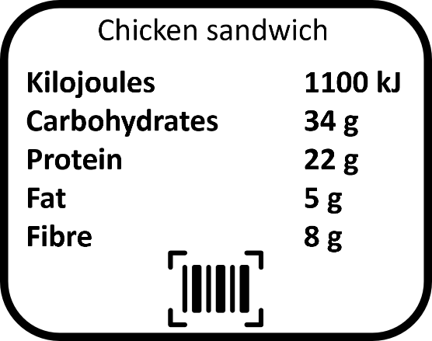
The average man needs to consume 10 500 kJ a day from their food, while the average woman needs 8400 kJ a day.
It is important that food is clearly labelled to show its energy content and how much of each food group it contains. This is so that we can make sure what we’re eating forms a balanced diet. An example food label is shown to the right.

Q1. State the unit of energy that we use when referring to food.
………………………………………………………………………………………………………………………………………………………………………………………………………..
Q2. Describe what might happen if we eat too little food.
………………………………………………………………………………………………………………………………………………………………………………………………………..
………………………………………………………………………………………………………………………………………………………………………………………………………..
Q3. Describe what might happen if we eat too much food.
………………………………………………………………………………………………………………………………………………………………………………………………………..
………………………………………………………………………………………………………………………………………………………………………………………………………..
Q4. Explain what basal metabolic rate means.
………………………………………………………………………………………………………………………………………………………………………………………………………..
………………………………………………………………………………………………………………………………………………………………………………………………………..
Q5. Describe how somebody’s overall metabolic rate depends on the amount they exercise.
………………………………………………………………………………………………………………………………………………………………………………………………………..
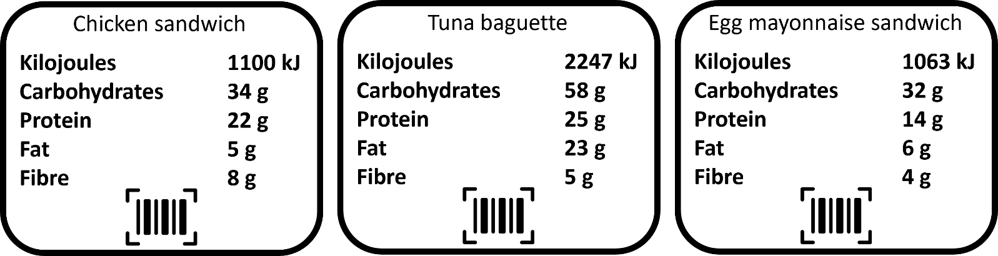
………………………………………………………………………………………………………………………………………………………………………………………………………..
Q6. Using the diagrams above, state which sandwich has:
- The highest energy content. ……………………………………..
- The highest amount of carbohydrates. ……………………………………..
- The least amount of fat. ……………………………………..
- The most amount of fibre. ……………………………………..
- The least amount of protein. ……………………………………..
Q7. Using the diagrams above, state which sandwich would be most suitable for someone who does a lot of exercise. Explain why.
………………………………………………………………………………………………………………………………………………………………………………………………………..
………………………………………………………………………………………………………………………………………………………………………………………………………..
Q8. State two risks of obesity.
………………………………………………………………………………………………………………………………………………………………………………………………………..
Q9. Describe why it is important that food is clearly labelled, showing the amounts of each food group.
………………………………………………………………………………………………………………………………………………………………………………………………………..
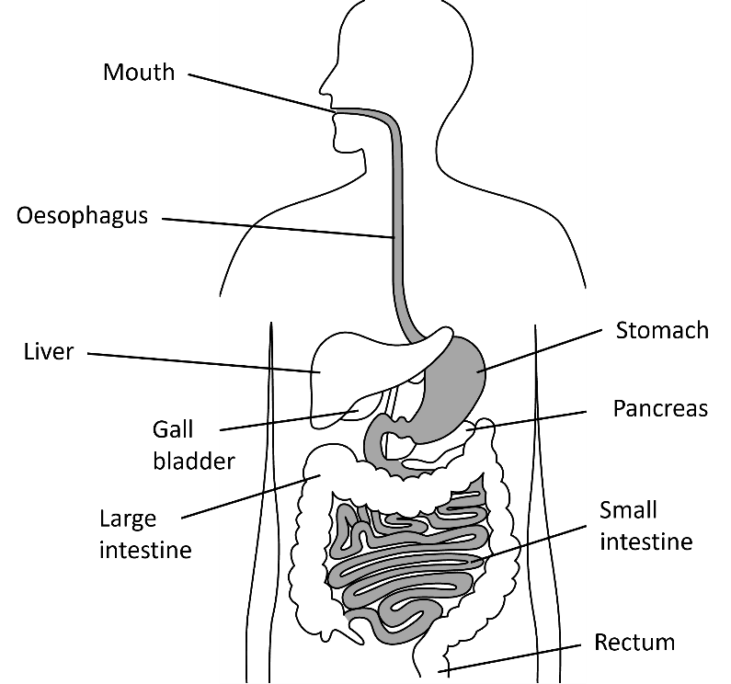
Food that we eat is broken down by our digestive systems into small molecules. The digestive system consists of many different organs which serve a specific role in the process of digestion.
Digestive system
Enzymes have an important role in digestion and help chemically break the food down. Enzymes are biological catalysts. Catalysts increase the rate of a chemical reaction.
Some bacteria also live in our digestive systems. They live mainly in the large intestine and protect against harmful bacteria and help with the digestion of food
Lozzaaa, Public domain, via Wikimedia Commons
Mouth | Contains teeth that mechanically break food down. Saliva in the mouth contains the enzyme amylase which breaks down starch (a carbohydrate).
Oesophagus | After food is swallowed, the walls of the oesophagus squeeze together and moves the food towards the stomach.
Stomach | The stomach has muscular walls that mechanically breaks food down. It also contains hydrochloric acid that kills bacteria. The enzyme protease works best in acidic conditions. Protease breaks down proteins.
Small intestine | Contains villi which have a very large surface area. This allows digested food to be absorbed more quickly into the blood stream.
Large intestine | The large intestine is where water is absorbed.
Rectum | Waste material (called faeces) is stored here before it leaves the body through the anus.
A diagram of the digestive system is shown above, food travels through each of the structures and organs in the order of the table below:
Food does not travel through the below organs, but they still play a vital role in digestion.
Liver | Produces bile, which is used to neutralise stomach acid.
Gall bladder | Stores bile and releases it into the small intestine.
Pancreas | Produces the enzymes protease, amylase and lipase which are passed into the small intestine. Lipase breaks down lipids.
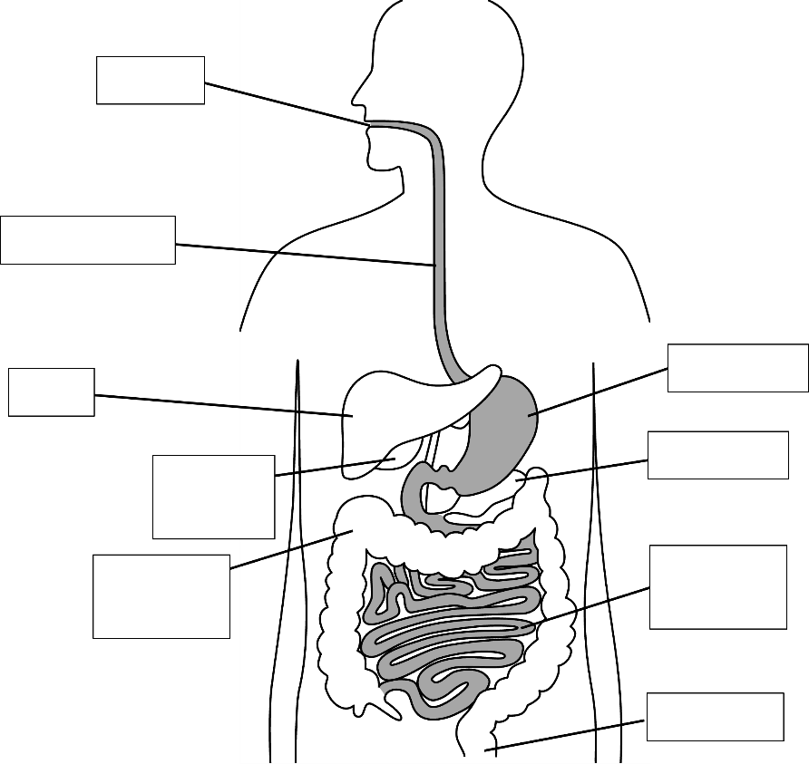
Q1. Label the diagram of the digestive system.

Q2. State the name of the organ that contains hydrochloric acid.
………………………………………………………………………………………………………………………………………………………………………………………………………..
Q3. State the name of the organ where digested food is absorbed into the blood.
………………………………………………………………………………………………………………………………………………………………………………………………………..
Q4. Describe the purpose of bile and state the name of the organ where bile is produced.
………………………………………………………………………………………………………………………………………………………………………………………………………..
Q5. State where villi are found and describe why it is advantageous for them to have a large surface area.
………………………………………………………………………………………………………………………………………………………………………………………………………..
Q6. State the name of the organ where water is absorbed.
………………………………………………………………………………………………………………………………………………………………………………………………………..
Q7. State the name of an organ where food is mechanically broken down.
………………………………………………………………………………………………………………………………………………………………………………………………………..
Q8. Describe what faeces is and state the name of the organ where faeces is stored.
………………………………………………………………………………………………………………………………………………………………………………………………………..
Q9. State an organ that produces an enzyme.
………………………………………………………………………………………………………………………………………………………………………………………………………..
Q10. Describe the role of enzymes in digestion. Include the name of a specific enzyme and the purpose of that enzyme.
………………………………………………………………………………………………………………………………………………………………………………………………………..
………………………………………………………………………………………………………………………………………………………………………………………………………..
We can carry out food tests to test what substances are in our foods. These food tests are:
Food Tests
- To test for the presence of protein we use Biuret solution.
To carry out the test, add a sample of the food to a test tube and then add a few drops of Biuret solution (which is coloured blue).
If the colour of the solution remains blue, then there is no protein in the food. If the colour of the solution changes to purple, then protein is present in the food.
Examples of foods that contain protein are meat, fish, eggs, cheese, milk and nuts.
- To test for the presence of sugar we use Benedict’s solution.
Again, the solution needs to be added to a sample of the food. The reaction is slow, though, and so it needs to be heated in a water bath for a few minutes.
If there is sugar in the food, then it will turn green, yellow, orange or red. The colour it turns depends on the concentration of sugar in the food.
Examples of foods that contain sugar are fizzy drinks, fruit juices, sweets and cakes.
- To test for the presence of starch (a carbohydrate) we use iodine solution.
The iodine reagent is initially yellow/brown but when it comes into contact with starch it quickly turns blue/black.
Examples of foods that contain carbohydrates are bread, pasta, potatoes and rice.
- To test for the presence of lipids (fats) we can use ethanol.
If fats are present in the sample of food, then the ethanol will turn a cloudy milky white.
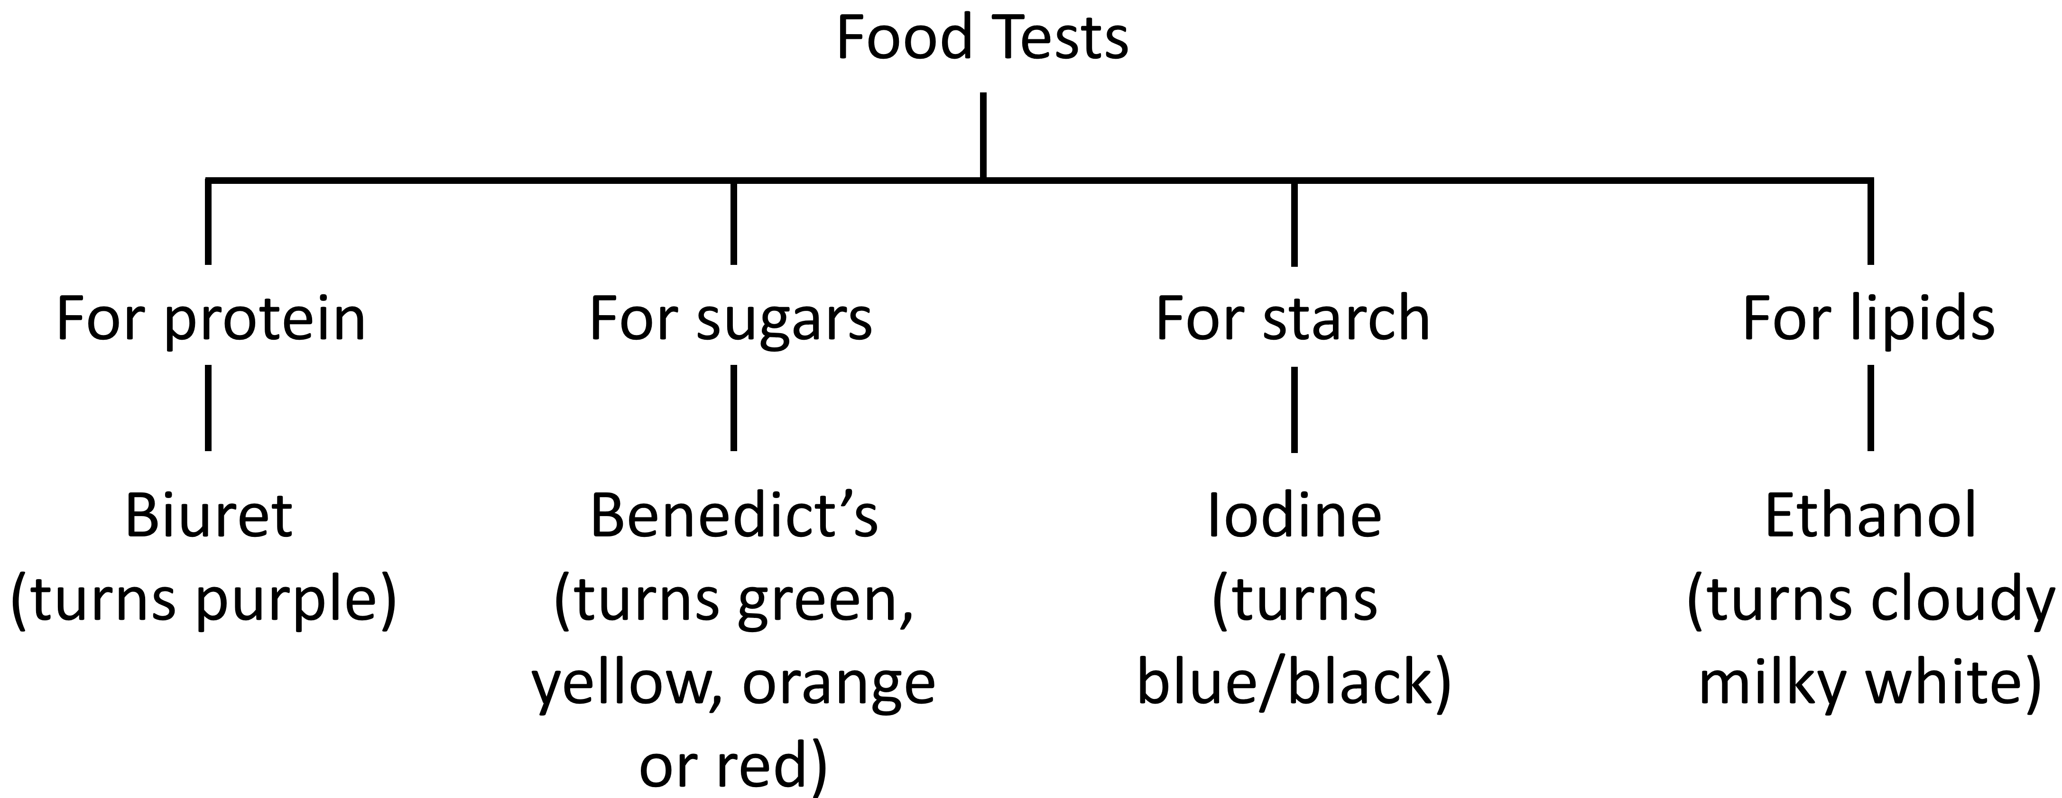
Examples of foods that contain lipids are oil, cheese, butter and some meats.
Q1. Give an example of a food that contains a lot of lipids.
………………………………………………………………………………………………………………………………………………………………………………………………………..
Q2. Give an example of a food that contains a lot of protein.
………………………………………………………………………………………………………………………………………………………………………………………………………..
Q3. Give an example of a food that contains a lot of sugars.
………………………………………………………………………………………………………………………………………………………………………………………………………..
Q4. Give an example of a food that contains a lot of carbohydrates.
………………………………………………………………………………………………………………………………………………………………………………………………………..
Q5. An investigation is carried out to determine if a food sample contains sugars. State which food test we should use and what colour changes will occur if sugar is present.
………………………………………………………………………………………………………………………………………………………………………………………………………..
………………………………………………………………………………………………………………………………………………………………………………………………………..
Q6. An investigation is carried out to determine if a food sample contains lipids. State which food test we should use and what colour changes will occur if lipids are present.
………………………………………………………………………………………………………………………………………………………………………………………………………..
………………………………………………………………………………………………………………………………………………………………………………………………………..
Q7. An investigation is carried out to determine if a food sample contains protein. State which food test we should use and what colour changes will occur if protein is present.
………………………………………………………………………………………………………………………………………………………………………………………………………..
………………………………………………………………………………………………………………………………………………………………………………………………………..
Q8. Some iodine solution is dropped onto a slice of bread. Describe what we will see. Explain why.
………………………………………………………………………………………………………………………………………………………………………………………………………..
………………………………………………………………………………………………………………………………………………………………………………………………………..
Retrieval questions:
Q9. State the reason why we need to eat carbohydrates.
………………………………………………………………………………………………………………………………………………………………………………………………………..
Q10. State the reason why we need to eat lipids.
………………………………………………………………………………………………………………………………………………………………………………………………………..
Q11. State the reason why we need to eat proteins.
………………………………………………………………………………………………………………………………………………………………………………………………………..
Q12. State the name of the deficiency disease caused by a lack of protein.
………………………………………………………………………………………………………………………………………………………………………………………………………..

