Gases consist of particles that move in random directions and at a range of different speeds.
Pressure in gases
We know this because of something called Brownian motion. In 1827, Robert Brown (which Brownian motion is named after) noticed that pollen particles moved around in a random way. Smoke particles move in a similar way in air. This is because of collisions with air particles that are moving in random directions and at a range of different speeds.
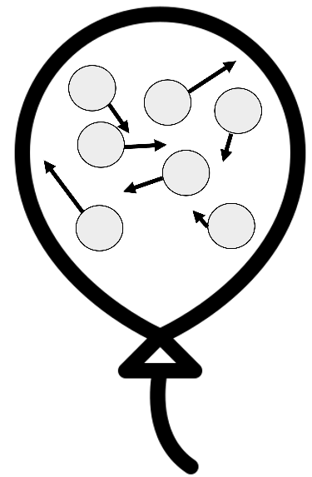
While the smoke particles are much larger than the air particles, the air particles are moving much faster and so they affect how the smoke particles move when they collide.
When a gas particle collides with a surface, pressure is exerted on that surface.
The reason balloons get bigger when you blow them up is because you are adding air into the balloon.
More air means more particles inside the balloon. In turn, this leads to more collisions between air particles and the walls of the balloon. More collisions cause a higher force on the walls, which then leads to a higher pressure. This makes the balloon expand.
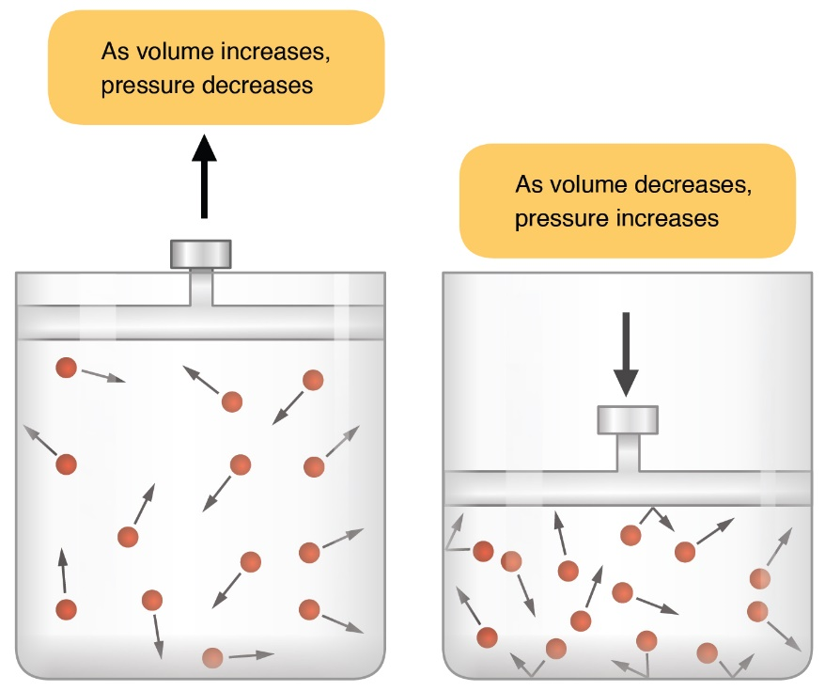
If we reduce the volume of a container, a similar thing happens. This is shown in the diagram to the left.
If the volume of a container is reduced, gas particles collide with the walls of the container more often.
This leads to a higher force on the walls of the container, and therefore a higher pressure.
OpenStax College, CC BY 3.0 <https://creativecommons.org/licenses/by/3.0>, via Wikimedia Commons

If we increase the temperature of a gas in a container, the kinetic energy and speed of the gas particles also increase. This also means the gas particles collide with the walls of the container more often (again leading to a higher force and a higher pressure on the walls of the container). This is why a balloon expands if we heat it.
Q1. Smoke particles are observed to move in a random way in air. State the name of this process and explain why this happens.
………………………………………………………………………………………………………………………………………………………………………………………………………..
………………………………………………………………………………………………………………………………………………………………………………………………………..
Q2. Air is being pumped into a balloon.
- State what happens to the number of air particles inside the balloon.
………………………………………………………………………………………………………………………………………………………………………………………………………..
- State what happens to the number of collisions between the air particles and the walls of the balloon.
………………………………………………………………………………………………………………………………………………………………………………………………………..
- State what happens to the force exerted by the air particles on the walls of the balloon.
………………………………………………………………………………………………………………………………………………………………………………………………………..
- State what happens to the pressure inside the balloon.
………………………………………………………………………………………………………………………………………………………………………………………………………..
- State what happens to the size of the balloon.
………………………………………………………………………………………………………………………………………………………………………………………………………..
Q3. Some gas is inside a container. The volume of the container is slowly increased.
- State what happens to the force exerted by the air particles on the walls of the container.
………………………………………………………………………………………………………………………………………………………………………………………………………..
- State what happens to the pressure inside the container.
………………………………………………………………………………………………………………………………………………………………………………………………………..
Q4. State what happens to the average speed of gas particles as the temperature of the gas is increased.
………………………………………………………………………………………………………………………………………………………………………………………………………..
Q5. Two containers have the same amount of gas particles inside them. Container A is smaller than container B. State and explain which container has the highest pressure.
………………………………………………………………………………………………………………………………………………………………………………………………………..
………………………………………………………………………………………………………………………………………………………………………………………………………..
Q6. Two containers have the same amount of gas particles inside them. Container A is at a lower temperature than container B. State and explain which container has the highest pressure.
………………………………………………………………………………………………………………………………………………………………………………………………………..
………………………………………………………………………………………………………………………………………………………………………………………………………..
Q7. A balloon is cooled. State and explain what happens to the size of the balloon.
………………………………………………………………………………………………………………………………………………………………………………………………………..
………………………………………………………………………………………………………………………………………………………………………………………………………..

