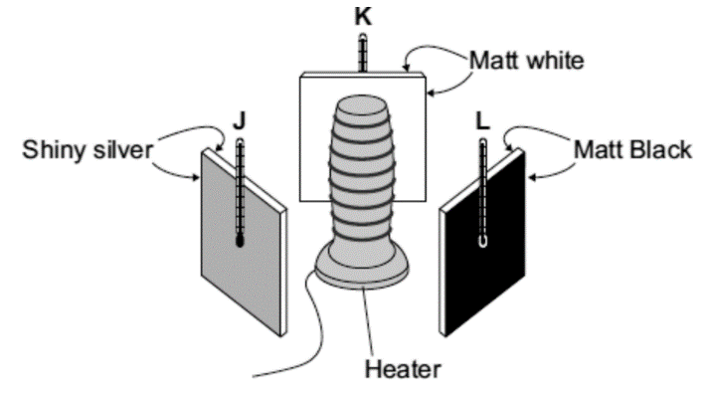
Basic
- How do infrared waves heat objects?
- What is another name for infrared waves?
- Which type of surface is the best absorber of infra-red radiation?
- Which type of surface is the worst absorber of infra-red radiation?
- Which type of surface is the best emitter of infra-red radiation?
- Which type of surface is the worst emitter of infra-red radiation?
- Using the diagram opposite, which of the metal plates (J, K or L) will have the hottest temperature after being heated for 5 minutes. Explain why.
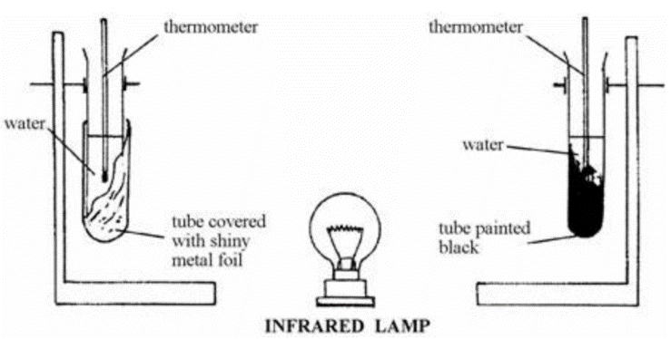
Medium
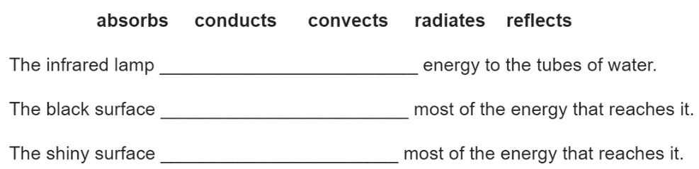
- The diagram to the left shows an experiment to find out what happens to infrared waves when they strike different surfaces. The water in the black tube gets hotter than the water in the shiny tube. Choose words from the list to complete the sentences below.

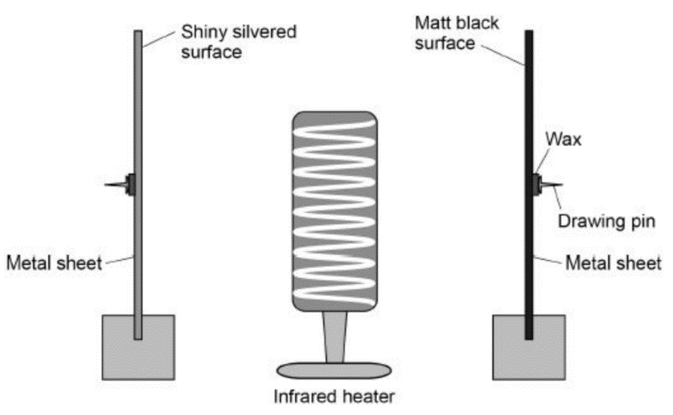
- The metal sheets in the diagram to the left absorb infrared radiation. The wax melts and the drawing pins fall off the surfaces.
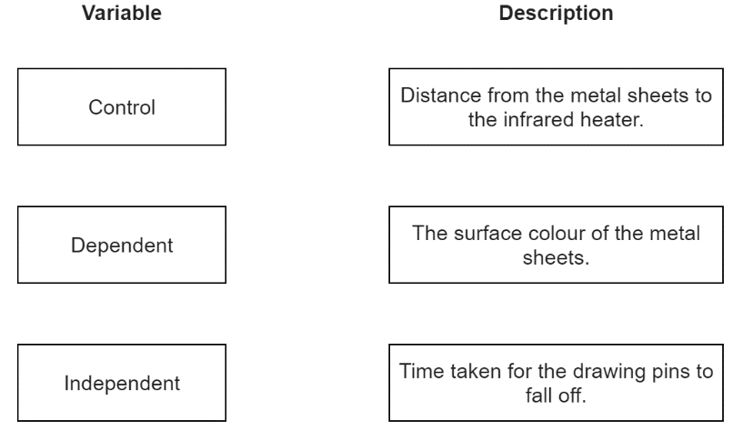
- Draw one line from each variable to the correct description of that variable.
- The drawing pin attached to the matt black metal sheet fell off first. What can be concluded from this result?
Hard
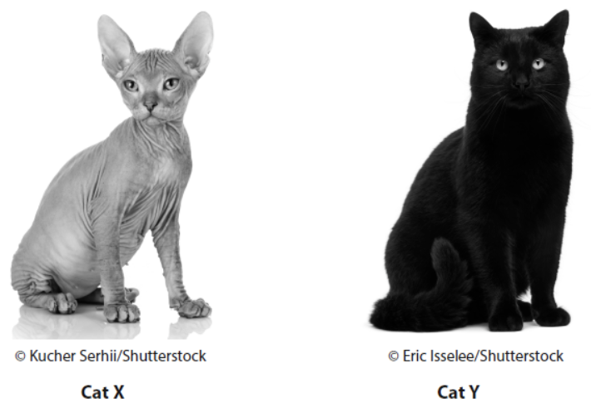
- The photographs show two different breeds of cat.

Cat X has no fur and light-coloured skin. Cat Y has thick, black fur. Both cats have the same body temperature and transfer energy to their surroundings when they are outside on a cold day.

Compare how cat X and cat Y transfer energy to their surroundings. Refer to conduction, convection and radiation in your answer.

