We have already learnt about the particle model, where matter is made of particles. This is one example of a scientific model.
The atom
Scientific models are usually simplified versions of an object or a phenomenon. This makes them easier to understand, while still representing the key features.
The particle model is used to explain and predict the behaviour of solids, liquids and gases. This is a simplification, as we know that particles are made of atoms and molecules (which, in turn, consist of smaller parts).
Models are also changed and updated over time, and the atomic model is one example of this. Previously, it was thought that atoms were indivisible (could not be broken down into anything smaller). This is the Dalton model of the atom.
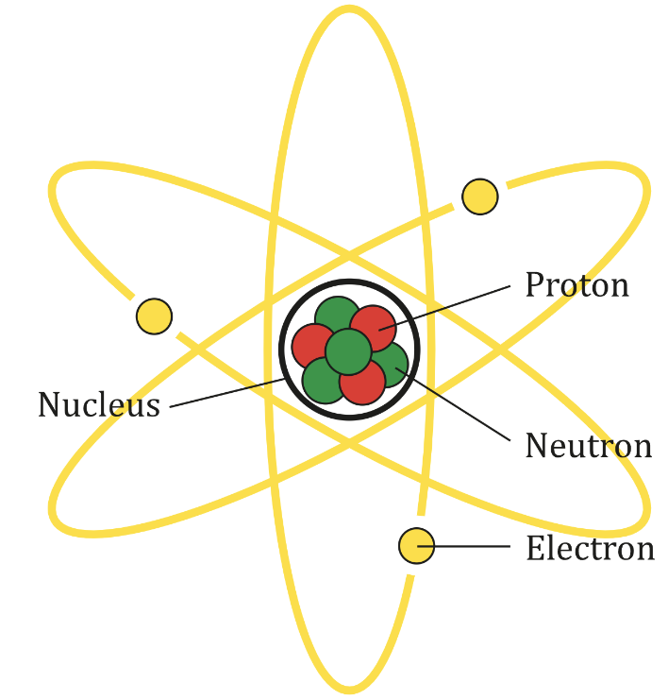
However, newer evidence from experiments suggested that the atom was made up of sub-atomic particles. They are called sub-atomic because they are smaller than the atom itself.
In the current model of the atom, there are three subatomic particles:
- Protons. These have a positive charge and are contained in the centre of atom. The centre of the atom is called the nucleus.
- Neutrons are also contained in the nucleus, but neutrons are neutral. Something that is neutral has no charge.
- Electrons orbit around the nucleus. They have a negative charge.
AG Caesar, CC BY-SA 4.0 <https://creativecommons.org/licenses/by-sa/4.0>, via Wikimedia Commons
Most of the mass of an atom is contained in the nucleus, with neutrons and protons having around 2000 times more mass than an electron.
Overall an atom is neutral as there as equal numbers of electrons and protons.
Generally, evidence is required to change a scientific model. New evidence and research go through a process called peer review.
Peer review is when other scientists look at the new evidence and decide whether or not it is valid. This is important as otherwise incorrect models and theories could be spread. After peer review, new research can be published. After this, other scientists may decide to try and reproduce the research to check whether the results are repeatable.

Q1. Describe the Dalton model of the atom.
………………………………………………………………………………………………………………………………………………………………………………………………………..
………………………………………………………………………………………………………………………………………………………………………………………………………..
Q2. The following questions are asking about the current model of the atom.
- Describe where the nucleus of an atom is.
………………………………………………………………………………………………………………………………………………………………………………………………………..
- Name the two sub-atomic particles that are in the nucleus.
………………………………………………………………………………………………………………………………………………………………………………………………………..
- Name the sub-atomic particle that orbits around the nucleus.
………………………………………………………………………………………………………………………………………………………………………………………………………..
- State the charge on a proton.
………………………………………………………………………………………………………………………………………………………………………………………………………..
- State the charge on an electron.
………………………………………………………………………………………………………………………………………………………………………………………………………..
- State the charge on a neutron.
………………………………………………………………………………………………………………………………………………………………………………………………………..
- Name the sub-atomic particle that has the least mass.
………………………………………………………………………………………………………………………………………………………………………………………………………..
Q3. Describe what a scientific model is.
………………………………………………………………………………………………………………………………………………………………………………………………………..
………………………………………………………………………………………………………………………………………………………………………………………………………..
Q4. Describe an advantage of using scientific models.
………………………………………………………………………………………………………………………………………………………………………………………………………..
………………………………………………………………………………………………………………………………………………………………………………………………………..
Q5. Describe what peer review is.
………………………………………………………………………………………………………………………………………………………………………………………………………..
………………………………………………………………………………………………………………………………………………………………………………………………………..
Q6. Describe the difference between the Dalton model and the current model of the atom.
………………………………………………………………………………………………………………………………………………………………………………………………………..
………………………………………………………………………………………………………………………………………………………………………………………………………..

