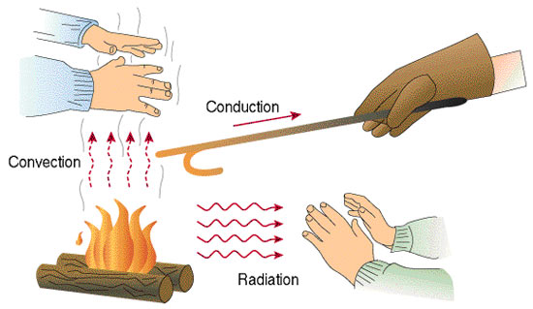
There are three ways that thermal energy can be transferred:
Thermal energy transfer
- Conduction.
- Convection.
- Radiation.
Thermal energy is transferred from hotter objects to colder objects.
Conduction occurs primarily in solids. As particles in a solid are heated, they vibrate more. These vibrations lead to collisions between particles and the vibrations are transferred onwards.
This Photo is licensed under CC BY-SA
If a material is able to conduct heat well, it is called a conductor. Metals are one example of a good conductor.
If a material is not able to conduct heat well, it is called an insulator. Plastics are an example of a good insulator. Gases (like air) are very good insulators, as their particles are so far apart from each other.
There are no particles in a vacuum. No conduction is possible through a vacuum.
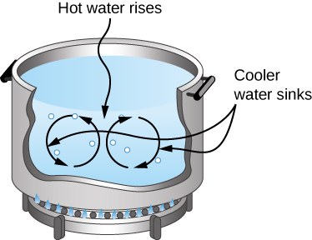
Convection happens in both liquids and gases. As a liquid or gas is heated, the particles move faster and become more spread out. Due to this they become less dense and therefore rise. Colder liquids or gases are more dense and sink. This is a convection current.
This is shown in the image to the left with a pan on a gas stove. The bottom of the pan is hot and so water at the bottom of the pan heats up and rises. Meanwhile, water at the top of the pan cools and sinks.
This Photo is licensed under CC BY
All objects emit radiation in the form of infrared waves. This can be referred to as thermal radiation or infrared radiation.
As infrared radiation is an electromagnetic wave, it can even travel through a vacuum. This is how thermal radiation reaches Earth from the Sun.
Matt black objects absorb the most infrared radiation, while shiny silver surfaces reflect infrared radiation.

Q1. State the three ways that thermal energy can be transferred.
………………………………………………………………………………………………………………………………………………………………………………………………………..
Q2. The following statements are either true or false. State which are true and which are false.
- Conduction happens mostly in solids.
………………………………………………………………………………………………………………………………………………………………………………………………………..
- Metals are good conductors.
………………………………………………………………………………………………………………………………………………………………………………………………………..
- Convection currents happen in liquids only.
………………………………………………………………………………………………………………………………………………………………………………………………………..
- No thermal energy can be transferred through a vacuum.
………………………………………………………………………………………………………………………………………………………………………………………………………..
- Only hot objects emit infrared radiation.
………………………………………………………………………………………………………………………………………………………………………………………………………..
- Thermal energy is transferred from hotter objects to colder objects.
………………………………………………………………………………………………………………………………………………………………………………………………………..
Q3. Describe why gases are good insulators.
………………………………………………………………………………………………………………………………………………………………………………………………………..
………………………………………………………………………………………………………………………………………………………………………………………………………..
Q4. Describe how a convection current forms.
………………………………………………………………………………………………………………………………………………………………………………………………………..
………………………………………………………………………………………………………………………………………………………………………………………………………..
Q5. Describe how conduction transfers thermal energy.
………………………………………………………………………………………………………………………………………………………………………………………………………..
………………………………………………………………………………………………………………………………………………………………………………………………………..
Q6. State which colour of object absorbs infrared radiation the best.
………………………………………………………………………………………………………………………………………………………………………………………………………..
Q7. Describe what a vacuum is.
………………………………………………………………………………………………………………………………………………………………………………………………………..
Q8. Describe what a conductor is.
………………………………………………………………………………………………………………………………………………………………………………………………………..
Q9. State which type of thermal energy transfer allows the Earth to be heated by the Sun.
………………………………………………………………………………………………………………………………………………………………………………………………………..

