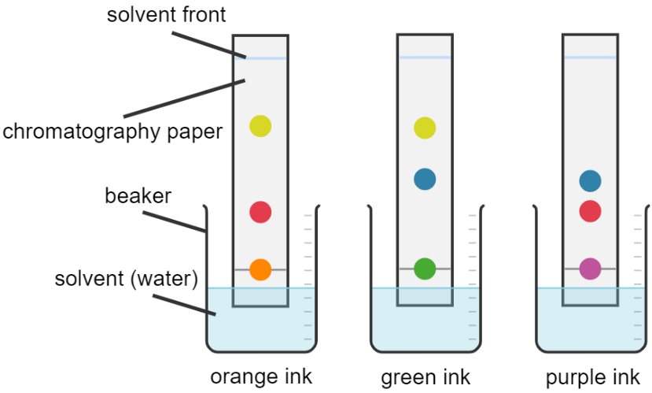
Chromatography allows us to separate different substances in a mixture. For example, the diagram to the right shows three inks undergoing chromatography.
Chromatography and distillation
Here, a spot of ink is placed on chromatography paper and the paper is placed in water. The water rises up the paper and acts as a solvent. The ink is made of different dyes that are soluble in water.
Created with Chemix (https://chemix.org)
As the water rises, it brings the dyes up the chromatography paper with it. However, different dyes move up the chromatography paper at a different rate. Therefore, the different dyes are separated.
If we look at the diagrams above, we can see that both orange ink and purple ink contain the same red dye. We know this because the dye has risen by the same amount up the chromatography paper.
The green and purple inks also contain the same blue dye, and the orange and green inks contain the same yellow dye.
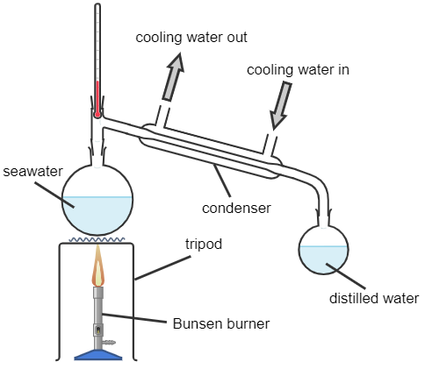
The apparatus to the left shows simple distillation.
Here, a Bunsen burner applies heat to some seawater. The water evaporates, leaving the salt in the seawater behind.
The water vapour then travels through a condenser where cooling water passes through.
Because the condenser is cool, it condenses the water vapour. The distilled water can then be collected.
This method can also be used to separate liquids with different boiling points.
Created with Chemix (https://chemix.org)

Q1. The following statements are either true or false. State which are true and which are false.
- In chromatography, ink is the solvent.
………………………………………………………………………………………………………………………………………………………………………………………………………..
- In chromatography, the dyes are soluble in water.
………………………………………………………………………………………………………………………………………………………………………………………………………..
- Chromatography allows us to separate different elements in a compound.
………………………………………………………………………………………………………………………………………………………………………………………………………..
- Simple distillation allows us to separate liquids with different boiling points.
………………………………………………………………………………………………………………………………………………………………………………………………………..
- Cooling water is used in a condenser to condense hotter gases.
………………………………………………………………………………………………………………………………………………………………………………………………………..
Q2. Name the state change in going from gas to liquid.
………………………………………………………………………………………………………………………………………………………………………………………………………..
Q3. Name the state change in going from liquid to gas.
………………………………………………………………………………………………………………………………………………………………………………………………………..
Q4. Describe what the word soluble means.
………………………………………………………………………………………………………………………………………………………………………………………………………..
Q5. Describe what the word solvent means.
………………………………………………………………………………………………………………………………………………………………………………………………………..
Q6. A mixture of liquids undergoes simple distillation. Liquid A has a boiling point of 100°C. Liquid B has a boiling point of 300°C. As the mixture is heated, state and explain which liquid will evaporate and be collected first.
………………………………………………………………………………………………………………………………………………………………………………………………………..
………………………………………………………………………………………………………………………………………………………………………………………………………..
Q7. Describe how chromatography is used to separate dyes in an ink.
………………………………………………………………………………………………………………………………………………………………………………………………………..
………………………………………………………………………………………………………………………………………………………………………………………………………..
………………………………………………………………………………………………………………………………………………………………………………………………………..
Q8. A student claims that salt can be filtered out of seawater by passing seawater through filter paper. Explain why the student is wrong and describe a correct method for obtaining pure water from seawater.
………………………………………………………………………………………………………………………………………………………………………………………………………..
………………………………………………………………………………………………………………………………………………………………………………………………………..
………………………………………………………………………………………………………………………………………………………………………………………………………..
………………………………………………………………………………………………………………………………………………………………………………………………………..

