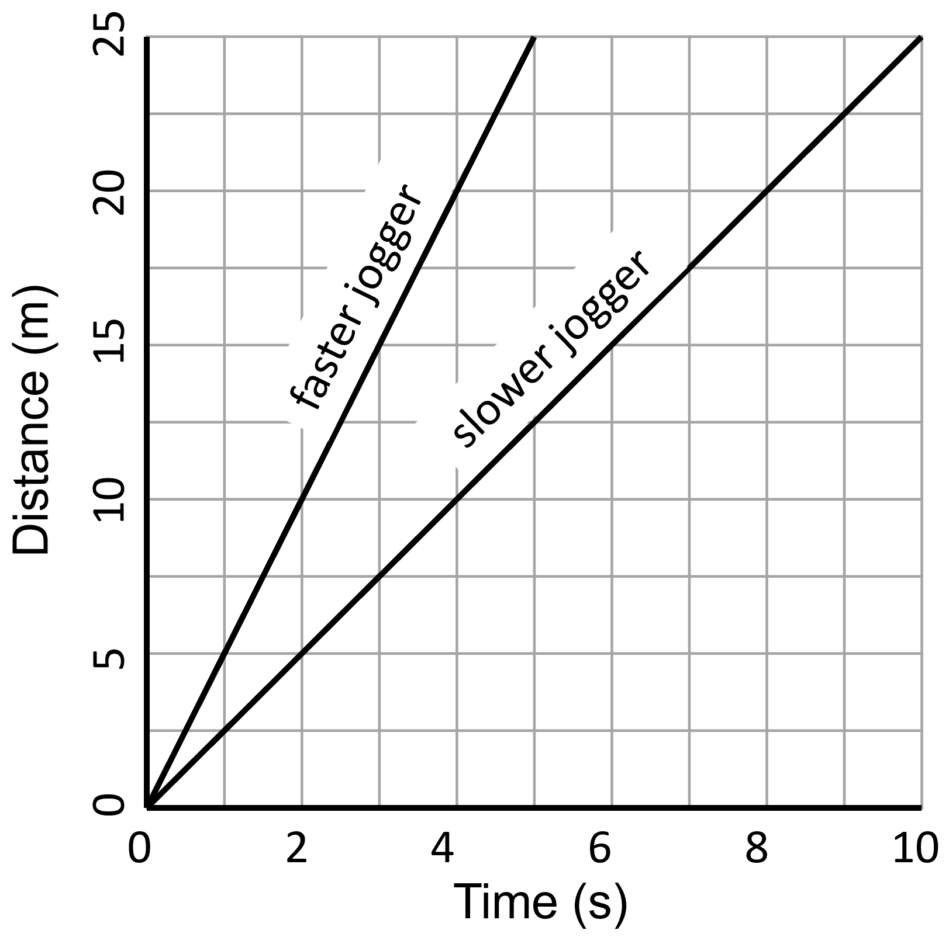
Distance-time graphs are used to represent the journey of an object that is travelling.
Distance-time graphs
One example distance-time graph is shown to the right, where two joggers are shown.
The steeper the gradient of a distance-time graph the greater the speed of the object.
Because of this, we can tell which jogger is travelling at a higher speed.
Mathematically, the gradient is calculated by using the equation:
$$\text{gradient =}\frac{∆y}{∆x}$$
For distance-time graphs, Δy is the distance travelled and Δx is the time taken to travel that distance. This makes sense, because we already know that the equation to calculate speed is:
Speed = Distance ÷ Time
The faster jogger in the diagram above travels a distance of 25 m in a time of 5 s. We can therefore calculate their speed to be 5 m/s.
The slower jogger travels a distance of 25 m in a time of 10 s. We can therefore calculate their speed to be 2.5 m/s.
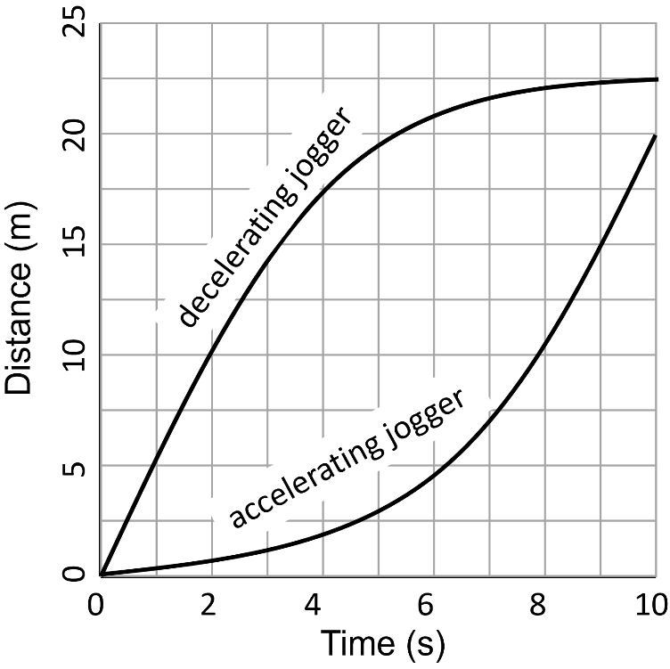
The diagram to the left shows two more distance time graphs.
The higher graph shows a jogger that is decelerating. We know that the jogger is decelerating because the gradient of the graph is reducing over time.
The lower graph shows a jogger that is accelerating. We know this because the gradient of the graph is increasing over time.

Q1. State what the gradient of a distance-time graph represents.
………………………………………………………………………………………………………………………………………………………………………………………………………..
Q2. State the equation for speed.
………………………………………………………………………………………………………………………………………………………………………………………………………..
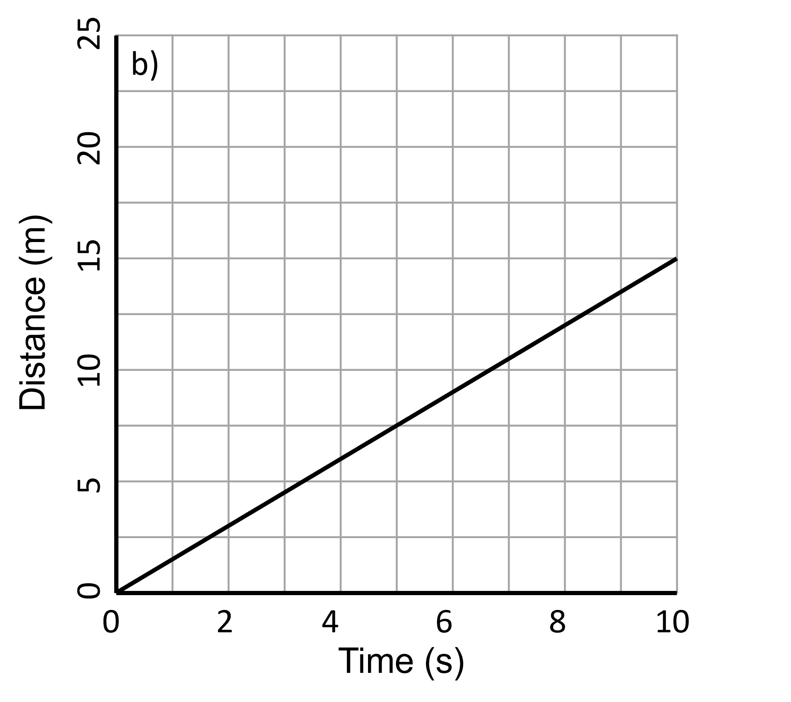
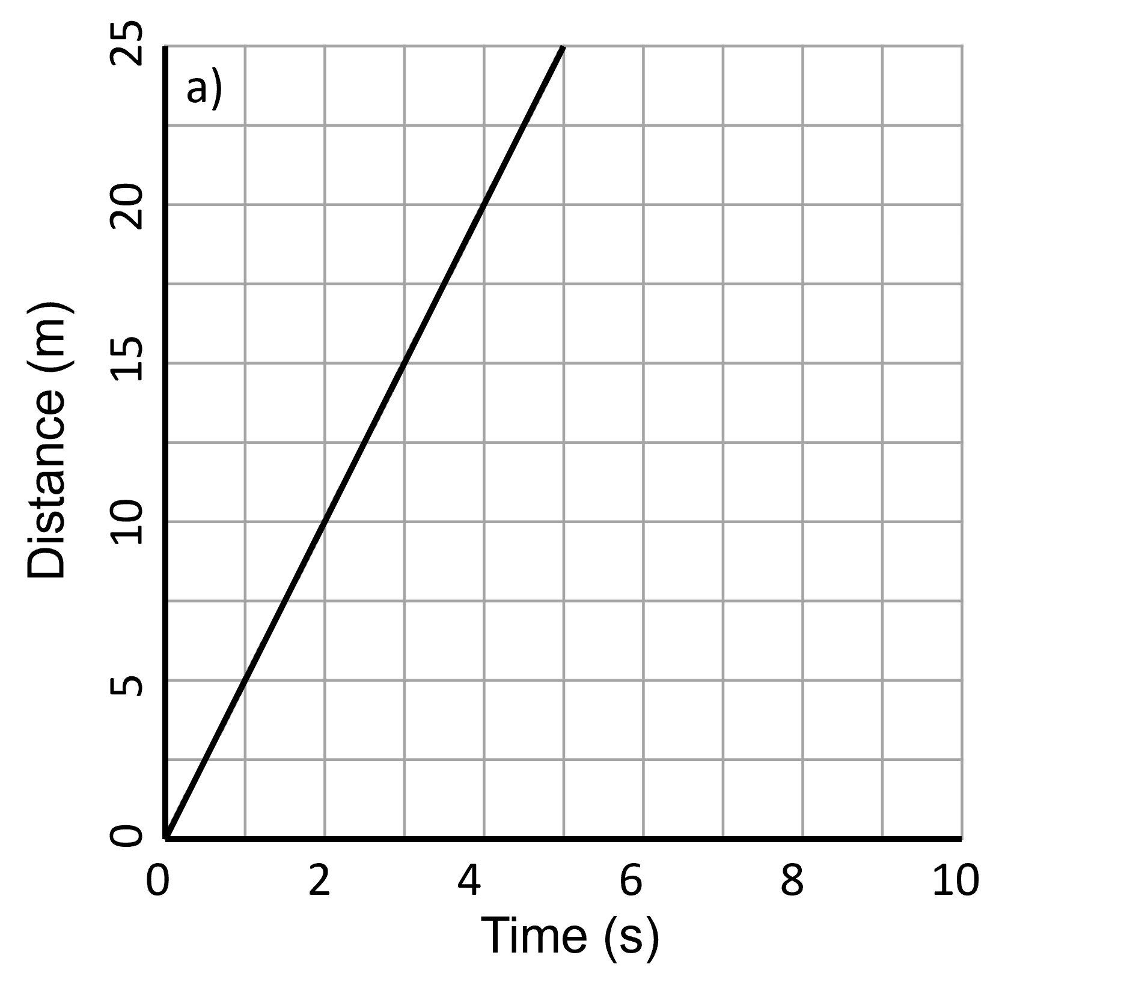
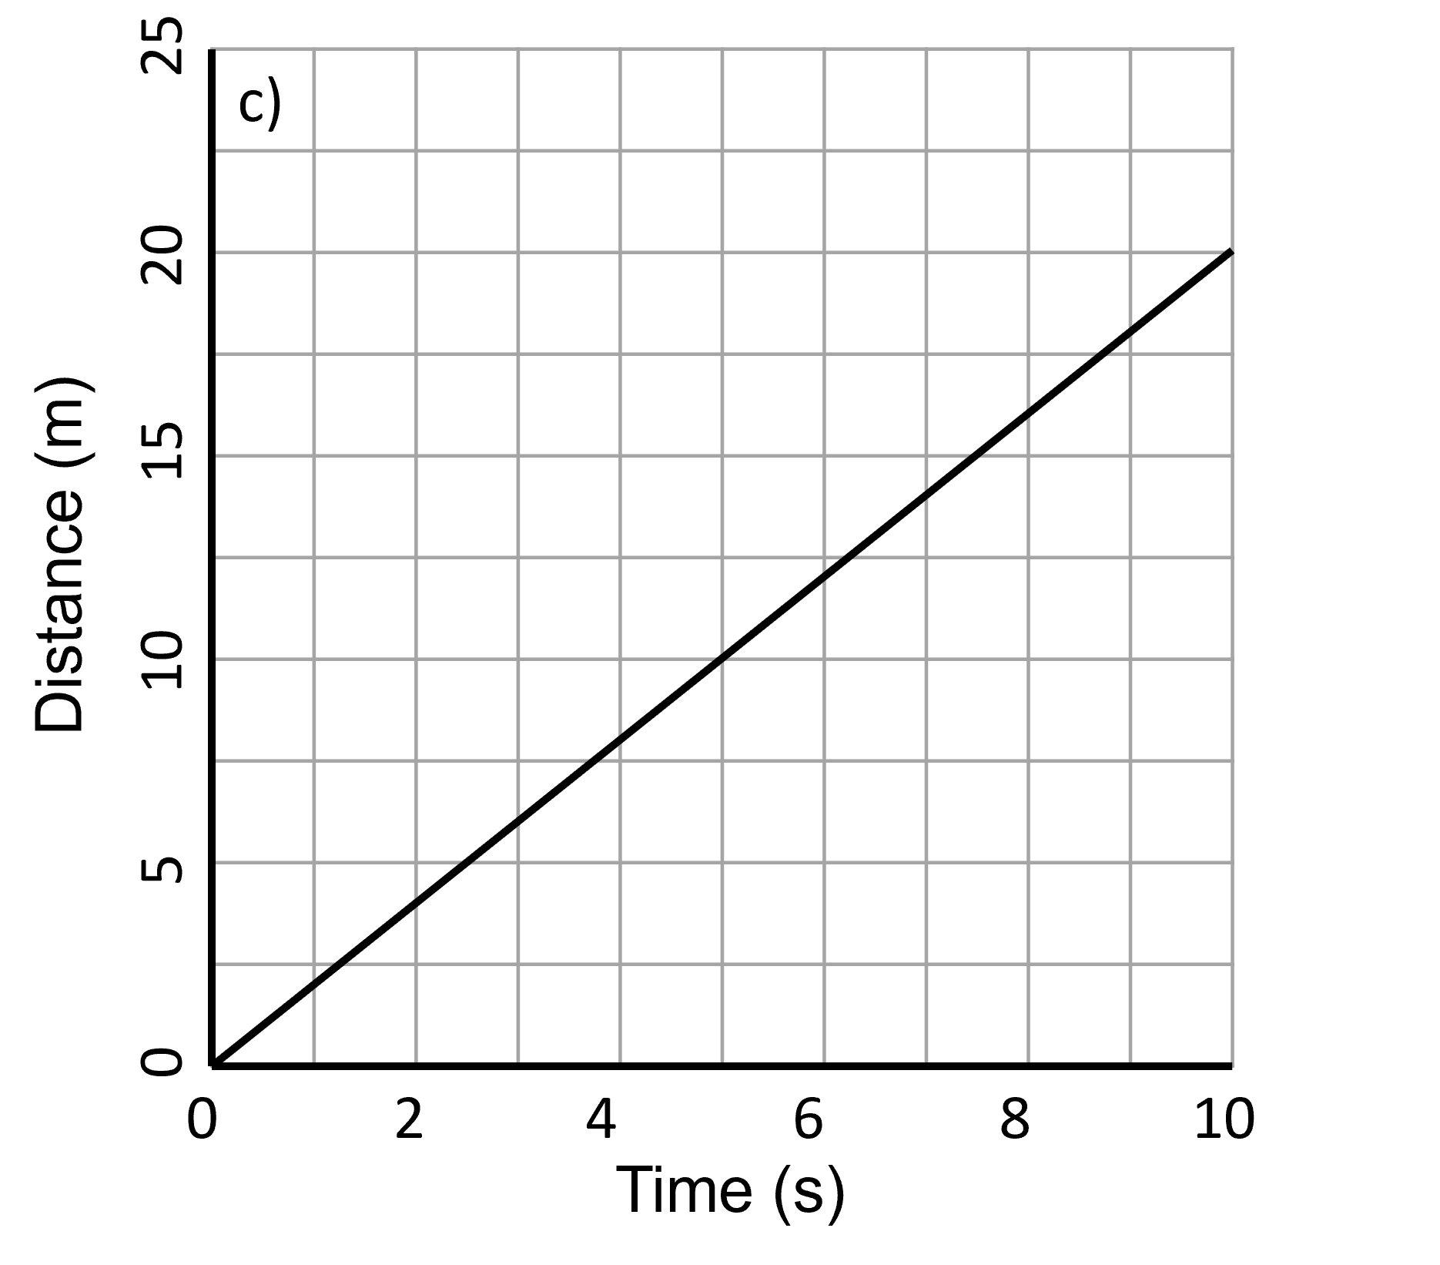
Q3. Using the distance-time graphs below, calculate the speed of each of the objects:


 

 

 

 

 

 

