Matter

Name ______________________________
Class ______________________________
Teacher ______________________________
All matter is made of particles. Depending on the substance, the particles could be atoms or molecules.
Particle model
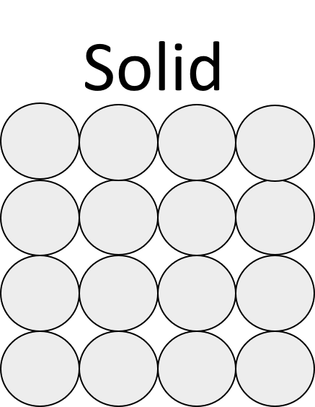
The three states of matter are solid, liquid, and gas. They all have different properties due to the arrangement and movement of their particles.
Solids have particles that are held tightly together. The particles are arranged in a regular pattern and vibrate around fixed positions. Solids have a definite shape and volume. Solids are dense and they can not be compressed easily because the particles are already packed closely together. Solids have the least amount of energy.

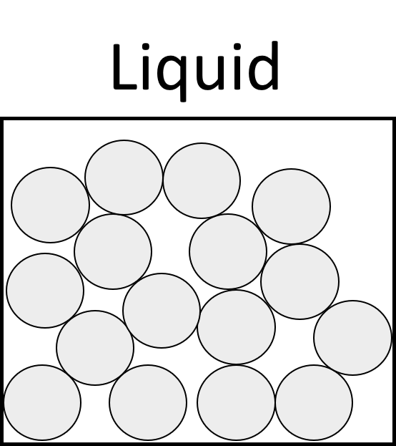
In a liquid the particles are still held closely together but the particles can also move past each other. This means that a liquid can flow. Liquids are dense and can not be compressed easily (hydraulics make use of this). A liquid can change its shape but not its volume.

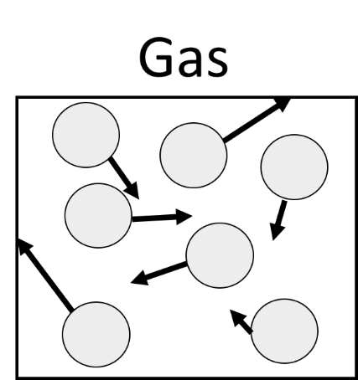
There are only very weak forces between gas particles, which are far apart. Because of this gases can be compressed, and so they have no fixed volume. The particles move around quickly, at a range of speeds. They cause pressure when they collide with the walls of a container. Gases have a low density and they do not have a definite shape or volume. Gases have the most energy. As you heat a gas, the particles move more quickly.

While solids are usually the most dense state of matter; water and ice are an exception. Water (a liquid) is more dense than ice (a solid). That’s why ice cubes float in a drink.

Q1. In the spaces below, draw the particle arrangement for solids liquids and gases.
Solids | Liquids | Gases

Q2. Name the state of matter that can be compressed. ……………………………………..
Q3. Name the state of matter that can change its shape but not its volume. ……………………………………..
Q4. Name the state of matter that has no fixed volume. ……………………………………..
Q5. Name the state of matter that has a low density. ……………………………………..
Q6. Name the state of matter that has particles that vibrate in a fixed patten. ……………………………………..
Q7. Name the state of matter that is used in hydraulics. ……………………………………..
Q8. Name the state of matter that has particles that flow but are still close together. ……………………………………..
Q9. State what happens to the speed of gas particles when the temperature of a gas is increased.
………………………………………………………………………………………………………………………………………………………………………………………………………..
Q10. Describe the movement of gas particles.
………………………………………………………………………………………………………………………………………………………………………………………………………..
………………………………………………………………………………………………………………………………………………………………………………………………………..
Q11. Describe how the particle arrangement changes as a material changes from a solid into a liquid.
………………………………………………………………………………………………………………………………………………………………………………………………………..
………………………………………………………………………………………………………………………………………………………………………………………………………..
………………………………………………………………………………………………………………………………………………………………………………………………………..
………………………………………………………………………………………………………………………………………………………………………………………………………..
Q12. Describe how the particle arrangement changes as a material changes from a liquid into a gas.
………………………………………………………………………………………………………………………………………………………………………………………………………..
………………………………………………………………………………………………………………………………………………………………………………………………………..
………………………………………………………………………………………………………………………………………………………………………………………………………..
………………………………………………………………………………………………………………………………………………………………………………………………………..
Q13. State the reason why ice cubes float in water.
………………………………………………………………………………………………………………………………………………………………………………………………………..
As the temperature of particles changes, they change state. In the process of changing state, the overall number of particles stays the same. The overall mass is conserved. This means that the mass before a state change is the same as the mass after a state change.
State changes
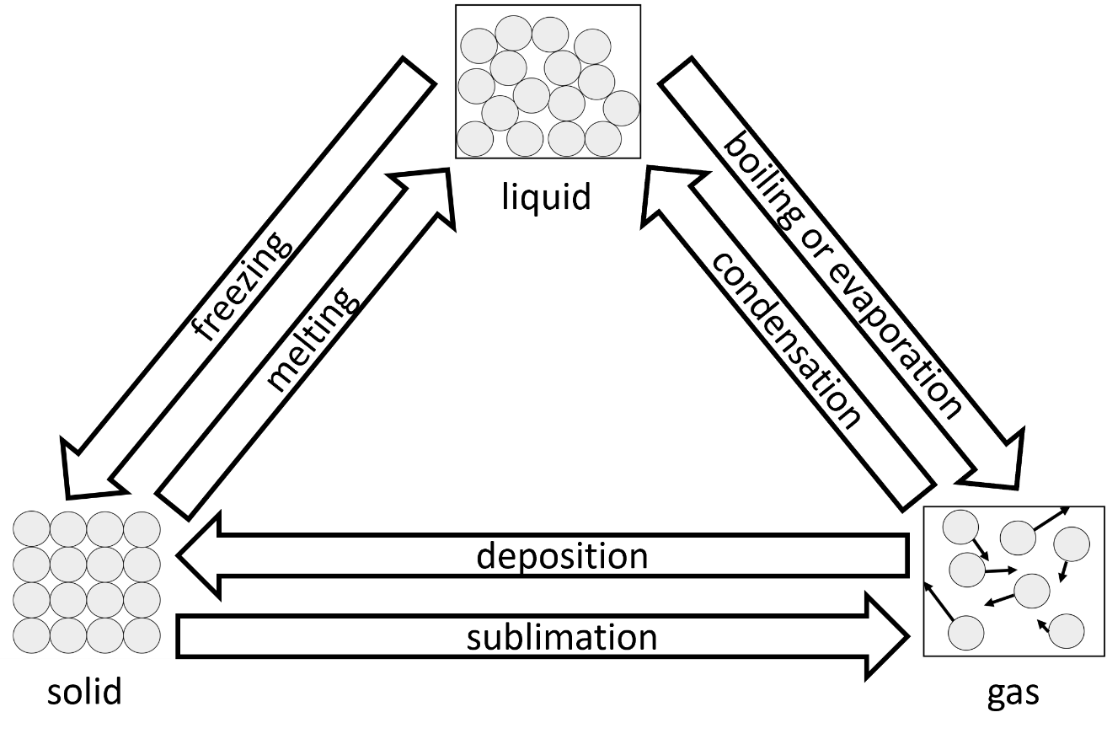
The different state changes are shown in the diagram below:
A solid has particles that are held together in a regular pattern. The particles vibrate around their fixed positions. As the solid is heated, these vibrations increase until it reaches its melting point. One example of a melting point is that of water at 0°C.
While the solid is melting, it stays at the same temperature. The particles start to be freed from their fixed positions until they are free to move past each other. Particles are still in contact. When the process of melting is complete, the particles are in the liquid state.
If we continue heating the liquid, the particles again move more quickly. When the liquid reaches its boiling point, it starts boiling and turning into a gas. Here, the particles are moving quickly enough so that they start separating from one another. Particles in a gas are far apart and move around quickly in random directions. One example of a boiling point is that of water at 100°C.
If a gas is cooled, it condenses into a liquid. If a liquid is cooled, it freezes to form a solid.
If cooled enough, gases can also undergo deposition so that they are turned directly into a solid. If heated enough, solids can undergo sublimation so that they are turned directly into a gas.
Q1. During a state change, mass is conserved. Describe what conservation of mass means.
………………………………………………………………………………………………………………………………………………………………………………………………………..
………………………………………………………………………………………………………………………………………………………………………………………………………..
Q2. Name the state change in going from solid to liquid. ……………………………………..
Q3. Name the state change in going from gas to liquid. ……………………………………..
Q4. Name the state change in going from liquid to gas. ……………………………………..
Q5. Name the state change in going from gas to solid. ……………………………………..
Q6. Name the state change in going from solid to gas. ……………………………………..
Q7. Name the state change in going from liquid to solid. ……………………………………..
Q8. State the melting point of water. ……………………………………..
Q9. State the boiling point of water. ……………………………………..
Q10. Describe the particle arrangement in a solid.
………………………………………………………………………………………………………………………………………………………………………………………………………..
………………………………………………………………………………………………………………………………………………………………………………………………………..
Q11. Describe the particle arrangement in a gas.
………………………………………………………………………………………………………………………………………………………………………………………………………..
………………………………………………………………………………………………………………………………………………………………………………………………………..
Q12. The following statements are either true or false. State which are true and which are false.
- As a solid melts, the temperature increases.
………………………………………………………………………………………………………………………………………………………………………………………………………..
- As a gas is heated, the particles move more quickly.
………………………………………………………………………………………………………………………………………………………………………………………………………..
- Regardless of temperature, particles in a solid vibrate the same amount.
………………………………………………………………………………………………………………………………………………………………………………………………………..
- If particles in a liquid evaporate into a gas, the gas has less mass than the liquid.
………………………………………………………………………………………………………………………………………………………………………………………………………..
Q13. Some water is at a temperature of −10°C. State which state of matter the water is in. Explain why.
………………………………………………………………………………………………………………………………………………………………………………………………………..
Q14. Some water is at a temperature of 200°C. State which state of matter the water is in. Explain why.
………………………………………………………………………………………………………………………………………………………………………………………………………..
Q15. Some water is at a temperature of 50°C. State which state of matter the water is in. Explain why.
………………………………………………………………………………………………………………………………………………………………………………………………………..
The graph below shows the heating curve of a pure substance. A pure substance is made from only one element or compound. Note how the temperature of the substance remains constant during a state change. 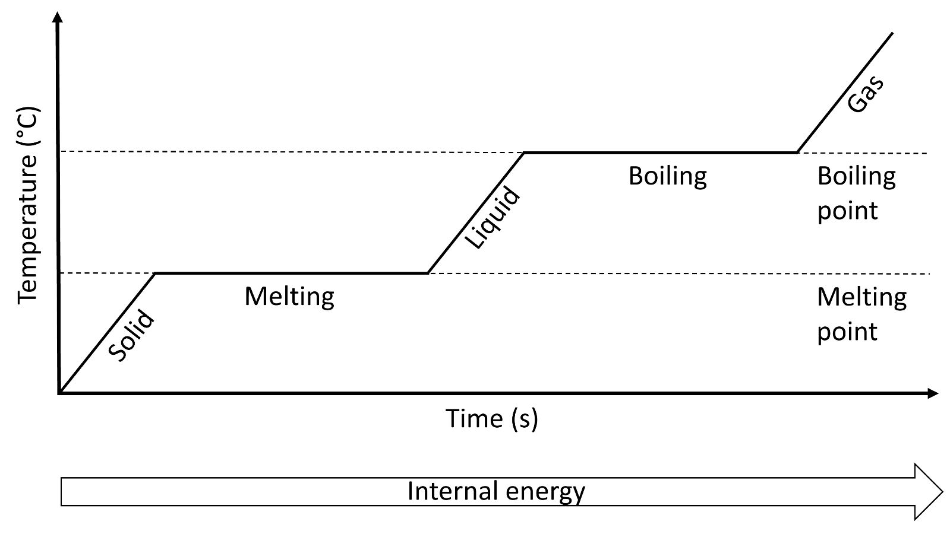
Heating and cooling curves
As thermal energy is transferred to the substance, the internal energy of the particles in the substance increases. The internal energy consists of the kinetic energy and potential energy stores of the particles.
While the substance is increasing in temperature, the kinetic energy store of the particles in the substance increases. As a solid increases in temperature, the vibrations of the particles in the solid increase.
Eventually, the solid start melting. During this time, some bonds are broken but the temperature remains constant. The potential energy store of the particles in the substance increases. The thermal energy supplied to the material is called “latent” here. Latent comes from the Latin for “hidden”.
Similar happens with liquids and gases. As a liquid or gas increases in temperature, particles move more quickly and their kinetic energy store increases. As a liquid is boiled, bonds are broken and the potential energy store of particles increases.
An impure substance contains more than one element or compound. We could also say that the substance contains impurities. For an impure substance, there is not a single temperature for melting and boiling. Instead, this happens over a range of temperatures.
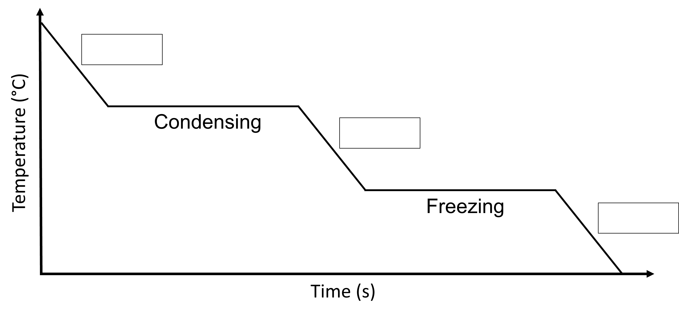
Q1. The diagram below shows the cooling curve of a pure substance. Label the three states of matter that are missing from the diagram.
Q2. Describe what a pure substance is.
………………………………………………………………………………………………………………………………………………………………………………………………………..
………………………………………………………………………………………………………………………………………………………………………………………………………..
Q3. Describe what happens to the motion and kinetic energy of gas particles as they cool.
………………………………………………………………………………………………………………………………………………………………………………………………………..
………………………………………………………………………………………………………………………………………………………………………………………………………..
Q4. Describe what internal energy is.
………………………………………………………………………………………………………………………………………………………………………………………………………..
………………………………………………………………………………………………………………………………………………………………………………………………………..
Q5. Describe what an impure substance is.
………………………………………………………………………………………………………………………………………………………………………………………………………..
………………………………………………………………………………………………………………………………………………………………………………………………………..
Q6. Describe how the heating curve for an impure substance is different to that of a pure substance.
………………………………………………………………………………………………………………………………………………………………………………………………………..
………………………………………………………………………………………………………………………………………………………………………………………………………..
Q7. Describe why the temperature of a pure substance stays constant while it melts.
………………………………………………………………………………………………………………………………………………………………………………………………………..
………………………………………………………………………………………………………………………………………………………………………………………………………..
Q8. State what happens to the internal energy of a substance as it increases in temperature.
………………………………………………………………………………………………………………………………………………………………………………………………………..
Gases consist of particles that move in random directions and at a range of different speeds.
Pressure in gases
We know this because of something called Brownian motion. In 1827, Robert Brown (which Brownian motion is named after) noticed that pollen particles moved around in a random way. Smoke particles move in a similar way in air. This is because of collisions with air particles that are moving in random directions and at a range of different speeds.
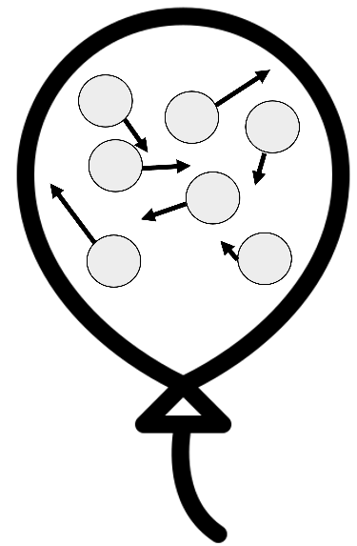
While the smoke particles are much larger than the air particles, the air particles are moving much faster and so they affect how the smoke particles move when they collide.
When a gas particle collides with a surface, pressure is exerted on that surface.
The reason balloons get bigger when you blow them up is because you are adding air into the balloon.
More air means more particles inside the balloon. In turn, this leads to more collisions between air particles and the walls of the balloon. More collisions cause a higher force on the walls, which then leads to a higher pressure. This makes the balloon expand.
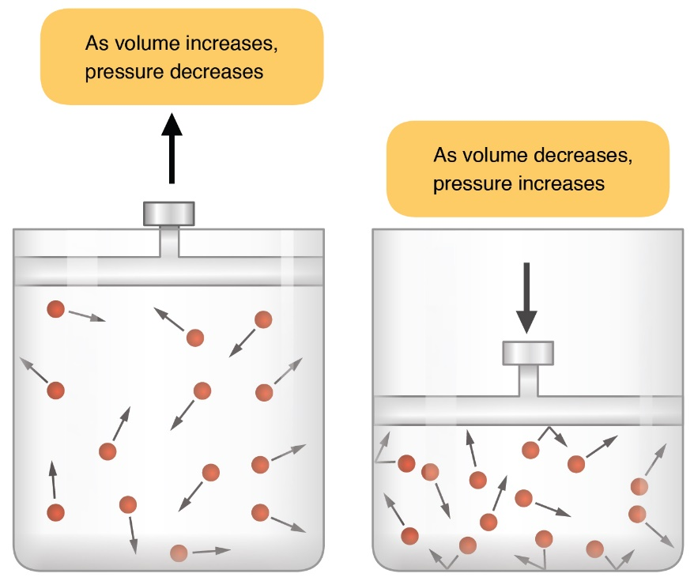
If we reduce the volume of a container, a similar thing happens. This is shown in the diagram to the left.
If the volume of a container is reduced, gas particles collide with the walls of the container more often.
This leads to a higher force on the walls of the container, and therefore a higher pressure.
OpenStax College, CC BY 3.0 <https://creativecommons.org/licenses/by/3.0>, via Wikimedia Commons

If we increase the temperature of a gas in a container, the kinetic energy and speed of the gas particles also increase. This also means the gas particles collide with the walls of the container more often (again leading to a higher force and a higher pressure on the walls of the container). This is why a balloon expands if we heat it.
Q1. Smoke particles are observed to move in a random way in air. State the name of this process and explain why this happens.
………………………………………………………………………………………………………………………………………………………………………………………………………..
………………………………………………………………………………………………………………………………………………………………………………………………………..
Q2. Air is being pumped into a balloon.
- State what happens to the number of air particles inside the balloon.
………………………………………………………………………………………………………………………………………………………………………………………………………..
- State what happens to the number of collisions between the air particles and the walls of the balloon.
………………………………………………………………………………………………………………………………………………………………………………………………………..
- State what happens to the force exerted by the air particles on the walls of the balloon.
………………………………………………………………………………………………………………………………………………………………………………………………………..
- State what happens to the pressure inside the balloon.
………………………………………………………………………………………………………………………………………………………………………………………………………..
- State what happens to the size of the balloon.
………………………………………………………………………………………………………………………………………………………………………………………………………..
Q3. Some gas is inside a container. The volume of the container is slowly increased.
- State what happens to the force exerted by the air particles on the walls of the container.
………………………………………………………………………………………………………………………………………………………………………………………………………..
- State what happens to the pressure inside the container.
………………………………………………………………………………………………………………………………………………………………………………………………………..
Q4. State what happens to the average speed of gas particles as the temperature of the gas is increased.
………………………………………………………………………………………………………………………………………………………………………………………………………..
Q5. Two containers have the same amount of gas particles inside them. Container A is smaller than container B. State and explain which container has the highest pressure.
………………………………………………………………………………………………………………………………………………………………………………………………………..
………………………………………………………………………………………………………………………………………………………………………………………………………..
Q6. Two containers have the same amount of gas particles inside them. Container A is at a lower temperature than container B. State and explain which container has the highest pressure.
………………………………………………………………………………………………………………………………………………………………………………………………………..
………………………………………………………………………………………………………………………………………………………………………………………………………..
Q7. A balloon is cooled. State and explain what happens to the size of the balloon.
………………………………………………………………………………………………………………………………………………………………………………………………………..
………………………………………………………………………………………………………………………………………………………………………………………………………..
We already know that particles in liquids and gases move in a random motion. Particles in a liquid are in contact with each other and free to flow past each other. Particles in a gas are separate from one another and move quickly in random directions at a range of speeds. We also know that this causes Brownian motion.
Diffusion
Diffusion happens in fluids (liquids and gases). Diffusion is the movement of particles from a high concentration (of those particles) to a lower concentration.
The diagram below shows some purple dye being introduced to a glass of water. Because the water particles are moving in random directions, this leads to diffusion of the purple dye.
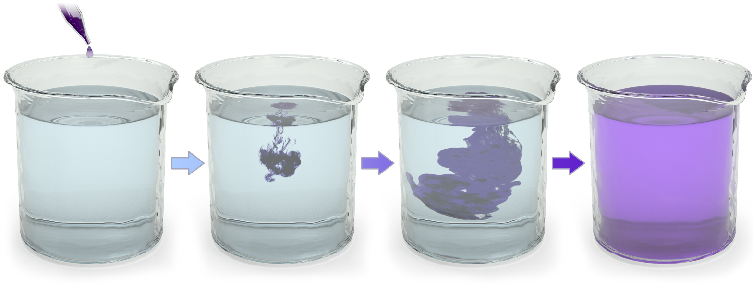
Immediately after the dye has been dropped it is at a high concentration in that area. Diffusion means that particles move from this high concentration to the surrounding areas (where there is a low concentration). Eventually the dye is evenly spread throughout the water.
BruceBlaus, CC BY 3.0, https://commons.wikimedia.org/w/index.php?curid=29452222
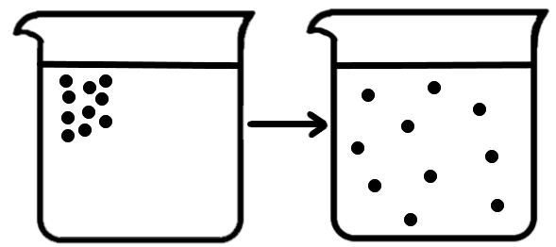
The diagram to the right also shows the initial and final stages in terms of particles. If we leave the water and dye for long enough then the dye particles are evenly distributed throughout the water.
If we wanted to speed this process up, then we could heat the water. Particles move faster in a hotter liquid or gas. Therefore diffusion would also be faster. We could also speed diffusion by stirring the liquid.
Christinelmiller, CC BY-SA 4.0 https://creativecommons.org/licenses/by-sa/4.0, via Wikimedia Commons
Q1. The following statements are either true or false. State which are true and which are false.
- In diffusion, particles move from a low concentration to a high concentration.
………………………………………………………………………………………………………………………………………………………………………………………………………..
- Diffusion happens at the same rate, regardless of the temperature of the liquid.
………………………………………………………………………………………………………………………………………………………………………………………………………..
- Diffusion happens only in liquids.
………………………………………………………………………………………………………………………………………………………………………………………………………..
- Diffusion in a liquid can be sped up by stirring the liquid.
………………………………………………………………………………………………………………………………………………………………………………………………………..
Q2. Describe how particles move in liquids.
………………………………………………………………………………………………………………………………………………………………………………………………………..
………………………………………………………………………………………………………………………………………………………………………………………………………..
Q3. Describe how particles move in gases.
………………………………………………………………………………………………………………………………………………………………………………………………………..
………………………………………………………………………………………………………………………………………………………………………………………………………..
Q4. Describe what diffusion is.
………………………………………………………………………………………………………………………………………………………………………………………………………..
………………………………………………………………………………………………………………………………………………………………………………………………………..
Q5. State what happens to the average speed of particles in a liquid as the temperature of the liquid is increased.
………………………………………………………………………………………………………………………………………………………………………………………………………..
Q6. Two beakers are full of water. Some red dye is dropped in each. Beaker A contains water at 20 °C, Beaker B contains water at 50 °C. State and explain in which beaker diffusion will be fastest.
………………………………………………………………………………………………………………………………………………………………………………………………………..
………………………………………………………………………………………………………………………………………………………………………………………………………..
Q7. Some deodorant is sprayed in a room. Explain how the deodorant spreads throughout the room.
………………………………………………………………………………………………………………………………………………………………………………………………………..
………………………………………………………………………………………………………………………………………………………………………………………………………..
Q8. A fan is on in the same room. State what this would do to the rate of diffusion.
………………………………………………………………………………………………………………………………………………………………………………………………………..

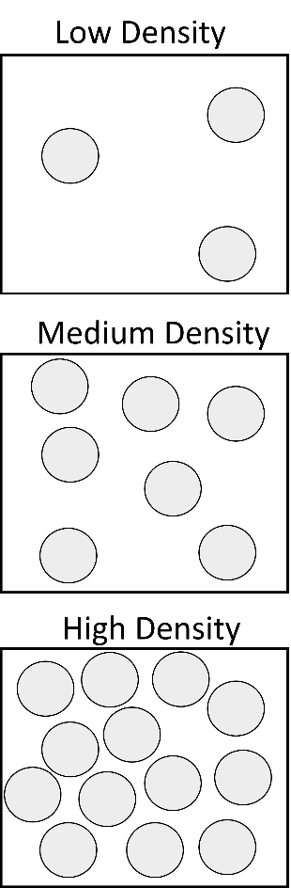
Density is a measure of how much mass is in a given volume.
Density
The diagram to the right shows three gases in the same volume. If we assume that each particle has the same mass, then the top gas must have the least density and the lowest gas must have the highest density.
The density of an object can be calculated using the equation:
Density = mass ÷ volume
The mass of an object is the amount of matter it contains and is measured in kilograms (kg). The volume is the amount of space that an object takes up and is measured in metres cubed (m³).
Density has units of kilograms per metre cubed (kg/m³).
Example question 1: Some wood has a mass of 210 kg and a volume of 0.3 m³. Calculate the density of the wood.
Step 1. Write down equation: Density = mass ÷ volume
Step 2. Put variables into equation: = 210 kg ÷ 0.3 m³
Step 3. Calculate answer. Remember units: = 700 kg/m³
The density of water is equal to 1000 kg/m³. Anything lower than this density will float on water. Therefore the wood that we calculated the density of in the example question will float on water.
Example question 2: The density of granite is 2700 kg/m³. Some granite has a mass of 5400 kg, calculate the volume of the granite.
Step 1. Write down equation: Density = mass ÷ volume
Step 2. Put variables into equation: 2700 kg/m³ = 5400 kg ÷ volume
Step 3. Rearrange equation: volume = 5400 kg ÷ 2700 kg/m³
Step 3. Calculate answer. Remember units: = 2 m³

Q1. State the equation that links density, mass and volume.
………………………………………………………………………………………………………………………………………………………………………………………………………..
Q2. State the units of density, mass and volume.
………………………………………………………………………………………………………………………………………………………………………………………………………..
Q3. Water has a density of 1000 kg/m³ and oil has a density of 800 kg/m³. State and explain whether the oil will float or sink in the water.
………………………………………………………………………………………………………………………………………………………………………………………………………..
………………………………………………………………………………………………………………………………………………………………………………………………………..
Q4. A book has a mass of 1 kg and a volume of 0.002 m³. Calculate the density of the book.
Density = mass ÷ volume
= 1 kg ÷ 0.002 m³
= ____________ kg/m³
Q5. A gold bar has a mass of 3.8 kg and a volume of 0.0002 m³. Calculate the density of the gold bar.
Density = ________ ÷ ________
= _____ kg ÷ _____ m³
= ____________ kg/m³
Q6. A rock has a mass of 300 kg and a volume of 0.1 m³. Calculate the density of the rock.
Density = ________ ÷ ________
= _____ __ ÷ _____ __
= ____________ ___
Q7. Steel has a density of 7800 kg/m³. Calculate the volume of steel that has a mass of 3900 kg.
………………………………………………………………………………………………………………………………………………………………………………………………………..
………………………………………………………………………………………………………………………………………………………………………………………………………..
Q8. The average human body has a density of 995 kg/m³.
- Explain why humans can float on water.
………………………………………………………………………………………………………………………………………………………………………………………………………..
- Calculate the volume of a human body that has a mass of 70 kg.
………………………………………………………………………………………………………………………………………………………………………………………………………..
………………………………………………………………………………………………………………………………………………………………………………………………………..
Q9. A crate has a mass of 250 kg and a density of 50 kg/m³. Calculate the volume of the crate.
………………………………………………………………………………………………………………………………………………………………………………………………………..
………………………………………………………………………………………………………………………………………………………………………………………………………..
Q10. A car has an average density of 280 kg/m³ and a volume of 4.2 m³. Calculate the mass of the car.
………………………………………………………………………………………………………………………………………………………………………………………………………..
………………………………………………………………………………………………………………………………………………………………………………………………………..
We have already learnt about the particle model, where matter is made of particles. This is one example of a scientific model.
The atom
Scientific models are usually simplified versions of an object or a phenomenon. This makes them easier to understand, while still representing the key features.
The particle model is used to explain and predict the behaviour of solids, liquids and gases. This is a simplification, as we know that particles are made of atoms and molecules (which, in turn, consist of smaller parts).
Models are also changed and updated over time, and the atomic model is one example of this. Previously, it was thought that atoms were indivisible (could not be broken down into anything smaller). This is the Dalton model of the atom.
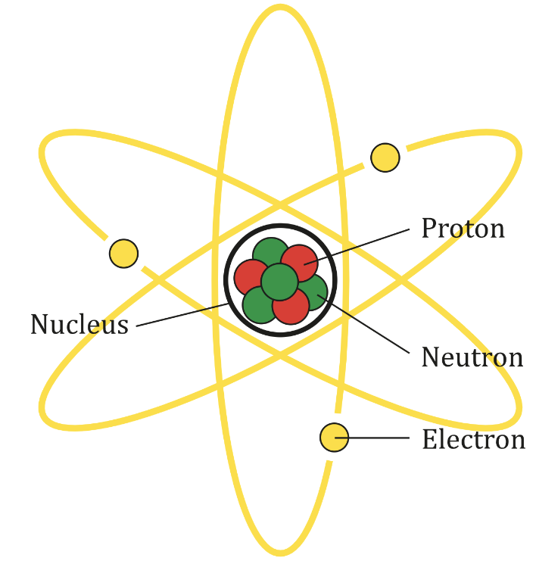
However, newer evidence from experiments suggested that the atom was made up of sub-atomic particles. They are called sub-atomic because they are smaller than the atom itself.
In the current model of the atom, there are three subatomic particles:
- Protons. These have a positive charge and are contained in the centre of atom. The centre of the atom is called the nucleus.
- Neutrons are also contained in the nucleus, but neutrons are neutral. Something that is neutral has no charge.
- Electrons orbit around the nucleus. They have a negative charge.
AG Caesar, CC BY-SA 4.0 <https://creativecommons.org/licenses/by-sa/4.0>, via Wikimedia Commons
Most of the mass of an atom is contained in the nucleus, with neutrons and protons having around 2000 times more mass than an electron.
Overall an atom is neutral as there as equal numbers of electrons and protons.
Generally, evidence is required to change a scientific model. New evidence and research go through a process called peer review.
Peer review is when other scientists look at the new evidence and decide whether or not it is valid. This is important as otherwise incorrect models and theories could be spread. After peer review, new research can be published. After this, other scientists may decide to try and reproduce the research to check whether the results are repeatable.

Q1. Describe the Dalton model of the atom.
………………………………………………………………………………………………………………………………………………………………………………………………………..
………………………………………………………………………………………………………………………………………………………………………………………………………..
Q2. The following questions are asking about the current model of the atom.
- Describe where the nucleus of an atom is.
………………………………………………………………………………………………………………………………………………………………………………………………………..
- Name the two sub-atomic particles that are in the nucleus.
………………………………………………………………………………………………………………………………………………………………………………………………………..
- Name the sub-atomic particle that orbits around the nucleus.
………………………………………………………………………………………………………………………………………………………………………………………………………..
- State the charge on a proton.
………………………………………………………………………………………………………………………………………………………………………………………………………..
- State the charge on an electron.
………………………………………………………………………………………………………………………………………………………………………………………………………..
- State the charge on a neutron.
………………………………………………………………………………………………………………………………………………………………………………………………………..
- Name the sub-atomic particle that has the least mass.
………………………………………………………………………………………………………………………………………………………………………………………………………..
Q3. Describe what a scientific model is.
………………………………………………………………………………………………………………………………………………………………………………………………………..
………………………………………………………………………………………………………………………………………………………………………………………………………..
Q4. Describe an advantage of using scientific models.
………………………………………………………………………………………………………………………………………………………………………………………………………..
………………………………………………………………………………………………………………………………………………………………………………………………………..
Q5. Describe what peer review is.
………………………………………………………………………………………………………………………………………………………………………………………………………..
………………………………………………………………………………………………………………………………………………………………………………………………………..
Q6. Describe the difference between the Dalton model and the current model of the atom.
………………………………………………………………………………………………………………………………………………………………………………………………………..
………………………………………………………………………………………………………………………………………………………………………………………………………..

An element is made from only one type of atom. There are over 100 known elements and they are listed on the periodic table. For example, argon and oxygen are both elements as they both contain only one type of atom.
Elements, compounds and mixtures.
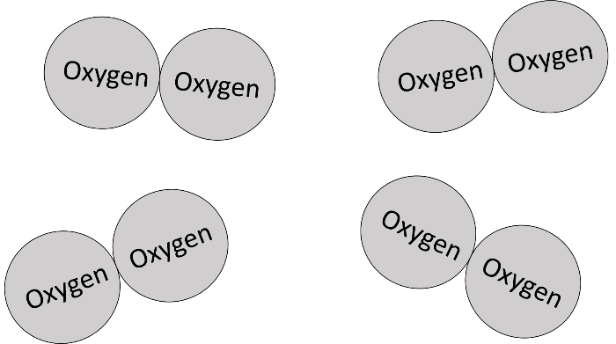
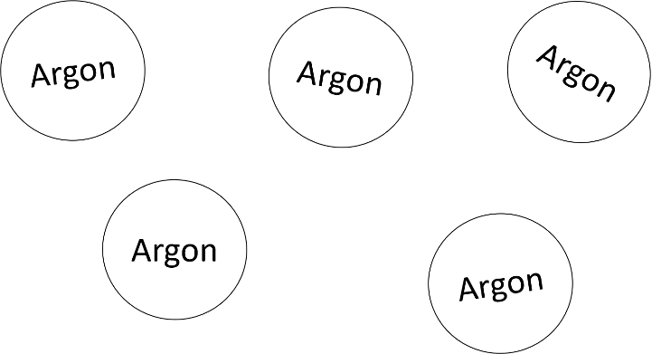

Here, we have the element argon. We know that we have an element because there is only one type of atom.
Here, we have the element oxygen. Oxygen is a diatomic gas as it contains two atoms that are chemically joined. A monatomic gas contains only single atoms that are not chemically joined.

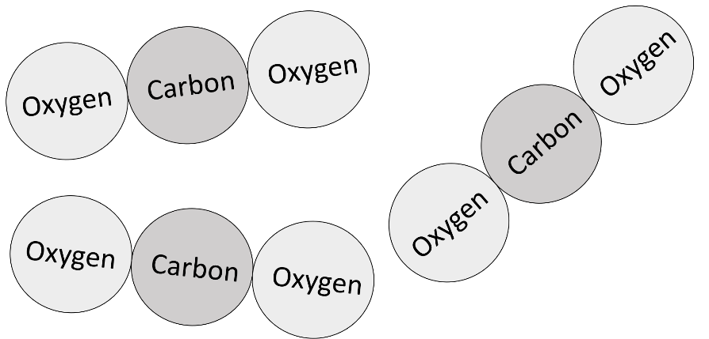

A compound is a substance where two or more atoms (of different elements) are chemically joined. For example, carbon dioxide is a compound as it contains the elements carbon and oxygen.
Carbon dioxide is a compound; it has two different types of atom that are chemically joined.

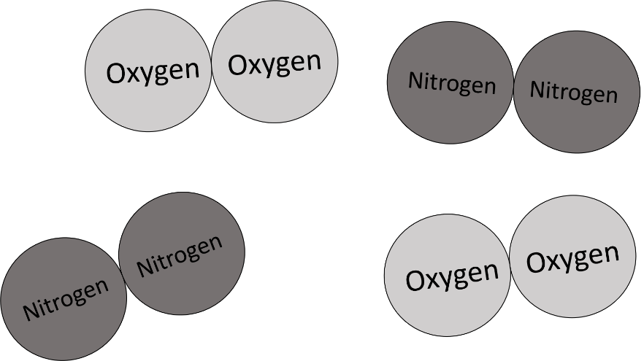
A mixture is a substance that contains two or more elements or compounds that are not chemically joined together. For example, nitrogen gas mixed with oxygen gas is a mixture of elements. Carbon dioxide mixed with carbon monoxide is a mixture of compounds.
Here we have a mixture of two different elements; nitrogen and oxygen.

Q1. Describe what an element is.
………………………………………………………………………………………………………………………………………………………………………………………………………..
………………………………………………………………………………………………………………………………………………………………………………………………………..
Q2. Describe what a compound is.
………………………………………………………………………………………………………………………………………………………………………………………………………..
………………………………………………………………………………………………………………………………………………………………………………………………………..
Q3. Describe what a mixture is.
………………………………………………………………………………………………………………………………………………………………………………………………………..
………………………………………………………………………………………………………………………………………………………………………………………………………..
Q4. Below is a list of substances. State which are elements and which are compounds.
Iron | Iron Oxide | Nitrogen | Oxygen
Carbon dioxide | Aluminium | Hydrochloric acid | Water
Elements:
………………………………………………………………………………………………………………………………………………………………………………………………………..
Compounds:
………………………………………………………………………………………………………………………………………………………………………………………………………..
Q5. For the compounds you’ve listed in Q4. state what elements each compound contains.
………………………………………………………………………………………………………………………………………………………………………………………………………..
………………………………………………………………………………………………………………………………………………………………………………………………………..
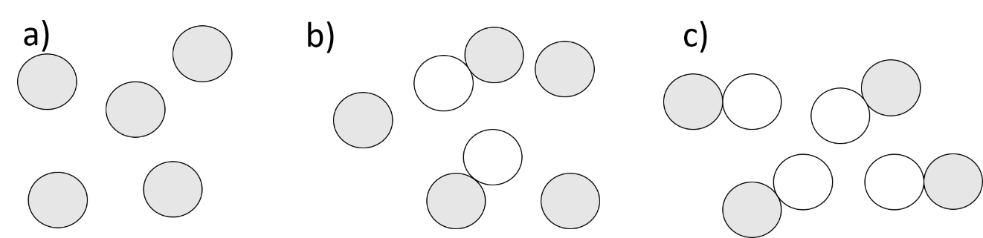
Q6. Below are diagrams of three different substances. State which is an element, which is a compound and which is a mixture.

………………………………………………………………………………………………………………………………………………………………………………………………………..
………………………………………………………………………………………………………………………………………………………………………………………………………..
Q7. Describe the difference between an element and a compound.
………………………………………………………………………………………………………………………………………………………………………………………………………..
………………………………………………………………………………………………………………………………………………………………………………………………………..
Q8. Describe the difference between a compound and a mixture.
………………………………………………………………………………………………………………………………………………………………………………………………………..
………………………………………………………………………………………………………………………………………………………………………………………………………..
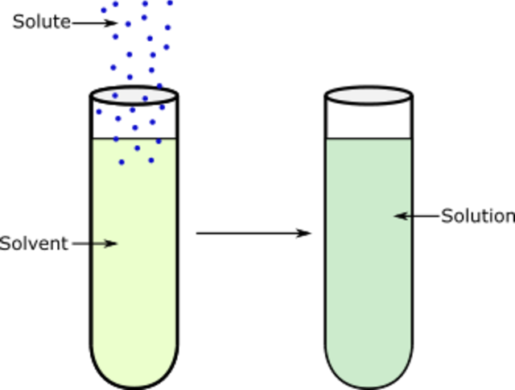
If we add a sugar cube to water, the sugar dissolves. It looks like the sugar has disappeared, but the particles are just mixed in with the water.
Making and separating solutions
To make the sugar dissolve faster, we could heat the water and stir it.
A substance that dissolves is called the solute, while something that dissolves other substances is called a solvent.
In the example above, sugar is the solute and water is the solvent. Once a solute is dissolved in a solvent, a solution is formed.
Maxmath12, CC0, via Wikimedia Commons
If a substance can dissolve, it is called soluble. If it is not able to dissolve it is insoluble. While salt dissolves in water, sand does not. Sand is insoluble in water.
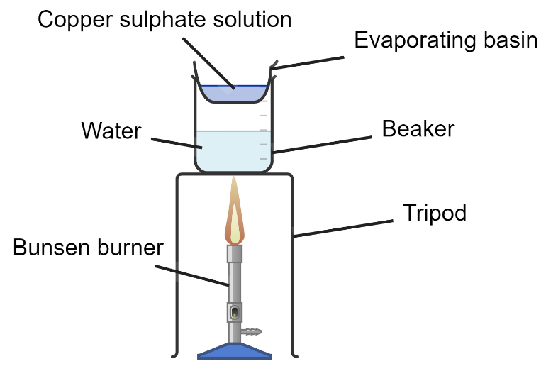
To separate out a solute we can use a setup like that in the diagram to the left. Here, we are trying to obtain copper sulphate crystals from the solution.
The solution is poured into an evaporating basin and gently heated. When some of the solvent has evaporated, the solution is removed from the heat.
Eventually, copper sulphate crystals are formed as the solvent evaporates.
Created with Chemix (https://chemix.org)
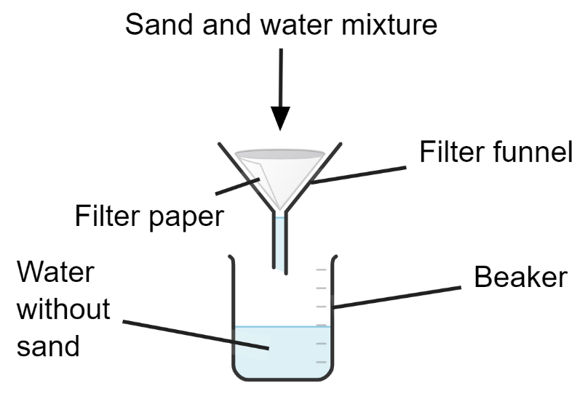
Because sand is insoluble in water, this method cannot work for a sand and water mixture.
Instead, we use filtration. The sand and water mixture is poured onto some filter paper.
Because the water molecules are smaller than the sand particles, water passes through the filter funnel but the sand doesn’t. Therefore, we can separate the water and sand.
Created with Chemix (https://chemix.org)
Q1. The following statements are either true or false. State which are true and which are false.
- Sand is soluble in water.
………………………………………………………………………………………………………………………………………………………………………………………………………..
- Salt is soluble in water.
………………………………………………………………………………………………………………………………………………………………………………………………………..
- Sugar dissolves faster in hot water than it does in cold water.
………………………………………………………………………………………………………………………………………………………………………………………………………..
- You can filter out the salt from a saltwater solution by passing the solution through filter paper.
………………………………………………………………………………………………………………………………………………………………………………………………………..
Q2. In fizzy drinks, the bubbles are caused by carbon dioxide. The carbon dioxide is initially dissolved in the water.
- State the solute.
………………………………………………………………………………………………………………………………………………………………………………………………………..
- State the solvent.
………………………………………………………………………………………………………………………………………………………………………………………………………..
Q3. Describe what the word soluble means.
………………………………………………………………………………………………………………………………………………………………………………………………………..
Q4. Describe what the word insoluble means.
………………………………………………………………………………………………………………………………………………………………………………………………………..
Q5. State two ways of making salt dissolve faster in water.
………………………………………………………………………………………………………………………………………………………………………………………………………..
Q6. Describe how you would separate sand from a sand and water mixture.
………………………………………………………………………………………………………………………………………………………………………………………………………..
………………………………………………………………………………………………………………………………………………………………………………………………………..
………………………………………………………………………………………………………………………………………………………………………………………………………..
Q7. Describe how you would separate sugar from a sugar and water solution.
………………………………………………………………………………………………………………………………………………………………………………………………………..
………………………………………………………………………………………………………………………………………………………………………………………………………..
………………………………………………………………………………………………………………………………………………………………………………………………………..

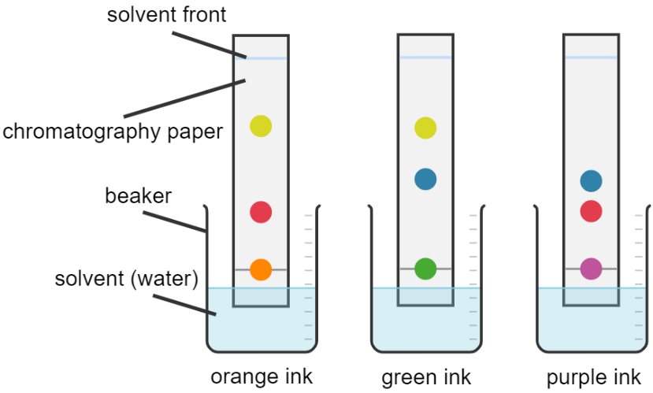
Chromatography allows us to separate different substances in a mixture. For example, the diagram to the right shows three inks undergoing chromatography.
Chromatography and distillation
Here, a spot of ink is placed on chromatography paper and the paper is placed in water. The water rises up the paper and acts as a solvent. The ink is made of different dyes that are soluble in water.
Created with Chemix (https://chemix.org)
As the water rises, it brings the dyes up the chromatography paper with it. However, different dyes move up the chromatography paper at a different rate. Therefore, the different dyes are separated.
If we look at the diagrams above, we can see that both orange ink and purple ink contain the same red dye. We know this because the dye has risen by the same amount up the chromatography paper.
The green and purple inks also contain the same blue dye, and the orange and green inks contain the same yellow dye.
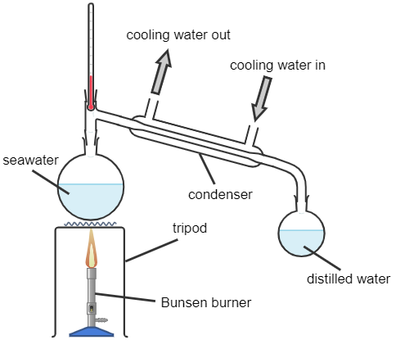
The apparatus to the left shows simple distillation.
Here, a Bunsen burner applies heat to some seawater. The water evaporates, leaving the salt in the seawater behind.
The water vapour then travels through a condenser where cooling water passes through.
Because the condenser is cool, it condenses the water vapour. The distilled water can then be collected.
This method can also be used to separate liquids with different boiling points.
Created with Chemix (https://chemix.org)

Q1. The following statements are either true or false. State which are true and which are false.
- In chromatography, ink is the solvent.
………………………………………………………………………………………………………………………………………………………………………………………………………..
- In chromatography, the dyes are soluble in water.
………………………………………………………………………………………………………………………………………………………………………………………………………..
- Chromatography allows us to separate different elements in a compound.
………………………………………………………………………………………………………………………………………………………………………………………………………..
- Simple distillation allows us to separate liquids with different boiling points.
………………………………………………………………………………………………………………………………………………………………………………………………………..
- Cooling water is used in a condenser to condense hotter gases.
………………………………………………………………………………………………………………………………………………………………………………………………………..
Q2. Name the state change in going from gas to liquid.
………………………………………………………………………………………………………………………………………………………………………………………………………..
Q3. Name the state change in going from liquid to gas.
………………………………………………………………………………………………………………………………………………………………………………………………………..
Q4. Describe what the word soluble means.
………………………………………………………………………………………………………………………………………………………………………………………………………..
Q5. Describe what the word solvent means.
………………………………………………………………………………………………………………………………………………………………………………………………………..
Q6. A mixture of liquids undergoes simple distillation. Liquid A has a boiling point of 100°C. Liquid B has a boiling point of 300°C. As the mixture is heated, state and explain which liquid will evaporate and be collected first.
………………………………………………………………………………………………………………………………………………………………………………………………………..
………………………………………………………………………………………………………………………………………………………………………………………………………..
Q7. Describe how chromatography is used to separate dyes in an ink.
………………………………………………………………………………………………………………………………………………………………………………………………………..
………………………………………………………………………………………………………………………………………………………………………………………………………..
………………………………………………………………………………………………………………………………………………………………………………………………………..
Q8. A student claims that salt can be filtered out of seawater by passing seawater through filter paper. Explain why the student is wrong and describe a correct method for obtaining pure water from seawater.
………………………………………………………………………………………………………………………………………………………………………………………………………..
………………………………………………………………………………………………………………………………………………………………………………………………………..
………………………………………………………………………………………………………………………………………………………………………………………………………..
………………………………………………………………………………………………………………………………………………………………………………………………………..

