A moment is a turning force. The equation to calculate a moment is
Moments
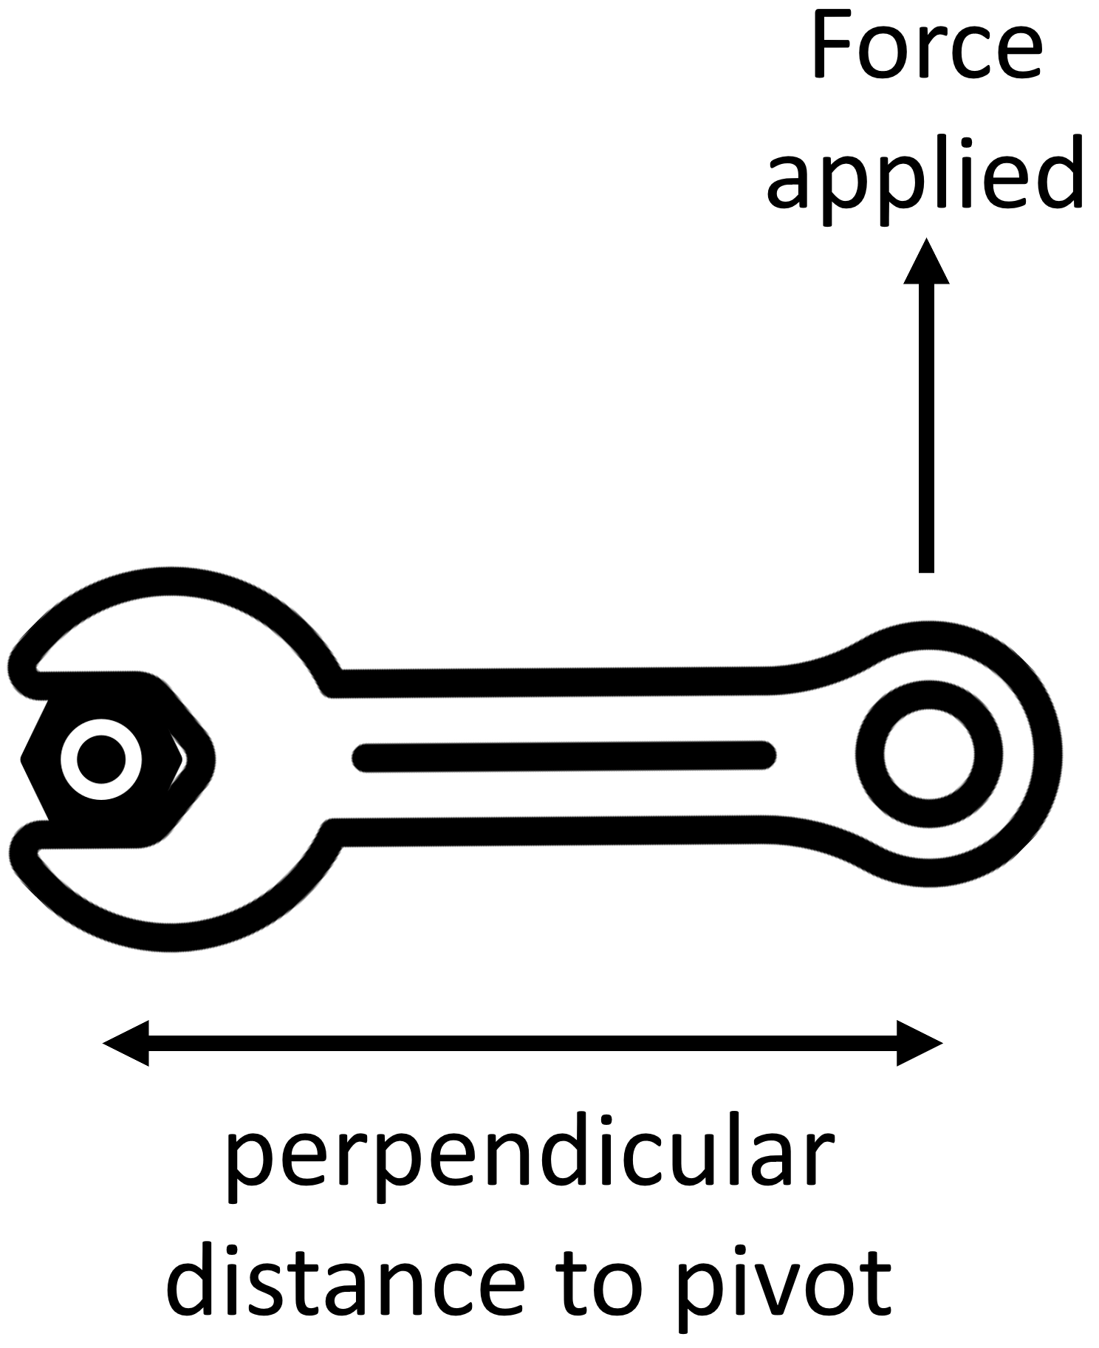
Moment = force × distance
where the distance (measured in metres) is the perpendicular distance to the pivot.
Forces are measured in Newtons (N) and moments are therefore measured in Newton metres (Nm).
The diagram to the right shows one example use of a turning force. A spanner is used as a force-multiplier. This means that by applying a force at a greater distance, we only need to apply a smaller force to turn the bolt.
The principle of moment tells us that:
An object is balanced when the sum of the clockwise moments about a point are equal to the sum of the anticlockwise moments about the point.
We can use this when talking about objects being balanced or unbalanced on a seesaw.
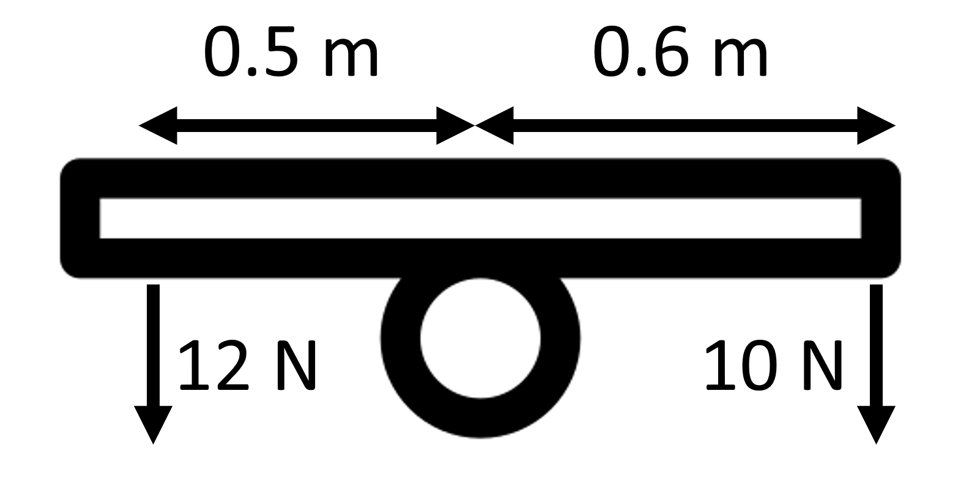
Example question:
Using the diagram to the right, state whether the seesaw is balanced or not.

Step 1. Calculate clockwise moments. Moment = 10 × 0.6 = 6 Nm
Step 2. Calculate anticlockwise moments. Moment = 12 × 0.5 = 6 Nm
Step 3. Conclusion. If equal; seesaw is balanced Yes, seesaw is balanced.

Q1. State the equation that links a moment, force and perpendicular distance to pivot.
………………………………………………………………………………………………………………………………………………………………………………………………………..
Q2. State the units of a moment, force and distance.
………………………………………………………………………………………………………………………………………………………………………………………………………..
Q3. Describe the principle of moments.
………………………………………………………………………………………………………………………………………………………………………………………………………..
………………………………………………………………………………………………………………………………………………………………………………………………………..
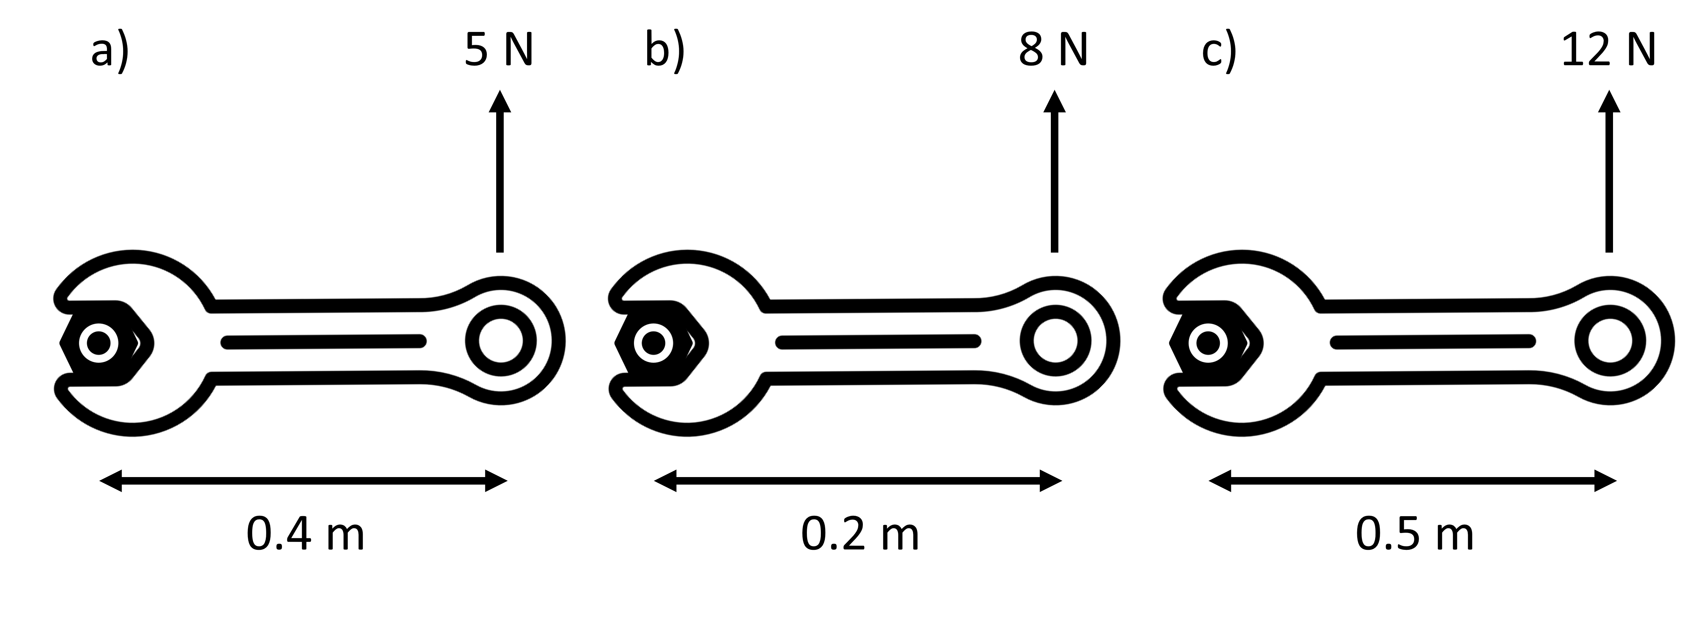
Q4. Using the diagrams below, calculate the moment applied to each of the bolts:
- …………………………………………………………………………………………………………………………………………………………………………………………

- …………………………………………………………………………………………………………………………………………………………………………………………

- …………………………………………………………………………………………………………………………………………………………………………………………

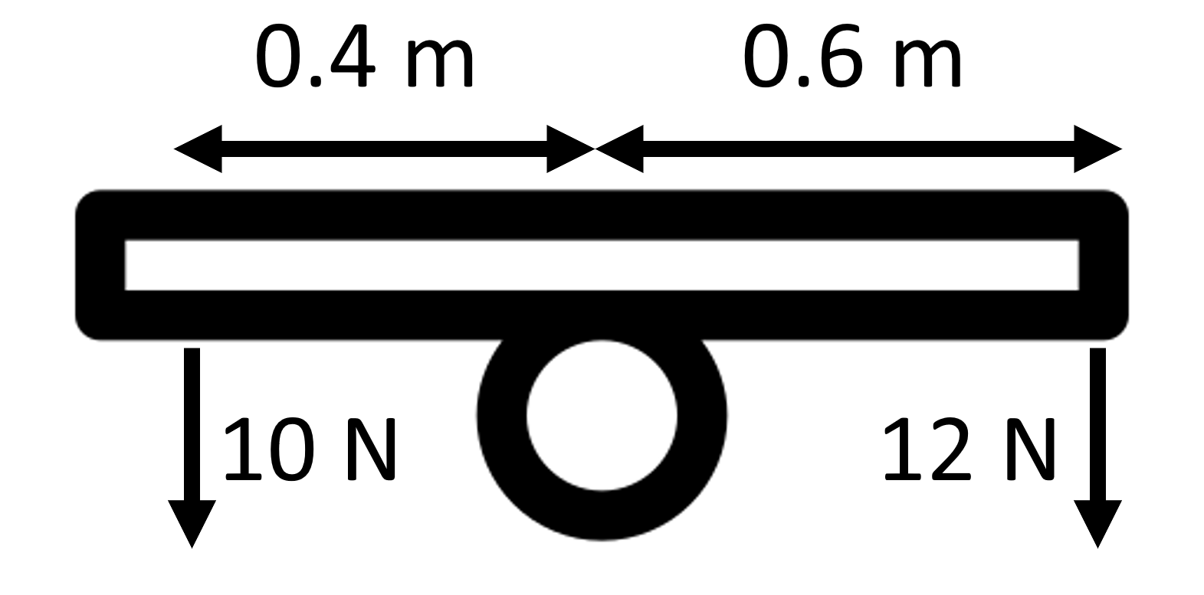
Q5. Using the diagram to the right, state whether the seesaw is balanced or not.
………………………………………………………………………………………………………………………
………………………………………………………………………………………………………………………
………………………………………………………………………………………………………………………

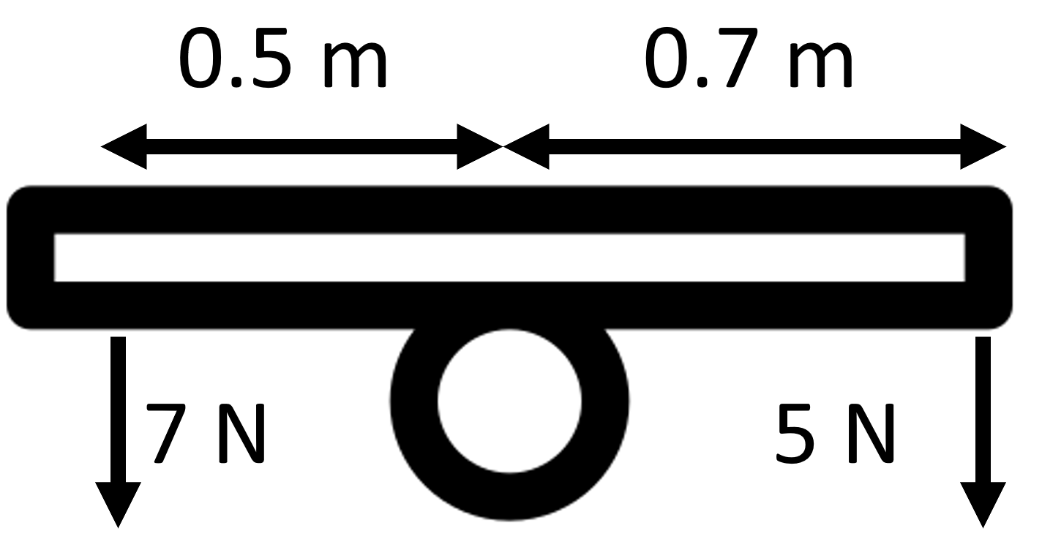
Q6. Using the diagram to the left, state whether the seesaw is balanced or not.
………………………………………………………………………………………………………………………
………………………………………………………………………………………………………………………
………………………………………………………………………………………………………………………

