When a skydiver jumps out of an aeroplane they accelerate. However, their acceleration (the rate at which they speed up) is not constant throughout the skydive. To understand this fully, we need to know Newton’s Laws. These describe the motion of objects.
Terminal velocity
Newton’s first law: The speed of an object will remain the same unless a resultant force acts on the object. This includes if an object is initially stationary; if there is no resultant force the object will remain stationary.
Newton’s second law: The acceleration of an object is proportional to the resultant force on the object. The larger the resultant force, the larger the acceleration of the object.
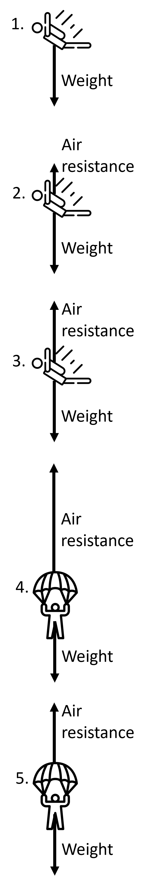
Newton’s third law: If object A exerts a force on object B, then object B exerts an equal and opposite force on object A.
The diagram to the right shows the force diagrams of a skydiver at different stages in their skydive:
- The skydiver has just jumped out of the aeroplane and hasn’t quite started falling yet. The only force acting on the skydiver is their weight. As this is the only force, the skydiver accelerates.
- As the skydiver increases in speed, the air resistance increases. The resultant force downwards is therefore less, and according to Newton’s second law the acceleration downwards must also be less.
- Eventually, when the skydiver reaches a certain speed, the air resistance is equal to the weight. There is no resultant force. Due to Newton’s first law, the speed of the skydiver remains the same. The acceleration is zero. The speed is called the terminal (maximum) velocity.
- When the skydiver opens their parachute, they have a much larger surface area. This dramatically increases the air resistance and there is a resultant force upwards. This means that the skydiver decelerates.
- As the skydiver slows down, the air resistance decreases until it is equal to the weight again. The forces are balanced and the skydiver reaches a second (slower) terminal velocity.
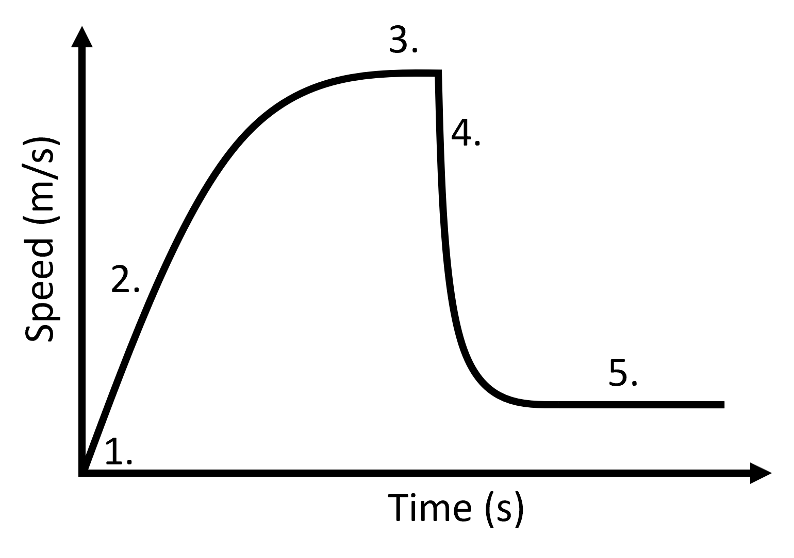
These stages are also shown in the graph to the left. Here, the speeds of the skydiver at shown at each stage. Note the terminal velocities at stages 3 and 5.

Q1. State what happens to air resistance as the speed of an object increases.
………………………………………………………………………………………………………………………………………………………………………………………………………..
Q2. A car is travelling at a speed of 70 mph on the motorway. All the forces on the car are balanced. State what happens to the speed of the car.
………………………………………………………………………………………………………………………………………………………………………………………………………..
Q3. The car now has a resultant force forwards. State what happens to the speed of the car.
………………………………………………………………………………………………………………………………………………………………………………………………………..
Q4. Using the diagram to the right, state and explain whether the skydiver will be accelerating, decelerating, or falling at a constant speed.
……………………………………………………………………………………………………………………………………………………………………………
……………………………………………………………………………………………………………………………………………………………………………
Q5. Using the diagram to the right, state and explain whether the skydiver will be accelerating, decelerating, or falling at a constant speed.
……………………………………………………………………………………………………………………………………………………………………………
……………………………………………………………………………………………………………………………………………………………………………
Q6. Using the diagram to the right, state and explain whether the skydiver will be accelerating, decelerating, or falling at a constant speed.
……………………………………………………………………………………………………………………………………………………………………………
……………………………………………………………………………………………………………………………………………………………………………
Q7. Describe what causes a terminal velocity of a skydiver.
………………………………………………………………………………………………………………………………………………………………………………………………………..
………………………………………………………………………………………………………………………………………………………………………………………………………..
………………………………………………………………………………………………………………………………………………………………………………………………………..
Q8. State and explain what happens to the air resistance on a skydiver straight after they open their parachute.
………………………………………………………………………………………………………………………………………………………………………………………………………..
………………………………………………………………………………………………………………………………………………………………………………………………………..
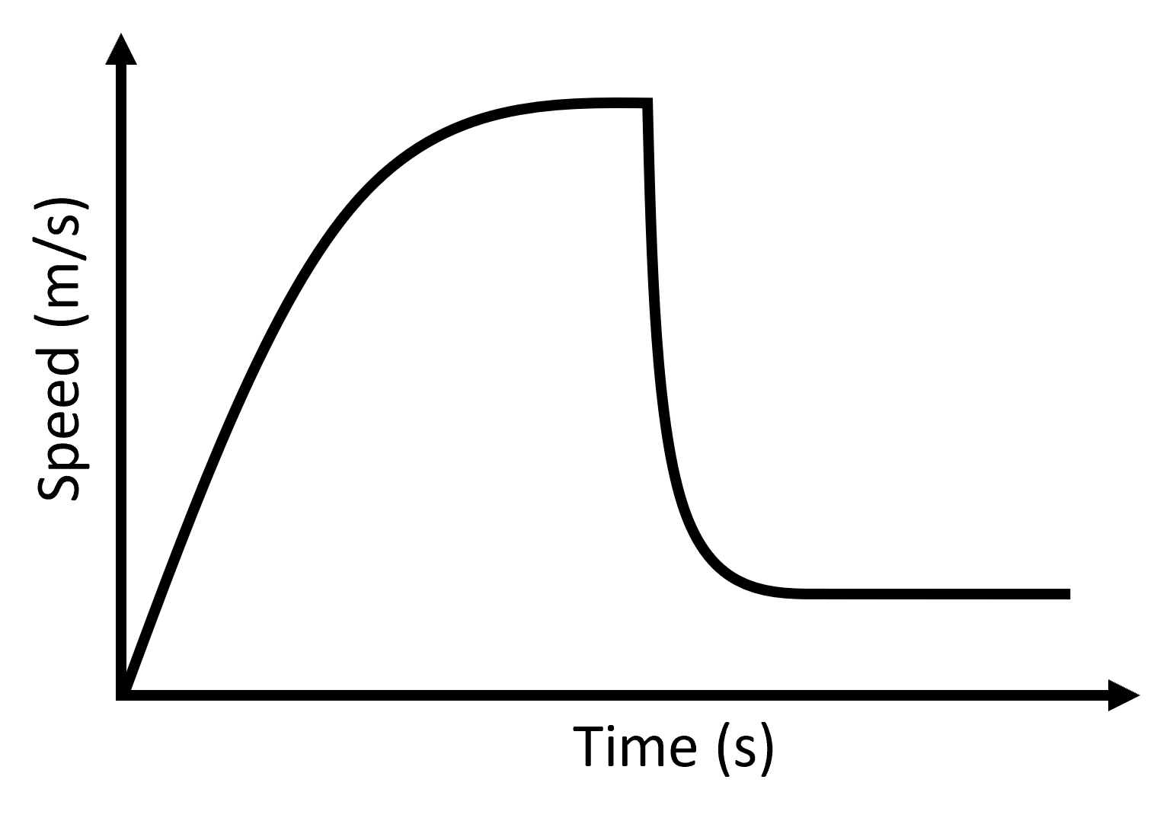
Q9. For the questions below, use the speed-time graph of a skydiver to the right.
- Annotate with an “A” where the skydiver is accelerating.
- Annotate with a “T” two regions of terminal velocity.
- Annotate with a “P” the time when the parachute is opened.

