Waves transfer energy from one place to another, without transferring any material.
Introduction to waves
There are two types of wave; longitudinal and transverse.
Both longitudinal and transverse waves are caused by vibrations. However, transverse waves are caused by a vibration that is perpendicular to the direction of wave travel. Longitudinal waves are caused by a vibration that is parallel to the direction of wave travel.
These waves are shown below, where a slinky is being used to demonstrate transverse and longitudinal waves (in images a) and b) respectively).
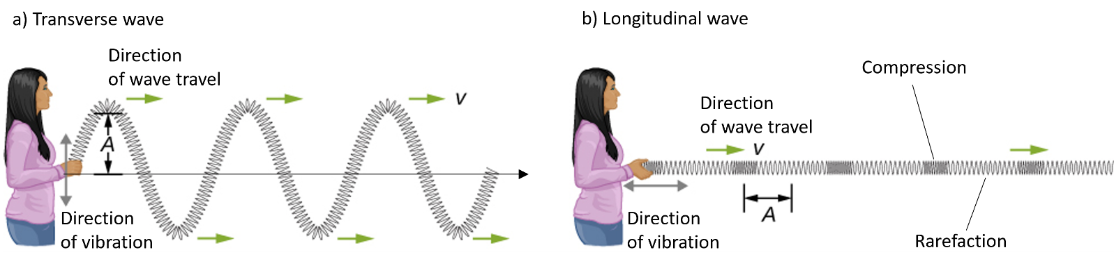
Note two areas that are labelled on the longitudinal wave. A compression is where particles in the wave are closest together, and a rarefaction is where they are furthest apart.
Adapted from original image at https://openstax.org/books/university-physics-volume-1/pages/1-introduction. Licensed under CC BY.
A diagram of a transverse wave is also shown below, including some key terminology:
Displacement | How far a point on the wave is from the rest position
Wavelength | Distance from peak to peak (or any complete wave cycle).
Amplitude | Maximum displacement of wave.
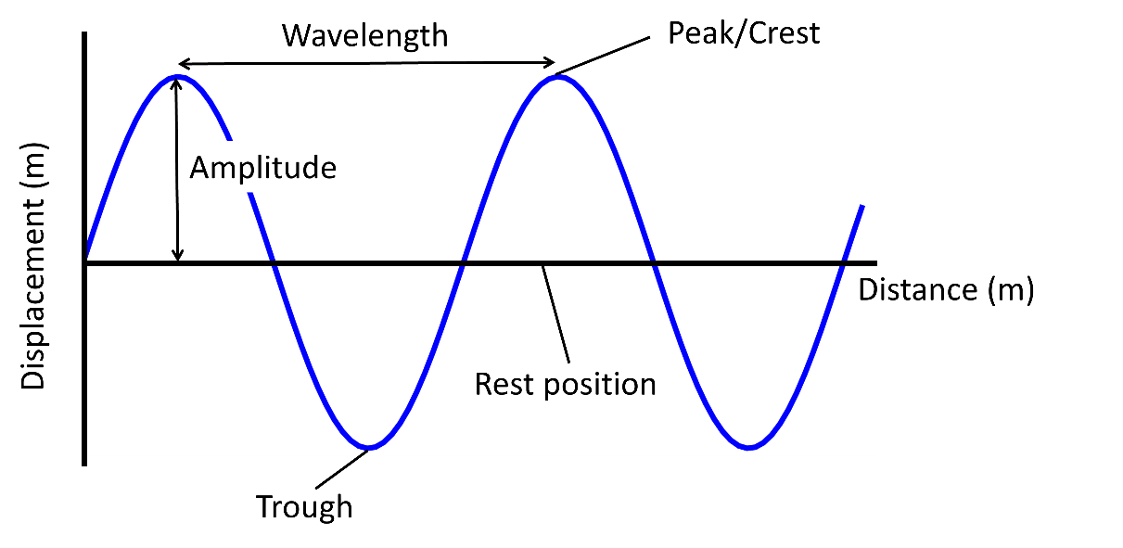

Q1. The following statements are either true or false. State which are true and which are false.
- A wave transfers energy from one place to another.
………………………………………………………………………………………………………………………………………………………………………………………………………..
- A wave transfers material from one place to another.
………………………………………………………………………………………………………………………………………………………………………………………………………..
- Vibrations are the cause of both longitudinal and transverse waves.
………………………………………………………………………………………………………………………………………………………………………………………………………..
- In a longitudinal wave, a compression is where particles in the wave are closest together.
………………………………………………………………………………………………………………………………………………………………………………………………………..
- In a transverse wave, the vibration that causes the wave is parallel to the direction of wave travel.
………………………………………………………………………………………………………………………………………………………………………………………………………..
Q2. Label the diagram of the transverse wave below.
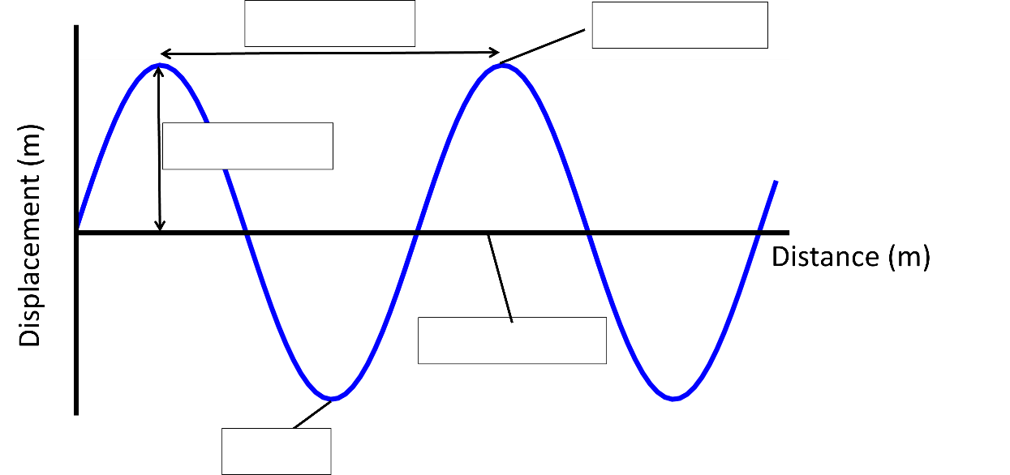

Q3. Describe what a rarefaction is in a longitudinal wave.
………………………………………………………………………………………………………………………………………………………………………………………………………..
………………………………………………………………………………………………………………………………………………………………………………………………………..
Q4. Describe a similarity between a longitudinal wave and a transverse wave.
………………………………………………………………………………………………………………………………………………………………………………………………………..
………………………………………………………………………………………………………………………………………………………………………………………………………..
Q5. Describe the difference between a longitudinal wave and a transverse wave.
………………………………………………………………………………………………………………………………………………………………………………………………………..
………………………………………………………………………………………………………………………………………………………………………………………………………..
………………………………………………………………………………………………………………………………………………………………………………………………………..
………………………………………………………………………………………………………………………………………………………………………………………………………..

