We can see ourselves in a mirror because mirrors reflect light.
Reflection
Light is another example of a transverse wave, and travels at 300 000 000 m/s (the speed of light). Transverse waves are caused by a vibration that is perpendicular to the direction of wave travel.
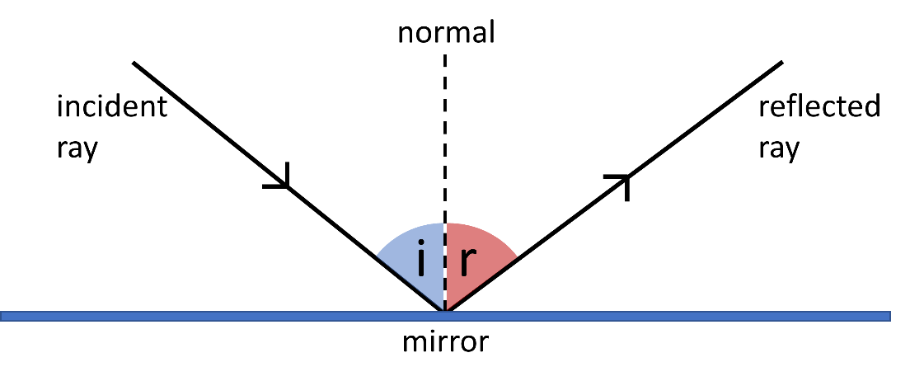
Specular reflections happen when rays of light are reflected from a very smooth surface like a mirror. The diagram below shows specular reflection of light from a mirror.
The ray going into the mirror is called the incident ray (labelled i on the diagram). The angle of incidence is the angle that this ray makes to the normal. The normal is an imaginary line that we draw at an angle of 90° to the mirror. An arrow shows the direction of the ray.
The angle of refraction is also measured between the reflected ray and the normal.
This diagram also shows the law of reflection. The law of reflection says that:

The angle of incidence is equal to the angle of reflection.
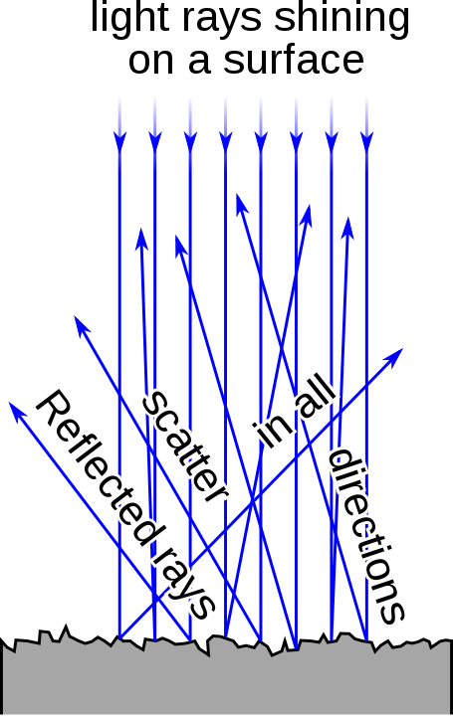
This law doesn’t only apply to light, but also to other waves. For example, light is part of a family of seven transverse waves in the electromagnetic spectrum.
If rays of light are shone onto a surface that isn’t smooth, then a diffuse reflection happens.
In a diffuse reflection, rays are reflected at many angles. The angle of incidence is still equal to the angle of reflection; it’s just that the surface isn’t smooth and points in different directions.
This is shown in the diagram to the right.
Jeff Dahl, CC BY-SA 3.0 <https://creativecommons.org/licenses/by-sa/3.0>, via Wikimedia Commons

Q1. The following statements are either true or false. State which are true and which are false.
- Light is a transverse wave.
………………………………………………………………………………………………………………………………………………………………………………………………………..
- Transverse waves are caused by a vibration that is perpendicular to the direction of wave travel.
………………………………………………………………………………………………………………………………………………………………………………………………………..
- Diffuse reflections happen when rays of light are reflected from a very smooth surface.
………………………………………………………………………………………………………………………………………………………………………………………………………..
- In a diffuse reflection, the angle of incidence is not always equal to the angle of reflection.
………………………………………………………………………………………………………………………………………………………………………………………………………..
- Light is shone onto a mirror. The angle of incidence is measured from the incident ray to the mirror.
………………………………………………………………………………………………………………………………………………………………………………………………………..
- Only light obeys the law of reflection.
………………………………………………………………………………………………………………………………………………………………………………………………………..
Q2. State the speed of light.
………………………………………………………………………………………………………………………………………………………………………………………………………..
Q3. State the law of reflection.
………………………………………………………………………………………………………………………………………………………………………………………………………..
………………………………………………………………………………………………………………………………………………………………………………………………………..
Q4. Describe the difference between a specular and a diffuse reflection.
………………………………………………………………………………………………………………………………………………………………………………………………………..
………………………………………………………………………………………………………………………………………………………………………………………………………..
Q5. The diagram of reflection below is incomplete. Draw the reflected ray and label the diagram completely.
