A pinhole camera is a simple way of making an image of an object.
Cameras
It consists of a box, with a small hole in one end and a “screen” at another. The screen should be made of a thin and translucent material like tracing paper. A translucent material is one that allows for some light to pass through it.
A diagram of a pinhole camera is below. Light rays are shown from the top and bottom of an object, but they come from all parts of the object.
Because the light rays from the top of the object are travelling at a different angle to the rays from the bottom of the object, the image is inverted. This means that the image is upside down.
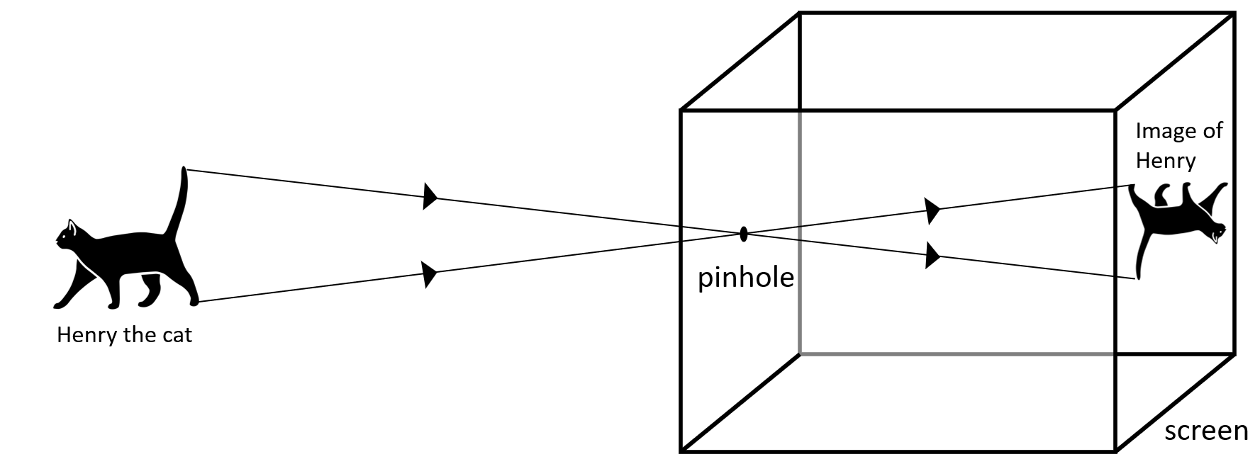
You can make a pinhole yourself at home by using a shoe box and some tracing paper.

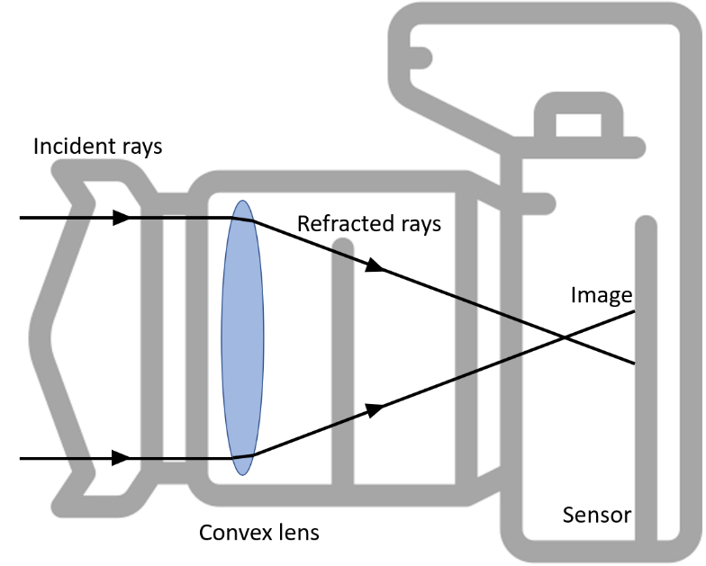
A more modern camera is shown in the diagram to the left.
Like the human eye, it contains a convex lens. The convex lens refracts light to a focus.
The camera also has a part of it that is sensitive to light. Instead of being called the retina (as it is in the eye), it is a sensor.
Even much smaller cameras (like the ones in phones) still contain lenses and sensors.

Q1. Describe what an object being translucent means.
………………………………………………………………………………………………………………………………………………………………………………………………………..
………………………………………………………………………………………………………………………………………………………………………………………………………..
Q2. Describe what an image being “inverted” means.
………………………………………………………………………………………………………………………………………………………………………………………………………..
………………………………………………………………………………………………………………………………………………………………………………………………………..
Q3. The following statements are either true or false. State which are true and which are false.
- Both the human eye and a camera contain a convex lens.
………………………………………………………………………………………………………………………………………………………………………………………………………..
- The human eye contains a retina, while the equivalent for a camera is a sensor.
………………………………………………………………………………………………………………………………………………………………………………………………………..
- A pinhole camera contains a convex lens.
………………………………………………………………………………………………………………………………………………………………………………………………………..
- Images formed by a pinhole camera are always the same way up as the object.
………………………………………………………………………………………………………………………………………………………………………………………………………..
Q4. Describe what refraction is and how a convex lens refracts light to a focus.
………………………………………………………………………………………………………………………………………………………………………………………………………..
………………………………………………………………………………………………………………………………………………………………………………………………………..
………………………………………………………………………………………………………………………………………………………………………………………………………..
………………………………………………………………………………………………………………………………………………………………………………………………………..
Q5. Complete the ray diagram below by showing the path of the rays of light from the lens to the focal point.
