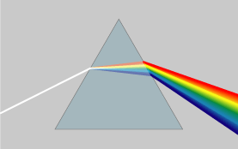
White light is made from different individual colours. We know this because when we pass white light through a prism, the light is split up into seven different colours called a spectrum. This splitting of the colours is called dispersion. Dispersion is what causes rainbows.
Colours in light
The order of the colours (from longest to shortest wavelength) is:
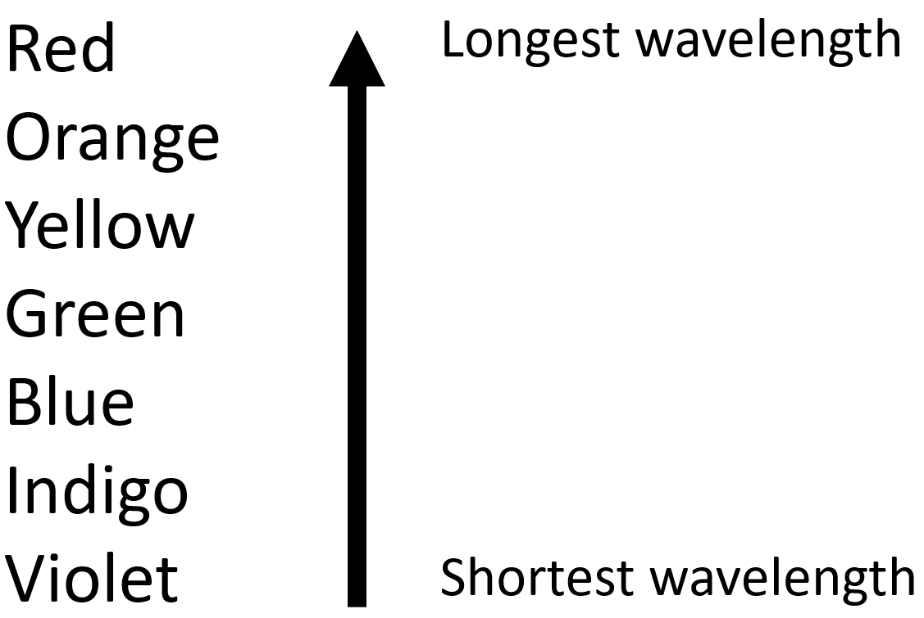
CC BY-SA 3.0, https://commons.wikimedia.org/w/index.php?curid=57730

Commonly, people use ROY G. BIV to remember this order. Dispersion happens because the different colours of light experience a different refractive index and so refract by different amounts.
Violet refracts most as violet experiences the highest refractive index. You can remember this with the phrase “violet bends most violently”. Red refracts least as red experiences the lowest refractive index.
A filter only allows one colour of light to be transmitted through it. Other colours are absorbed by the filter. The diagram below shows a red filter only letting red light go through it, a green filter only letting green light through it and a violet filter only letting violet light through it.
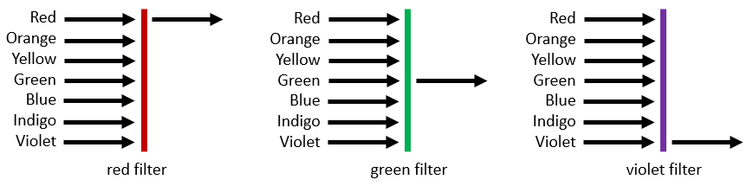

In a similar way, different objects look coloured because of the light that they reflect. A green object looks green because it reflects only green light into our eyes. A red object looks red because it reflects red light into our eyes. A white object reflects all seven colours of light in the spectrum.

Q1. The following statements are either true or false. State which are true and which are false.
- All colours of light experience the same refractive index when going into a prism.
………………………………………………………………………………………………………………………………………………………………………………………………………..
- Dispersion is caused by refraction.
………………………………………………………………………………………………………………………………………………………………………………………………………..
- Dispersion is what causes rainbows.
………………………………………………………………………………………………………………………………………………………………………………………………………..
- Red light refracts most in a prism.
………………………………………………………………………………………………………………………………………………………………………………………………………..
- Of all the colours, red light has the longest wavelength.
………………………………………………………………………………………………………………………………………………………………………………………………………..
Q2. Describe why dispersion happens.
………………………………………………………………………………………………………………………………………………………………………………………………………..
………………………………………………………………………………………………………………………………………………………………………………………………………..
Q3. State the order of colours in visible light, giving the order from longest to shortest wavelength.
………………………………………………………………………………………………………………………………………………………………………………………………………..
………………………………………………………………………………………………………………………………………………………………………………………………………..
Q4. State what colour of light is transmitted through an orange filter.
………………………………………………………………………………………………………………………………………………………………………………………………………..
Q5. Describe why a blue object looks blue.
………………………………………………………………………………………………………………………………………………………………………………………………………..
………………………………………………………………………………………………………………………………………………………………………………………………………..
Q6. White light is passed through a yellow filter.
- State what colour is transmitted through the yellow filter.
………………………………………………………………………………………………………………………………………………………………………………………………………..
- The light from this filter is then shone onto a blue object. Describe why the object looks black.
………………………………………………………………………………………………………………………………………………………………………………………………………..
………………………………………………………………………………………………………………………………………………………………………………………………………..

