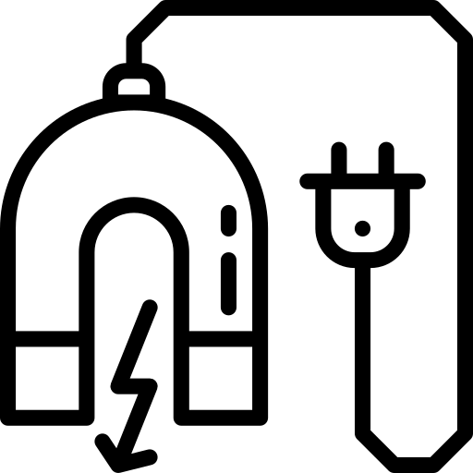
Electricity &
electromagnetism
Name ______________________________
Class ______________________________
Teacher ______________________________
All matter is made of atoms and molecules. In the centre of an atom is the nucleus. The nucleus is made of protons and neutrons. Electrons orbit around the nucleus.
Introduction to static electricity
Protons are positively charged, while electrons are negatively charged. Neutrons are neutral and so have no charge.
Atoms are ordinarily neutral as they have equal numbers of protons and electrons. If an atom loses an electron then it becomes positively charged. We call an atom that has lost an electron an ion and call the process of an atom losing/gaining an electron ionisation.
Objects gain a static charge when one object rubs against another. The friction between these objects causes one of them to lose electrons and one of them to gain electrons.
Objects with different charges exert electro-static forces on each other. This force is non-contact.
Like charges repel, unlike charges attract.
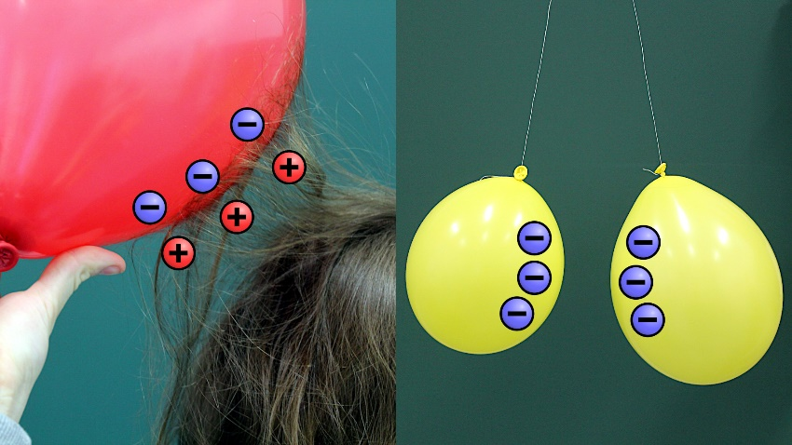
If somebody rubs a balloon against their hair, the friction transfers electrons from their hair onto the balloon.
If the balloon is removed from their hair, then the balloon will attract the hair. This is because the balloon and the hair have opposite charges.
Similarly, if two negatively charged balloons are placed next to each other then they will repel each other. This is because they have the same charge.
MikeRun, CC BY-SA 4.0 <https://creativecommons.org/licenses/by-sa/4.0>, via Wikimedia Commons

The Van de Graaff generator works in a similar way and very large charges can build up.
If somebody touches a the surface of a Van de Graaff (while insulated from the floor!) then the person gains a charge. This includes all of their hairs having the same charge. Because all of their hairs have the same charge, they repel each other and spread out.
Biswarup Ganguly, CC BY 3.0 <https://creativecommons.org/licenses/by/3.0>, via Wikimedia Commons

Q1. State the two particles that make up the nucleus.
………………………………………………………………………………………………………………………………………………………………………………………………………..
Q2. State the name of the particle that orbits around the nucleus. State what charge it has.
………………………………………………………………………………………………………………………………………………………………………………………………………..
Q3. State whether electro-static forces are contact or non-contact. Explain what this means.
………………………………………………………………………………………………………………………………………………………………………………………………………..
Q4. State the name of an atom that has lost or gained an electron.
………………………………………………………………………………………………………………………………………………………………………………………………………..
Q5. Explain why atoms usually have no overall charge.
………………………………………………………………………………………………………………………………………………………………………………………………………..
Q6. Describe how an object gains a static charge.
………………………………………………………………………………………………………………………………………………………………………………………………………..
Q7. The following statements are either true or false. State which are true and which are false.
- A positive charge attracts a negative charge.
………………………………………………………………………………………………………………………………………………………………………………………………………..
- A negative charge attracts a negative charge.
………………………………………………………………………………………………………………………………………………………………………………………………………..
- For an object to become charged, protons are transferred from one object to another.
………………………………………………………………………………………………………………………………………………………………………………………………………..
Q8. A balloon is rubbed against someone’s jumper. The balloon becomes negatively charged. Describe how the balloon becomes negatively charged. Include in your answer what charge the jumper will become.
………………………………………………………………………………………………………………………………………………………………………………………………………..
………………………………………………………………………………………………………………………………………………………………………………………………………..
………………………………………………………………………………………………………………………………………………………………………………………………………..
Q9. Someone drags their feet while walking across a carpet. Describe why they might get an electric shock if they touch a metal door handle.
………………………………………………………………………………………………………………………………………………………………………………………………………..
………………………………………………………………………………………………………………………………………………………………………………………………………..
………………………………………………………………………………………………………………………………………………………………………………………………………..

Electrostatic forces are non-contact.
Electric field lines
A contact force is one that acts when two objects are physically touching each other. Conversely, a non-contact force acts between objects that are not touching each other.
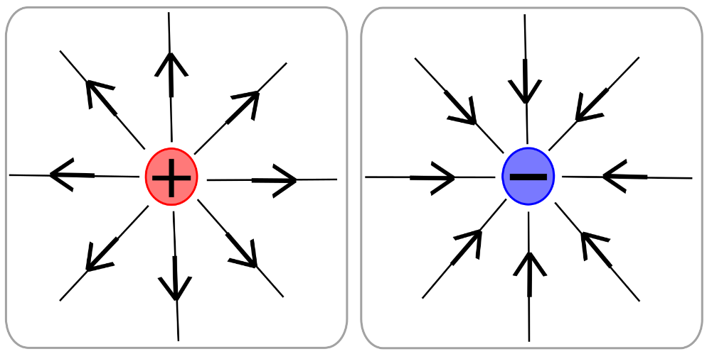
Non-contact forces are caused by field lines. A charged object creates an electric field. The electric field lines for a positive and negative charge are shown in the image to the right.
Electric field lines point away from a positive charge and towards a negative charge.
Nein Arimasen, CC BY-SA 3.0 <http://creativecommons.org/licenses/by-sa/3.0/>, via Wikimedia Commons
The electric field lines represent the direction of force that a nearby positive charge would experience (and the opposite to the direction of force on a nearby negative charge).
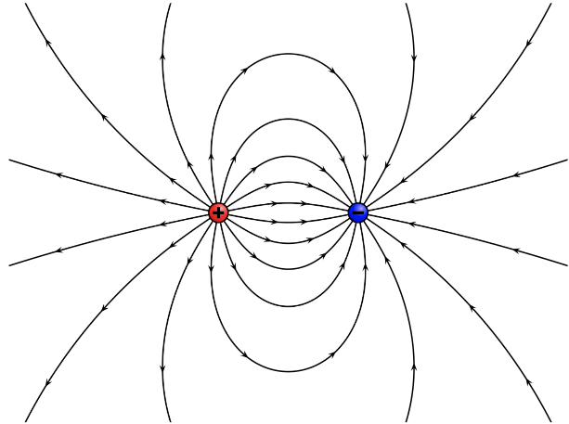
This is because like charges repel and opposite charges attract.
The closer together the field lines, the stronger the electric field. In the diagram above, the further you go away from each charge the weaker the field becomes. We know this because the field lines become more separated.
The top diagram to the left shows the electric field lines when a positive charge is near a negative charge.
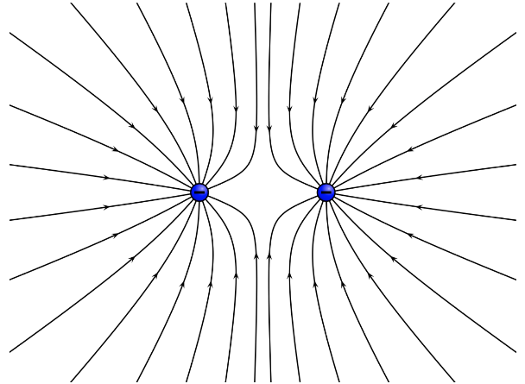
The second diagram to the left shows the electric field lines when two negative charges are near each other. If there were two positive charges near each other the pattern would be identical but with the arrows pointing in the opposite direction.
In all cases, the electric field lines point away from positive charges and towards negative charges.
Geek3, CC BY-SA 3.0 <https://creativecommons.org/licenses/by-sa/3.0>, via Wikimedia Commons

Q1. State the direction that electric field lines point.
………………………………………………………………………………………………………………………………………………………………………………………………………..
Q2. State the difference between a contact force and a non-contact force.
………………………………………………………………………………………………………………………………………………………………………………………………………..
………………………………………………………………………………………………………………………………………………………………………………………………………..
Q3. State whether electrostatic forces are contact or non-contact.
………………………………………………………………………………………………………………………………………………………………………………………………………..
Q4. State whether like charges repel or attract.
………………………………………………………………………………………………………………………………………………………………………………………………………..
Q5. In the space below, sketch the pattern of electric field lines around
- A positive charge.
- A negative charge.
Q6. State what the direction of the electric field lines represent.
………………………………………………………………………………………………………………………………………………………………………………………………………..
Q7. State what the happens to the strength of the electric field as you go further from a charge.
………………………………………………………………………………………………………………………………………………………………………………………………………..
Q8. In the space below, sketch the pattern of electric field lines around two positive charges that are near each other.

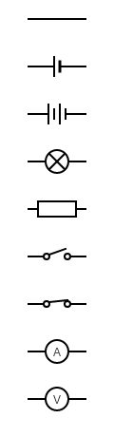
We use circuit diagrams to represent electrical circuits. We generally draw circuit diagrams in pencil and use a ruler to draw any connecting wires. Circuit symbols are used to represent different electrical components. A list of these circuit symbols are below:
Circuit symbols
Connecting wire. These are used to connect different parts of a circuit together.
A cell – provides potential difference to the circuit.
A battery – made of more than one cell.
A lamp – produces light.
A resistor – limits the amount of current in the current and used to vary potential differences.
Open switch. When a switch is open that part of the circuit is incomplete. Current cannot flow through an incomplete circuit.
Closed switch. When a switch is closed that part of the circuit is complete. Current can flow through a complete circuit.
An ammeter – measures the current in a circuit. Goes in series in the part of the circuit where you want to measure the current.
A voltmeter – measures the potential difference between two parts of a circuit. Goes in parallel around the component that you want to measure the potential difference across.
The diagrams below show a series circuit (on the left) and a parallel circuit (on the right). Remember that there’s only one path for the current to flow in a series circuit, but more than one path for a parallel circuit. Also note how the connecting wires are all straight lines.
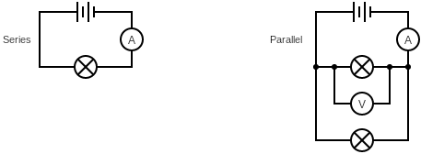

Q1. State the purpose of an ammeter.
………………………………………………………………………………………………………………………………………………………………………………………………………..
Q2. Describe the difference between a series and a parallel circuit.
………………………………………………………………………………………………………………………………………………………………………………………………………..
………………………………………………………………………………………………………………………………………………………………………………………………………..
Q3. State the difference between a cell and a battery.
………………………………………………………………………………………………………………………………………………………………………………………………………..
Q4. The following statements are either true or false. State which are true and which are false.
- Current can flow through an incomplete circuit.
………………………………………………………………………………………………………………………………………………………………………………………………………..
- Voltmeters go in series with the component you want to measure the potential difference across.
………………………………………………………………………………………………………………………………………………………………………………………………………..
Q5. In the space below, draw a series circuit that contains a battery, an open switch and a lamp.

Q6. In the space below, draw a series circuit that contains a cell, an ammeter, a resistor and a lamp. Also include a voltmeter in parallel around the lamp.

Q7. In the space below, draw a circuit that contains a battery and three lamps in parallel. On each path, include a switch so that each lamp can be switched on and off independently.

Current flows through an electric circuit. Current is equal to how much charge is flowing past a point in the circuit every second. A complete circuit is needed for current to flow.
Current
Current is measured in units of amps (A), and an ammeter is used to measure the current at a point in the circuit. The circuit symbol for an ammeter is a circle with an “A” in it.
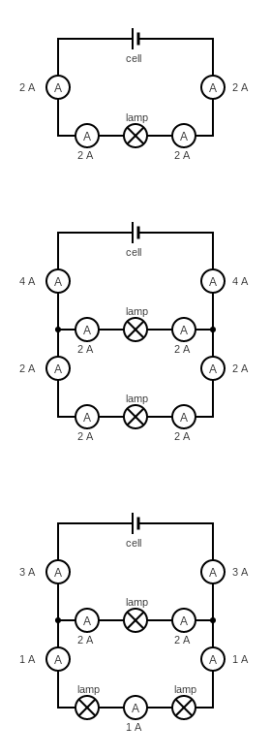
The charged particles that flow through a circuit are electrons. Electrons are negatively charged particles.
A series circuit only has one path for the current to flow. Therefore, current is the same everywhere in a series circuit.
The diagram to the right shows a series circuit with one lamp. The current is 2 A at each point in the circuit.
A parallel circuit has more than one path for the current to flow. The current going into a junction (that is, where a wire splits or combines) is equal to the current going out of a junction.
The circuit to the left shows a parallel circuit with each path having an identical lamp. Each branch has the same 2 A of current as before. Before and after each junction, though, the current is 4 A. Each path draws additional current from the cell.

To the right is a more complicated circuit diagram. All of the lamps are identical, so there is more resistance on one path than the other. The upper path has the same 2 A of current, but the lower path has twice the resistance (because there are two lamps) and so has half the current (at 1 A).
The overall current drawn from the battery is 3 A. The higher the resistance in a path, the lower the current.

Q1. The following statements are either true or false. State which are true and which are false.
- Current is equal to how much charge is flowing past a point in the circuit every second.
………………………………………………………………………………………………………………………………………………………………………………………………………..
- Protons are the charged particles that flow through a circuit.
………………………………………………………………………………………………………………………………………………………………………………………………………..
- Current can flow through an incomplete circuit.
………………………………………………………………………………………………………………………………………………………………………………………………………..
- In a series circuit, current is different at different points.
………………………………………………………………………………………………………………………………………………………………………………………………………..
Q2. State what we use to measure current in a circuit.
………………………………………………………………………………………………………………………………………………………………………………………………………..
Q3. State the units of current.
………………………………………………………………………………………………………………………………………………………………………………………………………..
Q4. In the space below, draw the circuit symbols for a cell, a bulb and an ammeter.

Q5. For each of the circuits below:
- Circle whether the circuit is series or parallel.
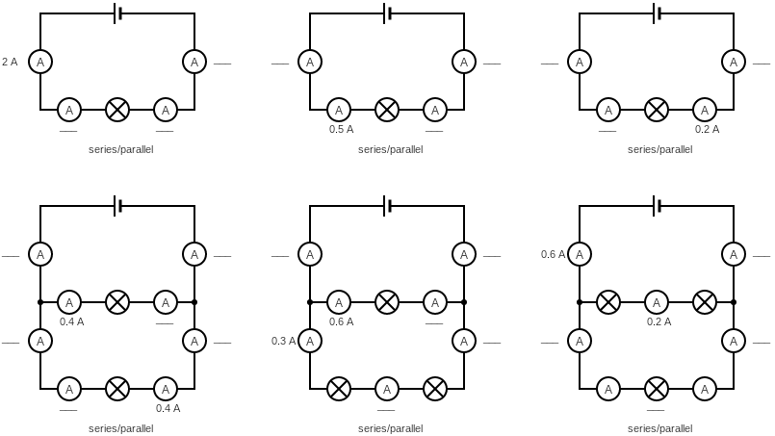
- For any ammeters that do not have a current written by them, write the missing current.
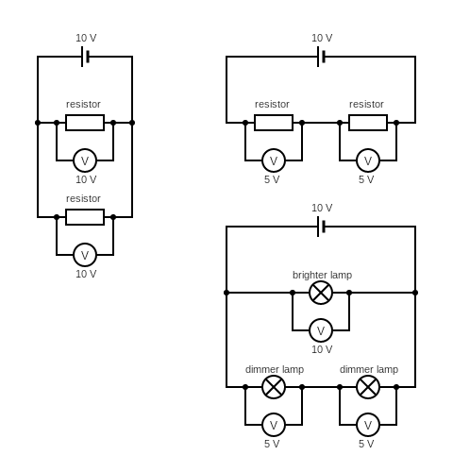
A battery or power supply gives each charge in an electrical circuit energy. Electrical components like lamps or resistors use this energy (which gets transferred into different energy stores). Potential difference is a measure of the difference in energy that charges have between each two points in a circuit.
Potential difference
Potential difference (commonly referred to as voltage) has units of volts and is measured by a voltmeter which goes in parallel across the component you’re measuring the potential difference across. The circuit symbol for a voltmeter is a circle with a “V” in it.
A circuit only experiences a drop in potential difference when the current goes through an electrical component. Therefore, potential difference across each parallel branch is the same.
The diagram to the right shows a cell that produces a potential difference of 10 V across it. The two resistors both have 10 V across them.
In a series circuit, potential difference is split across all components.
In the series circuit to the left, there are two identical resistors. Both resistors have a potential difference of 5 V across them (equal to half the potential difference across the cell).
The circuit diagram to the right is slightly more complicated. The total potential difference across each parallel path is 10 V. However, the lower path has two bulbs and so they each have 5 V across them.
Note how the top lamp is brightest. This is because it has a higher potential difference across it.
Lamps in parallel circuits have two main advantages:
- Each lamp receives the full potential difference and so is brighter.
- If there was a switch on each path, each lamp could be turned on and off independently. Remember that a circuit needs to be complete for a current to flow.
Lamps also have a rating. The lamp rating is the maximum potential difference that is safe to put across a lamp without it breaking.
Q1. The following statements are either true or false. State which are true and which are false.
- The potential difference across each parallel path is the same.
………………………………………………………………………………………………………………………………………………………………………………………………………..
- In a series circuit, potential difference is the same everywhere.
………………………………………………………………………………………………………………………………………………………………………………………………………..
- The higher the potential difference across a lamp, the brighter the lamp.
………………………………………………………………………………………………………………………………………………………………………………………………………..
- The lamp rating is the potential difference that the lamp turns on at.
………………………………………………………………………………………………………………………………………………………………………………………………………..
- Voltmeters go in series in a circuit.
………………………………………………………………………………………………………………………………………………………………………………………………………..
Q2. State an advantage of having lamps in a parallel circuit.
………………………………………………………………………………………………………………………………………………………………………………………………………..
Q3. In the space below, draw the circuit symbols for a resistor and a voltmeter.

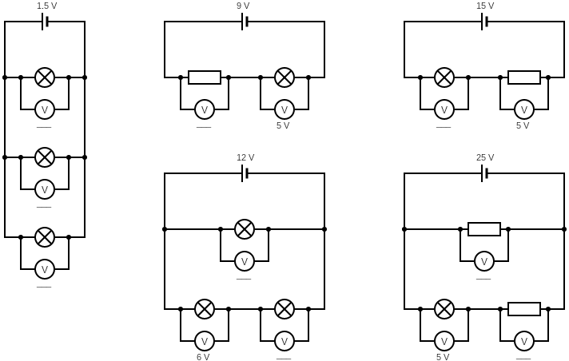
Q4. Each of the circuits below have some voltmeters that do not have a current written by them, write the missing potential differences.
Resistance is a measure of how hard it is for current to flow through an electrical component. Resistance is measured in ohms (Ω).
Resistance
Electrical conductors (like metals) have a low resistance, while insulators (like plastic) have a high resistance.
There is an equation that relates potential difference, current and resistance:
Potential difference = current × resistance or in symbols V = I × R
Remember that potential difference has units of volts (V) and current has units of amps (A).
We can also rearrange this equation to give:
Resistance = potential difference ÷ current or in symbols R = V ÷ I
In other words, resistance is the ratio of potential difference to current.

Example question 1:
A lamp has a resistance of 20 Ω and a current of 0.5 A flowing through it. Calculate the potential difference across the lamp.
Step 1. Write down equation: V = I × R
Step 2. Put variables into equation: = 0.5 × 20
Step 3. Calculate answer. Remember units: = 10 V
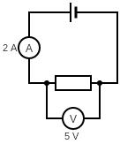

Example question 2:
Using the information in the circuit diagram to the right, calculate the resistance of the resistor.
Step 1. Write down equation: R = V ÷ I
Step 2. Put variables into equation: R = 5 ÷ 2
Step 3. Calculate answer. Remember units: = 2.5 Ω

Q1. State the equation that links potential difference, current and resistance.
………………………………………………………………………………………………………………………………………………………………………………………………………..
Q2. State the unit of resistance.
………………………………………………………………………………………………………………………………………………………………………………………………………..
Q3. Describe the difference between an electrical conductor and an insulator.
………………………………………………………………………………………………………………………………………………………………………………………………………..
Q4. A lamp has a resistance of 15 Ω and a current of 2.0 A flowing through it. Calculate the potential difference across the lamp.
V = I × R
= 2.0 A × 15 Ω
= ____________ V
Q5. A resistor has a resistance of 500 Ω and a current of 0.10 A flowing through it. Calculate the potential difference across the resistor.
V = I × R
= ____ __ × ____ __
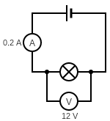
= ____________ V
Q6. Using the information in the diagram to the right, calculate the resistance of the lamp.
R = V ÷ I
= ____ __ ÷ ____ __
= ____________ Ω
Q7. A resistor has a resistance of 100 Ω and a current of 0.8 A flowing through it. Calculate the potential difference across the resistor.
………………………………………………………………………………………………………………………………………………………………………………………………………..
Q8. A light dependent resistor (LDR) has a potential difference of 6 V across it and a current of 0.02 A flowing through it. Calculate the resistance of the LDR.
………………………………………………………………………………………………………………………………………………………………………………………………………..
Q9. A thermistor has a resistance of 1.5 kΩ and a current of 0.5 A flowing through it. Calculate the potential difference across the thermistor.
………………………………………………………………………………………………………………………………………………………………………………………………………..
Q10. A resistor has a resistance of 2.0 kΩ and a potential difference of 10 V across it. Calculate the current flowing through the resistor.
………………………………………………………………………………………………………………………………………………………………………………………………………..
Magnetism is an example of a non-contact force.
Introduction to magnetism
A contact force is one that acts when two objects are physically touching each other. Conversely, a non-contact force acts between objects that are not touching each other.
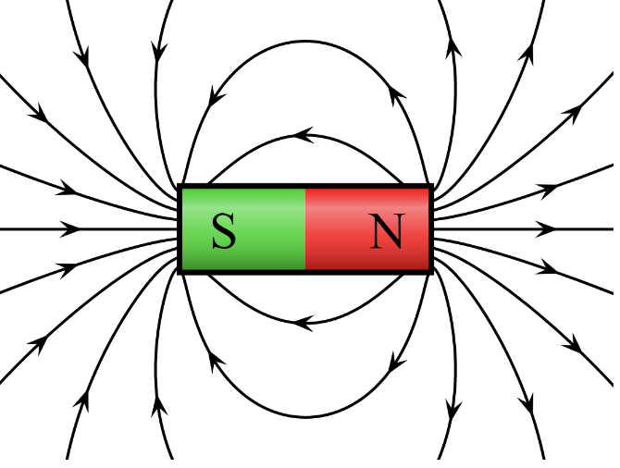
Non-contact forces are caused by field lines. The magnetic field lines for a bar magnet are shown in the diagram to the right.
The bar magnet consists of a North pole and a South pole. The magnetic field lines point away from the North pole and towards the South pole. The field lines give the direction of force on the North pole of another magnet.
Like poles repel. Unlike poles attract.
By Geek3 - Own work, CC BY-SA 3.0, https://commons.wikimedia.org/w/index.php?curid=10587119
The diagram also shows that the magnetic field is stronger near the ends (poles) of the bar magnet. We can tell this because the magnetic field lines are closer together.
A permanent magnet (like a bar magnet) produces its own magnetic field. There are three metals that become magnetic when placed in a magnetic field. These magnetic metals are iron, nickel and cobalt. Steel is also a magnetic metal as it contains iron. Metals other than these are not magnetic.
The magnetic metals are attracted by permanent magnets, but never repelled.
A permanent magnet can be demagnetised by heating it, hitting it with a hammer or by placing it in a reversed magnetic field.
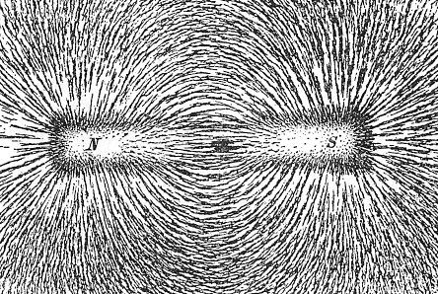
We can visualise the magnetic field around a bar magnet by using iron filings. A bar magnet can be put under a piece of paper, with iron filings then sprinkled on top of the paper.
Newton Henry Black, Public domain, via Wikimedia Commons
The iron filings arrange themselves in the shape of the field and are most attracted to the regions with the strongest field (the poles).

Q1. State the direction that magnetic lines point.
………………………………………………………………………………………………………………………………………………………………………………………………………..
Q2. State the difference between a contact force and a non-contact force.
………………………………………………………………………………………………………………………………………………………………………………………………………..
………………………………………………………………………………………………………………………………………………………………………………………………………..
Q3. State whether magnetism is a contact or non-contact force.
………………………………………………………………………………………………………………………………………………………………………………………………………..
Q4. In the space below, sketch the pattern of magnetic field lines around a bar magnet.
Q5. State the three magnetic metals.
………………………………………………………………………………………………………………………………………………………………………………………………………..
Q6. The following statements are either true or false. State which are true and which are false.
- Cobalt is attracted to a bar magnet.
………………………………………………………………………………………………………………………………………………………………………………………………………..
- A north pole repels another north pole.
………………………………………………………………………………………………………………………………………………………………………………………………………..
- Copper is attracted to a bar magnet.
………………………………………………………………………………………………………………………………………………………………………………………………………..
- A north pole attracts a south pole.
………………………………………………………………………………………………………………………………………………………………………………………………………..
- The closer together the magnetic field lines, the stronger the field.
………………………………………………………………………………………………………………………………………………………………………………………………………..
- Iron is repelled by a bar magnet.
………………………………………………………………………………………………………………………………………………………………………………………………………..
- Magnetic field lines point away from a South pole and towards a North pole.
………………………………………………………………………………………………………………………………………………………………………………………………………..
Any time a current flows through a wire, a magnetic field is formed around the wire. This is called an electromagnet. The magnetic field can be made stronger by increasing the current.
Electromagnetism
The magnetic field is strongest near to the wire and gets weaker further away.
If the current stops flowing, then the magnetic field also stops.
The field around a current carrying wire is in concentric circles around the wire. The circles are closer together closer to the wire. This shows that the magnetic field is strongest nearer the wire. We can see what direction the magnetic field goes in by using the right hand rule.
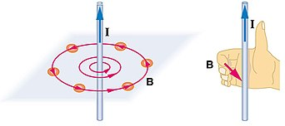
Here, you point the thumb on your right hand along the direction of current. The direction that your fingers point give the direction of the magnetic field. This is shown in the diagram to the right. The current is labelled I, and the magnetic field is labelled B.
OpenStax, CC BY 4.0 <https://creativecommons.org/licenses/by/4.0>, via Wikimedia Commons
We could also show the direction of the field by using plotting compasses in the same way that we used them to show the shape of a magnetic field around a bar magnet.
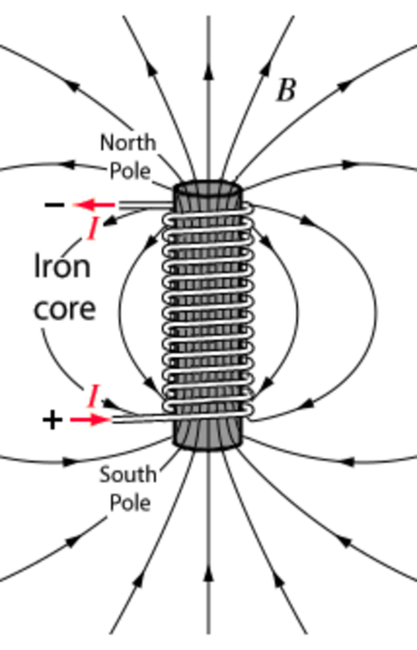
A coil of wire is called a solenoid. A solenoid creates a magnetic field in the same pattern as a bar magnet. The magnetic field is strongest inside a solenoid. There are three ways to increase the strength of the field produced by a solenoid:
P.Sumanth Naik, CC BY-SA 3.0 <https://creativecommons.org/licenses/by-sa/3.0>, via Wikimedia Commons
- Increase the number of turns in the coil.
- Increase the current.
- Add an iron core.
Iron is an example of a soft magnetic material. A soft magnetic material can be easily magnetised and de-magnetised. This is an advantage as we want electromagnets to be able to easily turn their magnetism on and off. A hard magnetic material is difficult to magnetise and de-magnetise. A hard material shouldn’t be used in the core of a solenoid as it would retain some magnetism.
Q1. State what has to flow through a wire to create an electromagnet.
………………………………………………………………………………………………………………………………………………………………………………………………………..
Q2. Describe what a solenoid is.
………………………………………………………………………………………………………………………………………………………………………………………………………..
Q3. Where is the magnetic field produced by a solenoid strongest?
………………………………………………………………………………………………………………………………………………………………………………………………………..
Q4. State three ways of making the magnetic field around a solenoid stronger.
………………………………………………………………………………………………………………………………………………………………………………………………………..
………………………………………………………………………………………………………………………………………………………………………………………………………..
………………………………………………………………………………………………………………………………………………………………………………………………………..
Q5. Describe the difference between a soft magnetic material and a hard magnetic material.
………………………………………………………………………………………………………………………………………………………………………………………………………..
………………………………………………………………………………………………………………………………………………………………………………………………………..
Q6. State one example of a soft magnetic material.
………………………………………………………………………………………………………………………………………………………………………………………………………..
Q7. Describe why hard magnetic materials are not placed in a solenoid.
………………………………………………………………………………………………………………………………………………………………………………………………………..
………………………………………………………………………………………………………………………………………………………………………………………………………..
Q8. State what happens to the strength of the magnetic field as you go further from a current carrying wire.
………………………………………………………………………………………………………………………………………………………………………………………………………..
Q9. Describe the shape of a magnetic field around a current carrying wire.
………………………………………………………………………………………………………………………………………………………………………………………………………..
Q10. State what the direction of the thumb represents in the right hand rule.
………………………………………………………………………………………………………………………………………………………………………………………………………..
Q11. State what the direction of the fingers represent in the right hand rule.
………………………………………………………………………………………………………………………………………………………………………………………………………..
Q12. Other than using the right hand rule, state how we could show the direction of a field around a current carrying wire.
……………………………………………………………………………………………………………………………………………………………………………………………………….

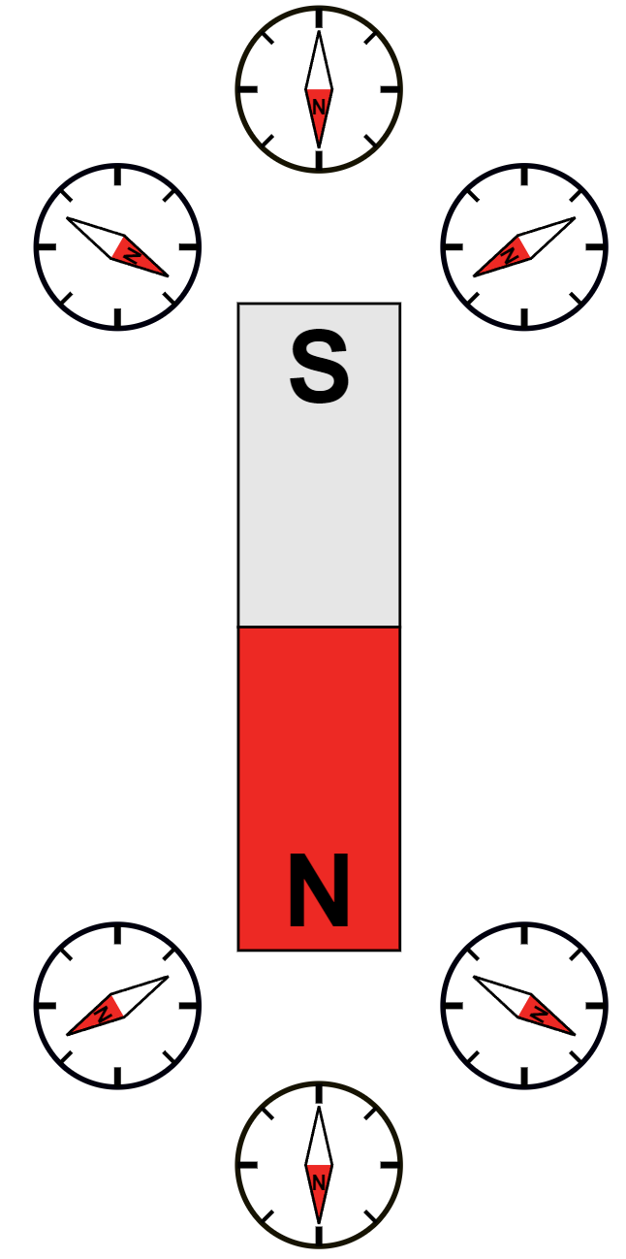
We already know that we can use iron filings to show the magnetic field around a bar magnet. Iron filings don’t show the direction of the field, though. If we want to show the direction of a magnetic field then we need to use plotting compasses.
Original file: TStein. This version: Chetvorno, CC BY-SA 3.0 <https://creativecommons.org/licenses/by-sa/3.0>, via Wikimedia Commons
Plotting magnetic fields
A plotting compass is a small bar magnet that is free to rotate. The north pole of the small bar magnet in the compass will always point towards magnetic south. The compass points towards magnetic south.
To show the direction of the field, we can place a bar magnet on a piece of paper and place a plotting around near one of its poles. The direction of the compass can then be marked and the compass moved to various other positions. The arrows can then be joined up to show the overall field shape.

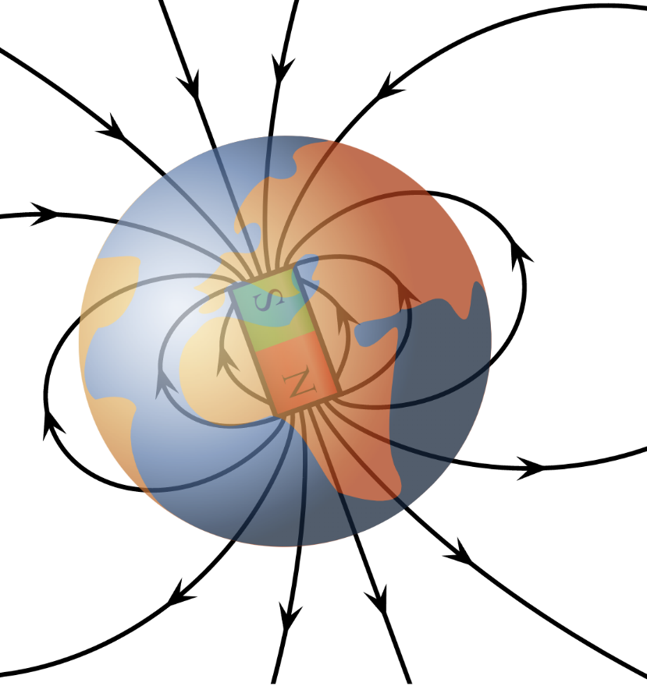
Compasses are also used to help navigate. The Earth’s outer core is made of molten iron and nickel and so it has its own magnetic field, in the same shape as that of a bar magnet.
Confusingly, the geographic North pole of the Earth is the magnetic South pole.
Because a compass always points to magnetic South, it points to geographic North.
VFPt Earths Magnetic Field Confusion.svg: Geek3 / derivative work: MikeRun, CC BY-SA 3.0 <https://creativecommons.org/licenses/by-sa/3.0>, via Wikimedia Commons

Q1. The following statements are either true or false. State which are true and which are false.
- A compass points towards magnetic North.
………………………………………………………………………………………………………………………………………………………………………………………………………..
- A compass points towards geographic North.
………………………………………………………………………………………………………………………………………………………………………………………………………..
- Geographic south is the same direction as magnetic south.
………………………………………………………………………………………………………………………………………………………………………………………………………..
Q2. State what a compass is made of.
………………………………………………………………………………………………………………………………………………………………………………………………………..
Q3. State what the outer core of the Earth is made of.
………………………………………………………………………………………………………………………………………………………………………………………………………..
Q4. Your answer to question 3 should contain two of the three magnetic metals. State the other magnetic metal.
………………………………………………………………………………………………………………………………………………………………………………………………………..
Q5. When visualising the magnetic field around a magnet, state a benefit of using a compass over iron filings.
………………………………………………………………………………………………………………………………………………………………………………………………………..
Q6. State why a compass cannot be used near an electronic device (like a mobile phone).
………………………………………………………………………………………………………………………………………………………………………………………………………..
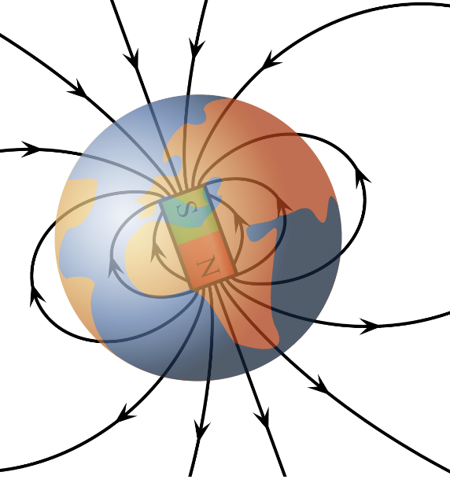
Q7. State where the magnetic field is strongest on the Earth. Explain, using the diagram to the left, how we know this.
…………………………………………………………………………………………………………………………..
…………………………………………………………………………………………………………………………..
Q8. Would we be able to use compasses to navigate if the Earth didn’t have a magnetic field? Explain why/why not.
…………………………………………………………………………………………………………………………..
…………………………………………………………………………………………………………………………..

VFPt Earths Magnetic Field Confusion.svg: Geek3 / derivative work: MikeRun, CC BY-SA 3.0 <https://creativecommons.org/licenses/by-sa/3.0>, via Wikimedia Commons

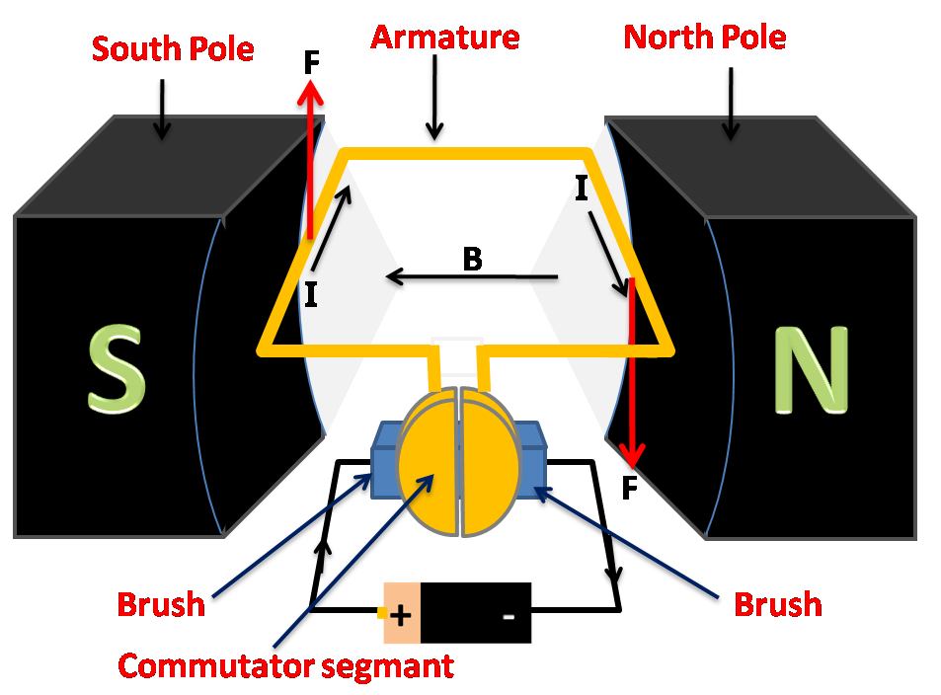
The construction of an electric motor is quite simple, it is made of a coil of wire inside a magnetic field. The magnetic field is produced by two permanent magnets.
Electric motor
In the diagram to the right, a battery supplies a current to a coil of wire (labelled armature). When a current flows through a wire, it creates a magnetic field. The magnetic field is labelled “B”, and the field lines point away from a north pole towards a south pole.
K.Venkataramana, CC BY-SA 4.0 <https://creativecommons.org/licenses/by-sa/4.0>, via Wikimedia Commons
This magnetic field interacts with the permanent magnetic field that surrounds the coil. This interaction produces a force.
A coil of wire is used, as the more turns in the coil the greater the strength of the overall magnetic field produced and the greater the force on the coil.
On the left side of the coil in the diagram this interaction of magnetic fields leads to an upwards force. As the current (labelled I) goes around the coil, though, it changes direction. There is therefore a downwards force on the right side of the coil in the diagram. These forces lead to a rotation of the coil.
However, if the coil rotates by 180° then the direction of those forces would reverse. To counter this a split ring commutator is used. A split ring commutator reverses the direction of current every half turn. This ensures that the motor continues to rotate in the same direction. The brushes (made of carbon) rub against the split ring commutator and allow it to rotate.
There are three main ways to make an electric motor rotate faster:
- Increase the current flowing through the coil.
- Increase the number of turns in the coil.
- Increase the strength of the magnetic field.
There are two ways of making an electric motor rotate in the opposite direction. You can either reverse the direction of the current or reverse the direction of the magnetic field produced by the permanent magnets.

Q1. The following statements are either true or false. State which are true and which are false.
- When a current flows through a wire, it creates a magnetic field.
………………………………………………………………………………………………………………………………………………………………………………………………………..
- Magnetic field lines point away from a south pole towards a north pole.
………………………………………………………………………………………………………………………………………………………………………………………………………..
Q2. State the different components in an electric motor.
………………………………………………………………………………………………………………………………………………………………………………………………………..
………………………………………………………………………………………………………………………………………………………………………………………………………..
Q3. Explain why there is a force on the coil in an electric motor.
………………………………………………………………………………………………………………………………………………………………………………………………………..
………………………………………………………………………………………………………………………………………………………………………………………………………..
Q4. Describe the role of the split ring commutator in an electric motor.
………………………………………………………………………………………………………………………………………………………………………………………………………..
………………………………………………………………………………………………………………………………………………………………………………………………………..
Q5. State three ways of making an electric motor rotate faster.
………………………………………………………………………………………………………………………………………………………………………………………………………..
………………………………………………………………………………………………………………………………………………………………………………………………………..
………………………………………………………………………………………………………………………………………………………………………………………………………..
Q6. State two ways of making an electric motor rotate in the opposite direction.
………………………………………………………………………………………………………………………………………………………………………………………………………..
………………………………………………………………………………………………………………………………………………………………………………………………………..
Q7. State what the brushes in an electric motor are made of.
………………………………………………………………………………………………………………………………………………………………………………………………………..
Q8. The current supplied to an electric motor is switched off. Explain why the motor stops spinning.
………………………………………………………………………………………………………………………………………………………………………………………………………..
………………………………………………………………………………………………………………………………………………………………………………………………………..
Q9. The battery powering an electric motor has been used for a long time and the current supplied by the battery is starting to decrease. Explain what happens to the electric motor.
………………………………………………………………………………………………………………………………………………………………………………………………………..
………………………………………………………………………………………………………………………………………………………………………………………………………..

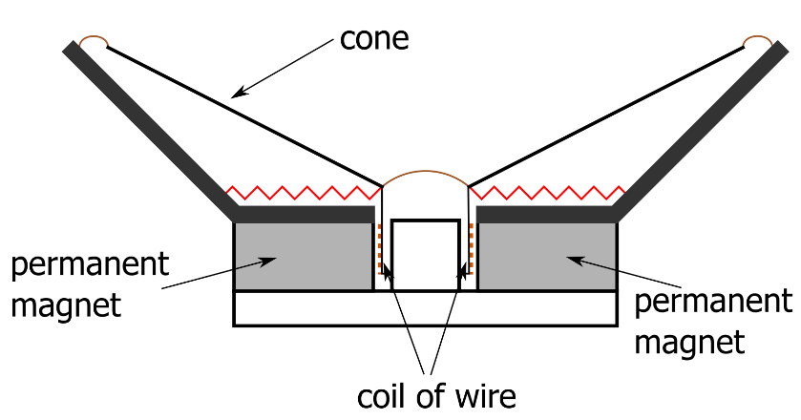
A speaker is made from a coil of wire, a permanent magnet and a cone.
Speakers and microphones
A current flows into the coil of wire. Any time a current flows through a wire, a magnetic field is formed around the wire.
This magnetic field interacts with the field caused by the permanent magnets. This causes a force which, in turn, causes the cone to move.
Adapted from: Harkonnen2 - Loudspeakerconstruction.png, CC BY-SA 3.0, https://commons.wikimedia.org/w/index.php?curid=9540717
If the current changes direction, then the magnetic field caused by the coil changes direction. This causes the force on the coil to be in the opposite direction to before.
A current that constantly changes direction is called an alternating current.
If the current constantly changes direction, then so does the direction of the force on the cone. The cone therefore vibrates back and forth, making a sound. The vibration of an object is what makes sound.
The frequency of the sound made is the same as the frequency of vibration. The faster the vibration of the cone, the higher the frequency of sound made.
There are three ways of making this sound louder:
- Increase the current flowing through the coil.
- Increase the number of turns in the coil.
- Increase the strength of the magnetic field caused by the permanent magnet.
A microphone is built in the same way as a speaker, but works in the opposite way.
In a microphone, a sound wave comes onto the cone and causes it to vibrate. In a microphone, the cone is sometimes called a diaphragm.
This causes the coil of wire to vibrate and the coil moves within the magnetic field of the permanent magnet.
Any time a coil of wire experiences a change in magnetic field (as it would when it moves in a magnetic field) then it causes a current to flow in the coil.
This changing current in the coil could then be passed into a speaker for playing (or the pattern of the changing current could be saved to play later).

Q1. The following statements are either true or false. State which are true and which are false.
- Any time a current passes through a wire, a magnetic field is formed around the wire.
………………………………………………………………………………………………………………………………………………………………………………………………………..
- A microphone contains a diaphragm which vibrates when sound reaches it.
………………………………………………………………………………………………………………………………………………………………………………………………………..
- An alternating current is one that always flows in the same direction.
………………………………………………………………………………………………………………………………………………………………………………………………………..
- If a coil moves in a magnetic field, a current is made.
………………………………………………………………………………………………………………………………………………………………………………………………………..
- If the current in the coil in a speaker is decreased, the sound made by the speaker is louder.
………………………………………………………………………………………………………………………………………………………………………………………………………..
Q2. State the names of the three different parts of a speaker.
………………………………………………………………………………………………………………………………………………………………………………………………………..
Q3. Describe what an alternating current is.
………………………………………………………………………………………………………………………………………………………………………………………………………..
Q4. Describe how a speaker makes a sound.
………………………………………………………………………………………………………………………………………………………………………………………………………..
………………………………………………………………………………………………………………………………………………………………………………………………………..
………………………………………………………………………………………………………………………………………………………………………………………………………..
………………………………………………………………………………………………………………………………………………………………………………………………………..
Q5. State three ways of making a speaker make a louder sound.
………………………………………………………………………………………………………………………………………………………………………………………………………..
………………………………………………………………………………………………………………………………………………………………………………………………………..
………………………………………………………………………………………………………………………………………………………………………………………………………..
Q6. Describe how a microphone works.
………………………………………………………………………………………………………………………………………………………………………………………………………..
………………………………………………………………………………………………………………………………………………………………………………………………………..
………………………………………………………………………………………………………………………………………………………………………………………………………..
………………………………………………………………………………………………………………………………………………………………………………………………………..

