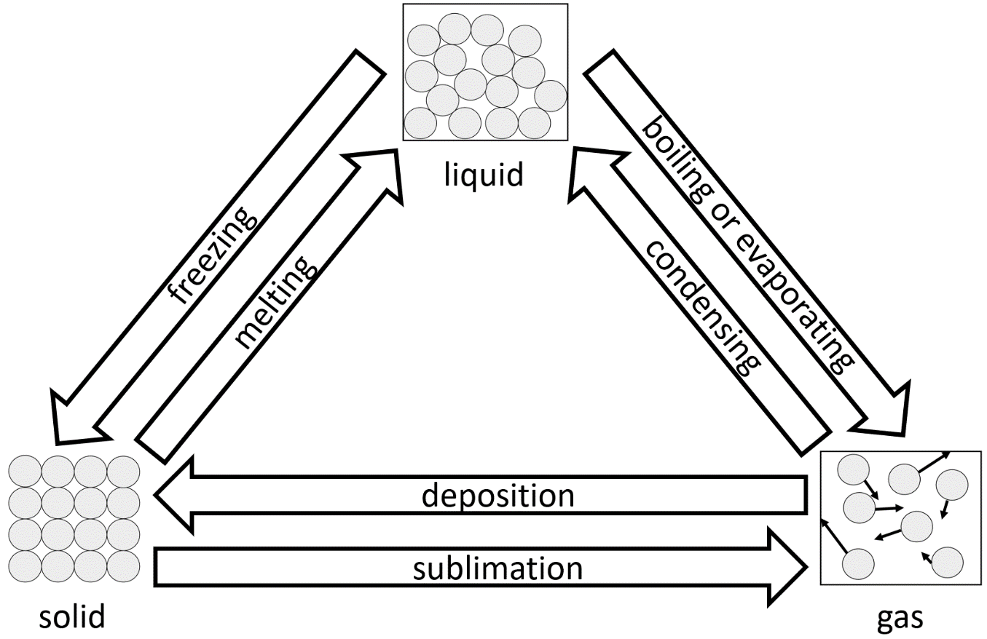
When a substance undergoes a physical change, the chemical composition of the substance does not change. Because of this, a physical change is reversible.
Physical changes and chemical reactions
One example of a physical change is that of ice melting to form water. Both ice and water have a chemical formula of H₂O, so there is no change to this. Water can also be frozen to form ice again. All the state changes are physical changes. The state changes are shown in the diagram to the right.
Another example of a physical change is the dissolving of sugar in water. This could also be reversed by heating the solution until all the water has evaporated. The sugar would be left behind.
In a physical change, mass is conserved. If 100 g of ice melts, it will form 100 g of water.
In a chemical reaction, the chemical composition of substances change. One example of this is the rusting of iron. Iron rusts when it reacts with oxygen to form iron oxide. The chemical composition has changed.
There are several signs that a chemical reaction has taken place. These include:
- A colour change.
- A temperature change.
- Gas being given out – this might show as effervescence (bubbles in a liquid).
- Light being emitted.
- Precipitation (a precipitate is a solid formed in a chemical reaction).
Going back to the example of iron rusting – the iron is initially a grey/silver colour. After it rusts it becomes a reddish/brown colour. The colour change is a sign that a chemical reaction has occurred. The temperature will also rise.
As the chemical composition of substances change during a chemical reaction, it cannot be easily reversed.
Mass is also conserved in a chemical reaction. The mass of the reactants (the substances that undergo a reaction) will be equal to the mass of the products of the reaction. This is called the conservation of mass. If a mass of 70 g of iron reacts with 30 g of oxygen, it will form 100 g of iron oxide.
Q1. The following statements are either true or false. State which are true and which are false.
- A chemical reaction is easily reversible.
………………………………………………………………………………………………………………………………………………………………………………………………………..
- When a mass of 200 g of water evaporates, the mass of the water vapour is less than 200 g.
………………………………………………………………………………………………………………………………………………………………………………………………………..
- A change in colour is a sign of a physical change.
………………………………………………………………………………………………………………………………………………………………………………………………………..
- Gas being given out is a sign of a chemical reaction.
………………………………………………………………………………………………………………………………………………………………………………………………………..
Q2. Describe what is meant by the conservation of mass.
………………………………………………………………………………………………………………………………………………………………………………………………………..
………………………………………………………………………………………………………………………………………………………………………………………………………..
Q3. A mass of 50 g of copper reacts with 12 g of oxygen to form copper oxide. The colour changes from a reddish/brown colour to black.
- State the mass of copper oxide formed.
………………………………………………………………………………………………………………………………………………………………………………………………………..
- State two reasons why we know that this is a chemical reaction.
………………………………………………………………………………………………………………………………………………………………………………………………………..
………………………………………………………………………………………………………………………………………………………………………………………………………..
- Aside from your reasons above, state three other signs that could show a chemical reaction has taken place.
………………………………………………………………………………………………………………………………………………………………………………………………………..
………………………………………………………………………………………………………………………………………………………………………………………………………..
Q4. A substance is changing from being a gas to being a liquid.
- State the name of the state change.
………………………………………………………………………………………………………………………………………………………………………………………………………..
- State whether this is a physical change or a chemical reaction.
………………………………………………………………………………………………………………………………………………………………………………………………………..
- Explain your answer to part b).
………………………………………………………………………………………………………………………………………………………………………………………………………..
Q6. Some table salt is dissolved in some water. Describe how we could reverse this physical change to have table salt again.
………………………………………………………………………………………………………………………………………………………………………………………………………..
………………………………………………………………………………………………………………………………………………………………………………………………………..

