If we place different metals into water or an acid, then some metals react much more strongly. This is because some metals are more reactive than others.
Reactivity series and displacement reactions
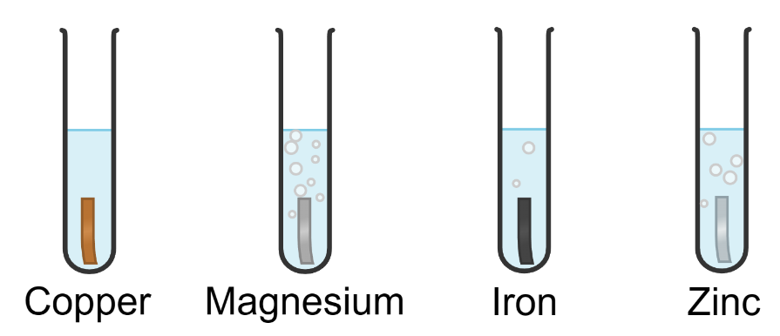
The diagram to the right shows four metals that have been placed into hydrochloric acid. We can see that magnesium is the most reactive metal as the most bubbles (of hydrogen) are released. Remember that a gas being out is a sign of a chemical reaction. Copper is the least reactive metal as no bubbles are being produced.
Created with Chemix (https://chemix.org)
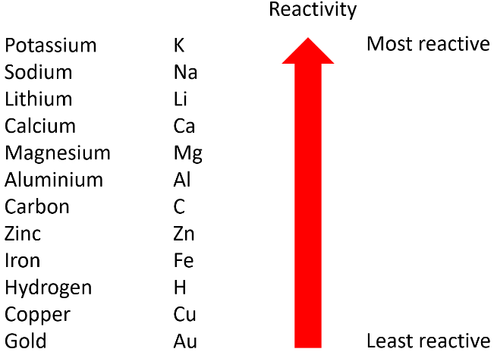
We can also test the reactivity of metals by looking at their reactions with water. If we study this over a larger range of metals, then we end up with an order of reactivity that we call the reactivity series.
Even though they are not metals, carbon and hydrogen are often included in the reactivity series as it makes it easy to predict what will happen in certain chemical reactions.
During a displacement reaction, an element that is more reactive replaces another less reactive element in a compound. One example of this is if some iron is placed into a copper sulfate solution. As iron is more reactive than copper, it displaces the copper in the solution:
iron + copper sulfate → iron sulfate + copper
In this case, we can tell that a chemical reaction has taken place as copper sulphate is a blue solution and iron sulphate is a green solution. A change in colour is another sign of a chemical reaction. However, no displacement occurs in the example below. This is because gold is less reactive than copper
gold + copper sulfate → gold + copper sulfate (no reaction)
Another example of a displacement reaction is below. Aluminium displaces the iron in iron oxide as aluminium is more reactive than iron.
aluminium + iron oxide → aluminium oxide + iron
Q1. The following statements are either true or false. State which are true and which are false.
- Magnesium is more reactive than sodium.
………………………………………………………………………………………………………………………………………………………………………………………………………..
- Calcium would not displace iron from iron oxide.
………………………………………………………………………………………………………………………………………………………………………………………………………..
- One way of telling how reactive a metal is by how vigorously it reacts with water.
………………………………………………………………………………………………………………………………………………………………………………………………………..
Q2. The reaction below is a displacement reaction.
magnesium + copper sulfate → magnesium sulfate + copper
As the reaction progresses, the blue copper sulfate colour fades and the solution becomes colourless.
- Describe why a displacement reaction occurs.
………………………………………………………………………………………………………………………………………………………………………………………………………..
………………………………………………………………………………………………………………………………………………………………………………………………………..
- State how we know that a chemical reaction has taken place.
………………………………………………………………………………………………………………………………………………………………………………………………………..
Q3. A chemical reaction occurs between magnesium and lead nitrate as follows:
magnesium + lead nitrate → lead + magnesium nitrate
State which of magnesium and lead is more reactive. Explain the reason for your answer.
………………………………………………………………………………………………………………………………………………………………………………………………………..
………………………………………………………………………………………………………………………………………………………………………………………………………..
Q4. Describe why the below reaction is not possible.
calcium + sodium carbonate → sodium + calcium carbonate
………………………………………………………………………………………………………………………………………………………………………………………………………..
………………………………………………………………………………………………………………………………………………………………………………………………………..
Q5. Complete the word equation for the displacement reaction between aluminium and iron oxide
aluminium + iron oxide → ……………………………………………………… + ………………………………………………………
Q6. Complete the word equation for the displacement reaction between magnesium and copper chloride.
magnesium + copper chloride → ……………………………………………………… + ………………………………………………………
Q7. Complete the word equation for the displacement reaction between zinc and iron sulfate
zinc + iron sulfate → ……………………………………………………… + ………………………………………………………

