In early versions of the periodic table, elements were arranged according to their atomic weight. This had some problems, though, as the order of the atomic weights did not align with the order of the properties of the elements.
The periodic table
In 1869, Dmitri Mendeleev made several changes to this arrangement. He put elements together in groups where elements had the same properties. As these properties are in a repeating pattern, it is called the periodic table.
The order of elements was no longer in the exact order of the atomic weight (although most elements were in this order) to allow for elements with similar properties to be in the same group. Gaps were also left for elements that had not yet been discovered. When new elements were discovered, they followed the pattern that Mendeleev predicted and were placed into the gaps. Below is a copy of the periodic table.
Periodic_table.svg: Cepheus. Public domain, via Wikimedia Commons
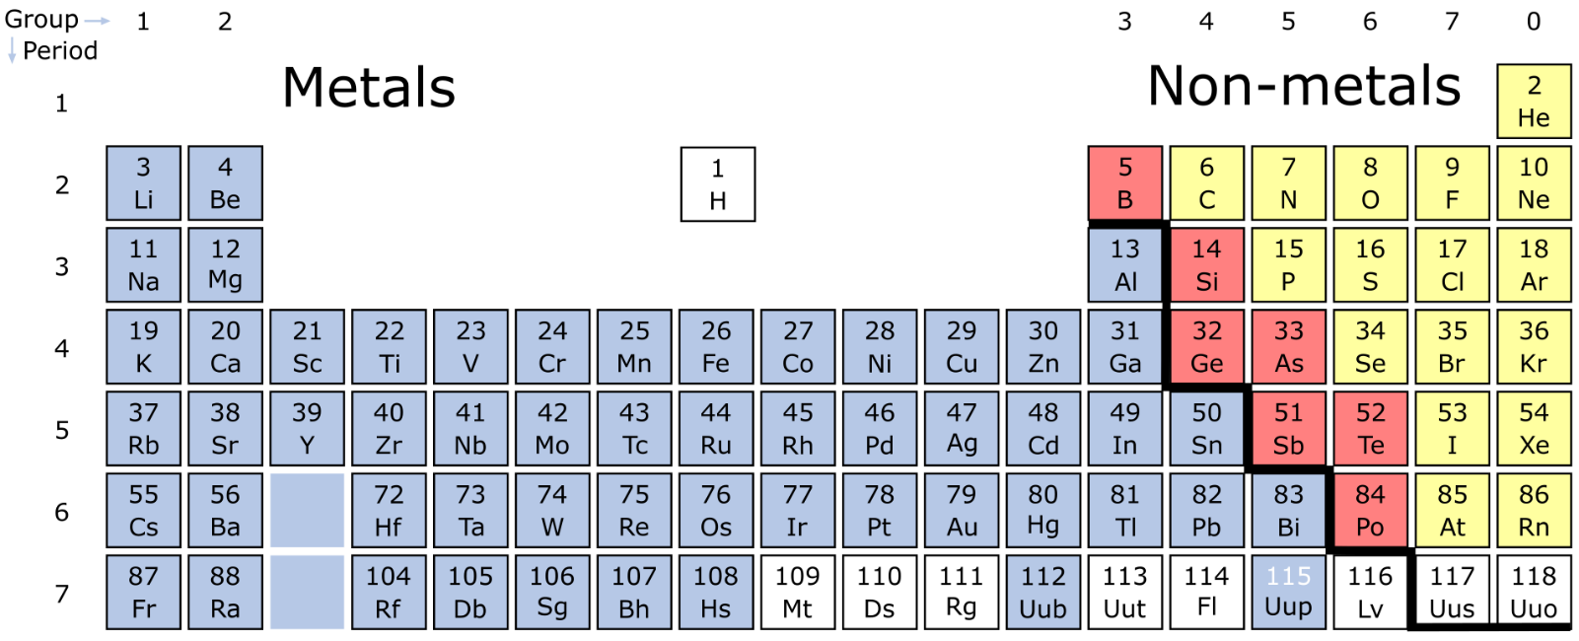
Elements are arranged by increasing atomic number (the number of protons that an element has). Elements are also represented by their chemical symbol. The atomic number is written above the chemical symbol.
The columns are called groups. Each group contains elements that have similar properties. For example, the metals in group 1 are known as the alkali metals. They all react vigorously when placed in water. As elements that have similar properties are in the same group, it makes it easy to predict what properties certain elements have.
Rows are called periods. Metals are to the left of the bold line, non-metals to the right. For example, Aluminium (with chemical symbol Al and atomic number 13) is a metal as it is to the left of the bold line.

Q1. The following statements are either true or false. State which are true and which are false.
- Elements in the same period have the same properties.
………………………………………………………………………………………………………………………………………………………………………………………………………..
- In the periodic table, elements are ordered according to their atomic mass.
………………………………………………………………………………………………………………………………………………………………………………………………………..
Q2. For each of the elements, write the atomic number of the element and whether it is a metal or a non-metal.
- Iron (chemical symbol Fe).
………………………………………………………………………………………………………………………………………………………………………………………………………..
- Carbon (chemical symbol C).
………………………………………………………………………………………………………………………………………………………………………………………………………..
- Helium (chemical symbol He).
………………………………………………………………………………………………………………………………………………………………………………………………………..
- Copper (chemical symbol Cu).
………………………………………………………………………………………………………………………………………………………………………………………………………..
- Sodium chemical (symbol Na).
………………………………………………………………………………………………………………………………………………………………………………………………………..
- Gold (chemical symbol Au).
………………………………………………………………………………………………………………………………………………………………………………………………………..
- Oxygen (chemical symbol O).
………………………………………………………………………………………………………………………………………………………………………………………………………..
- Silver (chemical symbol Ag).
………………………………………………………………………………………………………………………………………………………………………………………………………..
Q3. Describe why it is advantageous that elements with similar properties are kept in the same group.
………………………………………………………………………………………………………………………………………………………………………………………………………..
………………………………………………………………………………………………………………………………………………………………………………………………………..
Q4. State and explain which of aluminium (chemical symbol Al) or silicon (chemical symbol Si) is likely to make a better electrical wire.
………………………………………………………………………………………………………………………………………………………………………………………………………..
………………………………………………………………………………………………………………………………………………………………………………………………………..

