Chemical
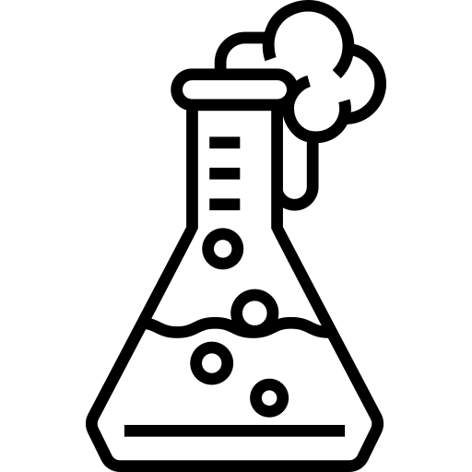
Name ______________________________
Class ______________________________
Teacher ______________________________

reactions

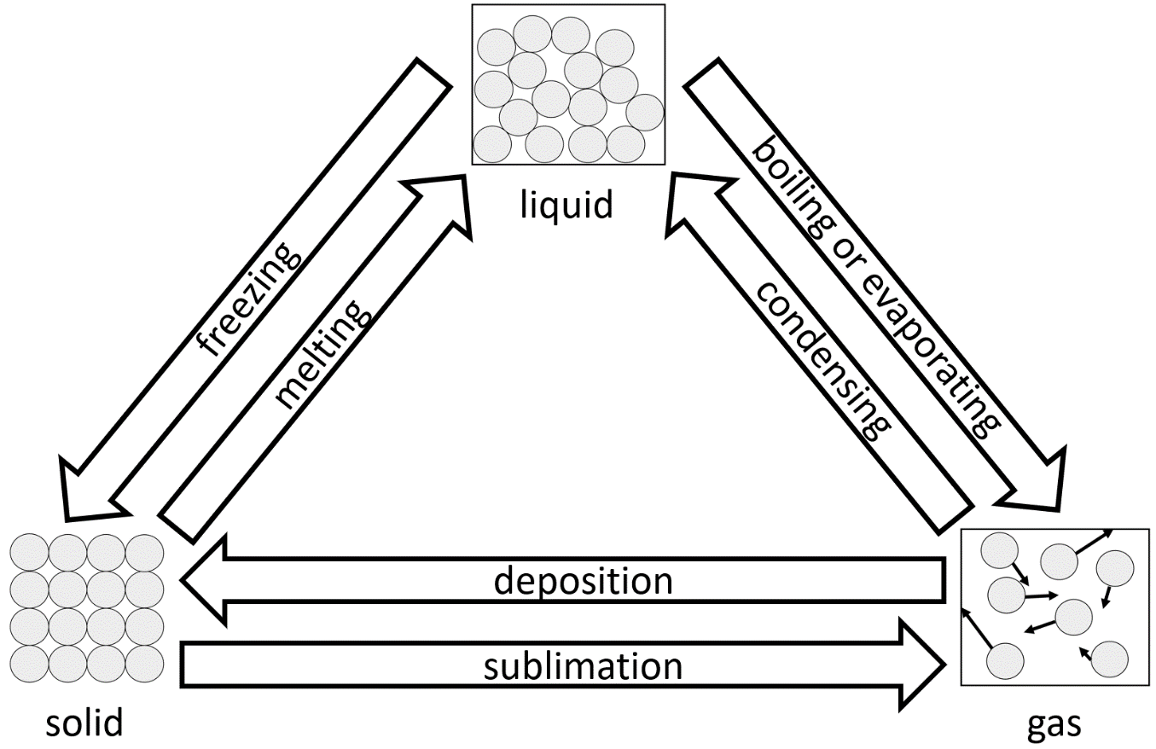
When a substance undergoes a physical change, the chemical composition of the substance does not change. Because of this, a physical change is reversible.
Physical changes and chemical reactions
One example of a physical change is that of ice melting to form water. Both ice and water have a chemical formula of H₂O, so there is no change to this. Water can also be frozen to form ice again. All the state changes are physical changes. The state changes are shown in the diagram to the right.
Another example of a physical change is the dissolving of sugar in water. This could also be reversed by heating the solution until all the water has evaporated. The sugar would be left behind.
In a physical change, mass is conserved. If 100 g of ice melts, it will form 100 g of water.
In a chemical reaction, the chemical composition of substances change. One example of this is the rusting of iron. Iron rusts when it reacts with oxygen to form iron oxide. The chemical composition has changed.
There are several signs that a chemical reaction has taken place. These include:
- A colour change.
- A temperature change.
- Gas being given out – this might show as effervescence (bubbles in a liquid).
- Light being emitted.
- Precipitation (a precipitate is a solid formed in a chemical reaction).
Going back to the example of iron rusting – the iron is initially a grey/silver colour. After it rusts it becomes a reddish/brown colour. The colour change is a sign that a chemical reaction has occurred. The temperature will also rise.
As the chemical composition of substances change during a chemical reaction, it cannot be easily reversed.
Mass is also conserved in a chemical reaction. The mass of the reactants (the substances that undergo a reaction) will be equal to the mass of the products of the reaction. This is called the conservation of mass. If a mass of 70 g of iron reacts with 30 g of oxygen, it will form 100 g of iron oxide.
Q1. The following statements are either true or false. State which are true and which are false.
- A chemical reaction is easily reversible.
………………………………………………………………………………………………………………………………………………………………………………………………………..
- When a mass of 200 g of water evaporates, the mass of the water vapour is less than 200 g.
………………………………………………………………………………………………………………………………………………………………………………………………………..
- A change in colour is a sign of a physical change.
………………………………………………………………………………………………………………………………………………………………………………………………………..
- Gas being given out is a sign of a chemical reaction.
………………………………………………………………………………………………………………………………………………………………………………………………………..
Q2. Describe what is meant by the conservation of mass.
………………………………………………………………………………………………………………………………………………………………………………………………………..
………………………………………………………………………………………………………………………………………………………………………………………………………..
Q3. A mass of 50 g of copper reacts with 12 g of oxygen to form copper oxide. The colour changes from a reddish/brown colour to black.
- State the mass of copper oxide formed.
………………………………………………………………………………………………………………………………………………………………………………………………………..
- State two reasons why we know that this is a chemical reaction.
………………………………………………………………………………………………………………………………………………………………………………………………………..
………………………………………………………………………………………………………………………………………………………………………………………………………..
- Aside from your reasons above, state three other signs that could show a chemical reaction has taken place.
………………………………………………………………………………………………………………………………………………………………………………………………………..
………………………………………………………………………………………………………………………………………………………………………………………………………..
Q4. A substance is changing from being a gas to being a liquid.
- State the name of the state change.
………………………………………………………………………………………………………………………………………………………………………………………………………..
- State whether this is a physical change or a chemical reaction.
………………………………………………………………………………………………………………………………………………………………………………………………………..
- Explain your answer to part b).
………………………………………………………………………………………………………………………………………………………………………………………………………..
Q6. Some table salt is dissolved in some water. Describe how we could reverse this physical change to have table salt again.
………………………………………………………………………………………………………………………………………………………………………………………………………..
………………………………………………………………………………………………………………………………………………………………………………………………………..
One example of a chemical reaction is that of oxidation. Oxidation is when a substance gains oxygen. A general chemical equation for a metal undergoing oxidation is:
Oxidation and combustion
metal + oxygen → metal oxide
In a chemical equation, the reactants go on the left hand side of the equation. The reactants are the substances that undergo a reaction. An arrow then shows what the reactants turn into. The products of the reaction go on the right hand side of the equation.
In the general chemical equation above, metal and oxygen are the reactants. The product is the metal oxide. Two specific examples of oxidation are:
iron + oxygen → iron oxide
copper + oxygen → copper oxide
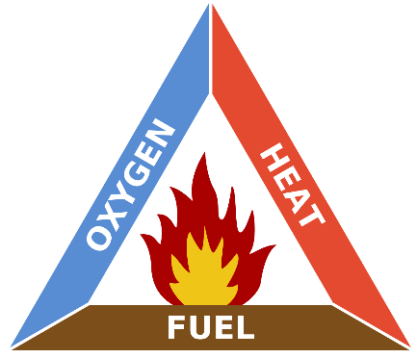
Another example of a chemical reaction involving oxygen is combustion. Combustion is the scientific word for the burning of a fuel. The fuel is generally made of hydrogen and carbon. A compound of hydrogen and carbon is called a hydrocarbon.
Three things are required for combustion to occur – oxygen, heat and fuel. This is shown in the fire triangle to the right.
There are two types of combustion – complete combustion and incomplete combustion.
By User: Gustavb - CC BY-SA 3.0, https://commons.wikimedia.org/w/index.php?curid=618468
A general equation for complete combustion is:
fuel + oxygen → carbon dioxide + water
Carbon dioxide is formed as the carbon in the fuel reacts with the oxygen. Water is also formed as the hydrogen in the fuel reacts with oxygen. The fuel can be any fuel (petrol, propane, methane etc.). One specific example of complete combustion is:
propane + oxygen → carbon dioxide + water
Incomplete combustion occurs if there is not enough oxygen available. A general equation for incomplete combustion is:
fuel + oxygen → carbon monoxide + water
Incomplete combustion is dangerous as carbon monoxide is a poisonous gas. Carbon monoxide is also a colourless and odourless gas – so it is very difficult to tell if the gas is present. Carbon monoxide detectors can be used in homes to make sure that we are safe. An alarm sounds if the levels of carbon monoxide are too high.
Q1. Three substances undergo oxidation. Complete the word equations below:
- magnesium + oxygen → ………………………………………………………

- ……………………………… + oxygen → calcium oxide

- aluminium + oxygen → ………………………………………………………
Q2. State the products of complete combustion.
………………………………………………………………………………………………………………………………………………………………………………………………………..
Q3. State the products of incomplete combustion.
………………………………………………………………………………………………………………………………………………………………………………………………………..
Q4. State what elements hydrocarbons consist of.
………………………………………………………………………………………………………………………………………………………………………………………………………..
Q5. State the three things that are required for combustion to occur.
………………………………………………………………………………………………………………………………………………………………………………………………………..
Q6. Describe why incomplete combustion is dangerous.
………………………………………………………………………………………………………………………………………………………………………………………………………..
………………………………………………………………………………………………………………………………………………………………………………………………………..
Q7. Three substances undergo complete combustion. Complete the word equations below:
- methane + oxygen → …………………………………………………………………………………

- ethane + oxygen → …………………………………………………………………………………

- butane + oxygen → …………………………………………………………………………………
Q8. The same substances undergo incomplete combustion. Complete the word equations below:
- methane + oxygen → …………………………………………………………………………………

- ethane + oxygen → …………………………………………………………………………………

- butane + oxygen → …………………………………………………………………………………
Q9. Oxidation is one example of a chemical reaction. State three ways that we can tell a chemical reaction has occurred.
………………………………………………………………………………………………………………………………………………………………………………………………………..
………………………………………………………………………………………………………………………………………………………………………………………………………..
Q10. Describe when incomplete combustion might occur.
………………………………………………………………………………………………………………………………………………………………………………………………………..
………………………………………………………………………………………………………………………………………………………………………………………………………..
When we write a chemical equation for the oxidation of copper, we can do so in words as in the equation below:
Balancing chemical equations
copper + oxygen → copper oxide
We can also represent this reaction using chemical symbols and formulae. The chemical symbol for copper is “Cu” and for oxygen is “O”. However, oxygen exists as a diatomic molecule meaning that we write it as “O₂” (instead of just “O” by itself). The symbol for copper oxide is “CuO” meaning that each copper oxide particle has one copper atom and one oxygen atom. If we just used these symbols instead of words, then we’d end up with:

 | Cu + O₂ | → CuO
Number of Cu atoms | 1 | → 1
Number of O atoms | 2 | → 1

As we can see, there are two oxygen atoms on the left side of the equation but only one oxygen atom is on the right side of the equation. This is not correct – there must be the same number of each of the atoms on each side of the chemical equation. We must balance the chemical equation to fix this.
The first step in balancing this equation will be to look at increasing the number of oxygen atoms on the right hand side of the equation. The only way that we can do this is to increase the number of “CuO” particles. We could change this to “2CuO” – this means that we have two lots of copper oxide particles. Changing the number in front of a compound is the only way that we can try to balance the equation. We cannot, for example, change “CuO” to “CuO₂” as that is changing what compound we have.
However, we now would have two copper atoms on the right side of the equation. We can fix this by changing the number of copper atoms on the left side of the equation to two. We now have:
 | 2Cu + O₂ | → 2CuO
Number of Cu atoms | 2 | → 2
Number of O atoms | 2 | → 2

The number of copper and oxygen atoms on each side of the equation is now the same. We have balanced the equation.
Note that if, for example, we have two lots of water particles (written as “2H₂O”) then we will have a total of four hydrogen atoms and two oxygen atoms. Changing the number in front of a compound multiplies the number of all the atoms by that amount.
Q1. Hydrogen has the chemical symbol “H”. State how many hydrogen atoms there are in each of the below:
- H₂O …………………
- 2H₂O …………………
- 10H₂O …………………
- CH₄ …………………
- C₂H₄ …………………
- 4C₂H₄ …………………
- 2C₇H₁₆ …………………
- Ca(OH)₂ …………………
Q2. a) Write a word equation for the oxidation of zinc.
………………………………………………………………………………………………………………………………………………………………………………………………………..
- Balance the chemical equation for the oxidation of zinc by filling in the gaps
……… Zn + O₂ → 2ZnO
Q3. Balance the chemical equations below by filling in the gaps:
- Oxidation of magnesium.

2Mg + O₂ → ……… MgO

- Complete combustion of methane.

CH₄ + ……… O₂ → CO₂ + 2H₂O

- Incomplete combustion of ethene.

C₂H₄ + 2O₂ → ……… CO + 2H₂O

- Oxidation of silver.

……… Ag + O₂ → 2Ag₂O

- Photosynthesis

6CO₂ + 6H₂O → C₆H₁₂O₆ + ……… O₂

- Reaction of sodium and chlorine.

……… Na + ……… Cl₂ → ……… NaCl
One example of a chemical reaction is that of thermal decomposition. Thermal decomposition is when a compound is heated and breaks down into smaller and simpler products.
Thermal decomposition
If we heat copper carbonate with a Bunsen burner, it will undergo thermal decomposition. The word equation for this process is:
copper carbonate → copper oxide + carbon dioxide
And in symbols, the balanced chemical equation for this is:
CuCO₃ → CuO + CO₂
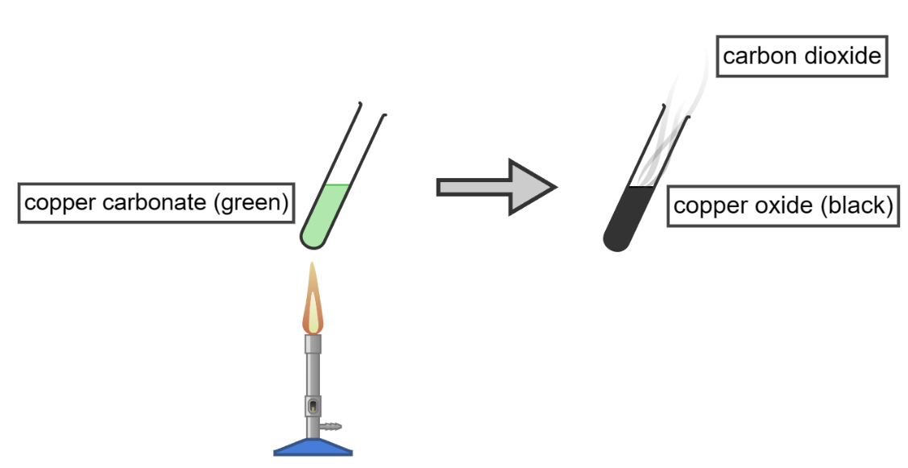
The carbon and some of the oxygen in copper carbonate have now formed carbon dioxide (CO₂). When heated, a metal carbonate will generally decompose into a metal oxide and carbon dioxde.
Created with Chemix (https://chemix.org)
Copper carbonate is green coloured, while copper oxide is black. This change in colour is a sign that a chemical reaction has occurred. Another sign that a chemical reaction has occurred is that a gas (carbon dioxide) is released.
We could verify that the gas is carbon dioxide by passing it through a calcium hydroxide solution (commonly known as limewater). If the gas is carbon dioxide, the limewater will turn milky or cloudy white.
Another example of thermal decomposition is that of hydrogen peroxide:
hydrogen peroxide → water + oxygen
This reaction creates oxygen gas. The test for oxygen is whether it will relight a glowing splint.

Q1. Describe what thermal decomposition is.
………………………………………………………………………………………………………………………………………………………………………………………………………..
………………………………………………………………………………………………………………………………………………………………………………………………………..
Q2. State two ways that we might know that a chemical reaction has taken place.
………………………………………………………………………………………………………………………………………………………………………………………………………..
………………………………………………………………………………………………………………………………………………………………………………………………………..
Q3. Magnesium carbonate undergoes thermal decomposition to form magnesium oxide and carbon dioxide.
- State the reactant in this reaction.
………………………………………………………………………………………………………………………………………………………………………………………………………..
- State the products of this reaction.
………………………………………………………………………………………………………………………………………………………………………………………………………..
- Complete the chemical equation.
MgCO₃ → …………… + ……………
- Describe how we could confirm that the gas produced was carbon dioxide.
………………………………………………………………………………………………………………………………………………………………………………………………………..
………………………………………………………………………………………………………………………………………………………………………………………………………..
Q4. Complete the chemical equation for the thermal decomposition of calcium carbonate.
CaCO₃ → …………… + ……………
Q5. Balance the chemical equation for the thermal decomposition of silver oxide by filling in the gaps.
…………… Ag₂O → …………… Ag + O₂
Q6. Hydrogen peroxide undergoes thermal decomposition to form water and oxygen.
- Balance the chemical equation of this process by filling in the gap:
2H₂O₂ → ……… H₂O + O₂
- Describe how we could confirm that the gas produced was oxygen.
………………………………………………………………………………………………………………………………………………………………………………………………………..
………………………………………………………………………………………………………………………………………………………………………………………………………..
If we place different metals into water or an acid, then some metals react much more strongly. This is because some metals are more reactive than others.
Reactivity series and displacement reactions
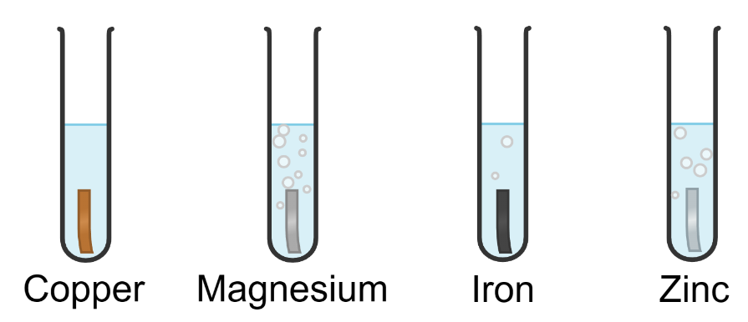
The diagram to the right shows four metals that have been placed into hydrochloric acid. We can see that magnesium is the most reactive metal as the most bubbles (of hydrogen) are released. Remember that a gas being out is a sign of a chemical reaction. Copper is the least reactive metal as no bubbles are being produced.
Created with Chemix (https://chemix.org)
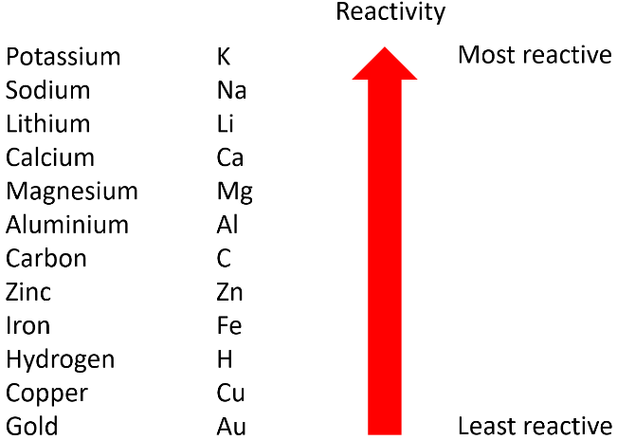
We can also test the reactivity of metals by looking at their reactions with water. If we study this over a larger range of metals, then we end up with an order of reactivity that we call the reactivity series.
Even though they are not metals, carbon and hydrogen are often included in the reactivity series as it makes it easy to predict what will happen in certain chemical reactions.
During a displacement reaction, an element that is more reactive replaces another less reactive element in a compound. One example of this is if some iron is placed into a copper sulfate solution. As iron is more reactive than copper, it displaces the copper in the solution.
iron + copper sulfate → iron sulfate + copper
In this case, we can tell that a chemical reaction has taken place as copper sulphate is a blue solution and iron sulphate is a green solution. A change in colour is another sign of a chemical reaction. However, no displacement occurs in the example below. This is because gold is less reactive than copper.
gold + copper sulfate → gold + copper sulfate (no reaction)
Another example of a displacement reaction is below. Aluminium displaces the iron in iron oxide as aluminium is more reactive than iron.
aluminium + iron oxide → aluminium oxide + iron
Q1. The following statements are either true or false. State which are true and which are false.
- Magnesium is more reactive than sodium.
………………………………………………………………………………………………………………………………………………………………………………………………………..
- Calcium would not displace iron from iron oxide.
………………………………………………………………………………………………………………………………………………………………………………………………………..
- One way of telling how reactive a metal is by how vigorously it reacts with water.
………………………………………………………………………………………………………………………………………………………………………………………………………..
Q2. The reaction below is a displacement reaction.
magnesium + copper sulfate → magnesium sulfate + copper
As the reaction progresses, the blue copper sulfate colour fades and the solution becomes colourless.
- Describe why a displacement reaction occurs.
………………………………………………………………………………………………………………………………………………………………………………………………………..
………………………………………………………………………………………………………………………………………………………………………………………………………..
- State how we know that a chemical reaction has taken place.
………………………………………………………………………………………………………………………………………………………………………………………………………..
Q3. A chemical reaction occurs between magnesium and lead nitrate as follows:
magnesium + lead nitrate → lead + magnesium nitrate
State which of magnesium and lead is more reactive. Explain the reason for your answer.
………………………………………………………………………………………………………………………………………………………………………………………………………..
………………………………………………………………………………………………………………………………………………………………………………………………………..
Q4. Describe why the below reaction is not possible.
calcium + sodium carbonate → sodium + calcium carbonate
………………………………………………………………………………………………………………………………………………………………………………………………………..
………………………………………………………………………………………………………………………………………………………………………………………………………..
Q5. Complete the word equation for the displacement reaction between aluminium and iron oxide.
aluminium + iron oxide → ……………………………………………………… + ………………………………………………………
Q6. Complete the word equation for the displacement reaction between magnesium and copper chloride.
magnesium + copper chloride → ……………………………………………………… + ………………………………………………………
Q7. Complete the word equation for the displacement reaction between zinc and iron sulfate.
zinc + iron sulfate → ……………………………………………………… + ………………………………………………………
Elements in group 7 of the periodic table are known as the halogens. As the halogens are all in the same group, they all have similar properties. The halogens are all non-metals and therefore do not conduct electricity or heat well. They also have low melting and boiling points. As you go down group 7, the melting and boiling points increase. This is because larger molecules have larger inter-molecular forces.
Group 7 elements
The halogens are also very reactive and, because of this, they are toxic. For example, chlorine gas was used as a weapon in World War One. In low concentrations, it is also used to limit bacteria growth in swimming pools.
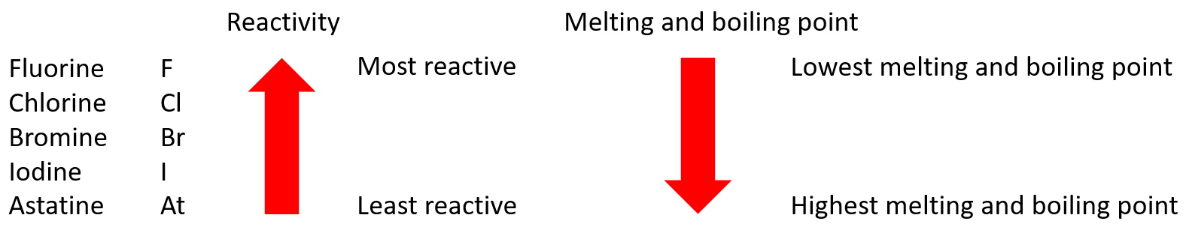
As you go down group 7, the reactivity decreases. A summary of these trends are shown in the diagram below.
During a displacement reaction, an element that is more reactive replaces another less reactive element in a compound. Both metals and halogens can undergo displacement reactions.
Before we see an example, it’s useful to know that if fluorine is in a compound the compound will generally end with “fluoride”. Chlorine will form a “chloride”, bromide will form a “bromide”, iodine will form an “iodide” and astatine will form an “astatide”. Collectively, these compounds are known as halides.
One example of this is the reaction between sodium bromide and chlorine. Chlorine is more reactive than bromine and so it displaces the bromine.
sodium bromide + chlorine → sodium chloride + bromine
However, no displacement occurs in the example below. This is because iodine is less reactive than bromine.
sodium bromide + iodine → sodium bromide + iodine (no reaction)
Another example of a displacement reaction is below. Chlorine displaces the iodine in potassium iodide as chlorine is more reactive than iodine.
potassium iodide + chlorine → potassium chloride + iodine
During this reaction, the colour changes from colourless to brown. A change in colour is one sign of a chemical reaction.
Q1. The following statements are either true or false. State which are true and which are false.
- Chlorine is an example of a halogen.
………………………………………………………………………………………………………………………………………………………………………………………………………..
- Bromine is less reactive than iodine.
………………………………………………………………………………………………………………………………………………………………………………………………………..
- Fluorine has a higher melting point than astatine.
………………………………………………………………………………………………………………………………………………………………………………………………………..
- Group 7 elements are all good electrical conductors.
………………………………………………………………………………………………………………………………………………………………………………………………………..
- Group 7 elements are toxic and highly reactive.
………………………………………………………………………………………………………………………………………………………………………………………………………..
- Group 7 elements have high melting and boiling points.
………………………………………………………………………………………………………………………………………………………………………………………………………..
Q2. Describe what a displacement reaction is.
………………………………………………………………………………………………………………………………………………………………………………………………………..
………………………………………………………………………………………………………………………………………………………………………………………………………..
Q3. The reaction below is a displacement reaction.
potassium bromide + chlorine → potassium chloride + bromine
- Describe why a displacement reaction occurs.
………………………………………………………………………………………………………………………………………………………………………………………………………..
………………………………………………………………………………………………………………………………………………………………………………………………………..
- Balance the chemical equation of this process by filling in the gaps:
……… KBr + Cl₂ → ……… KCl + Br₂
- State one way that we might know that a chemical reaction has taken place.
………………………………………………………………………………………………………………………………………………………………………………………………………..
Q4. Complete the word equation for the displacement reaction between potassium iodide and bromine.
potassium iodide + bromine → ……………………………………………………… + ………………………………………………………
Q5. Complete the word equation for the displacement reaction between sodium chloride and fluorine.
sodium chloride + fluorine → ……………………………………………………… + ………………………………………………………

