Crude oil is a liquid found deep under the Earth's surface. It is made from the remains of organisms like algae and plankton. These remains were deposited on the sea floor and were covered by sediments. Over millions of years, heat and pressure turned these remains into crude oil.
Crude oil
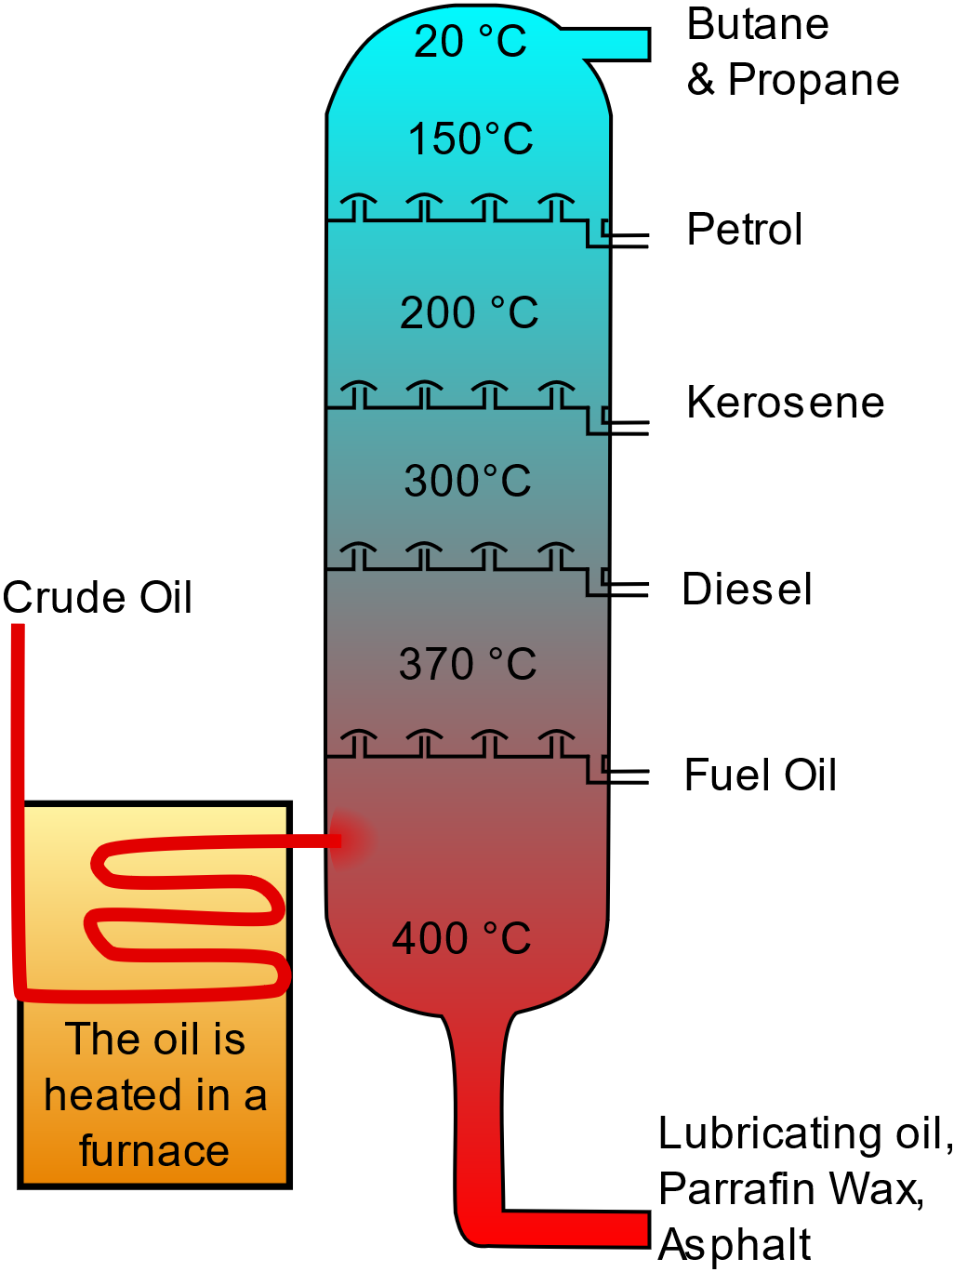
Crude oil is a mixture of many different substances. These are mostly hydrocarbons, which are compounds made of hydrogen and carbon. To use crude oil, we need to separate it into different parts. This is done using a process called fractional distillation. In a refinery, crude oil is heated until it turns into a gas. The gas then enters a tall tower called a fractionating column, which is hotter at the bottom and cooler at the top.
As the gas rises up the column, different substances cool down and turn back into liquids at different temperatures. This is because they have different boiling points.
The liquids are collected at various levels of the column. Each level collects a different fraction of the crude oil, such as petrol, kerosene, and diesel. This is why the process is called fractional distillation.
Some of the main uses of these products are:
- Petrol: Used as fuel for cars.
- Diesel: Is a fuel for trucks, buses, and some cars.
- Kerosene: Used as fuel for jet engines and heaters.
- Fuel Oil: Used in ships and large industrial plants for heating and power generation.
Crude_Oil_Distillation-fr.svg, CC BY-SA 3.0 via Wikimedia Commons
- Butane and Propane: Fuel for cooking, heating, and in lighters. Propane is also used as fuel for some engines and portable stoves.
- Lubricating oils: Used to reduce friction in engines and machines.
Burning the fuels made from crude oil releases carbon dioxide (CO₂), which is a greenhouse gas that contributes to global warming.
Q1. The following statements are either true or false. State which are true and which are false.
- A fractionating column is hotter at the top than the bottom.
………………………………………………………………………………………………………………………………………………………………………………………………………..
- Butane, petrol and diesel are examples of products that are made from the fractional distillation of crude oil.
………………………………………………………………………………………………………………………………………………………………………………………………………..
- Petrol has a higher boiling point than diesel.
………………………………………………………………………………………………………………………………………………………………………………………………………..
- Burning fuels made from crude oil releases carbon dioxide.
………………………………………………………………………………………………………………………………………………………………………………………………………..
- Carbon dioxide is a greenhouse gas.
………………………………………………………………………………………………………………………………………………………………………………………………………..
Q2. State what is meant by a hydrocarbon.
………………………………………………………………………………………………………………………………………………………………………………………………………..
Q3. Describe how crude oil is formed.
………………………………………………………………………………………………………………………………………………………………………………………………………..
………………………………………………………………………………………………………………………………………………………………………………………………………..
Q4. Describe the process of fractional distillation.
………………………………………………………………………………………………………………………………………………………………………………………………………..
………………………………………………………………………………………………………………………………………………………………………………………………………..
………………………………………………………………………………………………………………………………………………………………………………………………………..
………………………………………………………………………………………………………………………………………………………………………………………………………..
Q5. State three products that can be made from crude oil and describe their uses.
………………………………………………………………………………………………………………………………………………………………………………………………………..
………………………………………………………………………………………………………………………………………………………………………………………………………..
………………………………………………………………………………………………………………………………………………………………………………………………………..
………………………………………………………………………………………………………………………………………………………………………………………………………..
Q6. Describe why fuels produced from crude oil would be described as non-renewable resources.
………………………………………………………………………………………………………………………………………………………………………………………………………..
………………………………………………………………………………………………………………………………………………………………………………………………………..

