Materials
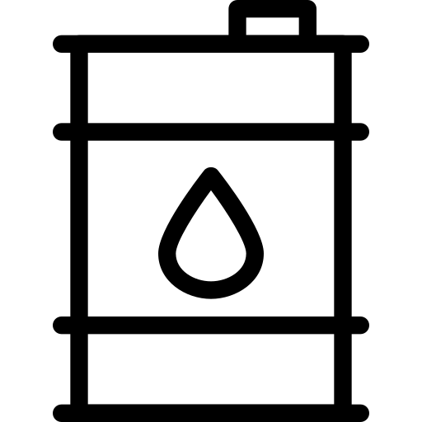
Name ______________________________
Class ______________________________
Teacher ______________________________

Many metals are found in the Earth in rocks called ores. To get the metals we need, we have to extract them from these ores. To understand which method we need to use for different metals, we need to recap the reactivity series.
Metal extraction
Metals have different levels of reactivity. Some are very reactive, like potassium and sodium, while others are not very reactive, like gold and silver. The reactivity series (shown below) is a list that shows metals from most reactive to least reactive.
If a metal is less reactive than carbon, then a displacement reaction can be used to extract a metal from a metal ore. Metals like zinc, iron and copper tend to react with oxygen to form metal oxide compounds in ores. A reaction that separates a metal from a metal oxide is called a reduction reaction.
For example, to extract iron, the iron ore is heated with carbon (in the form of coke) in a blast furnace. The carbon reacts with the oxygen in the iron oxide to form carbon dioxide and leave behind pure iron:
iron oxide + carbon → iron + carbon dioxide
Another example would be separating copper from copper oxide:
copper oxide + carbon → copper + carbon dioxide
If a metal is more reactive than carbon, then carbon would not displace the metal. Electrolysis would need to be used to extract the metal from the ore.
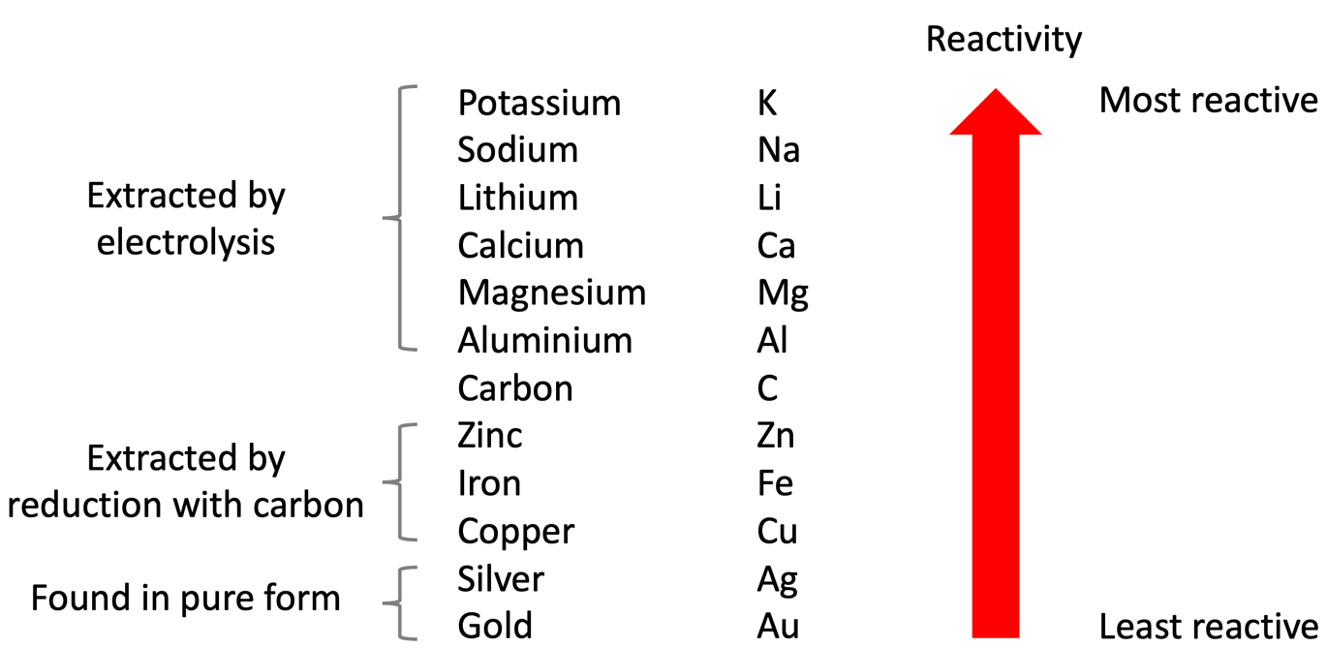
As gold and silver are very unreactive, they can be found as a pure metal. Gold and silver therefore don’t need to be extracted from ores by chemical reactions.

Q1. The following statements are either true or false. State which are true and which are false.
- Gold can be found as a pure metal.
………………………………………………………………………………………………………………………………………………………………………………………………………..
- Zinc is more reactive than carbon.
………………………………………………………………………………………………………………………………………………………………………………………………………..
- Iron can be extracted from its ore by heating with carbon.
………………………………………………………………………………………………………………………………………………………………………………………………………..
- Aluminium can be extracted from its ore by heating with carbon.
………………………………………………………………………………………………………………………………………………………………………………………………………..
- Magnesium can be extracted from its ore by electrolysis.
………………………………………………………………………………………………………………………………………………………………………………………………………..
- Carbon would not displace calcium from calcium oxide.
………………………………………………………………………………………………………………………………………………………………………………………………………..
Q2. Complete the word equation for the displacement reaction between carbon and iron oxide
carbon + iron oxide → ……………………………………………………… + ………………………………………………………
Q3. Complete the word equation for the displacement reaction between carbon and zinc oxide.
carbon + zinc oxide → ……………………………………………………… + ………………………………………………………
Q4. Copper is extracted from copper oxide using carbon. Write down a word equation for this reaction.
………………………………………………………………………………………………………………………………………………………………………………………………………..
Q5. Describe why the below reaction is not possible.
magnesium oxide + carbon → magnesium + carbon dioxide
………………………………………………………………………………………………………………………………………………………………………………………………………..
………………………………………………………………………………………………………………………………………………………………………………………………………..
Q6. Explain why carbon is used to extract metals like iron and copper but not aluminium.
………………………………………………………………………………………………………………………………………………………………………………………………………..
………………………………………………………………………………………………………………………………………………………………………………………………………..
………………………………………………………………………………………………………………………………………………………………………………………………………..
………………………………………………………………………………………………………………………………………………………………………………………………………..

Crude oil is a liquid found deep under the Earth's surface. It is made from the remains of organisms like algae and plankton. These remains were deposited on the sea floor and were covered by sediments. Over millions of years, heat and pressure turned these remains into crude oil.
Crude oil
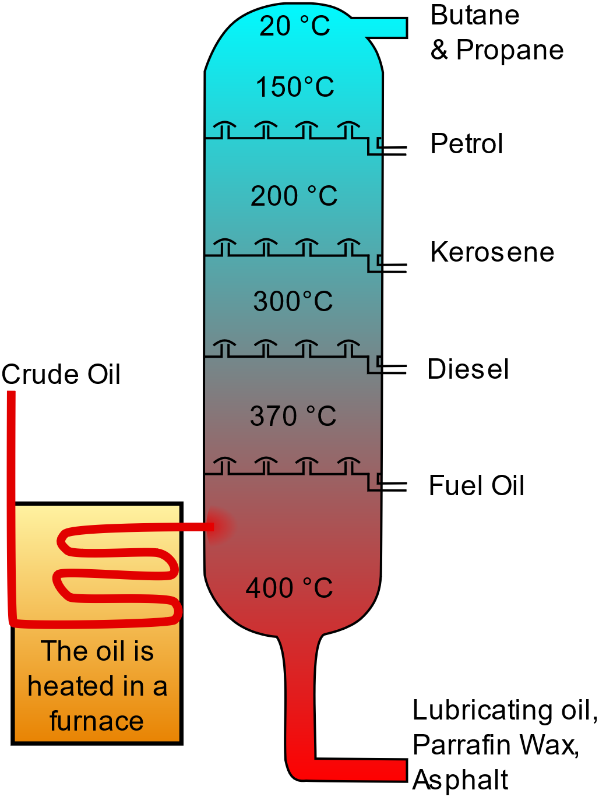
Crude oil is a mixture of many different substances. These are mostly hydrocarbons, which are compounds made of hydrogen and carbon. To use crude oil, we need to separate it into different parts. This is done using a process called fractional distillation. In a refinery, crude oil is heated until it turns into a gas. The gas then enters a tall tower called a fractionating column, which is hotter at the bottom and cooler at the top.
As the gas rises up the column, different substances cool down and turn back into liquids at different temperatures. This is because they have different boiling points.
The liquids are collected at various levels of the column. Each level collects a different fraction of the crude oil, such as petrol, kerosene, and diesel. This is why the process is called fractional distillation.
Some of the main uses of these products are:
- Petrol: Used as fuel for cars.
- Diesel: Is a fuel for trucks, buses, and some cars.
- Kerosene: Used as fuel for jet engines and heaters.
- Fuel Oil: Used in ships and large industrial plants for heating and power generation.
Crude_Oil_Distillation-fr.svg, CC BY-SA 3.0 via Wikimedia Commons
- Butane and Propane: Fuel for cooking, heating, and in lighters. Propane is also used as fuel for some engines and portable stoves.
- Lubricating oils: Used to reduce friction in engines and machines.
Burning the fuels made from crude oil releases carbon dioxide (CO₂), which is a greenhouse gas that contributes to global warming.
Q1. The following statements are either true or false. State which are true and which are false.
- A fractionating column is hotter at the top than the bottom.
………………………………………………………………………………………………………………………………………………………………………………………………………..
- Butane, petrol and diesel are examples of products that are made from the fractional distillation of crude oil.
………………………………………………………………………………………………………………………………………………………………………………………………………..
- Petrol has a higher boiling point than diesel.
………………………………………………………………………………………………………………………………………………………………………………………………………..
- Burning fuels made from crude oil releases carbon dioxide.
………………………………………………………………………………………………………………………………………………………………………………………………………..
- Carbon dioxide is a greenhouse gas.
………………………………………………………………………………………………………………………………………………………………………………………………………..
Q2. State what is meant by a hydrocarbon.
………………………………………………………………………………………………………………………………………………………………………………………………………..
Q3. Describe how crude oil is formed.
………………………………………………………………………………………………………………………………………………………………………………………………………..
………………………………………………………………………………………………………………………………………………………………………………………………………..
Q4. Describe the process of fractional distillation.
………………………………………………………………………………………………………………………………………………………………………………………………………..
………………………………………………………………………………………………………………………………………………………………………………………………………..
………………………………………………………………………………………………………………………………………………………………………………………………………..
………………………………………………………………………………………………………………………………………………………………………………………………………..
Q5. State three products that can be made from crude oil and describe their uses.
………………………………………………………………………………………………………………………………………………………………………………………………………..
………………………………………………………………………………………………………………………………………………………………………………………………………..
………………………………………………………………………………………………………………………………………………………………………………………………………..
………………………………………………………………………………………………………………………………………………………………………………………………………..
Q6. Describe why fuels produced from crude oil would be described as non-renewable resources.
………………………………………………………………………………………………………………………………………………………………………………………………………..
………………………………………………………………………………………………………………………………………………………………………………………………………..

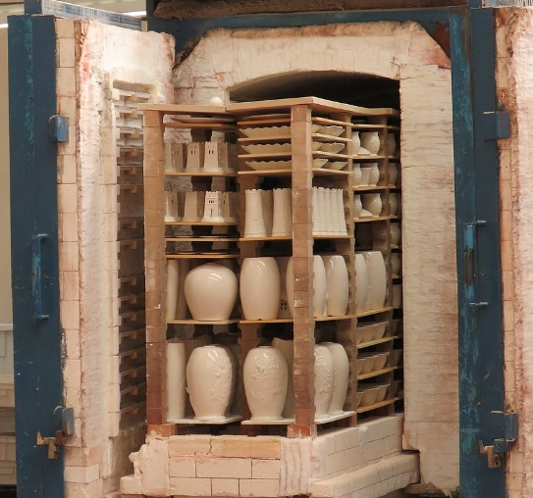
Ceramics are made by heating certain materials to high temperatures in a kiln. This process changes the properties of the starting material and makes them hard, but brittle. For example, clay can be heated in a kiln (shown in the image) to form pottery, bricks or tiles.
Ceramics, polymers and composites
Because ceramics like pottery are brittle, they will break if dropped. Ceramics are also resistant to high temperatures. This is why they are used in cookware.
Lomita, CC BY-SA 4.0 , via Wikimedia Commons
Polymers are long chains of molecules made by joining many small molecules (monomers) together. There are two main types of polymers: natural and synthetic. Natural polymers include things like rubber and silk, while synthetic polymers are made by humans and include plastics like polythene and polyvinyl chloride (PVC).
Polymers can be flexible or rigid, are usually lightweight and can be moulded into different shapes. This makes them useful for applications such as in plastic bags or plastic bottles and containers for storing food and drinks.
Another property of polymers is that they are electrical and thermal insulators. An application of this is that PVC is used as an electrical insulator around wires. Polymers are also very unreactive. This is advantageous in applications like water bottles so that they don’t react with their contents. It does mean that they do not break down quickly after being used, though. This can pose an environmental challenge.
Composites are made by combining two or more different materials to create a new material with improved properties. Each material in a composite keeps its own properties, but together they make the composite stronger, lighter, or more durable. Examples of composites include:
- Fibreglass is made from glass fibres and plastic. This combination results in a material that is lightweight like plastic but retains the strength of glass. Fibreglass is commonly used to make boat and car bodies.
- Concrete is made from cement, sand, and gravel and results in a material that can withstand high compressive forces. Concrete is therefore used as a building material in bridges, roads and buildings.
- Carbon fibre is made from a combination of carbon fibres and polymers and is a strong and lightweight material. It is used in high end sports cars, bicycles and other sports equipment.

Q1. The following statements are either true or false. State which are true and which are false.
- Polymers are good conductors of electricity.
………………………………………………………………………………………………………………………………………………………………………………………………………..
- Ceramics are brittle.
………………………………………………………………………………………………………………………………………………………………………………………………………..
- Concrete is an example of a composite.
………………………………………………………………………………………………………………………………………………………………………………………………………..
- Polymers are usually very reactive.
………………………………………………………………………………………………………………………………………………………………………………………………………..
- Carbon fibre is a strong and lightweight material.
………………………………………………………………………………………………………………………………………………………………………………………………………..
Q2. State an application of fibreglass.
………………………………………………………………………………………………………………………………………………………………………………………………………..
Q3. State an application of carbon fibre.
………………………………………………………………………………………………………………………………………………………………………………………………………..
Q4. State an application of PVC.
………………………………………………………………………………………………………………………………………………………………………………………………………..
Q5. Describe how ceramics are made.
………………………………………………………………………………………………………………………………………………………………………………………………………..
………………………………………………………………………………………………………………………………………………………………………………………………………..
Q6. Describe why ceramics are suitable for use in cookware.
………………………………………………………………………………………………………………………………………………………………………………………………………..
………………………………………………………………………………………………………………………………………………………………………………………………………..
Q7. State one example of a polymer and a use for that polymer.
………………………………………………………………………………………………………………………………………………………………………………………………………..
………………………………………………………………………………………………………………………………………………………………………………………………………..
Q8. Describe the difference between a polymer and a monomer.
………………………………………………………………………………………………………………………………………………………………………………………………………..
………………………………………………………………………………………………………………………………………………………………………………………………………..
Q9. State one composite material and describe what it is made from.
………………………………………………………………………………………………………………………………………………………………………………………………………..
………………………………………………………………………………………………………………………………………………………………………………………………………..

