Many metals are found in the Earth in rocks called ores. To get the metals we need, we have to extract them from these ores. To understand which method we need to use for different metals, we need to recap the reactivity series.
Metal extraction
Metals have different levels of reactivity. Some are very reactive, like potassium and sodium, while others are not very reactive, like gold and silver. The reactivity series (shown below) is a list that shows metals from most reactive to least reactive.
If a metal is less reactive than carbon, then a displacement reaction can be used to extract a metal from a metal ore. Metals like zinc, iron and copper tend to react with oxygen to form metal oxide compounds in ores. A reaction that separates a metal from a metal oxide is called a reduction reaction.
For example, to extract iron, the iron ore is heated with carbon (in the form of coke) in a blast furnace. The carbon reacts with the oxygen in the iron oxide to form carbon dioxide and leave behind pure iron:
iron oxide + carbon → iron + carbon dioxide
Another example would be separating copper from copper oxide:
copper oxide + carbon → copper + carbon dioxide
If a metal is more reactive than carbon, then carbon would not displace the metal. Electrolysis would need to be used to extract the metal from the ore.
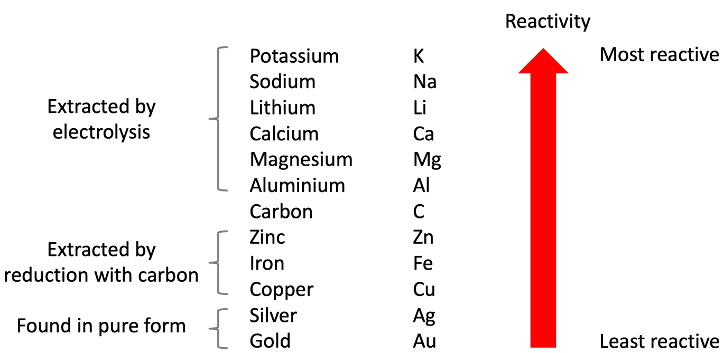
As gold and silver are very unreactive, they can be found as a pure metal. Gold and silver therefore don’t need to be extracted from ores by chemical reactions.

Q1. The following statements are either true or false. State which are true and which are false.
- Gold can be found as a pure metal.
………………………………………………………………………………………………………………………………………………………………………………………………………..
- Zinc is more reactive than carbon.
………………………………………………………………………………………………………………………………………………………………………………………………………..
- Iron can be extracted from its ore by heating with carbon.
………………………………………………………………………………………………………………………………………………………………………………………………………..
- Aluminium can be extracted from its ore by heating with carbon.
………………………………………………………………………………………………………………………………………………………………………………………………………..
- Magnesium can be extracted from its ore by electrolysis.
………………………………………………………………………………………………………………………………………………………………………………………………………..
- Carbon would not displace calcium from calcium oxide.
………………………………………………………………………………………………………………………………………………………………………………………………………..
Q2. Complete the word equation for the displacement reaction between carbon and iron oxide
carbon + iron oxide → ……………………………………………………… + ………………………………………………………
Q3. Complete the word equation for the displacement reaction between carbon and zinc oxide.
carbon + zinc oxide → ……………………………………………………… + ………………………………………………………
Q4. Copper is extracted from copper oxide using carbon. Write down a word equation for this reaction.
………………………………………………………………………………………………………………………………………………………………………………………………………..
Q5. Describe why the below reaction is not possible.
magnesium oxide + carbon → magnesium + carbon dioxide
………………………………………………………………………………………………………………………………………………………………………………………………………..
………………………………………………………………………………………………………………………………………………………………………………………………………..
Q6. Explain why carbon is used to extract metals like iron and copper but not aluminium.
………………………………………………………………………………………………………………………………………………………………………………………………………..
………………………………………………………………………………………………………………………………………………………………………………………………………..
………………………………………………………………………………………………………………………………………………………………………………………………………..
………………………………………………………………………………………………………………………………………………………………………………………………………..

