When we study ecosystems, we often need to assess the number of different species in a specific area. It isn’t possible to count every single one of an organism within a large area, so we instead carry out an estimate using quadrats.
Assessing ecosystems
A quadrat is a square frame, usually made of wood or metal, that is used to give a sample area within an ecosystem. The size of a quadrat can vary, but it’s often 1m x 1m. The quadrats are placed randomly in an area they want to study and count the organisms within the frame. By doing this in multiple places within the area, we can estimate the population size.
To do this correctly, we should use the following method.
- Random Placement. To avoid bias, the quadrat should be placed randomly in the area to be studied. This can be done by using a random number generator to determine coordinates within the area.
- Counting Organisms. Once the quadrat is placed, all organisms within the frame are identified and counted.
- Repeating the Process. The process is repeated multiple times in different parts of the area. A mean number of organisms can then be calculated per quadrat.
- Multiply mean by area. The mean number of organisms per quadrat gives the number in each m². Multiplying this by the total area gives an estimate of the population size.
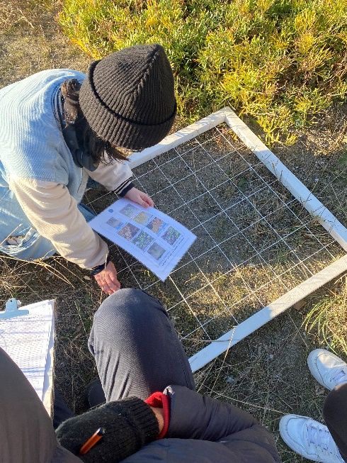
Example question
A field has an area of 10 000 m². Some students use quadrats of area 1 m² to estimate the number of daisies in the field. They find an average of 12 daisies per quadrat. Calculate an estimate for the total number of daisies in the field.
Step 1. Write down equation:
Total population = average number per quadrat × total area
Step 2. Insert variables into equation:
Total population = 12 × 10 000
Step 3. Calculate answer.
Giulia Castiglioni, CC0, via Wikimedia Commons

Total population = 120 000 daisies
By studying ecosystems, we can detect changes over time, such as a decline in a particular species or the impact of human activities like pollution or deforestation. This information can help us make decisions about how to protect and manage ecosystems.
Q1. The following statements are either true or false. State which are true and which are false.
- To calculate the population of an organism within a large area, it’s easiest to count them all.
………………………………………………………………………………………………………………………………………………………………………………………………………..
- Quadrats usually have an area of 1 m².
………………………………………………………………………………………………………………………………………………………………………………………………………..
- To calculate an estimate for the total population in an area, we can divide the average number per quadrat by the total area.
………………………………………………………………………………………………………………………………………………………………………………………………………..
Q2. A meadow has an area of 5000 m². Students use quadrats of 1 m² to estimate the number of clover plants in the meadow. They find an average of 20 clover plants per quadrat. Calculate an estimate for the total number of clover plants in the meadow.
………………………………………………………………………………………………………………………………………………………………………………………………………..
………………………………………………………………………………………………………………………………………………………………………………………………………..
………………………………………………………………………………………………………………………………………………………………………………………………………..
Q3. A field has an area of 2,500 m² and the average number of dandelions per m² quadrat is found to be 8. Calculate the estimated total number of dandelions in the field.
………………………………………………………………………………………………………………………………………………………………………………………………………..
………………………………………………………………………………………………………………………………………………………………………………………………………..
………………………………………………………………………………………………………………………………………………………………………………………………………..
Q4. After placing 15 quadrats in a 4,000 m² area, the average number of organisms counted per m² quadrat is 10. Calculate an estimate for the total population of the organisms in the area.
………………………………………………………………………………………………………………………………………………………………………………………………………..
………………………………………………………………………………………………………………………………………………………………………………………………………..
………………………………………………………………………………………………………………………………………………………………………………………………………..
Q5. Describe what a quadrat is and how it is used in studying ecosystems.
………………………………………………………………………………………………………………………………………………………………………………………………………..
………………………………………………………………………………………………………………………………………………………………………………………………………..
………………………………………………………………………………………………………………………………………………………………………………………………………..
………………………………………………………………………………………………………………………………………………………………………………………………………..
Q6. Describe a reason why it’s useful to assess ecosystem populations.
………………………………………………………………………………………………………………………………………………………………………………………………………..
………………………………………………………………………………………………………………………………………………………………………………………………………..
………………………………………………………………………………………………………………………………………………………………………………………………………..
………………………………………………………………………………………………………………………………………………………………………………………………………..

