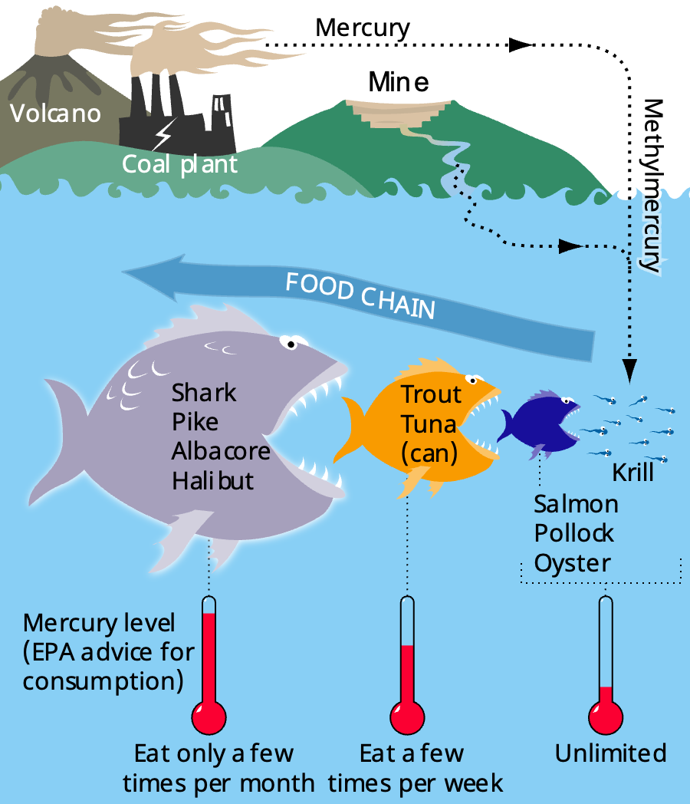
Bioaccumulation is the process by which toxic substances build up in the tissues of organisms over time. These toxic substances can include chemicals like pesticides, heavy metals (such as mercury or lead) and other pollutants that enter the environment through air, water or soil. Once these toxins are in an ecosystem, they can move through the food chain and become more concentrated in the bodies of animals higher up the food chain.
Bioaccumulation
One common example of bioaccumulation involves mercury, a heavy metal that can be released into the environment from industrial processes like coal burning. In aquatic ecosystems, mercury is absorbed by small organisms like plankton. Small fish eat the plankton and the mercury accumulates in their bodies. When larger fish (like tuna or trout) eat these smaller fish, they take in the mercury as well. By the time these large fish are eaten by humans or other top predators, the mercury concentration can be dangerously high, leading to health risks such as neurological disorders.
Bretwood Higman, Ground Truth Trekking., CC BY 3.0, via Wikimedia Commons

Another example of bioaccumulation is the pesticide DDT. DDT was used extensively in agriculture to control insects. However, it also accumulated in the environment and particularly in aquatic ecosystems. Small organisms in the water absorbed the DDT and, as it moved up the food chain, it became highly concentrated in birds of prey like eagles and ospreys. The high levels of DDT caused these birds to lay eggs with very thin shells, which often broke before the chicks could hatch. This led to a significant decline in bird populations before DDT was banned in many countries.
Preventing bioaccumulation involves reducing the release of harmful chemicals and pollutants into the environment. This can be achieved by using less toxic alternatives to pesticides, enforcing stricter regulations on industrial waste and ensuring that toxic materials are properly disposed of.

Q1. Define bioaccumulation and describe how it occurs in an ecosystem.
………………………………………………………………………………………………………………………………………………………………………………………………………..
………………………………………………………………………………………………………………………………………………………………………………………………………..
………………………………………………………………………………………………………………………………………………………………………………………………………..
………………………………………………………………………………………………………………………………………………………………………………………………………..
Q2. State two examples of toxic substances that can lead to bioaccumulation.
………………………………………………………………………………………………………………………………………………………………………………………………………..
Q3. A small fish in a polluted river absorbs 2 units of a toxin. If a larger fish eats 10 of these small fish, state how many units of toxin the larger fish has.
………………………………………………………………………………………………………………………………………………………………………………………………………..
Q4. A top predator in a food chain eats 15 animals, each with 10 units of toxin. State how many units of the toxin the predator accumulates from eating these animals.
………………………………………………………………………………………………………………………………………………………………………………………………………..
Q5. Describe how human activities contribute to bioaccumulation and suggest ways to reduce its impact on ecosystems.
………………………………………………………………………………………………………………………………………………………………………………………………………..
………………………………………………………………………………………………………………………………………………………………………………………………………..
………………………………………………………………………………………………………………………………………………………………………………………………………..
………………………………………………………………………………………………………………………………………………………………………………………………………..
Q6. NHS advice is for an adult to eat no more than 2 tuna steaks a week. Describe why this advice is in place.
………………………………………………………………………………………………………………………………………………………………………………………………………..
………………………………………………………………………………………………………………………………………………………………………………………………………..
………………………………………………………………………………………………………………………………………………………………………………………………………..
………………………………………………………………………………………………………………………………………………………………………………………………………..
Q7. Describe why the pesticide DDT has been banned in many countries.
………………………………………………………………………………………………………………………………………………………………………………………………………..
………………………………………………………………………………………………………………………………………………………………………………………………………..
………………………………………………………………………………………………………………………………………………………………………………………………………..
………………………………………………………………………………………………………………………………………………………………………………………………………..

