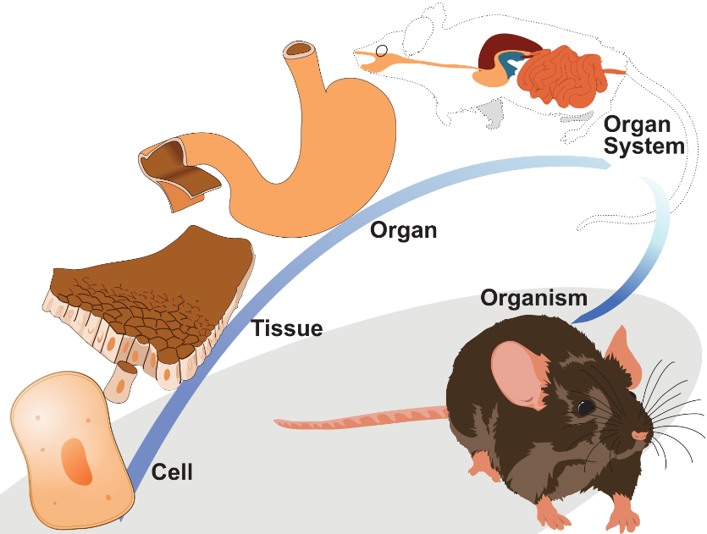
Multicellular organisms are made of many individual cells and need a way of organising cells so that they can work together. These levels are arranged in a hierarchy from simple to complex: cells, tissues, organs, organ systems, and finally, organisms.
Cell organisation
The diagram to the right shows cell organisation to form the digestive system of a mouse. Firstly, epithelial cells are shown. These cells line the stomach, providing a protective barrier and aiding in nutrient absorption.
Adapted from LadyofHats, CC0, via Wikimedia Commons
These cells are arranged into epithelial tissue which, in turn, is joined with other tissues to form the stomach. The stomach is an organ which is then combined with other organs, such as the intestines, to form the digestive system. Different organs join together to form organ systems. Collectively, organ systems form the whole organism.
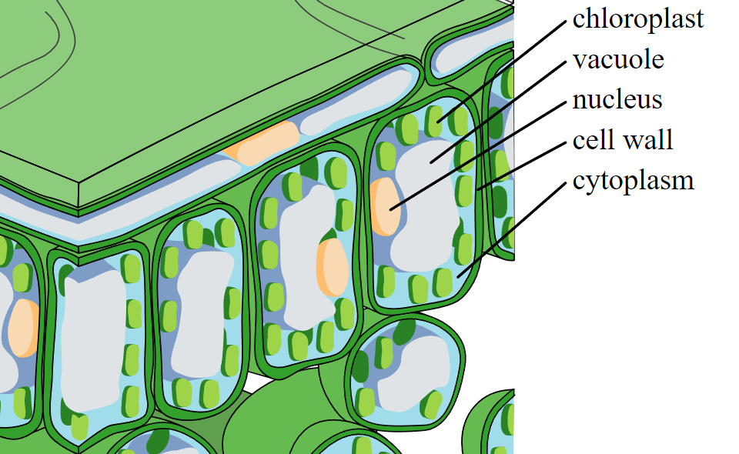
Another example of cell organisation is the organisation of cells in a leaf. One of the cells in a leaf is called a palisade cells. Palisade cells are near the surface of a leaf and have many chloroplasts for photosynthesis.
Palisade cells join together to form palisade tissue (shown in the image to the left). In turn, different tissues join to form a leaf which is an organ. Leaves combine with other organs to form the shoot system.
Cropped image from Zephyris, CC BY-SA 3.0, via Wikimedia Commons
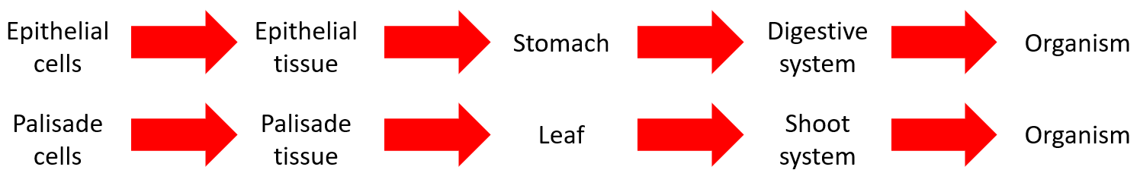
A summary of the cell organisation for both examples is below:
Q1. The following statements are either true or false. State which are true and which are false.
- Multicellular organisms are made of many individual cells.
………………………………………………………………………………………………………………………………………………………………………………………………………..
- The stomach is a tissue.
………………………………………………………………………………………………………………………………………………………………………………………………………..
- A tissue is made from a group of similar cells working together.
………………………………………………………………………………………………………………………………………………………………………………………………………..
- Plant leaves are organs.
………………………………………………………………………………………………………………………………………………………………………………………………………..
- Epithelial cells are needed for photosynthesis.
………………………………………………………………………………………………………………………………………………………………………………………………………..
Q2. Describe the difference between tissues and organs.
………………………………………………………………………………………………………………………………………………………………………………………………………..
………………………………………………………………………………………………………………………………………………………………………………………………………..
Q3. Describe an example of cell organisation in a plant. Include a description of how cells are organised into tissues, organs and organ systems.
………………………………………………………………………………………………………………………………………………………………………………………………………..
………………………………………………………………………………………………………………………………………………………………………………………………………..
………………………………………………………………………………………………………………………………………………………………………………………………………..
………………………………………………………………………………………………………………………………………………………………………………………………………..
Q4. Describe an example of cell organisation in an animal. Include a description of how cells are organised into tissues, organs and organ systems.
………………………………………………………………………………………………………………………………………………………………………………………………………..
………………………………………………………………………………………………………………………………………………………………………………………………………..
………………………………………………………………………………………………………………………………………………………………………………………………………..
………………………………………………………………………………………………………………………………………………………………………………………………………..
Q5. State three organelles that a palisade cell is made of and describe the purpose of each organelle.
………………………………………………………………………………………………………………………………………………………………………………………………………..
………………………………………………………………………………………………………………………………………………………………………………………………………..
………………………………………………………………………………………………………………………………………………………………………………………………………..
………………………………………………………………………………………………………………………………………………………………………………………………………..

